IMPROVING MULTIMEDIA FOUNDATIONS:
DESIGN OF A MICRO-SYLLABUS FOR INTEGRATION OF
MULTIMEDIA MODULES INTO COLLEGE COURSES
AT THE UNIVERSITY OF DELAWARE

by

Aaron Davis

An executive position paper submitted to the Faculty of the University of Delaware in partial fulfillment of the requirements for the degree of Doctor of Education with a major in Curriculum, Technology, and Higher Education (CTHE)

Spring 2013

© 2013 Aaron Davis
All Rights Reserved

IMPROVING MULTIMEDIA FOUNDATIONS:
DESIGN OF A MICRO-SYLLABUS FOR INTEGRATING
MULTIMEDIA MODULES INTO COLLEGE COURSES
AT THE UNIVERSITY OF DELAWARE

by

Aaron Davis

Approved:
Ralph P. Ferretti, Ph.D.
Director of the School of Education

Approved:
Lynn Okagaki, Ph.D.
Dean of the College of Education and Human Development

Approved:
James G. Richards, Ph.D.
Vice Provost for Graduate and Professional Education

I certify that I have read this executive position paper and that in my opinion it meets the academic and professional standard required by the University as an executive position paper for the degree of Doctor of Education.

Signed:
Fred Hofstetter, Ph.D.
Professor in charge of executive position paper

I certify that I have read this executive position paper and that in my opinion it meets the academic and professional standard required by the University as an executive position paper for the degree of Doctor of Education.

Signed:
Chrystalla Mouza, Ed.D.
Member of executive position paper committee

I certify that I have read this executive position paper and that in my opinion it meets the academic and professional standard required by the University as an executive position paper for the degree of Doctor of Education.

Signed:
Douglas Archbald, Ph.D.
Member of executive position paper committee

I certify that I have read this executive position paper and that in my opinion it meets the academic and professional standard required by the University as an executive position paper for the degree of Doctor of Education.

Signed:
Janet Hethorn, Ph.D.
Member of executive position paper committee

ACKNOWLEDGMENTS
While there are numerous people I’d like to thank, I’d first like to address that I wouldn’t have been able to complete this research without the involvement of my committee. Thank you, Dr. Fred Hofstetter, Dr. Douglas Archbald, Dr. Chrystalla Mouza, and Dr. Janet Hethorn. Thanks to all of you, I have been given great opportunities, leadership, and guidance that has prepared and enlightened me as an educator.
I’d also like to acknowledge and thank Paul Hyde, Sandy McVey, and everyone at Academic Technology Services, who for four years contributed to my knowledge and growth in both technology and education. I am truly fortunate for all of the opportunities awarded while working under some of the smartest and most talented people in my field.
Additionally thanks goes to all the participants of this project who gave valuable and immeasurable insights to the goals of this project.
Finally thanks and love to my friends and family, Mom, Dad, Adam, and all the other amazing individuals who have guided me and added to my growth as an artist, educator, and person.
TABLE OF CONTENTS
LIST OF TABLES vii
LIST OF FIGURES viii
ABSTRACT ix
- INTRODUCTION, PURPOSE, AND PROBLEM STATEMENT 1
Visual Culture 1
New Media 2
Problem Statement 2
Improvement Goal 5
Importance of Multimedia 5
Multimedia Literacy 9
Role of Technology 11
Student Multimedia Design Center 13
Problems with Use of Resources 14
Empathy through Creation 15
A Minor in Interactive Media 16
Other Examples of Multimedia Curricula 18
Benefits of Multimedia 19
- METHODOLOGY, AND RESULTS 24
Central Questions 24
Participants 25
Results and Discussion 27
- MICRO SYLLABUS, LIMITATIONS, AND CONCLUSIONS 36
Multimedia Micro-Syllabus 36
Limitations 48
Recommendations 49
Integration of Syllabus 49
Conclusions 50
REFERENCES 52
APPENDICIES 55
- INTERVIEW FIELD GUIDE 56
- RESOURCES FOR INTEGRATED MICRO-SYLLABUS 59
List of Multimedia Skills 59
Elements and Principles of Art Definitions 60
Roles for Digital Storytelling Handout 62

LIST OF TABLES
Table 1 Principles of Multimedia Design 8
Table 2 Two Approaches to Multimedia Design: Technology-Centered vs. Learner-Centered 13
Table 3 List of Syllabi Examined 18
Table 4 Average Amount of Time Spent with Media in a Typical Day 20
Table 5 List of Departments of Interview Participants 25
Table 6 Number of Participants in Interview 26
Table 7 Summarized Data from Faculty Interviews 28
Table 8 Summary of Micro-Syllabus 46

LIST OF FIGURES
Figure 1 Example of Title Card for AsapSCIENCE Video 9
Figure 2 Percentage of Employers Rating Skills as Valuable 21
Figure 3 Screenshot of Website Designed for Educators 37
Figure 4 Example of Assignment 1 40
Figure 5 Example of Sign Up for Multimedia Skills 41
Figure 6 Example of Assignment 2 42
Figure 7 Example of Assignment 3 43
Figure 8 Example of Assignment 4 45

ABSTRACT
At the University of Delaware there has been growth in the use of multimedia technologies to facilitate the process of learning. However, many students entering higher educational institutions today, despite growing up with access to these tools, do not use them in interesting and meaningful ways.
When given the opportunity to create multimedia projects, students tend to spend too much time on content or learning a specific technology, and not enough time on structure and design. Instead of a dynamic interactive presentation of content that aids cognition, students tend to produce a recitation of facts. The need for good multimedia skills is paramount not just in education, but in a world where technology and communication rely heavily on sound multimedia practices.
The purposes of this study were to identify the foundational skills associated with best practices in multimedia, and to design a curriculum that enables students to communicate effectively through visual interactive media. Interviews were conducted with faculty at the University of Delaware who use multimedia in their courses and represent a range of departments. The interviews revealed how faculty use multimedia and what they consider to be the skills needed to be proficient with multimedia tools.
These skills included data filtering, information retrieval, use of tools in a variety of multimedia formats, communication, aesthetics, and storytelling.
On the basis of the interview data, a syllabus was designed to empower students with the resources and skills to produce high-quality multimedia content. This “micro-syllabus” was determined to be the most reasonable and feasible means to integrate multimedia skills within academic content areas.

INTRODUCTION, PURPOSE, AND PROBLEM STATEMENT

Visual Culture
Our present-day culture is dominated by the visual aspect of communication.
Computers, originally designed to process numbers and text, have been adapted to the needs of the “personal” user through more visually complex user interfaces (Sturken & Cartwright, 2001, p. 1).
Even the most recent of new technologies such as tablet devices rely on visual communication to direct user inputs. As technologies have evolved so has our ability to quickly interpret and understand visual media. While some might argue that the natural evolution of technology led to the creation of these visual formats, others would argue that visual formats are a response to a social need to understand messages within specific contexts (Sturken & Cartwright, 2001, p. 119).
Regardless of technological or social needs, the fact is that we navigate our lives largely if not exclusively through recognition of visual cues. Advertisements, street signs, entertainment, and news media all use visual aesthetics to convey pleasure, disgust, anger, curiosity, shock, confusion, and the like.

New Media
Students in higher education settings have access to technologies that give them the ability not only to partake of visual content, but to create and share as well. The term new media refers to user-created content shared through the digital medium—a kind of instantaneous distribution and consumption that allows immediate feedback and participation (“New Media,” 2013). This conversation between creator and audience and the instantaneous nature of distribution are what make new media technologies so powerful in educational settings (ED, 2010). The new media constitute in themselves a new language, affecting all stages of communication, “including acquisition, manipulation, storage and distribution [as well as] all types of media: texts, still images, moving images and spatial constructions” (Manovich, 2001, p. 19). This combination of resources adds new dimensions through both visual and auditory input, and in some cases adds a dimension of interaction. These combinations provide a way for consumers of media to associate content with meaning (Martinec & Van Leeuwen, 2009, p. 1).

Problem Statement
Tracey Wilen-Daugenti’s book .Edu: Technology and Learning Environments in Higher Education (2009) describes a group of students “Generation V” born after 1996 that has grown up on what Wilen-Daugenti refers to as the “three Vs”: Visual, Virtual, and Versatile.
Wilen-Daugenti describes the 3 Vs as follows (p. 68):
- Visual: The students grew up with visual technologies such as handycams, digital cameras, and YouTube as ways to source information or express themselves.
- Virtual: This generation has been exposed to some of the newest gaming consoles such as Wii, Xbox, and PlayStations, as well as virtual reality games such as Habbo, The Sims, and a variety of multiplayer online games.
- Versatile: These students are accustomed to using a variety of devices such as iPods, iPod Touch, and smartphones with ease. Much of their usage is fueled by the constant stream of new products released by manufacturers of digital devices and software.
These students, who are now beginning to enter higher education institutions, are immersed in a culture that did not exist a decade ago. Technologies like multimedia messaging services, social media, smartphones, and Web 2.0 determine how students spend their downtime interacting with their peers (Kaiser Family Foundation, 2010, p. 2).
The U.S. Department of Education’s National Education Technology Plan states that:
Many students’ lives today are filled with technology that gives them mobile access to information and resources 24/7, enables them to create multimedia content and share it with the world, and allows them to participate in online social networks where people from all over the world share ideas, collaborate, and learn new things. Outside school, students are free to pursue passions in their own way, and at their own pace. The opportunities are limitless, boundless, and instantaneous (USDOE, 2010).
Yet according to Renee Hobbs’ analysis in Digital and Media Literacy (2011), while these students are engaged and invested in these technologies, the media being presented to them are rarely discussed with adults in a way that helps students understand and appreciate the content being presented (p. 8).
While there are many examples of students leveraging media towards a meaningful discussion, in which a type of tangential learning process takes place where one’s consummation of media can turn to the creation of media (Collins & Halverson, 2009), these individual instances are the result of customization, an aspect of technology proliferation tailored to an individual student’s interests, not a universal skill set needed to understand and create media.
At the University of Delaware students now have access to a vast array of multimedia technologies that can assist in communicating through a visual medium. Multimedia technologies like video, blogs, and the Internet offer students countless resources for both learning and creation.
While UD has begun to redefine its general education goals, and slowly begun to recognize the potential multimedia technologies offer, and the strong need for educating students with these competencies, there is no universal standard or policy with regards to multimedia competency. This is partially due to the idea that because students are immersed in this multimedia culture, the expectation from educators is proficiency simply as a result of student consumption of multimedia content.

Improvement Goal
The purposes of this project were to identify foundational skills of multimedia practices, design a curriculum that helps students understand and communicate more effectively through visual, interactive media, and identify an ideal means for delivering these techniques to students at the University of Delaware.
I first conducted a literature review of best practices in multimedia design and communication in order to examine “the theoretical and research literature [that] may help in identifying a testable hypothesis or a specific research purpose or research question” (Patten, 2009, p. 31). This review, along with faculty interviews and my own experiences as an information technology professional, enabled me to produce a micro-syllabus whose purpose is to be integrated into an existing curriculum, while efficiently and quickly prepare students in the concepts associated with best practices in multimedia without deterring from content of that curriculum. Mastery of best practices, in turn, should help students to create multimedia products that effectively communicate intended ideas.

Importance of Multimedia
According to Department of Public Instruction consultant Martin Rayala, “There are seven ways to communicate information, and words and numbers are only two of them. The other five are: movement, sound, images, objects, and spaces” (cited in Hurly, 2004).
Traditionally, education has been conducted through a type of schooling referred to by Collins and Halverson (2009) as “uniform learning”:
This belief stipulates that everyone should learn the same things. Despite the practices of innovations, such as special education, typical school courses are still structured so that everyone studies the same texts, and has to pass the same examinations. This notion extends beyond the individual course to the notion of a set of required courses extending up to graduate school. The notion that everyone must come through the process meeting a set of common requirements is very deeply ingrained in the notion of school (pp. 43-44).
This method of instruction is based on a single means of communication, words—disregarding the cognitive benefits of learning through visual interactive media.
How one experiences information is closely related to how one learns. James Catterall argues that the experience of learning is just as important as the material being learned, and that by learning through means of communication other than words one can stimulate parts of the brain that are associated with cognition (Catterall, 2002, p. 152). For example, research indicates that musical experience affects spatial reasoning, which in turn affects language development, mathematics proficiency, and a broad class of skill sets identified by standardized tests (Catterall, 2009, p. 35).
Higher education institutions have a unique opportunity to present students with an alternative way to learn. Emerging multimedia technologies make possible customization, which can be viewed as an antithesis to uniform learning (Collins and Halverson, 2009). Multimedia is the combination of different media formats, such as text, graphics, sound, and video, forged together to communicate an idea. Multimedia allows users to experience information—to make connections, interact, and communicate in ways that are not possible through uniform learning.
Take, for example, the popular YouTube Channel AsapSCIENCE. This channel is dedicated to answering questions about the science behind specific topics. Since its inception in the summer of 2012, the channel has garnered close to 600,000 subscribers, with over 50 million views of its videos. Its videos have also been featured on many other websites, including MNBC and the Washington Post.
Topics featured on the AsapSCIENCE channel include The Science of Love, Which Came First – The Chicken or the Egg?, Motion Sickness – What Is It?, and The Science of Productivity.
What makes AsapSCIENCE’s videos so memorable and successful is its method of content delivery, which closely follows Richard Mayer’s principles of multimedia design (Mayer, 2001; see Table 1). The videos are short (two to three minutes) and use combinations of text, color, audio, and animated drawings. The combination of these elements creates short but effective messages that both entertain and inform the audience.

- Principles of Multimedia Design
Principle | Definition
Multimedia Principle | Students learn better from words and pictures than words alone.
Spatial Contiguity Principle | Students learn better when corresponding words and pictures are presented near rather than far from each other on the page or screen.
Temporal Contiguity Principle | Students learn better when corresponding words and pictures are presented simultaneously rather than successively.
Coherence Principle | Students learn better when extraneous words, pictures, and sounds are excluded rather than included.
Modality Principle | Students learn better from animation and narration than from animation and on-screen text.
Redundancy Principle | Students learn better from animation and narration than from narration and on-screen text.
Individual Differences Principle | Design effects are stronger for low-knowledge learners than for high-knowledge learners and for high spatial learners than for low spatial learners.
AsapSCIENCE belongs to a new generation of content creators who recognize that the delivery of content is just as important as the content itself. This has led individual content creators to strive for and in some cases achieve production values that meet professional studio standards.

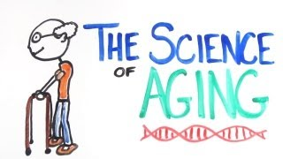
- Example of Title Card for AsapSCIENCE Video
Note. The image was retrieved from AsapSCIENCE: The Science of Aging (7 March 2013).

Multimedia Literacy
To understand the benefits of multimedia, we first have to understand how multimedia technology is affecting today’s educators and learners. According to Hobbs (2011), both educators and students are using multimedia technologies, but in very different ways:
When teachers use the Internet, for example, it’s often to check e-mail or surf the web for information related to career, health, or hobbies. When teens use the Internet, the purpose is for socializing or entertainment, generally by playing games, watching videos, searching for and listening to music, and interacting with friends through social networks like Facebook or MySpace
(p. 8).
Hobbs (2011, p. 12) delineates five dimensions necessary for proficiency in multimedia literacy:
- ACCESS. Finding and sharing appropriate and relevant information and using texts and technology tools well.
- ANALYZE. Using critical thinking to analyze message purpose, target audience, quality, veracity, credibility, point of view, and potential consequences of messages.
- CREATE. Composing or generating content using creativity and confidence in self-expression, with awareness of purpose, audience, and composition techniques.
- REFLECT. Considering the impact of media messages and technology tools on our thinking and actions in daily life and applying social responsibility and ethical principles to our own communication behavior and conduct.
- ACT. Working individually and collaboratively to share knowledge and solve problems in the family, the workplace, and the community, and participating as a member of the community at local, regional, national, and international levels.
By understanding these five dimensions, both educators and students can better interact and understand how personal experiences with multimedia can be used as a powerful educational tool. These five dimensions work together not just to enable students interact better with multimedia, but also work to turn students into lifelong learners that can understand and communicate effectively despite specific technologies.

Role of Technology
As mass media has become more centralized, the Internet has enabled creator-driven content to become more diverse and accessible (Collins & Halverson, 2009).
However, diversity and accessibility don’t necessarily mean “good.” For every AsapSCIENCE there are many more channels that lack professional production values. One must learn to analyze and judge the merit of multimedia content, using as guidelines such questions as the following:
- What is the purpose of the content?—e.g., entertainment, tutorial, personal.
- What groups or individuals constitute the intended audience?
- Is the delivery of content in tandem with its purpose?
- Are different media elements working together to form a cohesive argument?
- Are design elements working together to form an aesthetically pleasing structure?
According to Mayer (2001), there are two approaches to multimedia design (see Table 2). The first—what Mayer calls the technology-centered approach— focuses on using technology as the primary method of content delivery; content is determined by available technologies, which leads to an investigation of technologies in order to decide which are the most appropriate to deliver a particular message.
The drawback to this approach, according to Mayer, is the same drawback that technology has met with historically when used in education. Technologies such as photography, telephones, cinema, radio, and television were all at one point considered new media (Wardrip-Furin & Montfort, 2003, p. 19). Yet they all failed to have a lasting impact on education; with respect to film for example, “In spite of grand predictions, a review of educational technology reveals that most teachers used films infrequently in their classrooms” (Mayer, 2001, p. 9). As Mayer points out, new technologies like radio and television emerge with great promise for education; there is a rush to use them in classrooms; and in the end, expectations and hopes are unmet, largely because educators succumb to the demands of technology instead of adapting technology to fit the needs of learners.
The second approach to multimedia design is what Mayer calls learner- centered. Here the technological tools are subordinated to the goal of determining the best means to enhance content; multimedia design is viewed primarily as an aid to cognition.

- Two Approaches to Multimedia Design:
Technology-Centered vs. Learner-Centered
Design Approach | Starting Point | Goal | Issues
Technology- centered | Capabilities of multimedia technology | Provide access to information | How can we use cutting-edge technology in designing multimedia presentations?
Learner-centered | How the human mind works | Aid human cognition | How can we adapt multimedia technology to aid human cognition?
Note: Adapted from Mayer (2001).

Student Multimedia Design Center
At the University of Delaware students today have access to a vast array of multimedia technologies that can assist in communication. The Student Multimedia Design Center (SMDC) is a centralized resource “designed to meet the current and future needs of the increasing number of classes which involve creation of multimedia projects and presentations as a course requirement. The Center offers space for practicing presentations and video multimedia equipment to use individually or in collaborative groups” (personal communication, January 9, 2013).
The SMDC is available to the entire student body and houses resources that include hardware such as cameras, lighting kits, tripods, and microphones, as well as experienced personnel to help instruct and assist with specialized software. Along with hardware and software, free workshops are offered each semester to help students become proficient in the use of these technologies.

Problems with Use of Resources
Despite all the resources available through the SMDC there is still a gap between the services offered and their use by the student population. Attendance at seminars hosted by the SMDC is usually no more than 10-15 students (personal communication, January 9, 2013). Traditionally both educators and students have been slow to incorporate new technologies in the classroom. Educators seem content with using technology for administrative purposes, while students appear unaware that there are other means of presenting projects than through pedestrian slide presentations.
Pamela Harris Lawton (2007, p.10) recognizes that traditional “left brain” cognition, i.e., logical analytical thinking, is no longer sufficient in a society that communicates through visual media. Rather the abilities associated with right-brain thinking, “artistry, empathy, seeing the big picture and pursuing the transcendent” are equally relevant in today’s society. There are many multimedia technologies available to students that can foster such “right brain” abilities, as the following examples illustrate:
- With e-portfolios, students create an archive and timeline of a selected body of work and deliver it electronically. This allows anyone to see how a student’s work has evolved over time.
- By creating “digital stories” usually through video, students form a bond with what they are learning; this can change a student’s mentality from having to learn, to wanting to learn.
- Using presentation tools such as PowerPoint and Keynote, students create dynamic interaction between the audience and presenter—much more than a simple recitation of facts on slides.

Empathy through Creation
According to Mouza and Lavigne (2013), “Constructivism asserts that learning does not transmit from teachers to students through didactic methods, but that learners actively construct their understanding through interactions with peers, teachers, and their environment.” This idea of constructivist learning, or “learning by making,” suggests that students learn best when they are actively engaged in creating something they care about. Through the creation of multimedia products such as digital stories, students learn not only about the content of their product (the material being taught to them); they also learn to care about what they are making. This increases a student’s engagement and commitment, and is particularly effective with students who do not respond well in traditional classroom settings.
Students are constantly learning what makes a good movie or video game or TV show while they are watching or interacting with these media (Hobbs, 2011, p. 4). Consequently, when students are asked to create a visual story, they are likely to be aware of their aesthetic choices. Moreover, they will want to make something they would watch. This is what makes multimedia so powerful in the classroom.

A Minor in Interactive Media
At the University of Delaware there is a small but growing minor called Interactive Media. According to the Interactive Media website, this minor gives students a method of thinking that relies heavily on contemporary media. Though there is a strong emphasis on web design and video production, the ultimate goal of this minor is to teach students how to keep their content and designs current with evolving technology.
This minor is headed by the Art Department at the University of Delaware, and accepts students across majors. While the minor is run by the Art Department, Students are required to take a range of cross interdisciplinary classes from other departments. These classes include; Introduction to Computer Science and Web Applications (Computer Science), New Media Design (Art), Designing Online Information (English), and New Media Project Development (Communication).
According to the Interactive Media website (2013) these classes benefit students because:
Education is becoming more and more interdisciplinary as jobs require a broader range of skills, many of them related to digital media. The IMM complements study in any subject by giving students an opportunity to apply their major knowledge to media. Through the minor's required and elective courses, students can learn to plan, write, organize, design, and create web sites—individually and in collaborative groups. Animation, video, games, fine art applications and other forms of digital communication are viewed and discussed. In advanced courses, students can create various forms of media, according to their interests. Interactive media skills are an advantageous addition to any student’s resume (Retrieved from: http://interactivemedia.udel.edu/index.html).

One of the starting points for this project occurred while I was teaching a required course for the Interactive Media minor. This course is designed to teach students how to create effective media content and presentations using multiple digital media formats; students must research, plan, and produce complete media projects consisting of websites and video. Students entering the class are presumed to have a certain level of proficiency in using multimedia technologies. However, conceptual and technical practices were harder to instill. Unlike a computer science class, which focuses on function and on how media forms work in relation to the technology available, the interactive media design (Now New Media Design) class focuses on design form and good multimedia practices through an exploration of the creative process. A firm understanding of design concepts and development approaches should enable students to communicate through multimedia regardless of the how specific technologies are evolving. While the interactive media design class is geared towards artists and designers, the idea of preparing students both conceptually and practically when using multimedia technologies is universal in its application to other subject areas.

Other Examples of Multimedia Curricula
To help discover best practices in multimedia curricula and application, I examined similar collegiate syllabi found through a web search using Google and Google Scholar; using search terms such as multimedia syllabus (see Table 3). These syllabi were selected by looking for specific key words regarding multimedia, such as digital imaging, animation, video, audio editing, and digital media, as well as trends that were reflected within the syllabi’s course goals compared to the literature. Upon examination these syllabi tended to divide along Mayer’s two types of multimedia curriculum; i.e., schools tended to view their curricula as being either technology-based or learner-based. A secondary trend was that the curricula were either tech-specific—leaning toward a particular set of technologies—or tech-aggregate in an attempt to include everything on the technological horizon.
- List of Syllabi Examined
School | Class Title | Tech-Specific or Tech-Aggregate | Technology Centered or Learner Centered
A. Linwood Holton Governor's School | Advanced Multimedia Applications | Tech-Aggregate | Learner-Centered
Boise State University | Integrating Multimedia | Tech-Aggregate | Technology- Centered
Eastern Illinois University | Introduction to Multimedia Journalism | Tech-Specific | Learner-Centered
Lincoln High School | Digital Multimedia | Tech-Specific | Technology- Centered
Panola College | Introduction to Multimedia | Tech-Specific | Technology- Centered
Rutgers University | Introduction to Imaging and Multimedia | Tech-Specific | Technology- Centered
Note: Syllabi were located through web searches.

The tech-specific syllabi tend to emphasize how specific professions practice multimedia through delivery of content. The tech-aggregated syllabi seem intended to help students understand how multimedia can be used to enhance and aid in the understanding of the content being delivered. Most of the syllabi, however, did not address certain fundamental skill sets identified in this project (see Chapter 3, Findings), which include data filtering, information retrieval, use of tools in a variety of multimedia formats, communication, aesthetics, and storytelling. Moreover, these syllabi do not seem to address the necessity for students to adapt their communication skills to different technologies.

Benefits of Multimedia
Researchers have found that children between the ages of 8 and18 spend up to 7.5 hours of their day using various media (Kaiser Family Foundation, 2010). Thanks to mobile technologies and universal Internet access, these children are growing up with the ability to multitask and use more than one medium at a time, which adds up to a staggering 10 hours and 45 minutes per day of media exposure (see Table 4).
- Average Amount of Time Spent with Media in a Typical Day
 | 2009 | 2004 | 1999
TV content | 4:29 | 3:51 | 3:47
Music/audio | 2:31 | 1:44 | 1:48
Computer | 1:29 | 1:02 | :27
Video games | 1:13 | :49 | :26
Print | :38 | :43 | :43
Movies | :25 | 25 | :18
TOTAL MEDIA EXPOSURE | 10:45 | 8:33 | 7:29
Multitasking proportion | 29% | 26% | 16%
TOTAL MEDIA USE | 7:38 | 6:21 | 6:10
Source: Generation m2 media in the lives of 8- to 18-year-olds (Kaiser Family Foundation, 2010).

The fact that students are using these technologies abundantly indicates no more than that they have the ability to “consume” multimedia. The task for higher education is to harness their experience in such a way that they are well-prepared to use media in original and creative ways, which in turn will give them marketable skills.
A study conducted by EMC Research shows that certain skills needed for multimedia creation are valued by employers in today’s job market (Figure 2).
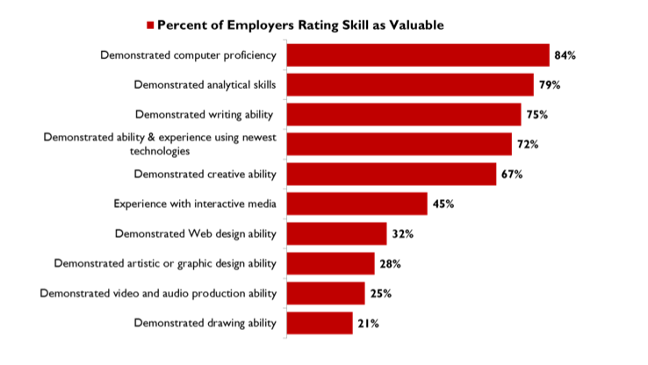
- Percentage of Employers Rating Skills as Valuable
Source: Highlights from a national survey of US employers (Bernstein, 2007).

This survey indicates that 45% of employers value interactive media abilities in prospective employees, with 67% of employers valuing creative abilities. “Even companies that are not in traditional arts businesses report that they are very likely to be hiring or contracting for web design, multimedia, graphic design, photography, animation and other arts backgrounds” (Bernstein, 2007, p.2). The recognition that multimedia skills offer professional benefits is further strengthened by the National Educational Technology Plan (2010) by the Department of Education, which states: “Answers to questions about 21st-century learning also must take into account that people no longer can learn everything there is to know in a lifetime, and the economic reality is that most people will change jobs throughout their lives” (p 13).

Challenges of Multimedia
While the benefits of multimedia include media literacy, communication skills, empathic learning, and a desirable professional skill set, multimedia-based curricula are not without their own set of challenges. Hobbs (2011, pp. 94-99) suggests that the following challenges should be considered when developing and implementing a multimedia curriculum:
Challenge 1: Students reproduce mass media and pop culture texts Educators need to be aware of the difference between imitation and self-expression and of the effect that cultural stereotypes may have on student-produced work.
Challenge 2: Students challenge adult authority Educators need to be aware of the “adolescent voice” in the creation of media. If a student’s production is harmful or detrimental to school policy, the teacher may be held liable.
Challenge 3: The major production goes unfinished Educators need to recognize the amount of time needed to produce a multimedia project, in addition to keeping the project within the parameters of an assignment. However, it should be noted, that too much control over a project can lead to student discouragement before a project makes it past pre-production.
Challenge 4: Coordinating student collaboration Educators need to be aware of the collaborative nature of multimedia projects such as video production and must reinforce collaborative skills in the classroom.
Challenge 5: Quality of work is superficial when style reigns over substance
Educators need to be as clear and concise as possible when giving a multimedia assignment, specifically concerning the role of the multimedia component and the content to be conveyed.
Challenge 6: Celebrating completion leads to an absence of reflection or critique Upon reviewing a multimedia project educators need to ask, Was the goal of the project accomplished? Was the content communicated clearly? What was effective/not effective? It is this dialogue that can have a meaningful effect on a student’s learning experience.
“When these challenges are addressed with well-designed assignments and effective instructional practices, multimedia composition projects can deliver on their promise of sustaining students in the process of deep engagement and exploration of ideas” (Hobbs, 2011, p. 102).

METHODOLOGY, AND RESULTS
There is a wide range of technologies and practices that can be used when developing a multimedia curriculum. Before designing a curriculum it was my intent to find and evaluate what educators considered the foundational principles of a multimedia curriculum.

Central Questions
Based on the literature and on my own experience teaching multimedia courses at the University of Delaware, two central questions emerged—bearing in mind that research questions need to imply complex, interesting, and informative results (Patten, 2009):
- What do educators who use multimedia in the curriculum consider to be the foundational principles and skills necessary for student proficiency?
- What type of delivery would best serve to educate students in these foundational principles and skills?
I approached these questions by conducting interviews with educators at the University of Delaware who use multimedia in their courses.

Participants
A “biased” sample was generated through what Patten (2009, p. 45) describes as volunteerism. A list of 16 faculty members was generated after conferring with Academic Technology Services (ATS) on campus. ATS works with faculty on a wide range of technological projects, including assistance in various multimedia endeavors. ATS helped to identify faculty members across departments and colleges who had experience with multimedia projects. The final list consisted of faculty who had worked with multimedia in some capacity with their students, from the following departments:
- List of Departments of Interview Participants
Department | Class Description
Art | Printmaking, Interactive Media Design
English | Critical Reading and Writing
Foreign Languages | Second Language Testing
Geology | Independent Documentary Filmmaker Instructor
History | Planning a Course of Instruction
IT Services | Academic Technology Services
Library and Media Services | Student Multimedia Design Center
Plant and Soil Sciences | Plants and Human Culture
Once the list was generated, potential participants were asked if they would be able to participate in an interview regarding their perceptions of multimedia at the University of Delaware. If the faculty member was unable to participate in person, an electronic document was sent. Of the 16 faculty contacted, 9 were interviewed, 6 in person with 3 responding electronically (see Table 6)
- Number of Participants in Interview
Number of Participants Contacted | Number of Participants Responded | Number of Participants Interviewed
16 | 9 | In Person | Electronically
16 | 9 | 6 | 3
Interviews
Interviews took place between January 9 and February 7, 2013. In-person interviews were held in locations comfortable for participants, usually in their office. I personally conducted each interview, taking notes during in-person interviews and recording them, with participants’ permission; recording enabled me to take notes that were strategic rather than verbatim (Patton, 2002, p. 383). All participants had signed consent forms which indicated that all identifying information would be kept confidential and that their views would not be used against them in any way.
As suggested by Patton (2002), I did everything possible to create rapport (empathy without judgment) with participants while maintaining neutrality with respects to participants’ opinions and information. The interview questions were open ended, so that the use of multimedia in the classroom could be understood through the eyes of the educators without presuming what they already knew (Patton, 2002, p. 21). The content of the questions stemmed from my literature review and from what I have observed when working with students on multimedia projects. Questions and follow-up probing ranged from general observations of student proficiency, to opinions about what would best help students to become proficient in multimedia practices, to observations regarding the application of multimedia practices in the classroom. (See Appendix A, Interview Field Guide).
The findings were then coded with IFG# to designate what questions certain skills, observations, and responses pertained to. For example IFG 03 refers to question 3 of the Interview Field Guide (Appendix A), What skills are necessary for proficiency in multimedia?

Results and Discussion
I analyzed the transcribed interviews and electronic questionnaire results by using what Patton (2002) calls qualitative inquiry. I looked for patterns, themes, categories, and typologies that seemed to trend among the interviews (Patton, 2002, p. 463). These trends can be found in table 7 which shows a summary of these findings gathered in the interviews. I then used these findings to generate a course syllabus to help prepare students in multimedia proficiencies.
- Summarized Data from Faculty Interviews
Topic/Question | Summarized Responses
Observations With Multimedia [IFG 02] | - Students Creating More Media  - All Students Media Consumers  - Student Underutilization of Technology  - Student Understanding of Structure of Media
Skills Necessary for Multimedia Proficiency [IFG 03] | - Search Skills  - Ability to Search  - Ability to Filter through “Trash”  - Ability to Write  - Rudimentary Skill-Set with Video Editing Software  - Troubleshoot
UD Student Skill Proficiency [IFG 03A] | Proficient | Not Proficient
UD Student Skill Proficiency [IFG 03A] | - Daily Use of Tools, e.g.,E-mail, Facebook | - Advanced Tools and Concepts  - Ability to Find Content  - Ability to Filter Content
Role of Storytelling [IFG 03B] | - Easier to Absorb Information Through Story  - Helps to Fuel Creativity  - Helps to Organize Thoughts to Communicate  - Culture Is Narrative-Based  - Allows for Memorability of Content
Role of Evolving Technology [IFG 03C] | Easier | Harder
Role of Evolving Technology [IFG 03C] | - Tools Readily Available  - Resources Readily Available  - Better Technologies  - Students Have the Ability to Absorb New Technologies | - Basic Skills to Use Tools Are Not Intuitive  - Advanced Technologies Not Intuitive
Role of Organizational Skills [IFG 03D] | - File Structure, File Formats, and Storage of Different Types of Media  - Access of Files/Media  - Difference Between Individual Organization and Group Organization  - Time Management  - Bookmarking Skills
Utilization of Multimedia with Students at UD [IFG 04] | - Potentially Beneficial  - SMDC Powerful Resource  - Faculty Slow to Incorporate New Technologies  - Not Enough Experts  - Underutilization of Available Resources  - Redundancy in Skills Being Taught  - No Communication Across Departments
Purpose of Multimedia in Higher Education [IFG 05] | - Enhance Student Engagement  - Exploration of Student Learning Outside of Reading/Writing  - Alternative Assimilation/Delivery of Content  - Enhance Communication Skills  - Present a Context for How One Assimilates Information
Core Concepts Needed to Produce Good Multimedia [IFG 06] | - Clear Workflow  - Clear Understanding of Content  - Good Communication/Writing Skills  - Quality of Media Being Used  - Accessibility  - Basic Artistic Aesthetic Concepts
Student Assimilation of Content Through Multimedia vs. Traditional Learning [IFG 07] | - Technology Is the “Hook” to Garner Learning  - Needs to Be a Balance Between Media and Tradition  - Better Engagement/Retention, but Less Overall Content Assimilated  - More Diversity in Media Created by Students  - More Skills Acquired Through Creation
Purpose of Visual Literacy [IFG 08] | - One Lives in a Visual Society  - Understanding a Non-Verbal Language  - A Lot of Information Packed into Visuals  - Ability to Discern Between Good and Bad Media  - Ability to Analyze What One Sees
Ideal Situation to Best Serve Student Proficiency in Multimedia [IFG 09, 10] | - Basic Multimedia Course as Early as Possible  - First Year Essentials of Multimedia Concepts  - Course Integration With English 110  - Consistency Across Student Learning of Multimedia  - Team-Taught Classes  - Effective Content Based Support Structure
Importance of Multimedia in Professional Field [IFG 11] | - Ability to Present Oneself Online  - Self-Awareness of How One Presents Themselves Online  - Alternative Ways to Present the Same Content
Additional Observations [IFG 12] | - Need More Analysis of What One Consumes and Produces  - iPad Integration  - Need More Communication Between Departments  - More Attention Paid to Accessibility  - Incorporate More “Real” Interaction

The following skills faculty identified as “core concepts” have little to do with actual multimedia technologies; rather they are fundamental writing skills and basic skills in searching and filtering information.
These skills were identified as:
- Information search [IFG 03, 03A]
- Visual literacy (Analysis of consumption of content) [IFG 06, 08,]
- Visual communication (Creation and distribution of content) [IFG 02, 05, 06]
- Creating and maintaining an online presence [IFG 11]
- Basic storytelling [IFG 03B, 06]
- Video presentation [IFG 03B, 03C, 04]
Not surprisingly, faculty who taught outside of the arts curriculum observed that students who majored in art were more at ease with multimedia-based projects than were students in other majors.
One participant said:
They [art majors] all had already done some kind of project where they were much more comfortable and experienced. And that’s probably because it’s art [IFG 03].
When asked if students were proficient in multimedia skills, most of the educators observed that this was not the case. Educators were quick to note that students were proficient with familiar technologies such as email and Facebook, but were unable to demonstrate proficiency when working with multimedia tools.
One respondent stated:
I think that they [students]have been lifelong consumers, and you expect them to be informed and that this would make them better creators, but really they are starting from scratch. Audio is a simple example. They’ll be lifelong consumers of iTunes, and now you say we’re going to mix and match audio and video and they don’t know what audio format is [IFG 02B].
Responses indicate that storytelling plays a huge role in multimedia projects, giving context to themes and messages. Creativity in multimedia is fostered through the processes inherent in storytelling, as another respondent noted:
I’d say the role of storytelling or the difference between communication and storytelling is that storytelling has a lot to do with two things. One is attention getting and the other is memorability. So we’re in what a lot of people call an attention economy now and you’re competing for attention with all the other things that are flooding people’s inputs. Storytelling I think is a way for people to get attention, and I think that it also helps with memorability., You remember a story long after you start to forget some other details. I think if somebody strictly did communication without storytelling it might be clear but it might be kind of like a technical paper or something like that. They’ve got all the facts right but it’s too dry to read; there’s no thread that holds it together. If it gets your attention and you happen to pay attention to it, you might not remember it because it was just a lot of information but no story to draw your attention and your imagination together [IFG 03B].
When participants were asked how the nature of evolving technology is effecting the production of multimedia projects, there were mixed responses. Most agreed that software and hardware have become more intuitive and user-friendly. One participant put it this way:
Nowadays it’s just everybody has access to the same tools—the tools to create video or create images or whatever. Everybody has access in their pocket; even if they have just a flip-phone, they have a camera on it. They can shoot video; they can take pictures with something that was given to them when they signed up for their plan with their phone carrier. The tools are cheaper, they’re available to everybody [IFG 03C].
However, many agreed that the core skills needed to use these tools are still not as intuitive as the tools themselves. The same participant added:
Not everybody can use them professionally. A lot of people use those tools in a way that’s very amateur and a lot of people would feel offended. When you’re a professional you feel offended when you see that kind of stuff [IFG 03C].
When asked about the importance of organization skills when working with multimedia, many respondents referred to the core skills necessary for proficiency in multimedia. They recognized the importance of not just being able to find and filter information but having the ability to store it and access it at a moment’s notice.
While participants observed that there have been substantial steps forward in the university’s recognition and support of multimedia on campus—specifically with the opening of the Student Multimedia Design Center—some felt that multimedia technologies are underutilized. They suggested that this stems from faculty inexperience with new technologies; there are too few experts available for a growing demand. In addition, a lack of communication between departments and the absence of a universal policy have led to a redundancy in the multimedia skills being taught.
Some participants pointed out that multimedia is not necessarily a substitute for traditional education but rather an alternative way to help students assimilate and deliver content. A multimedia project is inherently different from a research paper, and the goals of the teacher should determine which should be assigned. One participant stated:
In a 20-page paper you have to do so much more research. You have taken a number of different things that people have said and you have to assimilate that and you have to then translate that into some type of an essay, some type of structure that makes sense, that presents an argument in an intelligent manner. Now, with video I can get away with about one-tenth of the content of [a research paper]. I’m not saying that it isn’t appropriate for certain projects, but I think that what I’m seeing is that people will want to follow a trend and feel like they’re very current and then just say this is what we’re doing with all of our classes [IFG 07].
When participants were asked what would best serve students in an ideal situation, the answers, surprisingly, tended toward course integration of multimedia rather than classes geared specifically to multimedia design. All participants agreed that multimedia skills need to be taught early in a student’s career.
Faculty respondents agreed that the skills necessary for proficiency in multimedia translate into professional advancement. The ability to get one’s ideas across clearly is paramount in today’s workplace, and the skills acquired through multimedia practices give students entering today’s job market the means to excel in communication.
Participants had a range of ideas on how to incorporate multimedia in higher education, from using specific tools such as the iPad, to cross-departmental classes, to apprenticeship learning. All agreed, however, that the fundamentals of good multimedia practices had less to do with specific technologies than with good organization and communication skills.

MICRO SYLLABUS, LIMITATIONS, AND CONCLUSIONS

Multimedia Micro-Syllabus
Using the findings of both faculty and the review of the literature on multimedia in education, I developed a micro-syllabus that addresses the core skills needed for multimedia proficiency. This syllabus is designed to be easily incorporated into a variety of courses students may take early in their academic career.
It is detailed enough to address the fundamental skills suggested by faculty participants, and flexible enough to be integrated into a class whose teacher may not be an expert in multimedia. It follows a learner-centered approach, which allows students to take control of their learning without the need for an experienced multimedia teacher.

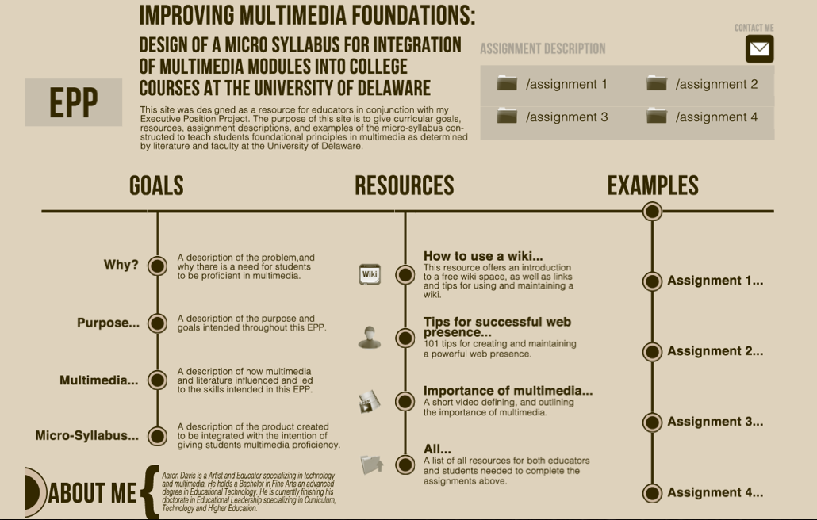
- Screenshot of Website Designed for Educators
Can be located at: http://www.udel.edu/present/aaron/epp

Additionally in order to assist educators I also designed an online component to be used to help visually explain assignments, and give resources to help educators not proficient in multimedia practices. The site for this resource can be found at http://www.udel.edu/present/aaron/epp.
The skills explored in the syllabus are very similar to the skills provided by the Educational Testing Service’s framework for Information and Communication Technologies (ICT). The ICT framework was developed to “provide a foundation for the design of instruments including large-scale assessments intended to inform public policy and diagnostic measures to test an individual’s skills associated with information and communication technology” (Educational Testing Service, 2007, p. iii).
The ICT framework identifies five critical components necessary for “ICT literacy”:
- Access - Knowing about and knowing how to collect and/or retrieve information.
- Manage - Applying an existing organizational or classification scheme.
- Integrate - Interpreting and representing information. This involves summarizing, comparing, and contrasting.
- Evaluate - Making judgments about the quality, relevance, usefulness, or efficiency of information.
- Create - Generating information by adapting, applying, designing, inventing, or authoring information.
The multimedia syllabus assignments are designed, not to teach the entirety of a multimedia curriculum, but rather to integrate multimedia into an existing curriculum and give students the skills identified by faculty. These skills include:
- Information search
- Visual literacy
- Visual communication
- Creating and maintaining an online presence
- Basic storytelling
- Video presentation
Overview: Students participate in a variety of assignments designed around communication, multimedia technologies, and the skill sets required for multimedia proficiency.
Time: 4-5 class periods, plus outside work
Resources Needed: Computer (preferably with Apple software), camera (cell camera acceptable)
Expected Learning Outcomes:
- Gain the ability to find, filter, save, and retrieve information, specifically resources regarding multimedia technologies.
- Recognize the resources that are available to help master multimedia technologies.
- Gain the ability to effectively communicate an idea through recognition of the audience.
- Gain the ability to create, maintain, and project a web presence.
- Gain the ability to use screen capture to express an idea.
- Understand the foundational aspects of design.
- Gain the ability to take an idea through the stages of pre-production, production, and post-production.
Prior Skills Needed: Students should be given a brief lesson in multimedia practices. Pre-Class Preparation: Print or make available online the resources in Appendix B.

Assignment 1: Bookmark and Search [IFG 03, 03A, 06, 08, 11]
Part 1: This assignment asks students to find resources from the List of Multimedia Skills (See Appendix C). These skills are basic to intermediate skills needed to create and analyze media. Each student will find what he or she considers the best available online resource for each skill. Students will then bookmark these resources using their Internet browser or online bookmarking site (e.g., Diigo) and submit an .html file or a link to their collection of bookmarks.
Submission: File or link to bookmarks
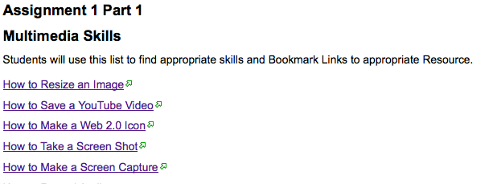
- Example of Assignment 1

Goal: Teach students to find, filter, save, and retrieve information, specifically all tools and resources they may encounter when working with multimedia technologies.
Part 2: After collecting their resources, each student will choose a skill by signing up through a class prepared sign up (wiki preferable), and go through the process that skill entails. If the resource is a tutorial, the student will actively participate and write about the level of difficulty of the tutorial. If the resource is a description of a skill, the student will write about how that skill applies in the creation of content.
Submission: Brief write-up of tutorial or other resource
Goal: Help students evaluate the content they are discovering and judge its merit.
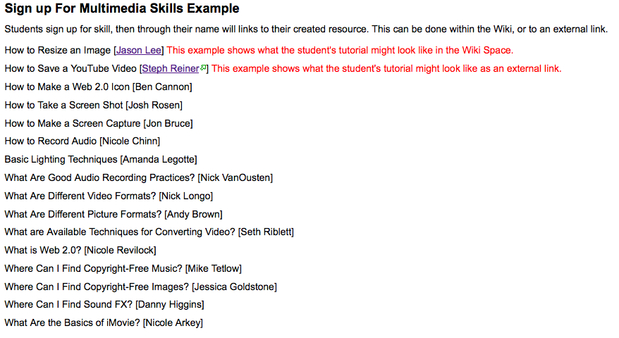
- Example of Sign Up for Multimedia Skills

Assignment 2: Write and Communicate [IFG 02, 05, 06, 08, 11]
After they have participated in Assignment 1, students will have become “expert” in a specific skill and will in their own words instruct the rest of the class in that skill by presenting it through an online resource (blog, wiki, Facebook post, etc.). The instructor will then collect the student-created resources and produce an online resource of a list of student prepared skills.
Submission: Link to student-created online resource
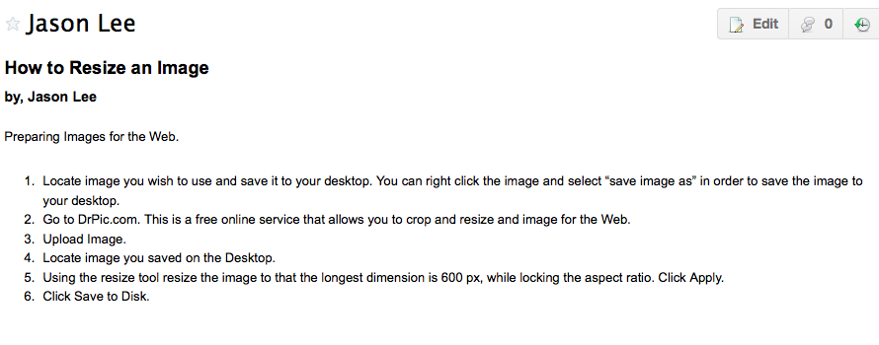
- Example of Assignment 2
Goal: Help students gain the ability to effectively communicate ideas and concepts based on their own experiences with online resources. Students will begin to recognize what an online presence is and the importance of a cohesive design.
Assignment 3: Shoot and Present [IFG 02, 05, 06, 08, 11]
Students are provided with a list of the elements and principles of design. They are then asked to photograph examples of these elements and principles using either their phone or a camera. Students will then create an online “visual glossary” of their examples in an online format, including their reasons for choosing these particular examples. Students will share their work with the class, and the class will critique the choices each student has made from both a creative and a technical standpoint.
Submission: Link to visual glossary
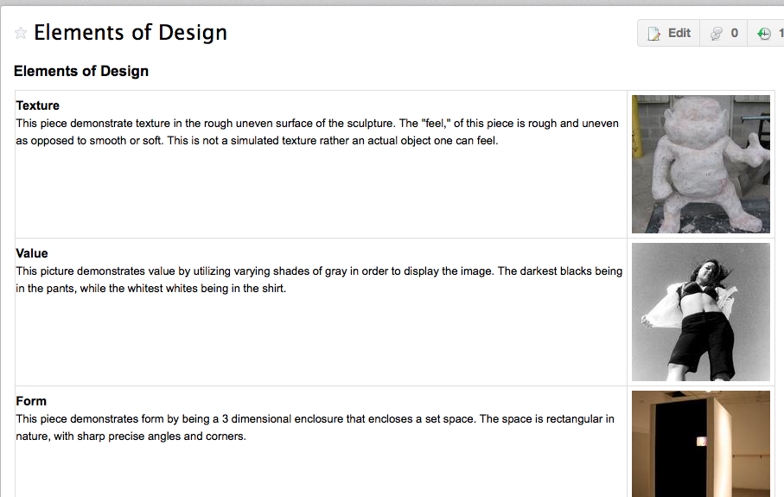
- Example of Assignment 3

Goal: Help students gain an understanding of the elements and principles of design and recognize the importance of image resolution. Students will recognize that the resources already collected can help in doing this assignment and that they have the ability to find the needed information.
Assignment 4: Create a Video Story [IFG 03B, 03C, 04, 05, 06, 08]
Students work collaboratively to create a 60-90 second video story. The story must have a clear beginning, middle, and end. Students will create a storyboard, shoot, and edit. They may use any technology (Apple iMovie is suggested for editing). Upon completion, students will collectively watch and critique the stories presented by their peers. Students will also write a brief analysis of their roles and the roles of their teammates in the creation of the story.
Submission: Completed story and brief write-up

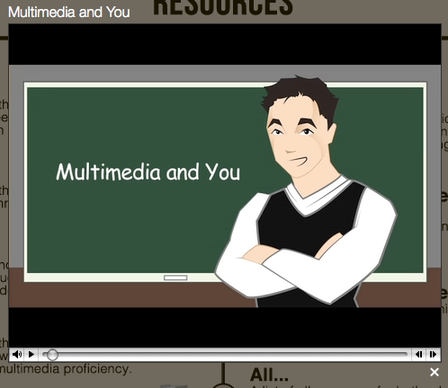
- Example of Assignment 4

Goal: Help students understand that they must make conscious decisions when producing a video story and that a video project is collaborative and requires delegation of tasks to efficiently complete the story. Students will recognize that the resources already collected can help with this assignment and that they have the ability to find the needed information. Students will also learn how to actively critique their own work and the work of others.
Table 8 summarizes each assignment and how it seeks to help students become proficient in skills indicated by faculty participants as well as components covered by the ICT framework.
- Summary of Micro-Syllabus
Assignment | Description of Assignment | ICT Foundation | Skill Set Indicated by Interview Participants
Search and Bookmark | - Students are given a list of multimedia skills one might encounter, e.g.:  - How to Resize an Image  - How to Make a Google Site  - How to Save a YouTube Video  - Students are to find the best tutorials for each item on the list and bookmark them using either an Internet browser or social bookmarking site.  - Students pick a single tutorial to put into practice and write a brief summary of the difficulty of the tutorial.  Students submit bookmark list and brief summary. | - Access  - Manage  - Evaluate | - Ability to Save and Easily Retrieve Data [IFG 03]  - Ability to Filter “Good and Bad” Data [IFG 03, 03A.]  - Visual Literacy [IFG 08]  - Introduction to Multimedia Technologies [IFG 05]  - Recognition of Available Information [IFG 03A]
Write and Communicate | - After evaluating the effectiveness of an online tutorial for a particular multimedia component, student will create a tutorial using all original content (e.g., students’ own screenshots).  - The student must create an online method for delivering the tutorial. (This can be done through a blog, forum, wiki, etc.) | - Integrate  - Evaluate | - Ability to Effectively Communicate [IFG 03, 03D]  - Ability to Recognize Audience [IFG 03, 03B]  - Creating a Web Presence and Recognizing What that Looks Like [IFG 03D, 11]
Shoot and Present | - Students are given a list of definitions of the foundational elements of design (color, value, form, line, space, shape, and texture).  - Students are asked to use a digital camera to shoot examples of these elements outside the classroom. This can be done through stills or video.  - Students will format and upload images through the same online method as the tutorial, with an explanation of why their image represents a specific element of design. | - Integrate  - Create | - Basic Skills in Shooting Both Stills and Video [IFG 03C, 7]  - Basic Skills in Recognizing Basic Aesthetic Design Principles [IFG 06, 08, 12]
Create a Story | - Students will team up and work collaboratively to create a 60-90 second video story.  - Students will assume different roles necessary to make a video presentation.  - Students will present and critique each other’s work.  - Students will write a brief analysis of the collaborative process. | - Manage  - Evaluate  - Create | - Creative Storytelling [IFG 03, 03B]  - Ability to Keep Aesthetics in Mind When Creating [IFG 06, 08, 12]
Note: Codes refer to questions addressed by assignments. Codes can be found in Appendix A.

Limitations
While the faculty who participated represented a wide range of departments, the actual number of participants represents only a small proportion of University of Delaware faculty.
The bulk of the interviews were also conducted during the UD winter session, a voluntary semester for students who wish to take an additional class over a six-week period. Most of the faculty who were contacted were not on campus at this time, and certain faculty who were willing to participate was unable to due to geographic distance and Internet availability due to traveling abroad in other countries over the session.
It should also be noted that the trends identified in this project pertain to the University of Delaware. Findings may vary in different educational institutions with different multimedia policies and practices.
Finally, student perceptions were not considered in this project because of time constraints coupled with the wide range of student experience with multimedia technologies. Future research projects in this field will no doubt benefit from interviews with students.

Recommendations
The following recommendations are divided between practical suggestions for curricular implementation and suggestions for future research.

Integration of Syllabus
The design of these modules allow for this syllabus to be easily distributed into a variety of classes. With very few classes and experiences at UD where the entire student population is required to participate, one method of delivery for the multimedia syllabus would be through English 110, which is a class that is mandatory for all incoming freshman. Additionally the class’s curricular goals, while designed from a writer’s perspective, closely align with the foundational communication skills addressed in the multimedia syllabus. As stated in the ENGL 110 syllabus, “...focuses will include the rhetorical analysis of addressing audience, defining purpose, and deciding on appropriate genres for our writing.” These emphases can easily be adapted to the goals and assignments of the multimedia syllabus. Such integration would also allow the ENGL 110 syllabus to be applied in communication media other than written language; as suggested earlier, this may foster a stronger cognitive connection between communication goals and a student’s concept of these goals.
Regardless of whether these modules are integrated into English 110 or another class altogether the design of the micro-syllabus would keep the cost of curricular integration to the university would be relatively low, and efficient implementation would require only that the Student Multimedia Design Center prepare its staff adequately to help students through the process. (The role of the Design Center would be critical in that there is a shortage of expert knowledge in multimedia technologies among the faculty.)

Conclusions
George Lucas (1983) once said, “Special effects are just a tool, a means of telling a story. People have a tendency to confuse them as an end in themselves. A special effect without a story is a pretty boring thing.” Likewise, multimedia is only a tool, a means of presenting and communicating content. Multimedia in education is nothing but style and showmanship when visual language, so prevalent in our time, is not harnessed to communicate ideas and information. The job of educators is not to use these technologies for the sake of using them, but to identify new and effective ways to create dynamic and original content.
It was clear that the educators interviewed in this study recognize the importance of leveraging multimedia technologies to enhance both the content they present and the content their students create. By including the multimedia syllabus in any class or as a more refined course unto itself early on in a student’s career, the student will become better prepared to create and recognize quality content. While this syllabus is not expected to prepare students in advanced multimedia principles and tactics, it will help in preparing students to find the resources needed to advance toward the expert level. Students will be prepared to create content using visual language, to understand what it means to have an online presence, to understand how effective storytelling skills combined with multimedia technologies can create meaningful content. Ultimately, students will possess the skills needed to be proficient in a world that increasingly communicates through visual media.
REFERENCES

AsapSCIENCE. (2013, March 7). The science of aging. Retrieved March 31, 2013 from http://www.youtube.com/watch?v=BkcXbx5rSzw
Bernstein, R. (2011). Highlights from a national survey of US employers. Oakland, CA. EMC Resarch.
Bolter, J.D., & Grusin, R. (2000) Remediation: Understanding new media. Cambridge, MA: MIT Press.
Catterall, J.S. (2002). The arts and the transfer of learning. Learning in the Arts and Student Academic and Social Development, 151-157.
Catterall, J.S. (2009). Doing well and doing good by doing art. Los Angeles: Imagination Group.
Davis, A. (2012, Spring). Art 307: Interactive media design. [Course syllabus]. University of Delaware, Newark.
Department of Education. (2010). Transforming American education learning powered by technology: National Education Plan 2010. Washington, D.C. Education Publications Center.
Eastern Illinois University. (Spring, 2009). Introduction to multimedia journalism. [Course syllabus]. Eastern Illinois University, Charleston.
Educational Testing Service. (2007). Digital transformation: A framework for ICT literacy. Princeton, NJ: ETS.
Elgammal, A. (n.d.). Introduction to imaging and multimedia. [Course syllabus]. Rutgers University, New Brunswick, NJ.
Hobbs, R. (2011). Digital and media literacy: Connecting culture and classroom. Thousand Oakes, CA: Corwin.
Hurly, Ryan. (2004). Cuts in arts programs leave sour notes in schools. Wisconsin Education Association Council, from http://www.weac.org/Captiol/2003-04/jun04/arts.htm
Rideout, V.J., Foehr, U.G., & Roberts, D.F. (2010). Generation m2: Media in the lives of 8- to 18-year-olds. Menlo Park, CA: Kaiser Family Foundation.
Lambert, J. (2010). Digital storytelling cookbook. Berkeley, CA: Center for Digital Storytelling.
Lawton, P.H. (2007). Balancing act: Bridging the traditional and technological aspects of culture through art education. Forum on Public Policy: A Journal of the Oxford Round Table.
Manovich, L. (2001). The language of new media. Cambridge, MA: MIT Press.
Martinec, R., & Leeuwen, T. (2009). The language of new media design: Theory and practice. New York: Routledge
Mayer, R.E. (2001). Multimedia learning. New York: Cambridge University Press.
McCombs, J. (2001, September). Coloring outside the lines. Learning and Leading with Technology, 29(1), 28-57.
Mouza, C., & Lavigne, N. (2013) Emerging technologies for the classroom: A learning sciences perspective.,NY: Springer.
Panola College. (2010). Imed 140: Introduction to multimedia. [Course syllabus]. Panola College, Carthage, TX.
Patten, M.L. (2009). Understanding research methods. Glendale, CA: Pyrczak.
Patton, M.Q. (2002). Qualitative research & evaluation methods. Thousand Oakes, CA: Sage.
Principles of art. (n.d.). Wikipedia. Retrieved April 8, 2013, from http://en.wikipedia.org/wiki/Principles_of_art
Schickel, R. (Producer & Writer). (1983). From ‘star wars’ to ‘jedi’: the making of a saga [Documentary]. USA: Lucasfilm.
Snelson, L. (Spring, 2007). Edtech 583: Integrating multimedia. [Course syllabus]. Boise State University, Boise, ID.
Student video project roles. (2002). [Class handout]. Educational Technology Resources, Grossmont Union High School District, La Mesa, CA. Retrieved from http://edtech.guhsd.net/video/roles.pdf
Sturken, M., & Cartwright, L. (2003). Practices of looking: An introduction to visual culture. New York: Oxford University Press.
Thai, D. (2011, Spring). Digital multimedia. [Course syllabus]. Lincoln High School, San Jose, CA.
University of Delaware. (n.d.). Interactive media minor. Retrieved from http://interactivemedia.udel.edu/
Wardrip-Fruin, N., & Montfort, N. (2003). The new media reader. Cambridge, MA: MIT Press.
Wikipedia (n.d.). Elements of art. Retrieved April 8, 2013, from http://en.wikipedia.org/wiki/Elements_of_art
Wilen-Daugenti, T. (2009). .edu: Technology and learning environments in higher education. New York: Peter Lang.
Wilson, M. (n.d.). Ite 170: Multimedia software [Course syllabus]. A. Linwood Holton Governor School, Abingdon, VA.

APPENDICIES

INTERVIEW FIELD GUIDE
Background Information
For the purposes of this project and interview I define multimedia as a combination of different media formats coming together to communicate an idea. This can take form through a presentation, a website, a video, and any number of interactive forms.
The purpose of this interview is to help gain insights into how professionals who use multimedia practices academically perceive student proficiency in multimedia both conceptually and technologically.
Demographic Information [IFG 01]
  - Name: [IFG 01A]
  - Department: [IFG 01B]
- Observations with Multimedia:
  - Please explain your background using multimedia here at the University of Delaware with your students. [IFG 02A]
  - How would you define the difference between the consumption of media and the creation of media? [IFG 02B]
- What skills are necessary for proficiency in multimedia?—e.g., media literacy, technological skills. [IFG 03]
  - Based on your previous answer, are students at the University of Delaware proficient, or is there a learning curve pertaining to your definition of proficiency? [IFG 03A]
  - How would you describe the role of storytelling in creating multimedia projects? [IFG 03B]
  - Is evolving technology making multimedia projects easier or harder to produce? [IFG 03C]
  - How would you describe the importance of good organization skills when working with multimedia? [IFG 03D]
- How do you see the University of Delaware utilizing and/or underutilizing multimedia with students? [IFG 04]
- What would you define as the purpose of multimedia in serving a higher educational curriculum? [IFG 05]
- Multimedia stems from content, the communication of desired information, and aesthetics, how the content “looks” in its delivery. What do you see as the core concepts needed to produce good multimedia? [IFG 06]
  - What do you feel is the difference is between good multimedia and bad multimedia? [IFG 06A]
- Do you feel students learn the content of your courses better through multimedia vs. content delivery through traditional means—e.g., lectures, readings, papers? [IFG 07]
- What do you feel is the purpose of being visually literate in today’s society? [IFG 08]
- In an ideal situation what format would best help students to become proficient in multimedia?—e.g., course integration, a series of classes designed to teach multimedia. [IFG 09]
- What else would you like to see change in multimedia literacy here at the University of Delaware? [IFG 10]
- What is the importance of multimedia in a professional field? [IFG 11]
- Is there anything additional you would like to add that you feel was not asked of you with regard to multimedia? [IFG 12]

RESOURCES FOR INTEGRATED MICRO-SYLLABUS

List of Multimedia Skills
- How to Resize an Image
- How to Save a YouTube Video
- How to Make a Web 2.0 Icon
- How to Take a Screen Shot
- How to Make a Screen Capture
- How to Record Audio
- Basic Lighting Techniques
- What Are Good Audio Recording Practices?
- What Are Different Video Formats?
- What Are Different Picture Formats?
- What are Available Techniques for Converting Video?
- What is Web 2.0?
- Where Can I Find Copyright-Free Music?
- Where Can I Find Copyright-Free Images?
- Where Can I Find Sound FX?
- What Are the Basics of iMovie?

Elements and Principles of Art Definitions
Elements of Design
The elements of art are a commonly used group of aspects of a work of art used in teaching and analysis, in combination with the principles of art. Lists of the elements of art vary somewhat but typically include the following: color, value, form, line, space, shape, and texture.
- COLOR
  - Color is an element of art with three properties:
    - Hue, the name of the color, e.g. red, yellow, etc.
    - Intensity or the purity and strength of the color such as brightness or dullness.
    - Value, or the lightness or darkness of the color.
- VALUE
  - Value describes the lightness or darkness of a color. Value is needed to express volume.
- FORM
  - Form is an element of art that is three-dimensional and encloses volume. Cubes, spheres, and cylinders are examples of various forms.
- LINE
  - Line is an element of art which refers to the continuous mark made on some surface by a moving point. It may be two dimensional, like a pencil mark on a paper or it may be three dimensional (wire) or implied (the edge of a shape or form); often it is an outline, contour or silhouette.
- SPACE
  - Space refers to the distance or area between, around, above or within things. It can be a description for both two- and three-dimensional portrayals.
- SHAPE
  - Shape is an enclosed space defined by other elements of art. Shapes may take on the appearance of two-d or three-d objects.
- TEXTURE
  - Texture refers to the surface quality or "feel" of an object, such as roughness, smoothness, or softness. Actual texture can be felt while simulated textures are implied by the way the artist renders areas of the picture.

Principles of Design
The principles of design are the set of rules or guidelines of art that are to be considered when considering the impact of a piece of artwork. They are combined with the elements of design in the production of art. The principles are movement, unity, variety, balance, emphasis, contrast, proportion, and pattern.
- MOVEMENT
  - Movement adds excitement to your work by showing action and directing the viewer’s eye throughout the picture plane.
- UNITY
  - Unity is seen in a painting or drawing when all the parts equal a whole. Your work should not appear disjointed or confusing.
- VARIETY
  - Variety refers to the differences in the work; you can achieve variety by using different shapes, textures, colors and values in your work.
- BALANCE
  - Balance is a sense of stability in the body of work. Balance can be created by repeating the same shapes and by creating a feeling of equal weight.
- EMPHASIS
  - Emphasis in a composition refers to developing points of interest to pull the viewer's eye to important parts of the body of the work.
- PROPORTION
  - Proportion or scale refers to the relationships of the size of objects in a body of work. Proportions give a sense of size seen as a relationship of objects, such as smallness or largeness.

Roles for Digital Storytelling Handout
This handout was found online and has been used in my Art 307 class. A more detailed version can be found at: http://edtech.guhsd.net/video/roles.pdf
Team roles for Digital Storytelling
There are many ways your team can divide the work. One way is to think of roles, such as the list below (not an exhaustive list).With so many roles and so few team members, each person will have to do multiple tasks and sometimes roles will be shared among individuals (e.g., a single project may have multiple cinematographers).

- Graphics artist: The person in charge of graphics may search for visual elements that support the story line, shoot photos that capture the message, or modify images from other team members to develop a consistent presentation feel across the entire piece--or a combination of all three.
- Typographer: Type is one way to make your message memorable. It can reinforce the narration or contrast with it. Having someone on your team pay attention to the judicious use of typography will ensure your team doesn't miss out on this potentially strong asset.
- Writer and storyboard/script supervisor: Sticking to the point and maintaining focus is a key element of any successful short video. A concise and succinct script with a supporting storyboard is a start. During production, someone should maintain integrity with the original concept and message.
- Narrator: The narrator does more than read the script. To a large extent, the narrator sets the emotional tone for the project. Their vocal inflection and pacing can change the reception that a story receives.
- Videographer: The person behind the camera, they have the opportunity to think creatively about camera placement, framing the shot, ambient lighting, foreground and background settings, etc.
- Video editor: Putting it all together is the role of the video editor. In addition to knowing the functions and capabilities of the Final Cut Express video editing program, the video editor should have excellent file management capabilities. The video editor will need to keep track of files from different team members and multiple versions of files as the project progresses.
- Audio mixer: Audio comprises voice narration, on-camera audio recording of speech and ambient sound, a musical sound track, and (optionally) sound effects.
- On-screen talent: The on-screen talent could be a narrator talking to the screen, as you would see in a documentary, or an actor/actress playing a role, as you might see in the recreation of an event that happened in the past.
Outside of these technical roles, team responsibilities will include initiating meetings, organizing data files, and keeping track of individual responsibilities. Obviously, in such a small team, each individual must make a commitment to attend all team meetings, respond to e-mails, and be prepared to contribute on time.

Personal communication refers to faculty interviews. All interviews were conducted with the promise of anonymity.

