EDUC685 Research Paper | Lisa Tossey

Using POV cameras in education to capture personal and unique perspectives – how are emerging visual technologies being used to further learning?

Introduction

As digital camera technology evolves, devices have become increasingly more powerful as they have also shrunk in size and become more portable. This has been especially evident over the past decade. Many folks can now capture high-resolution images and video using the smartphone that fits in their pocket or their tablet computer that’s the size of a small paperback and as powerful as a laptop. Additionally, the popularity of compact point of view (POV) cameras, such as the GoPro Hero series, has caused them to go mainstream, and wearable technology, like Google Glass, is starting to enter the public sphere.
Many might know GoPro cameras for the footage athletes have captured in extreme sports – from snowboarding down powdery peaks to surfing towering waves – but these emerging technologies are also being utilized to give viewers unique educational experiences. These small, wearable cameras have the advantage of being able to be worn or go places where most traditional cameras cannot, and even broadcast their footage live. GoPro cameras have been sent up to the edge of space and down into the depths of the ocean, and Google Glass has been used to give a virtual field trip to CERN and taken into operating rooms to show students how surgical procedures are being done. They are giving us new ways of looking at the world and sharing our experiences, and offering low-cost approaches to capturing footage we have not been able to do previously without high-end, specialized photographic equipment.
These emerging technologies are becoming more accessible to both educators and students, making it possible to find new ways of encouraging students to take a closer look at and document what they are studying. In this paper, I will be exploring how these POV cameras are being utilized in teaching, with a focus on science education, to gather data and provide virtual experiences – both in the lab and in the field.
GoPro Cameras

The GoPro Hero series of cameras have soared in popularity for being rugged, wearable camcorders that are best known for capturing high-definition action sequences. GoPro’s founder, Nick Woodman, came up with the first prototype in 2001, when he strapped a film camera to his wrist using rubber bands and part of a surfboard leash (Mac, 2013). That early effort was fine-tuned over many surf trips, and eventually became the GoPro 35mm Hero wrist-mounted camera, which Woodman debuted in 2004 at an action sports trade show.
The camera has gone through many upgrades in the decade since, going digital and adding video capabilities along the way. It is now in its fourth iteration and is the fasting-growing camera company in the U.S., selling the leading “pocket camera” on the market (Mac, 2013). Today’s model, the HERO4, boasts the rugged, waterproof capabilities the diminutive camera has been known for, with the ability to take high-resolution still images and high definition video footage at high frame rates. The addition of Bluetooth technology has also simplified remote control of the cameras, allowing users access to control a camera from afar through robust smartphone app interfaces.
One of the popular features of the GoPro cameras is their flexible case and mounting system (Photo 1), which allows them to be securely attached to a variety of things from helmets to vehicles to long telescoping sticks that allow users to turn the camera back on themselves. These mounts, combined with waterproof casing, allow users to records themselves undertaking difficult or dangerous activities, but they also allow for the cameras to be attached to vehicles to explore remote places or record activity that might not otherwise be seen. 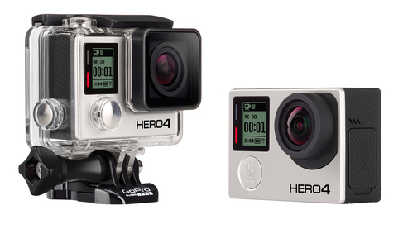
Photo 1: GoPro Hero4 shown with waterproof case and mounting clip (Image: GoPro.com)
As Chalfen (2014) points out, in his piece on visual social science, the resulting videos give the idea of ‘presence’ and ‘being there’ in the action, with efforts being directed toward allowing a viewer to believe she/he is/was there, participating. In short, these types of cameras facilitate and extend ways and means of seeing.
This can be particularly useful in science applications, for researchers are continuously pushing boundaries in an effort to better understand the world around us. One of GoPro’s educational efforts does just that. In Project Aether, GoPro launches high altitude weather balloons in collaboration with schools to teach students physics concepts, experimental research skills, and to make space exploration accessible to students. Resulting videos like Project Aether Flight 2 (2010), in which a weather balloon lifts a specially designed payload package that is composed of GoPro HD cameras, GPS tracking devices, and other science equipment, bring the high altitude experience to student’s computers, allowing them to virtually travel to the edge of space.
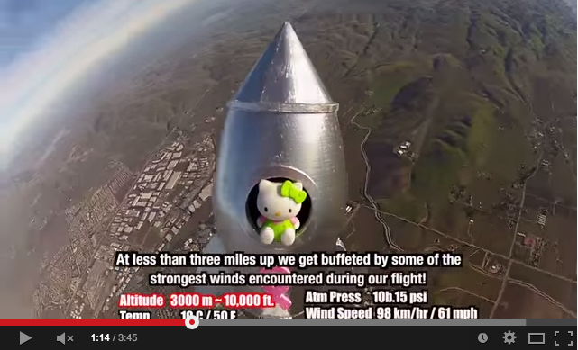
Photo 2: Hello Kitty in Space (2013) combined GoPro footage with scientific measurements

Such videos have provided inspiration for other schools to launch their own explorations and share their results. One adorable example, which has racked up over 1 million views on YouTube, is Hello Kitty in Space (2013). The video is a result of a science project by 7th graders from Cornerstone Christian School in California in which the cartoon character Hello Kitty was placed in her own retro silver rocket ship and sent aloft, several GoPro cameras in tow, with the help of a weather balloon (Photo 2) . The footage is cute, but her journey was also used to examine the effects of altitude on air pressure and temperature, and that data was incorporated into the final product.
GoPros aren’t only taking to the sky – they are also helping students explore underwater. In 2011 Reef Environmental Education Foundation (REEF), a SCUBA diving community that works to contribute to the understanding and protection of marine populations, joined with collaborators to develop an education program. This program coincides with the Grouper Moon Project, which is a collaborative conservation program between REEF and the Cayman Islands Department of the Environment studying Nassau grouper (Epinephelus striatus).
They piloted the program during the 2012 field season and worked in collaboration with classrooms from Cayman Prep and High School, with funding from the Disney Worldwide Conservation Program. The results can be seen in Grouper Moon Education Dive (2012), in which students were able to do a live question and answer session with a scientist who was actively diving at a spawning spot while wearing a GoPro and transmitting a live feed. The program includes curricular materials and classroom lessons, as well as such "meet the scientist" and "live from the field" sessions that bring students along for dives in the Cayman Islands (Photo 3).
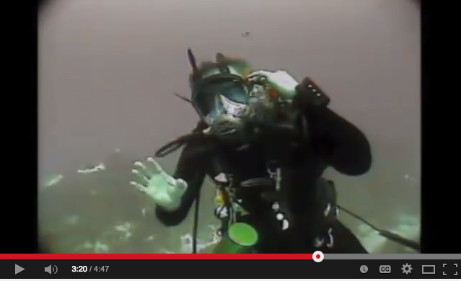
Photo 2: Grouper Moon Education Dive (2012) included a live Q&A session broadcasted from grouper spawning grounds using a GoPro camera in an underwater housing
However, GoPro cameras aren’t only being used in extreme environments – they are also being used in laboratories and classrooms to help facilitate learning. One recent example is the use of GoPro Hero2 cameras as part of an engineering class to improve understanding of material failure mechanisms and increase student motivation in a material sciences course.
McCaslin, Young, and Kesireddy (2014) incorporated the GoPros into the class to examine if they might impact student learning and motivation. The cameras were used in two ways: first, students recorded footage of their laboratory work in order to evaluate material failure, then they used the GoPros and specialized editing software to develop video presentations in lieu of written laboratory reports.
The researchers recognized that modern science students need skills not only to collect data, but also to present their results to others, so the second goal was added in an effort to prepare students to present scientific results in a video format appropriate to a wide audience. The videos were uploaded to a dedicated YouTube channel and made available publically.
Students in the class had only used visual aids to help their understanding of material failure up until the time of the study. McCaslin, Young, and Kesireddy (2014) explained that GoPro cameras were chosen to supplement the activity for several reasons: they were a low cost, student-friendly option for capturing high-speed video footage, their small size made them easy to move and provided the ability to view experiments from different, safe vantage points that didn’t get in way of operation of equipment, and their WiFi capabilities allowed for safe, coordinated operation. The cameras also allowed fearful students to remain a comfortable distance from the experiments without fear of missing the action.
Additionally, the camera’s option to capture footage at 120 frames per second (a higher rate that provides more detail than the standard 30 frames per second) was ideal for digital recording of destructive material tests like impact and tensile tests. The high definition footage allowed students to further evaluate damage mechanisms involved – giving them visual data to work with as well as numerical data. Having a long detailed sequence of frames that covered the brief moments in which a failure occurred provided an opportunity for students to see a metal specimen undergo failure of a span of seconds rather than in a literal blink of an eye.
Students were surveyed after the laboratory activity and presentations were completed. All who completed the survey indicated they achieved adequate understanding of material failure (55% indicated their understanding was adequate and 45% indicated more than adequate), and a majority (75%) indicated a perceived increase in their ability to share technical information through a medium other than written reports. Overall, students felt that their technical communication skills had increased and the instructor perceived that the students had a better understanding of material failure.
In another classroom experiment with GoPros, a teacher turned the cameras onto himself to experience his teaching from the vantage point of his class. Kindt (2011) was intrigued by one of the main draws of POV style cameras: the ability of a viewer to watch an event through the eyes of a wearer. Therefore, he decided to try to use GoPros as a tool to help teachers see classroom events through the eyes of their students.
He recognized that there might be issues involved with using POV cameras this way – that such use of the camera can be intrusive, possibly affecting behavior (both positively or negatively) and that he’d need volunteers to wear it. He identified several logistical challenges as well, including proper camera set-up and the number of steps required to successfully record and organize files.
He donned the camera personally and taped himself to make students more comfortable before asking for volunteers from the class, which he readily got. Students wore the GoPros on their heads, using a headband mount that secured the camera a few inches above their eyes (Photo 4).
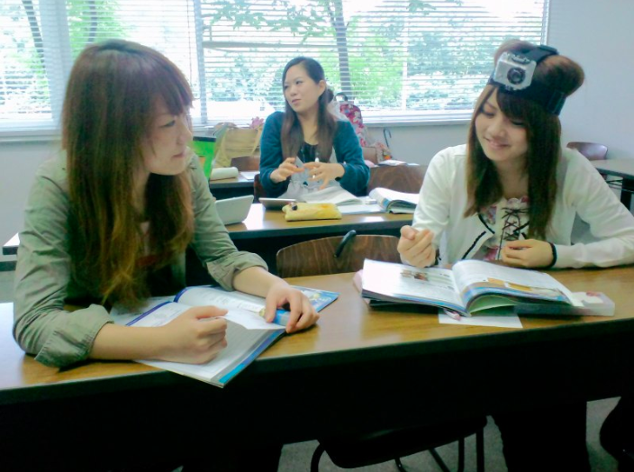
Photo 4: Kindt (2011) had student volunteers wear a GoPro camera during class sessions in order to capture the experience from a student perspective (Image: www.profkindt.com).
After 9 weeks of using the cameras, Kindt saw that they had several advantages. The GoPros captured the view of a participant unconstrained by a stationary perspective and provided the ability to “see the class” through their eyes – something teachers rarely see. In doing so, the footage captured teacher behavior and a participant’s view of events, providing an exceptional record of one participant’s experience.
Although there are many potential issues related to implementation, including cost, logistic concerns, student comfort, and integration with other technologies, Kindt sees potential for new insights from further work on this front, particularly from the participant perspective. The ability to look at not only what was being said, but also at what participants were doing, could be useful in many different applications, including collaborative learning, materials development, student motivation, teacher education, and classroom research.

Google Glass

The type of work Kindt started with the GoPro in 2011 might easily be adapted to one of the newest entrants to the wearable technology field: Google Glass.
I was first introduced to Google Glass when I was chosen to use it as one of their Glass Explorers – testers that were given the opportunity to secure a pair before they went public. Unlike the GoPro camera, Glass was designed to be worn straight out of the box. The thin titanium frames rest on the nose like a pair of glasses without the lenses, with a small adjustable glass block in front of the right eye that serves as a viewfinder and contains “floating” screen (Photo 5).
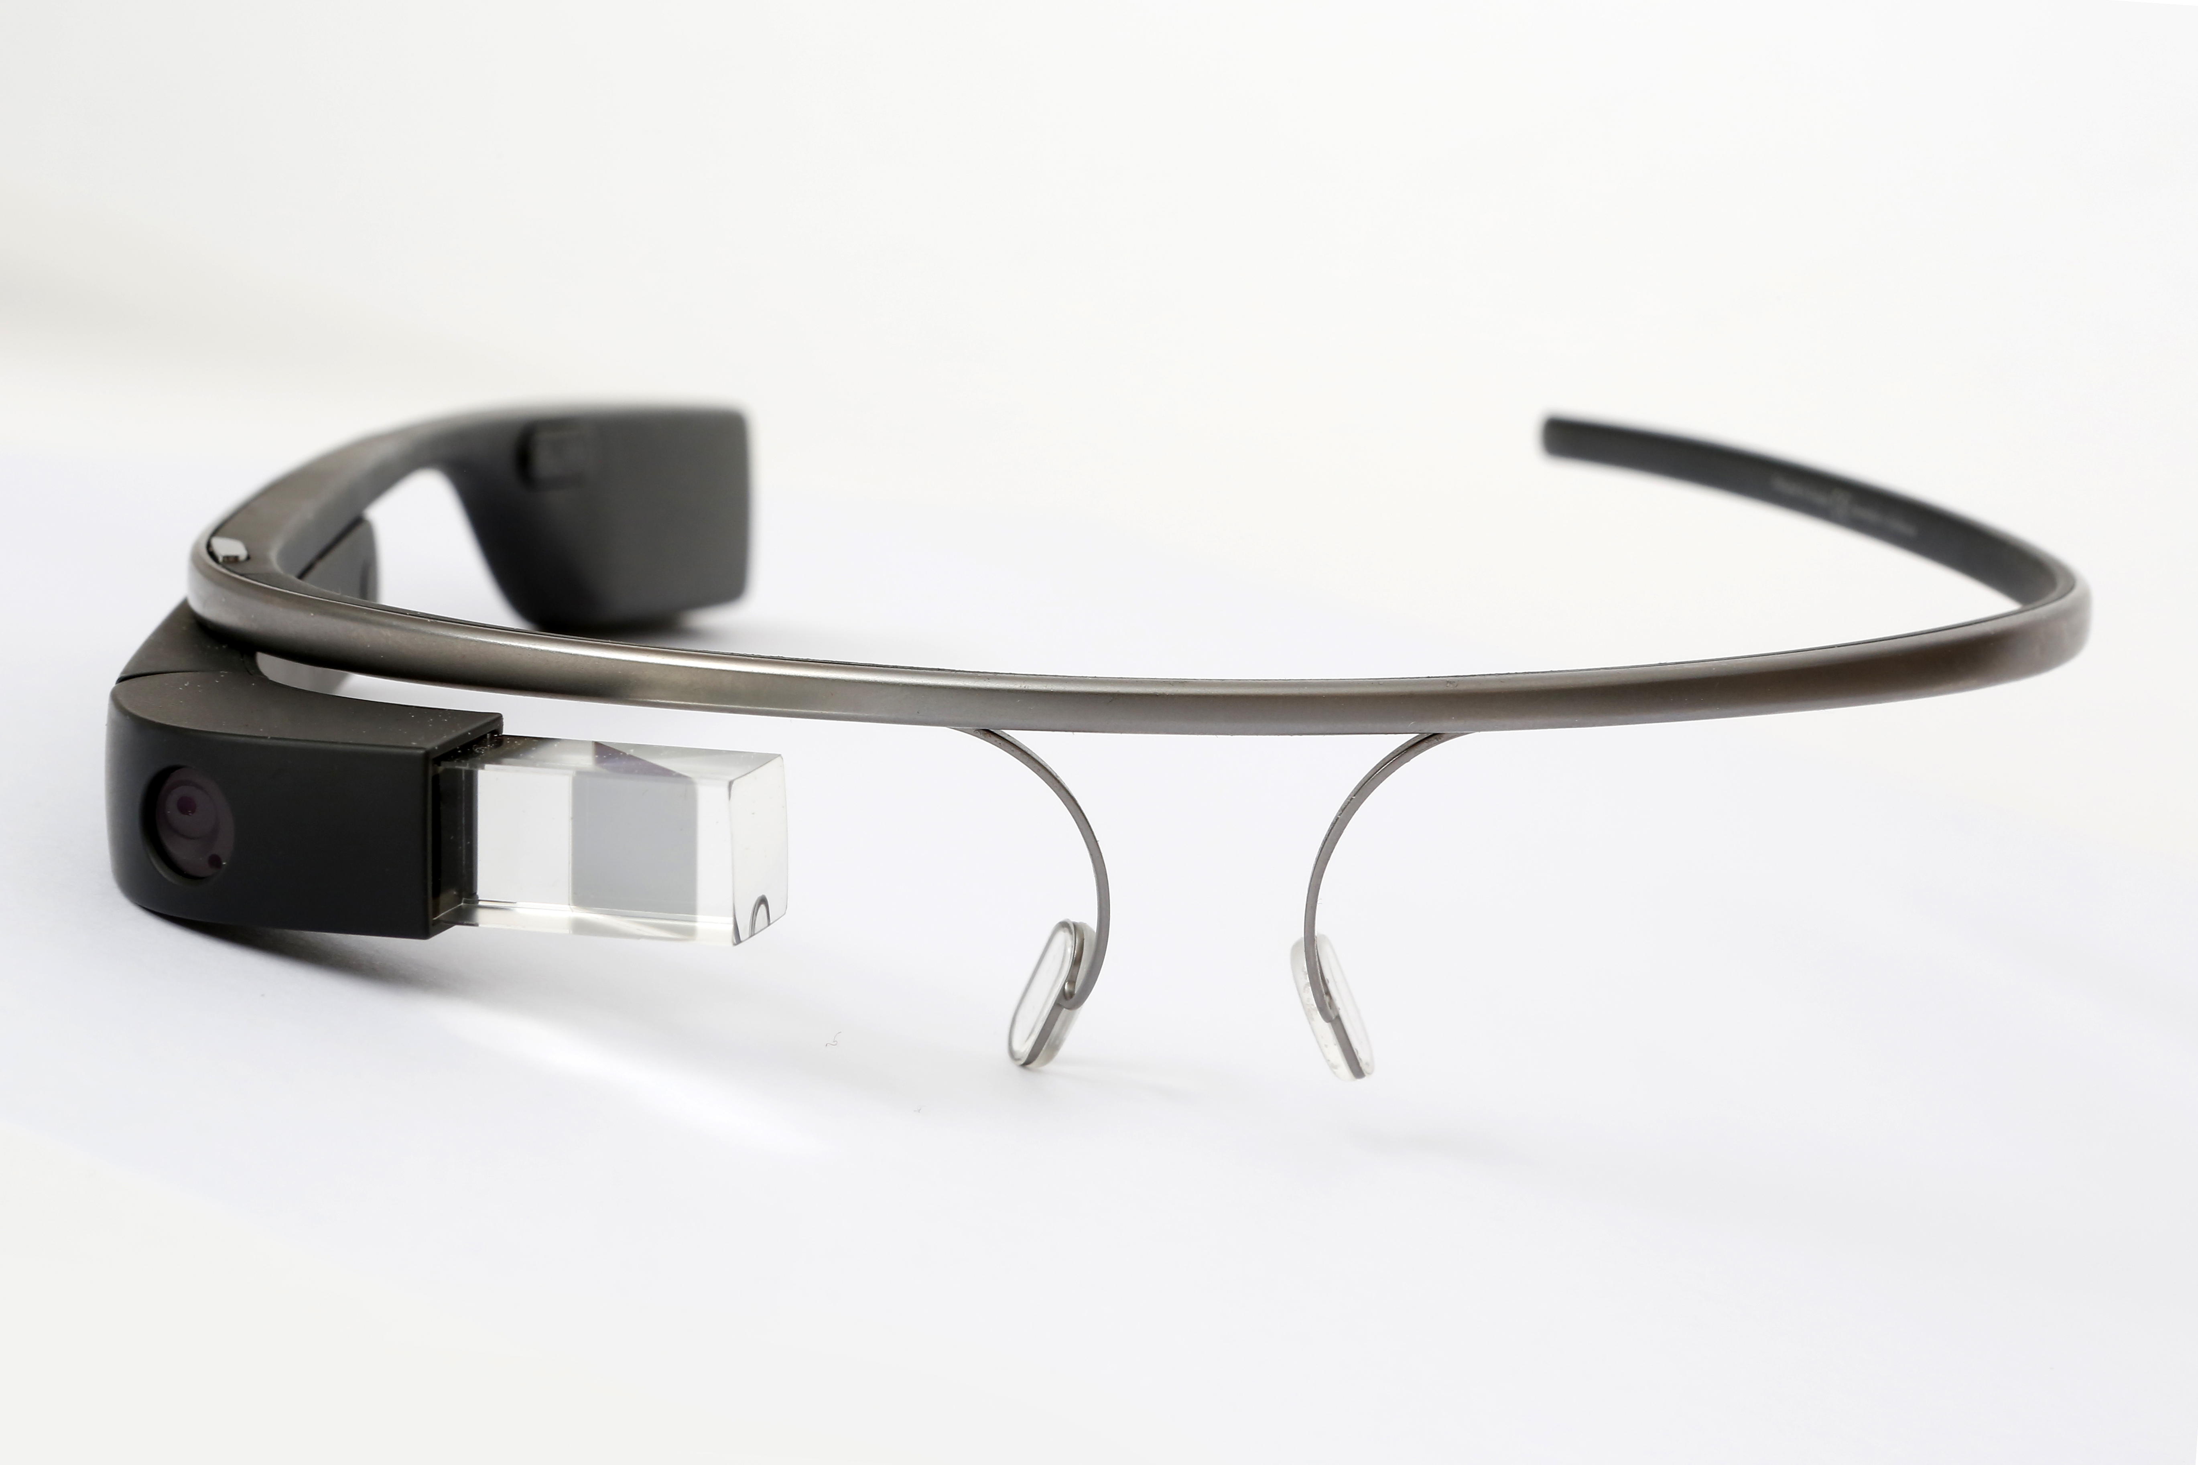
Photo 5: Google Glass (Image: www.google.com/glass)
The right ear stem is wider, and holds the battery, memory, power switch, and manual camera control. Glass also has built-in GPS, a high-definition camera in the front that captures stills and video, and a microphone that allows for voice activated commands. Voice prompts starting with “Okay Glass…” can be used, so phrases like “Okay Glass, take a picture…” or “Okay Glass, shoot video…” allow for hands-free use. It can be connected to WiFi and tethered to a smartphone using Bluetooth, which allows for live stream broadcasts when those connections are available.
This wearability and flexibility of use makes it ideal for a range of situations and research applications. As Chalfen (2014) points out, by wearing the camera as headwear, Glass users are “owning” the view, and can provide a true first-person perspective with the footage they capture. However, he also warns that since Glass can be worn while completing everyday tasks and interacting with others in live environments, it can be problematic in that users can collect a great deal of information with minimal kinds of permissions.
These privacy concerns are coming to the forefront as many other similar wearable technologies, including the Samsung Galaxy Gear (wrist-mounted), Apple iWatch, and DoCoMo’s ‘Intelligent Glass,’ are nearing release. Chalfen (2014) believes these potential drawbacks may be solved in part through explanation, demonstration, and being aware of and sensitive to concerns. He also postulates that for institutional use it might be helpful for younger colleagues to fully explain benefits to senior members who may be less familiar with the emergence and capabilities of technological advances and potential applications.
One of the fields in which Google Glass is being embraced is medicine. It is currently being used to provide intimate looks at surgical procedures and provide demonstrations for students, residents and other practitioners. As can be seen in
Point-of-View Surgery Shown Via Google Glass (2013), Ohio State University is using Glass to broadcast surgery live to students watching on main campus (Photo 6). The instructor states the benefits from his point of view:
“I appreciated the connectivity it gave me…the fact that I could sit there in real time and both audibly, and more importantly, visually communicate with someone when I’m in the middle of a case.”

As does a student:

“We’ve all shadowed surgeons before in the operating room and are on the outside looking in, but this really shows you what’s going on in the surgery itself.”

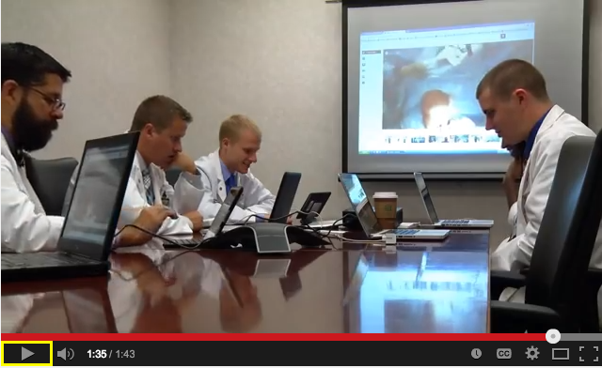
Photo 6: OSU students watching a surgery through a Google Glass broadcast in Point-of-View Surgery Shown Via Google Glass (2013)

Grossmann (2013), who pioneered the use of Google Glass in medical education, states that its potential to improve the interface between the human user and the device, connecting to the internet and enabling synchronous audio-video communication, is what excites him the most about it. In his view, Glass could radically improve remote mentoring of students and providers with less experience and possibilities for its use are only limited by our imagination and creativity.

Another creative educator has embraced Google Glass for virtual field trips and to broadcast hands-on science activities. Andrew Vanden Heuvel, a physics teacher in Grand Rapids, Michigan, was also chosen as a Glass Explorer and took students on a virtual field trip through the Large Hadron Collider at CERN in Switzerland.
The results can be seen in Explorer Story: Andrew Vanden Heuvel [through Google Glass] (2013). Heuvel was able to connect with his brother’s classroom in the U.S. via a Google Hangout, and virtually share and narrate his view, and even take questions, as he rode a bike through the world’s largest and most powerful particle accelerator (Photo 7).
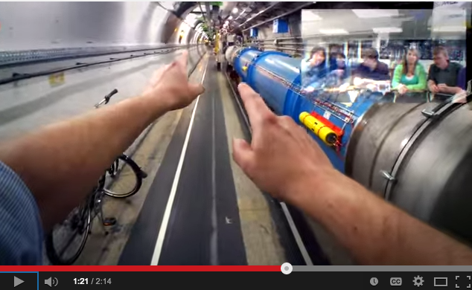
Photo 7: Physics teacher Andrew Vanden Heuvel takes students on a virtual field trip through CERN via a Google Hangout in Explorer Story: Andrew Vanden Heuvel [through Google Glass] (2013)
Heuvel is also using Glass to live-stream science lessons through Google Glass, which he has dubbed STEMbites, and can be previewed in Welcome to STEMbite (2014). These short (around 2 minutes in length), engaging lessons tackle everything from seed dispersal to the physics of tennis, from a first-person viewpoint.
As Grossmann (2014) states, as a “pioneer” device and a “pseudo-beta” product (a ready-product, not ready for the general public but instead for a very select group of skilled individuals in specific disciplines), Glass has awakened the imagination and creativity of the technologic community, the industry, and the geeks out there. And educators like himself and Heuvel are leading the way in showing what can be accomplished with it.
Conclusion

Both GoPros and Google Glass are capable of producing original and rare views featuring first-person perspectives, and are proving to be valuable technological tools for both research applications and teaching students in new and creative ways. Some medical schools and science teachers are already demonstrating this and are paving the way for others to utilize POV cameras to provide richer classroom interactions and field experiences with others from afar.
Many challenges remain, including concerns about privacy and the logistics and learning curves involved in adding new technologies to an education program. However, there seems to be great potential in harnessing the power of these cameras to allow us to examine the world more carefully, see what we have not been able to see before, and connect with others virtually in new and engaging ways.

References

Chalfen, Richard. "'Your Panopticon or Mine?' Incorporating Wearable Technology's Glass and GoPro into Visual Social Science." Visual Studies 29, no. 3 (2014): 299-310.

Chalfen, Richard. “Looking Two Ways: Mapping the Social Scientific Study of Visual Culture.” In The SAGE Handbook of Visual Research Methods, edited by Eric Margolis and Luc Pauwels, 24-49. London: SAGE Publications Ltd., 2011. doi: http://dx.doi.org/10.4135/9781446268278.n2.

Explorer Story: Andrew Vanden Heuvel [through Google Glass]. Performed by Andrew Vanden Heuvel. U.S.: YouTube (http://youtu.be/yRrdeFh5-io), 2013. Documentary.

Grossmann, MD, FACS, Rafael J. "OK Glass: Teach Me Medicine!" @ZGJR Blog. June 26, 2013. Accessed October 8, 2014. http://rgrosssz.com/.

Grossmann, MD, FACS, Rafael J. "Is Google Glass Immortal?" @ZGJR Blog. November 17, 2014. Accessed November 23, 2014. http://rgrosssz.com/.

Grouper Moon Education Dive. Performed by Brice Semmens. Cayman Islands: YouTube (http://youtu.be/T4K_CR5xyr0), 2012. Film.

Hello Kitty in Space. U.S.: YouTube (http://youtu.be/5REsCTG4-Gg), 2013. Film.

Kindt, Duane. "Seeing through the Eyes of the Students: First Impressions from Recording in the Classroom with a GoPro Head-mounted Camcorder." Academic Journal of the School of Contemporary International Studies 11 (2011): 179-99.

Mac, Ryan. "GoPro Evolution: From 35mm Film To America's Fastest-Growing Camera Company." Forbes.com. March 4, 2013. Accessed November 21, 2014. http://www.forbes.com/sites/ryanmac/2013/03/04/gopro-evolution-from-35mm-film-to-americas-fastest-growing-camera-company/.

McCaslin, Sara, Marilyn Young, and Adarsh Kesireddy. "Using GoPro Hero Cameras in a Laboratory Setting." Proceedings of the 2014 ASEE Gulf-Southwest Conference, 2014, 1-14.

Point-of-View Surgery Shown Via Google Glass. U.S.: YouTube (http://youtu.be/DbQY1ay8Sew), 2013. Film.

Project Aether Flight 2, 1080p. U.S.: YouTube (http://youtu.be/9ufw47qLcGY), 2010. Film.

Welcome to STEMbite. Performed by Andrew Vanden Heuvel. U.S.: YouTube (http://youtu.be/DODHyUj29F0), 2014. Film.

