Virtual Open House:

December 4, 2014 and January 5, 2015

7:00-8:00pm EST
7:00-7:35pm Presentation by Anja Leefeldt, UD Dietetic Internship Director
7:35-8:00pm Question and answer session

Accessing the Virtual Open House
- If using headphones, plug them into your computer first

- Go to http://udel.adobeconnect.com/aleef

- Choose to enter as a guest, type in your full name, then click “Enter Room”

- A presentation will begin at 7:00 pm EST, followed by time for questions and answers.

- To ask a question during the question & answer portion, type your question into the Chat box. Questions will be answered in the order they are received.
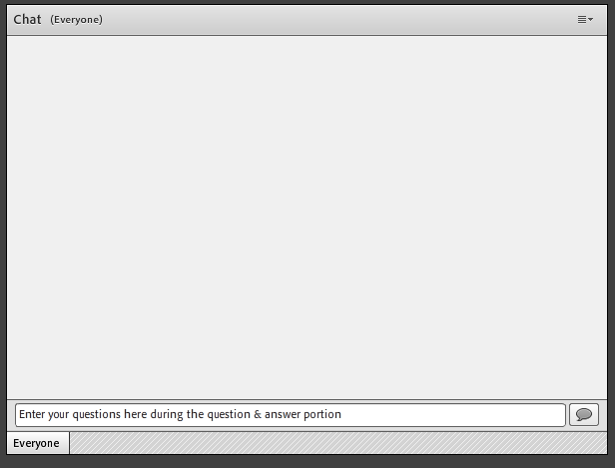

Tips:
- If at all possible, use a computer with a wired/LAN connection instead of a wireless (WiFi) Internet connection. It can be difficult for wireless networks to keep up with the video stream.
- To test your connection prior to the Virtual Open House, go to https:/udel.adobeconnect.com/common/help/en/support/meeting_test.htm

