Bill Non-Student Customers Webform

Departments will enter their miscellaneous billing activity for goods or services to outside customers using the Bill Non-Student Customers webform. This webform will replace the FFAR form and the Single-Charge Miscellaneous Billing EZ Form. Account Services will print and send out the invoices.
► For help or questions with this webform, contact Billing Services at 831-1526.

Access the UD Webform system as you would for any of the other HR or Financial webforms (http://www.udel.edu/webforms).
- Login by the UD Central Authentication Service.
- Choose “Blanks” tab to access the list of webforms
- Choose “FIN Bill Non-Student Customers”

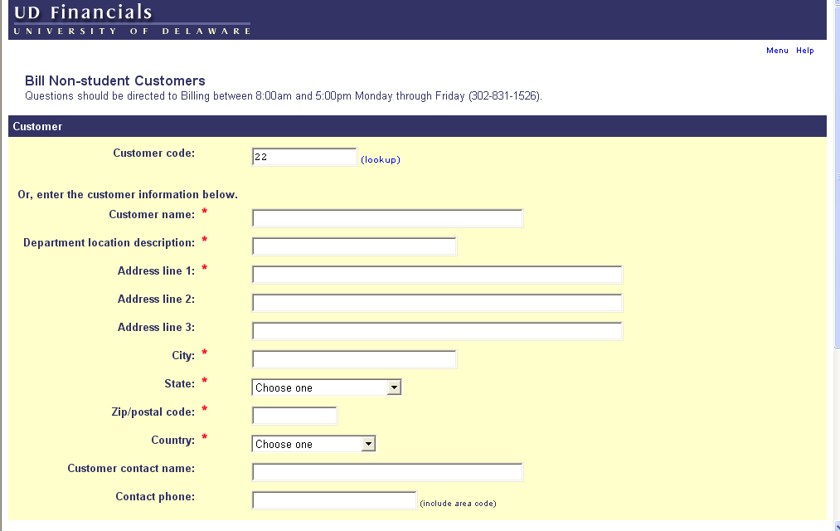
Enter: Customer Code OR
Customer Information
- Enter Customer:
- Existing customer - use “lookup” to find Customer Code

OR
- New customer - enter customer information (* = required field):
- *Customer name – enter customer name as it should appear on invoice. Names of individuals should be in Last name, First name format.
- *Department location description – enter your department name, it will distinguish this customer and address as belonging to your department (e.g. “Public Relations” or “BCC Admin”)
- *Address line 1 (s), *City, *State, *Zip Code, *Country – enter all fields (country is required)
- Customer contact name – enter the contact person from the company (not a UD employee)
- Contact phone – enter the customer contact’s phone number

Entering Invoice Information

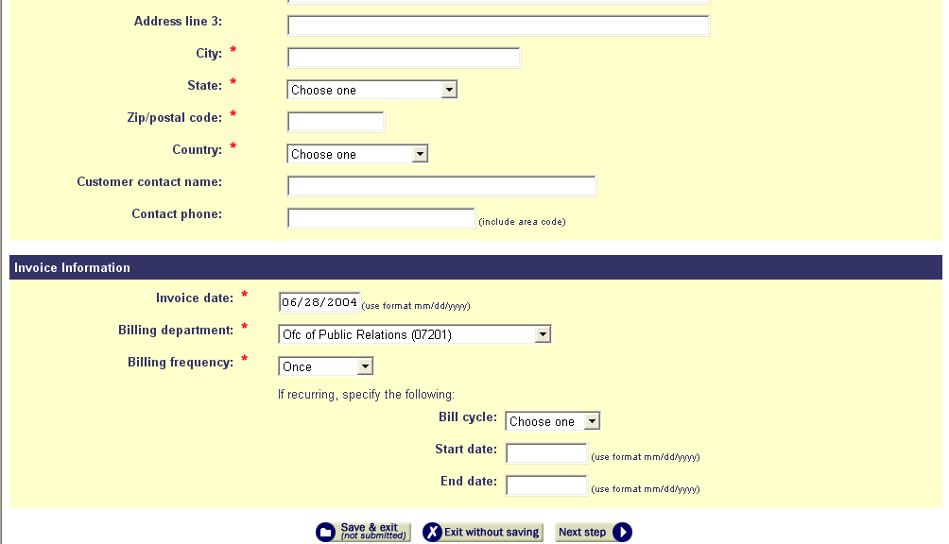

      - Enter Invoice Information:

- *Invoice date – enter current or future date

- *Billing department – choose your department using the drop-down list

- *Billing frequency – choose from drop-down list:
- Once for single billing
OR
- Recurring (see below) for multiple billing on a regular cycle, enter:

- Bill cycle - choose “Monthly” or “Quarterly”
- Start date – enter date the billing period begins (format = mm/dd/yyyy)
- End date – enter date the billing period ends (format = mm/dd/yyyy)

- Click the “Next step” button

.
Recurring bills are generated on the first day of each month for the time period you designate with the start and end dates. The accounting date will also be the first day of each month for bills generated with a recurring cycle. We suggest you use a start date of the first of the first month and an end date of the last day of the last month you want to bill.
For example: Start date = 08/01/2004 and End date = 12/31/2004 will generate five invoices. They will be on August 1, September 1, October 1, November 1 and December 1, 2004. Bills are generated 7 days prior to the accounting date to insure the customer receives the invoice in a timely manner

Entering Invoice Items

Entering Invoice Items

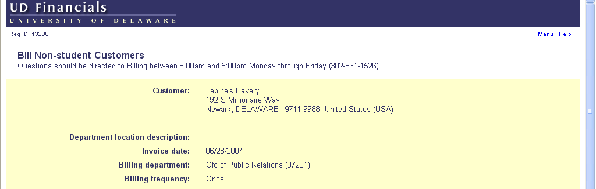
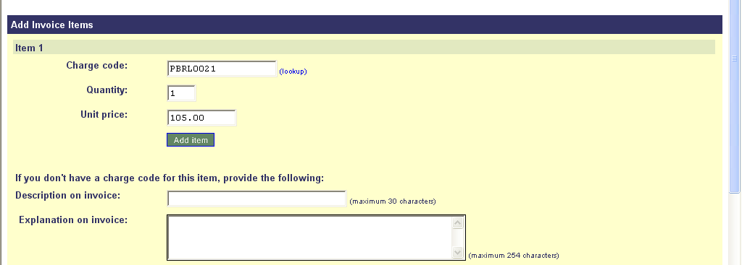

- Customer information is displayed at the top.

- Add Invoice Items, enter by one of two methods:
  - Charge Code – Codes for goods or services setup by Billing & Collection in PeopleSoft with assigned PS chartfields for accounting entries. Enter the following fields:
- Charge code - use “lookup” to find correct code by its description (they have dept. acronyms in parentheses followed by a 4-digit number, e.g. CHEM0001 or PBRL0021)
- Quantity
- Unit price – enter unit price with decimal points (may be negative for credits)
- Explanation on invoice – enter additional information to print on invoice if desired (e.g. “Fall 2004 Issue”)
- Click “Add item” button

  - Manually entered charges (requires accounting to be entered on webform) – enter the following fields:
- Description on invoice – enter description of good or service
- Explanation on invoice – enter additional information to print on invoice if desired (e.g. “Fall 2004 Issue”)
- Accounting information (see below)

Entering Invoice Items (cont’d)

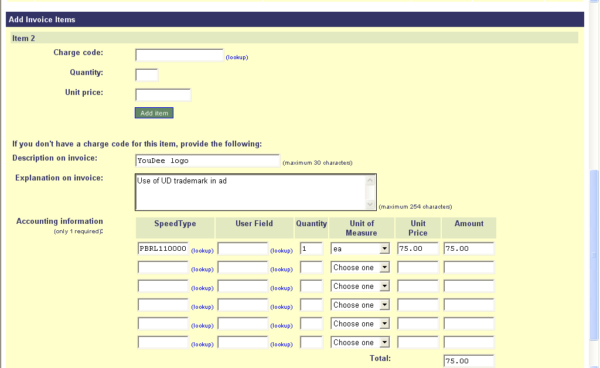
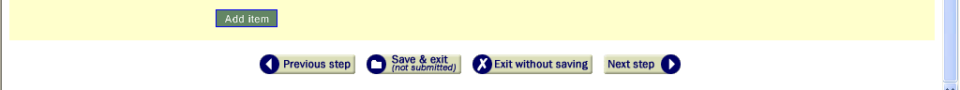

  - Manually entered charges (cont’d)

(NOTE – most items will have only one line of accounting and only one is required; warning - multiple accounting lines on this page pertain to this one item.)

- Accounting information – enter at least one line:
  - SpeedType – enter code or user “lookup”
  - User Field (optional) – enter code or user “lookup”
  - Quantity
  - Unit of Measure – choose “ea” or “hours” or “day”
  - Unit Price – enter unit price with decimal points (may be negative for credits)
  - Amount – webform will auto-calculate based on quantity and unit price
- Click “Add item” button

Entering Invoice Items (cont’d)

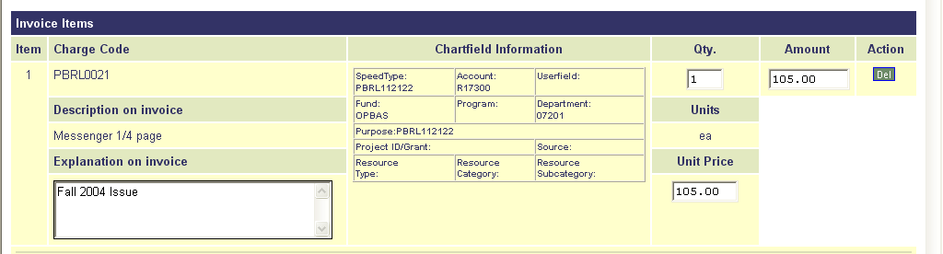
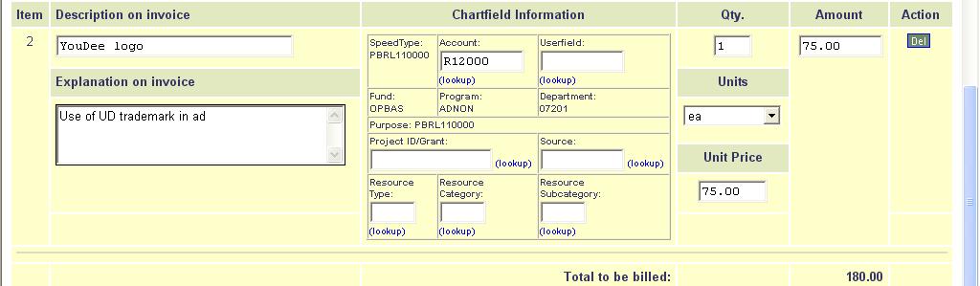

- If using a Charge Code, enter:
- Qty. (quantity)
- Unit Price - enter unit price with decimal points (may be negative for credits)
- Amount is auto-calculated
- Explanation on invoice – this can be entered or changed as needed

- If using Description on invoice, enter accounting for each line for an item:
- Account (required)
- User Field (optional)
- Project ID/Grant (required for Grants, optional otherwise)
- Source (do not change unless instructed to do so)
- Resource Type (optional, used for Grants)
- Resource Category (optional, used for Grants)
- Resource Subcategory (optional, used for Grants)

- Note – Description, Explanation, Quantity and Unit Price can all be changed if needed.

Adding Additional Lines

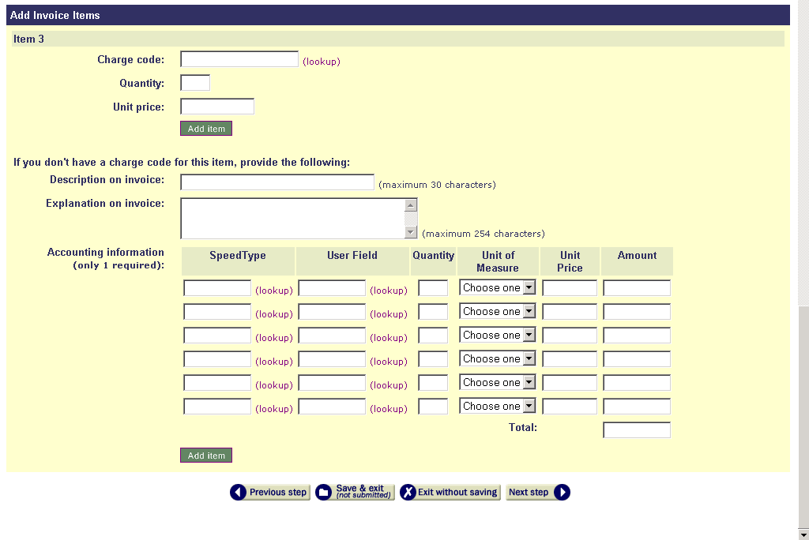

- Additional items can be added by either method, Charge Code or as Manually Entered Charges. Follow the above instructions for all new items.

- Click “Next step” button when done adding items.

Approval/Routing

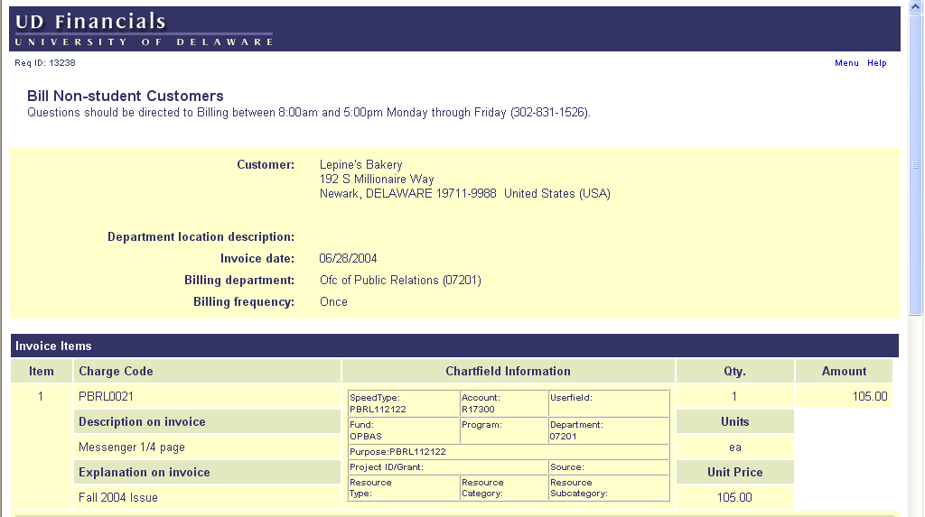
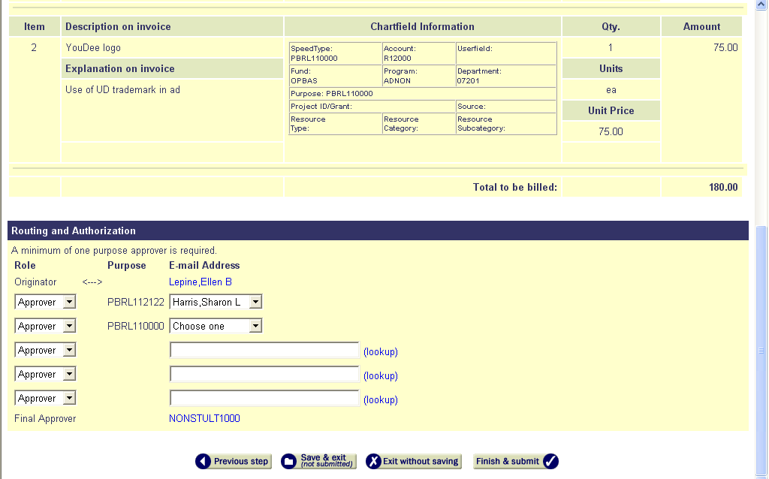
Only ONE Approver from ONE Purpose is required.
}
{

- Top portion displays each billing item with its related accounting.
- Routing and Authorization – The webform will give you a drop-down list for each Purpose used. Choose at least one approver, only one is required.
- Select additional approvers or copies as desired with the Role drop-down list
- Click “Finish & Submit” button

