Pre-Written Queries

D-1 Non-Student Billing A/R Queries
Use these pre-written EZQ queries to get information about your department’s customers and other accounts receivable and billing information.

Navigation:
► Go to PeopleSoft Reporting Database (www.udel.edu/financials)
► Menu: Reporting Tools → Query → Query Viewer

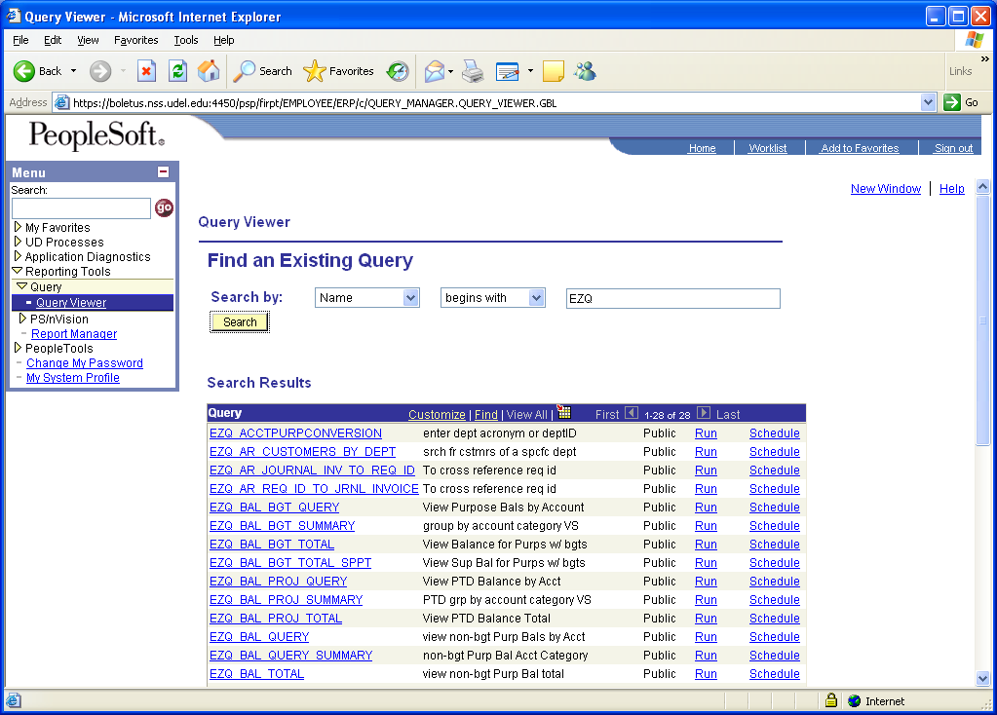

- In Find an Existing Query, type EZQ in the empty box
- Click the “Search” button
- The Search Results brings up a list all the existing queries that begin with “EZQ”
- These are the Non-Student Accounts Receivable EZQ’s:

EZQ_AR_CUSTOMERS_BY_DEPT - use this query to see customers and their addresses based on your department’s location description. (Pages 2 - 3)

EZQ_AR_JRNL_TO_REQ_ID_AND_INV – use this query to lookup a Web Request Number and invoice number by general ledger journal id. (Pages 4 - 5)

EZQ_AR_REQ_ID_TO_JRNL_INVOICE – use this query to look up general ledger id and invoice number by Web Request Number. (Pages 6 - 7)

The following pages will look at each of these EZQ’s.
EZQ_AR_CUSTOMERS_BY_DEPT - use this query to see customers and their addresses based on your department’s location description.

1

- Click on the Run link to start the query.

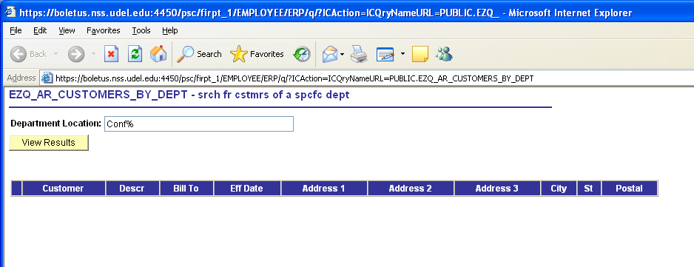
3

2

- Type your department’s location description in the open box using upper and lower case letters. The % sign is a wild card and can be used to just enter a partial description. In this example, Conf% is typed instead of Conference Services.
- Click the “View Results” button to run the query.

EZQ_AR_CUSTOMERS_BY_DEPT (cont’d)
7

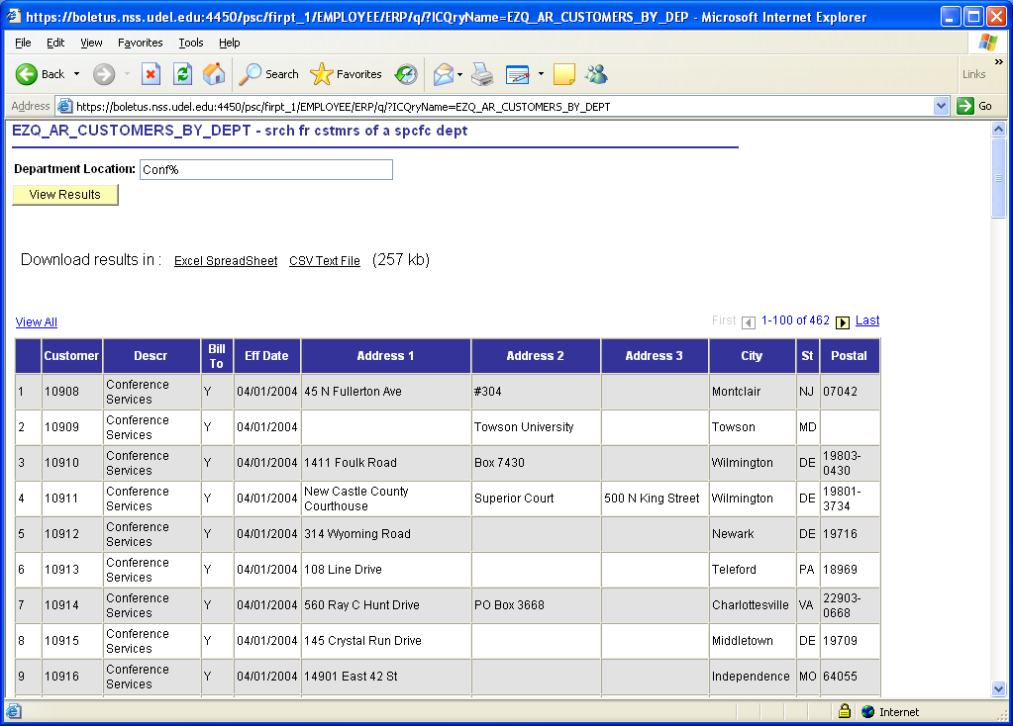
6

4

5

The results are displayed in like above. Please note:

- The Descr is the full department location description of “Conference Services.”
- The query returned 462 rows of data, of which it shows 100 rows at a time. Use the yellow arrows 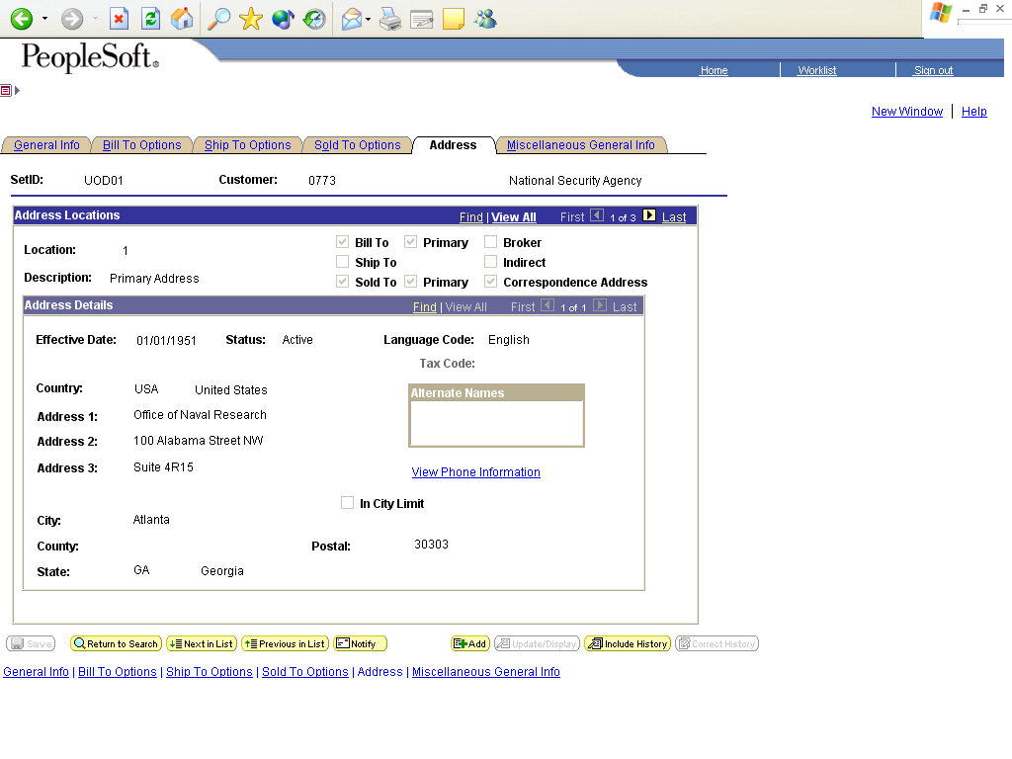 or First or Last to view.
- You may download your results to an Excel spreadsheet by clicking the Excel Spreadsheet link.
- Close this page by clicking the red “X” in the upper right corner.

EZQ_AR_JRNL_TO_REQ_ID_AND_INV - use this query to lookup a Web Request Number and invoice number by general ledger journal ID. You will most likely see the “BILL” journal ID’s on your monthly statements or in other EZQ queries that use the UOD Transaction table.

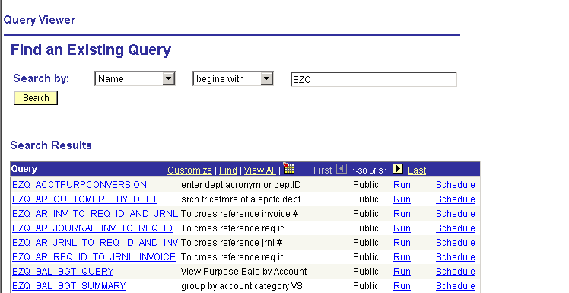
1

- Click on the Run link to start the query.

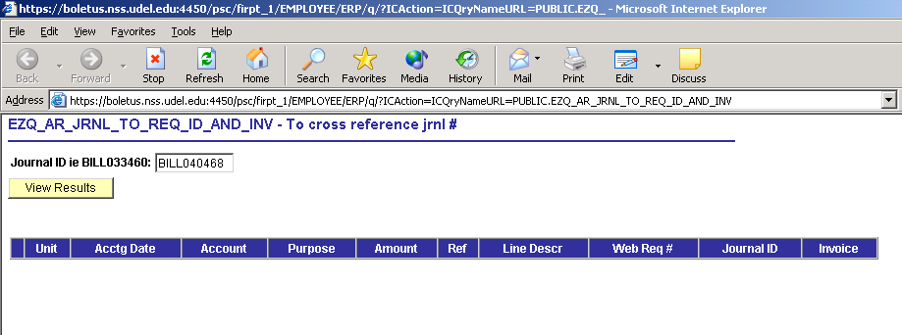
2

3

- Type the Journal ID in the open box. The Non-Student Billing journal IDs begin with “BILL.”
- Click the “View Results” button to run the query.

EZQ_AR_JRNL_TO_REQ_ID_AND_INV (cont’d)
7

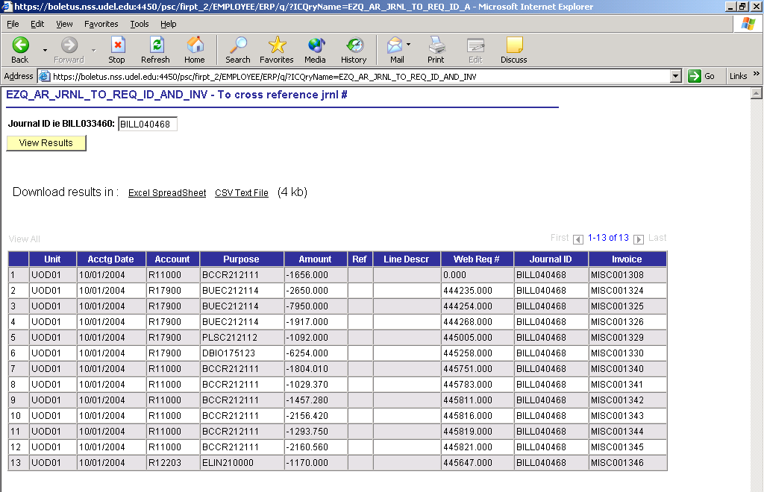
4

6

5

The results are displayed in like above. Please note:

- The Account column values will usually begin with “R” denoting REVENUE.
- The query returned 13 rows of data. (If the results were larger than 100 rows, you would use the yellow arrows or First or Last to view the additional rows.)
- You may download your results to an Excel spreadsheet by clicking the Excel Spreadsheet link.
- Close this page by clicking the “X” in the upper right corner.

EZQ_AR_REQ_ID_TO_JRNL_INVOICE – use this query to look up general ledger id and invoice number by Web Request Number.

1

- Click on the Run link to start the query.

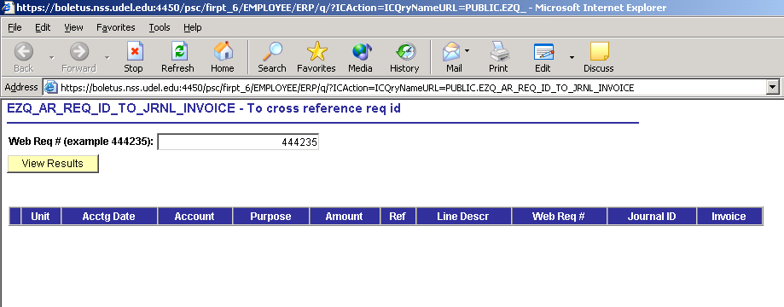
3

2

- Type the Web Request Number from the Bill Non-Student Customer webform in the open box. This is a 6-digit number.
- Click the “View Results” button to run the query.

EZQ_AR_REQ_ID_TO_JRNL_INVOICE (cont’d)
7

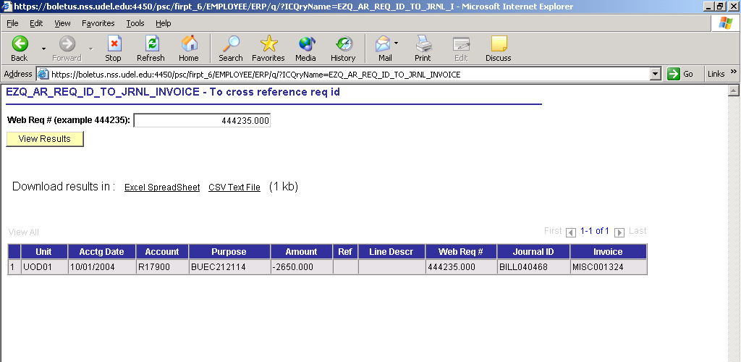
6

5

4

The results are displayed in like above. Please note:

- The Account column value will usually begin with “R” denoting REVENUE.
- The query returned 1 row of data.
- You may download your results to an Excel spreadsheet by clicking the Excel Spreadsheet link.
- Close this page by clicking the “X” in the upper right corner.

