Reviewing Billing Information

C-4 Reprinting Invoices
This process allows you to reprint an existing invoice.

Navigation in Production Database:
► Go to PeopleSoft menu: Billing → Generate Invoices → Non-Consolidated → Reprint Invoices
► At Reprint Invoices, select Add a New Value (or Find an Existing Value)

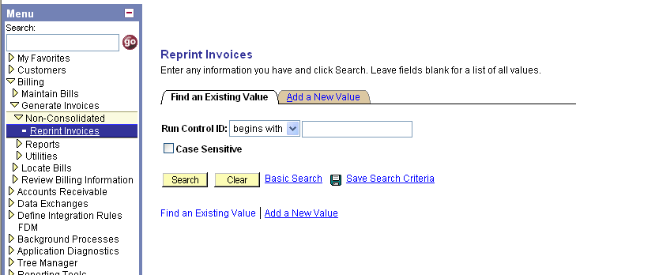
1

2

- The first time you reprint an invoice, click on “Add a New Value” tab.
- After the first time, stay in “Find an Existing Value” tab and type in the name of your Run Control ID from the previous time. If you don’t remember it, click the “Search” button to bring up a list. And then click on the Run Control ID.

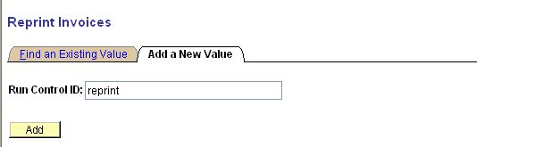
4

3

Add a New Value Tab:
- Name this Run Control ID (suggestion: reprint OR reprint_invoice – please note that the name cannot have any spaces, the “_” is used instead.)
- Click the “Add” button

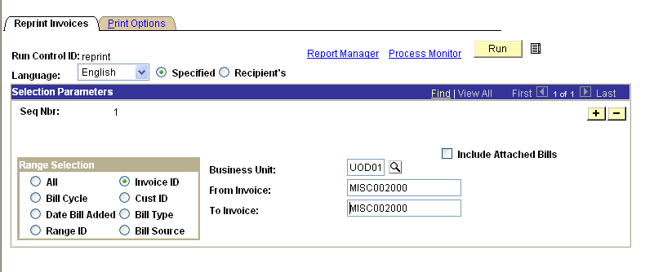
6

5

7

8

9

- Range Selection – click the Invoice ID radio button (may be on already)
- Business Unit – enter UOD01
- From Invoice – enter the invoice number
(Note: If don’t know your invoice number refer to the instructions “C3: Review AR Account – Overview” in your Non-Student Billing & A/R Instruction Booklet)

- To Invoice - Use the Tab button to auto-populate the same number in this field.
(Do not click the Include Attached Bills checkbox)
- Click the Run button

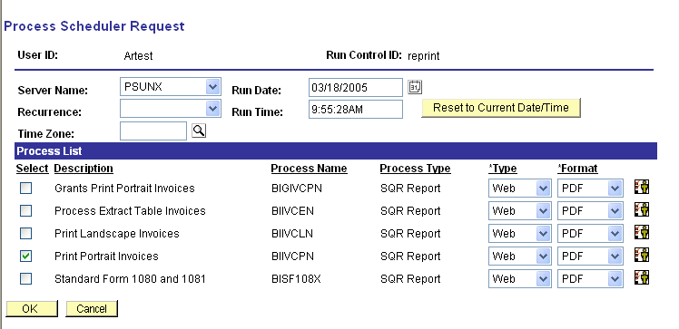
11

10

12

In the Process Scheduler Request page:
- Server Name – use drop down to choose PSUNX
- Click the box in front of “Print Portrait Invoices”
- Click the “OK” button to run the report.
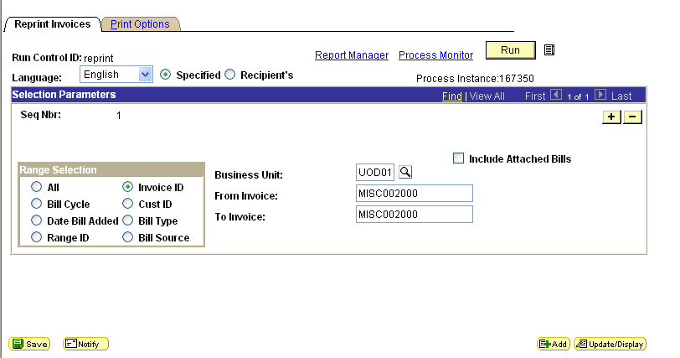
13

15

X
14

After you click the “OK” button on the Process Scheduler Request page, you will be returned to the Reprint Invoices page.

- DO NOT click the “Run” button again
- Click the “Save” button
- Click the Process Monitor link to make sure the report runs successfully

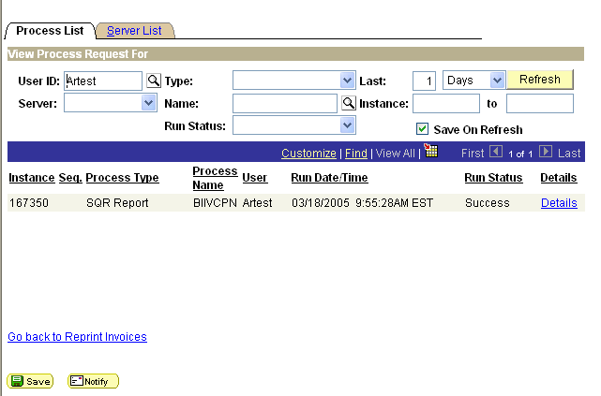
16

19

18

17

In Process List:
- Change Last to 30 Days
- Click “Save” button
- Run Status – click the “Refesh” button until the status is Success
- Once the Run Status is Success, click Details link on the report that you want to see.

(Note: Eventually you may have other reports listed here. These are ones you’ve run previously; the most recent one will be at the top of the list.)

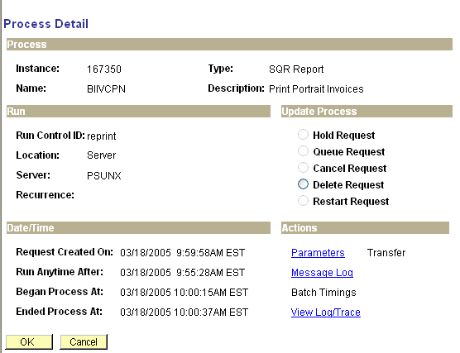
20

In Process Details page:
- Click on View Log/Trace link

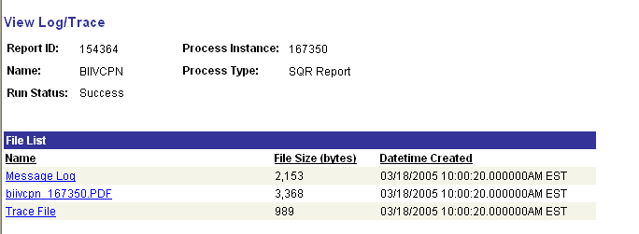
21

In View Log/Trace page:
- Click the PDF file link

24

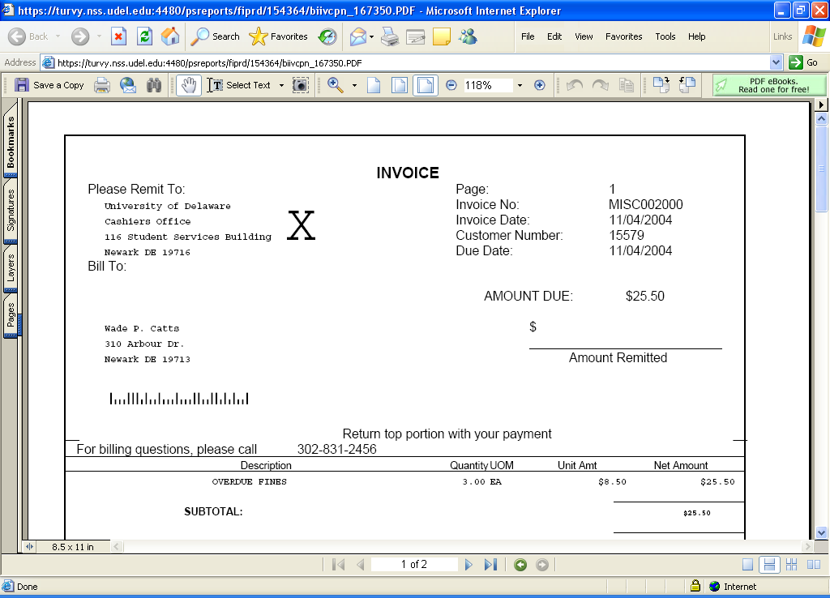
23

Customer Name
14 E. Main St.
Newark, DE 19711
22

This launches Acrobat Reader:
- You can:
- print the invoice
- view the invoice on-line

- You’ll notice a large “X” next to the University’s return address. This is due to the UD logo not being present in the PDF file and more importantly it indicates this is a REPRINTED invoice.
- We suggest you “white-out” the “X” before presenting the invoice to a customer!
- Contact billing@udel.edu for special instructions if you need the UD logo to print on the invoice.

- Close this window (to return to PeopleSoft) by clicking the red “X” in the upper right corner.

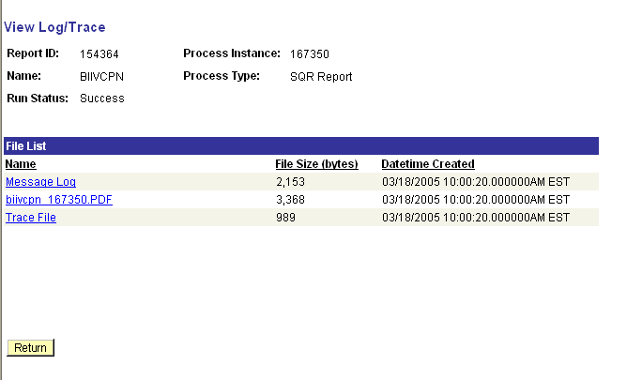

Click the "Return” button.

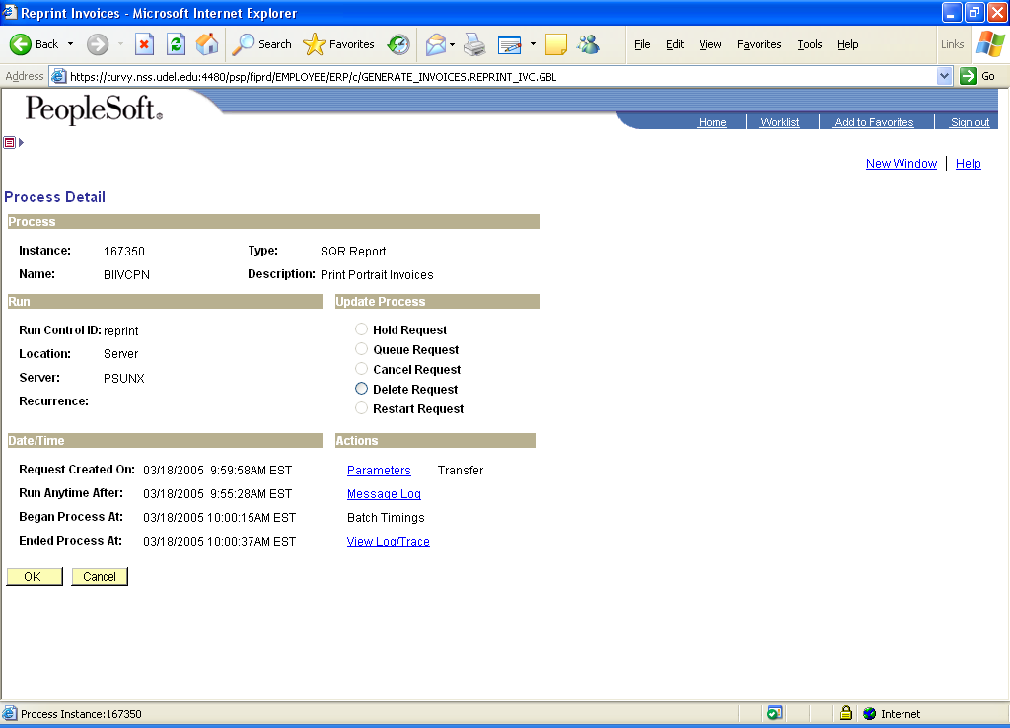

Click the “OK” button

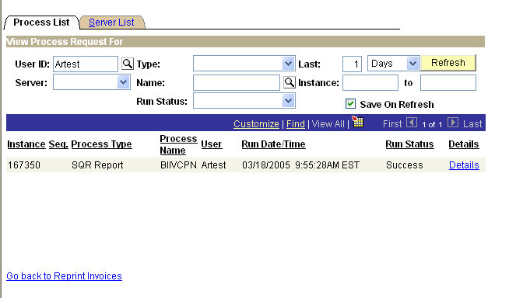

Click the
Go back to Reprint Invoices
link
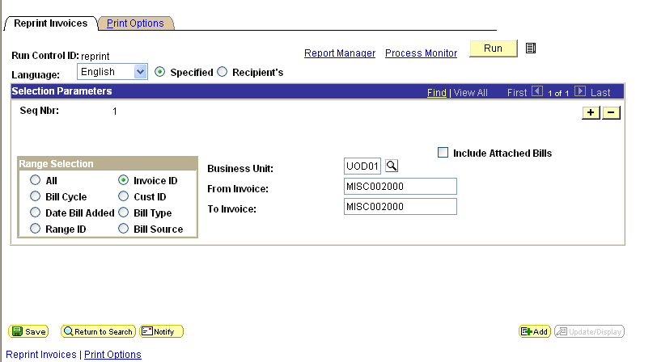

You are now back where you started at the Reprint Invoices page.

