UNIVERSITY OF DELAWARE

Cisco 6961 User Guide

Busy Lamp Field / Line Buttons

Amber —Ringing call on this line
Green —Active or held call on this line
Red —Shared line in-use remotely
- Message Waiting Light
- Display
- Soft keys
- Transfer Button
- Conference Button
- Hold Key Button
- Navigation Button
- Line Keys
- Headset Button
- Speaker Button
- Key Pad Mute Button
- Mute Button
- Volume Toggle
- Voicemail Button
- Application Button
- Contacts Button
- Handset

Basic Call Handling

Internal Dialing
- Dial the 4 digit extension .
- Calls between 831 numbers will be 4 digit dial.
- Calls between 837 numbers will be 4 digit dial.
- Calls from 831 to 837 will be 5XXXX.
- Calls from 837 to 831 will be 5XXXX.
- Callers in Lewes can dial 55 + 4 digit extension
- For further dialing instructions follow the link
http://www.udel.edu/voip/dialing.html

External Dialing
- Local: 9+ Number
- Domestic: 9+1 Area Code + Number
- International: 9+011+Country Code+Number
- Emergency External 911 & 9911

Basic Call Placing Options
- Pick up the handset.
- Press the Call or Redial icon.
- Press the Speakerphone button.
- Press a Speed Dial button.

Answering Calls
While idle:
- Lift the handset
- Press the speakerphone button
- Press the amber flashing session button

Hold/Resume
While on an active call:

Press the Hold key. 

Press the Resume softkey.

Call Join
During an Active call, if a second calls rings in
You will hear a single beep
To Answer (the original call will be put on hold automatically)
- Press the flashing amber line button
Or
- Select the Answer softkey.

Call Join
Start with two connected calls.

Make sure that one of the calls is active (not on hold). If both calls are on hold, resume one call.

Press the Conference button .

Press the line button for the other (held) call.

Transfer Options

Blind Transfer
While in an active call:

Press the Transfer key. 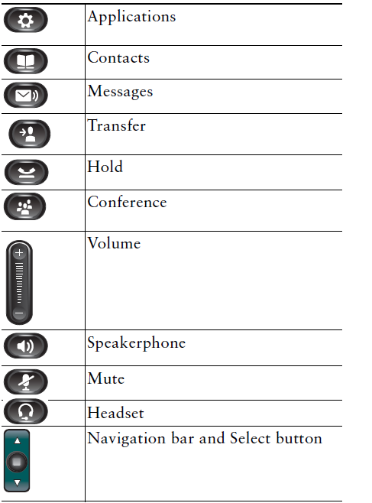

Dial the intended party.

Press the Transfer key again to complete the transfer.

Consult Transfer
While in an active call:

Press the Transfer key.

Dial the intended party.

Wait for the party to answer and announce the call, press the Transfer key again to complete the transfer.

If dialed party does not wish to take the call, press End Call (red hardkey), then resume the original call.

Transfer to Voicemail

Press the Transfer key.

Dial * plus the 4 or 5 digit extension.

Press Transfer again.

Conferencing Options

Ad-Hoc Conferencing (max 6)
While in an active call:

Press the Conference key.

Dial the intended party.

Press the Conference key again to complete the conference.

Repeat to add additional parties.

View Conference Participants
While in an Ad-Hoc or Joined Conference call:

Press show detail icon.

To refresh the screen participants, press the Update icon.

Remove Conference Participants
While in an Ad-Hoc or Joined Conference call:

Press Show Detail Icon.

Highlight the party you wish to remove using the toggle button.

Press the Remove icon.

Call Forwarding
To activate:

Press the ForwardAll icon.

Dial the desired destination.

To deactivate: Press the Forward Off icon.

Intercom (Speaker Call)
To Intercom
- Press the intercom button
- Enter the desired extension

The Receiving Extension
- Press the Intercom button or the
originator of the speaker call will not be able to hear you
Note if the receiving extension is on the phone
You can whisper the message your message without the
Person they are talking to hearing you.

Voicemail

id & Pin
Internally from your own phone:
Press the Message Key
The “default” PIN is “159357”
You will be prompted to change it during initial set up.

initial setup
Follow the prompts to setup your mailbox
“Record your name”
“Record your greeting”
“Change your temporary PIN”
If you “hang up” before you have completely enrolled, you will have to repeat the setup process next time you access voicemail.

internal Access
Internally from another phone:
- Press the Message envelope
- Enter 7-digit(831-XXXX) extension,#
- Enter your PIN & #

External Access
- Dial your number
- Press the “” key
- Enter 7-digit (831-XXXX) extension, #
- Enter your PIN & #.

Main Menu
1- Listen to messages
2- Send a message
3-Review old messages
4-Setup options

Performing Common Tasks
4-1-1 Re-Record Standard Greeting
4-1-2 Re-Record Alternate Greeting
4-3-2 Re-Record Name
4-3-1 Change Pin

Listening to Messages
1- Listen to new messages
3- Listen to old messages
[1][1] Rewind to beginning of message

While listening to messages
[3] Delete
[4] Slower
[6] Faster
[#] Skip

After listening to messages
[1] Repeat Message
[2] Save Message
[3] Delete Message
[4] Reply to Message
[5] Forward a Message
[6] Save message as new
[7] Go back 5 seconds
[8] Pause/Restart
[9] Message Properties
[#][#] Skip to next message
[*] Cancel playing messages
[1] [4]-Previous Message
[1][6] Next Message

NOTES or Help Desk INFO

