Exam 3 Sample

Multiple Choice
Identify the letter of the choice that best completes the statement or answers the question.

____ 1. A musical tone, such as that which is produced by striking a piano key, would usually consist of
a. | many harmonics.
b. | pure tones.
c. | single frequencies.
d. | sound that could be represented by a single sine-wave.

____ 2. In the Fourier frequency spectrum below, the height of the lines represents the

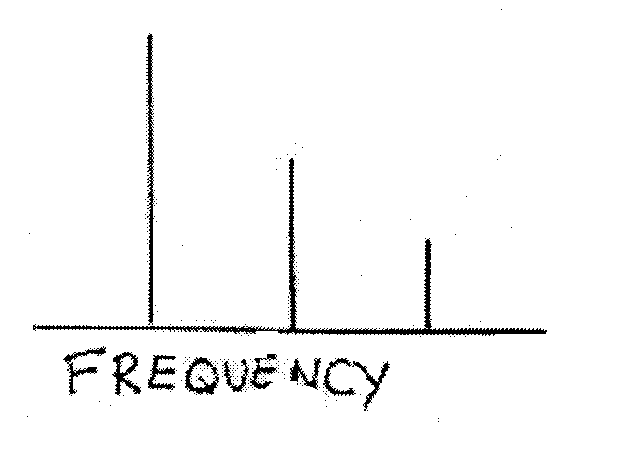

a. | amplitude at each frequency.
b. | change in pressure over time.
c. | change in pitch at each frequency.
d. | number of harmonics in the tone.

____ 3. The unit for loudness is the
a. | decibel.
b. | Hertz.
c. | mel.
d. | sound pressure level.

____ 4. The middle ear contains the
a. | auditory canal.
b. | cochlea.
c. | organ of Corti.
d. | ossicles.

____ 5. The bones of the middle ear amplify sound vibrations both by concentrating the vibrations of the large tympanic membrane onto the smaller stapes and through
a. | bending.
b. | lever action.
c. | resonance.
d. | transduction.

____ 6. The organ of Corti is located in the
a. | auditory canal.
b. | cochlea.
c. | middle ear.
d. | oval window.

____ 7. Of the two types of hair cells, the ________ are more numerous. It is the ________ hair cells that are primarily responsible for sending signals to the auditory nerve.
a. | inner; inner
b. | inner; outer
c. | outer; inner
d. | outer; outer

____ 8. When he analyzed the structure of the basilar membrane, Békésy found that
a. | it is stiffer at its apex than at its base.
b. | it is wider at its apex than at its base.
c. | the end near the far end of the cochlea is wider than the end nearer to the oval window and the stapes.
d. | the end near the far end of the cochlea is stiffer than the end nearer to the oval window and the stapes.

____ 9. Which of the following frequencies will cause a maximal deflection that is closest to the base of the basilar membrane?
a. | 500 Hz
b. | 1,000 Hz
c. | 2,400 Hz
d. | 4,800 Hz

____ 10. When auditory signals arrive at the cortex, they follow which of the following sequences?
a. | From the core area to the parabelt area to the belt area
b. | From the belt area to the parabelt area to the core area
c. | From the primary auditory area to the association area to the secondary area
d. | From the primary auditory area to the secondary auditory area to the auditory association cortex

____ 11. One similarity between the visual and auditory systems is that both
a. | exhibit tonotopic mapping.
b. | have cortical neurons that are organized with a columnar arrangement.
c. | send signals to a primary receiving area in the occipital lobe.
d. | transmit information through the lateral geniculate nucleus.

____ 12. Smoothing out irregularities in the pinna
a. | makes tones sound louder.
b. | makes tones sound less harsh.
c. | decreases a person's ability to differentiate between pitches.
d. | decreases a person's ability to localize sounds.

____ 13. Plugging one ear of an owl
a. | causes a narrowing of the tuning curve for neurons in the cochlea.
b. | changes the owl's tonotopic map.
c. | eliminates its receptive fields in space.
d. | has little effect other than to require higher stimulus intensity to achieve the same rate of neural firing.

____ 14. The somatosensory system consists of
a. | hearing and vision.
b. | taste and smell.
c. | the cutaneous senses, proprioception, and kinesthesis.
d. | the vestibular senses.

____ 15. Proprioception is the perception of
a. | biological motion.
b. | position of the arms and legs.
c. | shape by active touching.
d. | stimulus movement by a moving observer.

____ 16. Which fiber is best at resolving a detailed pattern of raised dots that are rolled across the fingertips?
a. | RA1 (Meissner)
b. | RA2 (Pacinian)
c. | SA1 (Merkel)
d. | SA2 (Ruffini)

____ 17. The records below represent the output of a

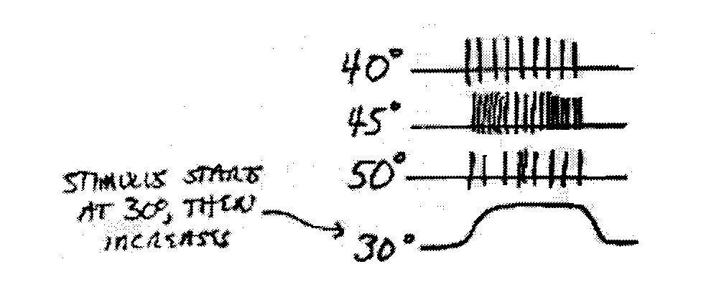

a. | cold fiber.
b. | nociceptor.
c. | transmission cell.
d. | warm fiber.

____ 18. Which of the following body parts has the smallest two-point threshold?
a. | arm.
b. | back.
c. | forehead.
d. | thumb.

____ 19. A small receptive field corresponds to
a. | a small cortical area.
b. | a small two-point threshold.
c. | deeply-buried receptors.
d. | low tactile acuity.

____ 20. The map of the human body on the somatosensory cortex is called
a. | a body-centered representation.
b. | the body-locus map.
c. | the homunculus.
d. | the threshold map.

____ 21. The area of sensory cortex that is devoted to the thumb is
a. | adjacent to the area that is devoted to the toe.
b. | as large as the area devoted to the forearm.
c. | made up of neurons with large receptive fields.
d. | proportional to its size.

____ 22. What is theorized to cause a person without an arm to feel touch sensations in the phantom arm when her face is stroked?
a. | An overwhelming desire to feel the arm again
b. | Associated memories of having been touched on the arm
c. | Neural signals sent from the stump that remains after amputation
d. | The expansion of the face area into the arm area of the somatosensory cortex.

____ 23. Which type of receptor below is most closely associated with pain perception?
a. | Nociceptor
b. | PC neuron
c. | proprioceptor
d. | thermoreceptor

____ 24. It is theorized that female varsity athletes report less pain than non-athlete females because
a. | exercise decreases the sensitivity of the receptors.
b. | in a muscular body, the receptors are buried deeper in the skin.
c. | they have become used to lower levels of pain after constant exposure.
d. | they want to appear as tough as male athletes.

____ 25. Endorphins are
a. | morphine-like substances that naturally produce analgesic effects.
b. | naturally-occurring chemicals whose effect is magnified by the drug naloxone.
c. | placebos which have a larger-than-normal analgesic effect.
d. | synthetically-produced addictive, opiates.

____ 26. The senses of taste and smell are considered "gatekeeper senses" because
a. | both monitor stimuli that enter the body.
b. | each is crucial to survival.
c. | neither is subject to neurogenesis.
d. | they have the most protected receptors.

____ 27. The loss of the ability to smell is called
a. | agnosia.
b. | amblyopia.
c. | anosmia.
d. | protanopia.

____ 28. The difficulty we have in identifying substances based on their odors is due primarily to
a. | problems in retrieving odor names from memory.
b. | the fact that most of the odors used in testing odor identification are unfamiliar substances.
c. | the small number of olfactory receptors in the human olfactory system.
d. | variability in the olfactory stimulus.

____ 29. According to the experiments on menstrual synchrony described in the text, menstrual synchrony occurred
a. | because of a physiological process involving odor.
b. | only when the women knew each other well.
c. | only when the women spent a substantial time with one another.
d. | only when the women were aware of each other's cycles.

____ 30. All of the following are contained within a taste bud, EXCEPT?
a. | A taste cell
b. | A taste papilla
c. | A taste pore
d. | A taste receptor

____ 31. Most researchers agree that there are how many basic taste qualities?
a. | 3
b. | 4
c. | 6
d. | 8

____ 32. The same neuron can fire with equal intensity to both salty and sour tastes. That supports ________ coding. Some neurons fire intensely only to sweet tastes. That supports ________ coding.
a. | distributed; distributed
b. | distributed; specific
c. | specific; distributed
d. | specific; specific

____ 33. Five minutes after finishing the his sixth slice of pizza, Rodney, the food critic, lowered his initial rating of the taste of the pizza from "worth a detour" to "nothing to write home about." Rodney probably experienced
a. | alliesthesia.
b. | anosmia.
c. | sensory-specific satiety.
d. | taste-blindness.

____ 34. A person's eye is too long, so light is focused in front of the retina. One way to remedy this situation would be to make the cornea
a. | flatter.
b. | more powerful.
c. | more rounded.
d. | smoother.

____ 35. Which of the following eye problems is caused by a misshapen cornea?
a. | Astigmatism
b. | Cataract
c. | Glaucoma
d. | Myopia

____ 36. Which part of the eye is responsible for most of its focusing power?
a. | The cornea
b. | The fovea
c. | The iris
d. | The lens

____ 37. Laser photocoagulation is one possible treatment for
a. | cataract.
b. | diabetic retinopathy.
c. | glaucoma.
d. | retinal degeneration

____ 38. Otitis media occurs in which part of the ear?
a. | Cochlea
b. | Middle
c. | Outer
d. | Semicircular canals

____ 39. Conductive hearing loss involves the ________ ear; sensorineural hearing loss involves the ________ ear.
a. | inner; middle or outer
b. | middle or inner; outer
c. | outer; middle or inner
d. | outer or middle; inner

____ 40. Presbycusis causes a loss of hearing at which frequencies?
a. | Low
b. | Middle
c. | High
d. | All

Short Answer

41. Describe, with the help of an illustration, the components and function of a cochlear implant.

42. Novacaine is commonly used to limit the pain of surgical procedures. Why doesn’t it have the “street popularity” of drugs like heroine?

43. How can the firing patterns of two classes of thermoreceptors represent a “thermometer” for the brain? Could accurate temperature information be derived from a single type of thermoreceptor? Why/Why not?

Exam 3 Sample
Answer Section

MULTIPLE CHOICE

1. A

2. A

3. A

4. D

5. B

6. B

7. C

8. B

9. D

10. D

11. B

12. D

13. C

14. C

15. B

16. C

17. A

18. D

19. B

20. C

21. B

22. D

23. A

24. C

25. A

26. A

27. C

28. A

29. A

30. B

31. B

32. B

33. C

34. A

35. A

36. A

37. B

38. B

39. D

40. C

