
September 2001
WebCT: Student Presentations
Information
Technologies
Copyright © 2001 University of Delaware. Permission to copy without fee all or part of this material is granted provided that the copies are not made or distributed for direct commercial advantage or profit and that the material duplicated is attributed to Information Technologies, University of Delaware. To copy otherwise or to republish requires specific permission and a fee.
Table of Contents

Introduction 1
System Setup 1
Accessing WebCT 1
Student Group Presentations: Designer Instructions 2
Introduction 2
Getting Started 2
Adding the Student Presentations Tool 3
Creating Student Groups with the Group Generator 4
Creating Student Groups Manually 5
Creating Student Groups Manually 5
Editing a Group 6
Deleting a Group 7
Viewing a Student Submission 7
Managing Student Group Files 8
Student Group Presentations: Student Instructions 9
Accessing the Student Presentations Area 9
Uploading Files to the Group Folder 10

Introduction
This document is designed as a supplement to the WebCT Introduction. It is assumed that you are working on a course following the University of Delaware template.

System Setup
To be able to view changes as you make them while designing a WebCT course, it is important that you set the cache settings of your browser to verify web documents Every time. If you have not made this change, your web browser will often display a cached copy of a document (i.e. a previous version which it has stored locally on your computer). In addition, you will need to Enable Java in your browser.

The following table provides the instructions for what you need to change in your browser.

Browser Type | How to Enable Java | Change the Cache
Netscape Communicator 4.x | Edit →  Preferences →  Advanced →  Enable Java and JavaScript | Edit →  Preferences →  Advanced →  Cache →  Every time
Internet Explorer 5.0 | Tools →  Internet Options →  Advanced →  Java JIT compiler enabled | Tools →  Internet Options →  General →  Temporary Internet files →  Settings →  Every visit to the page

Note: Your students will also need to make this change in their browsers.

Accessing WebCT
- The main WebCT course server is located at

http://www.udel.edu/webct

When you arrive at this site, click the link Logon to WebCT, then:

- Click Log on to myWebCT.
- Type your WebCT ID and password.
- Close all browser windows when you are finished, including any mail windows. Failure to do so will make your personal course information available to the next person who uses the computer.

Student Group Presentations:
Designer Instructions

Introduction
The Student Presentations tool in WebCT enables you to coordinate student group projects, while overcoming traditional boundaries to collaborative learning such as time, geographical distance, and communication differences.

This tool allows you and your students to upload and store files in the WebCT file manager, work collaboratively on group files, and post completed presentations.

There are several different access levels within the Student Presentations tool:

- Group members can edit files in their group folder
- Instructor and other class members can view a group’s files
- Instructor can comment on or edit student files

Getting Started
The Student Presentations tool can work dynamically with the WebCT Discussions tool. When you create a student group, a discussion topic can be formed automatically. If you plan to use this feature, you should set the instructor’s name so your students will see your name when you post a message instead of just “Instructor.”

- On the Navigation Bar, click Change Settings.
- Type your first and last name in the “Instructor first / last name” text boxes.

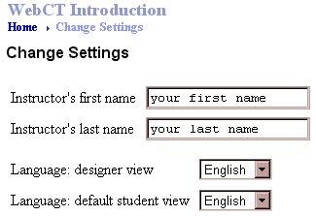

- Click the Update button.
- On the Navigation Bar, click Homepage.

Adding the Student Presentations Tool

- While in Designer Options, Click Add Page or Tool;
- Under Study Tools, select Student Presentations;
- Click Add.
- Click the link, Modify the Presentations tool.

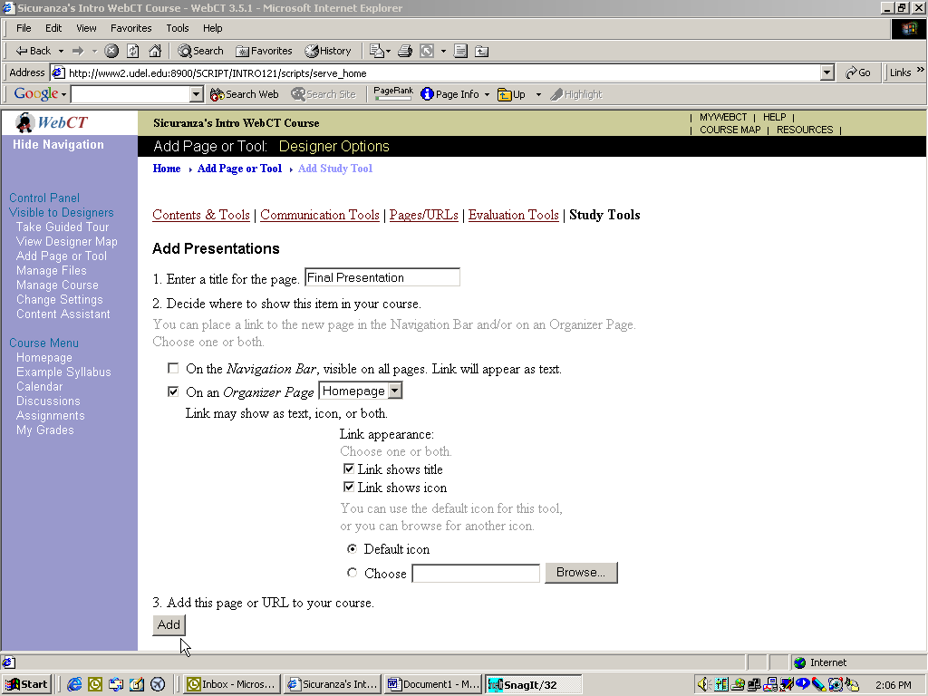

Creating Student Groups with the Group Generator

- Select Group Generator.
- Click Go.
- Select the method by which to generate the groups (i.e., number of groups OR number of students per group)
- Indicate what should happen to any leftover students if the numbers are uneven.
- Under Group Discussions, select the first checkbox if you wish to automatically create group-specific topics within the Discussions tool.
  - Once you select the first checkbox, the second will be selected automatically, giving the Instructor access to all group discussions. This option can be deselected if you wish.

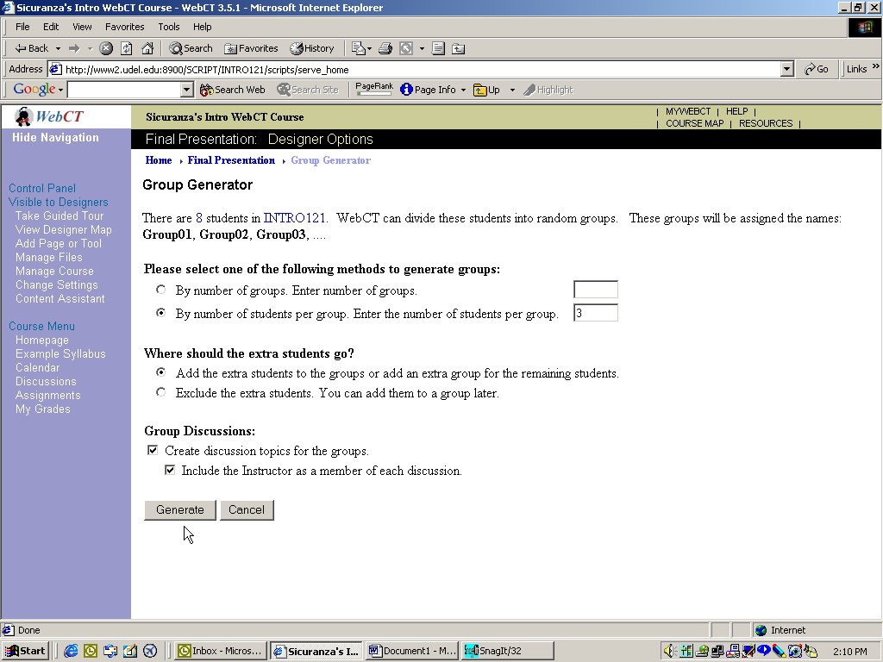

Creating Student Groups Manually

- Select Add.
- Click Go.
- Enter the Group Name (required), and a description if you wish.
- Select the checkbox to create a discussion topic for this group if you wish to have a group-specific topic in the Discussions area of WebCT. Checking this option will automatically select the second checkbox to include the Instructor in the discussion topic.
- In the Class List to the right, choose the students that will be members of the current group.
  - We recommend that you only show unassigned students in this list; otherwise, it will be difficult to determine which students are already in another group.
- Click the Add button.

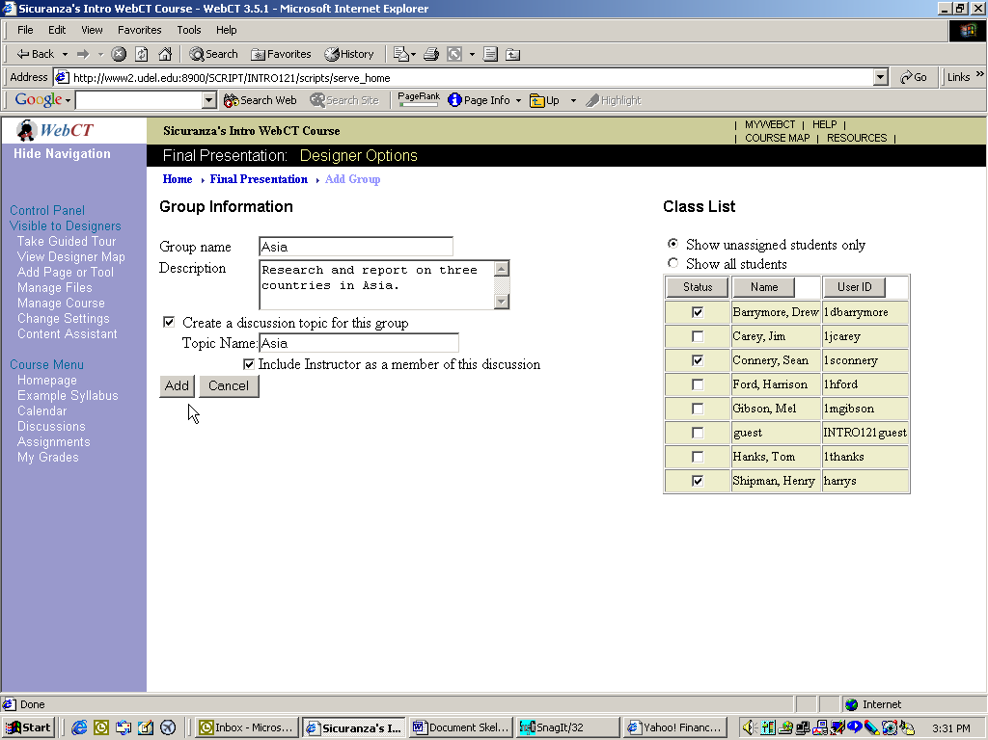

Editing a Group

- Select the radio button next to the group you wish to edit.
- Select Edit in the Other Options menu.
- Click Go.
- On the Edit Group screen, you have the option to:
  - Change the group name
  - Add, delete, or change the group description
  - Add or remove members
  - Manage the group files, which takes you to the WebCT file manager

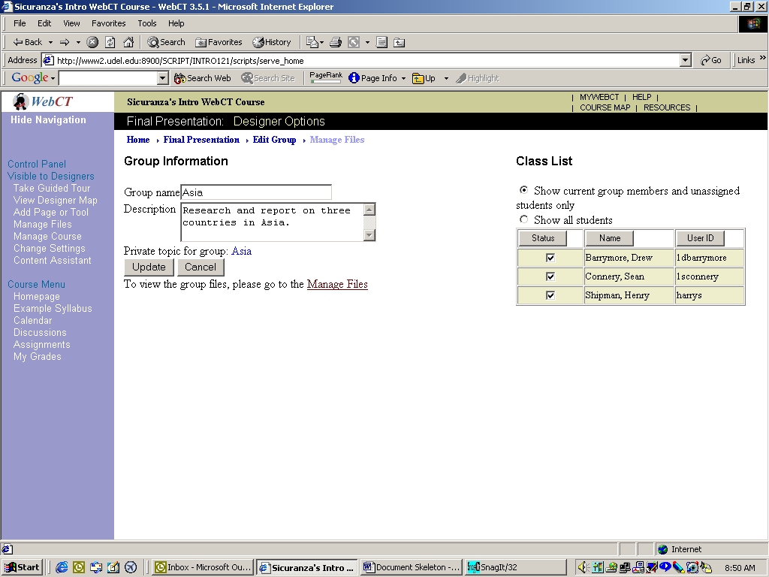

Deleting a Group

- Select the radio button next to the group you wish to delete.
- In the Other Options menu, select Delete.
- Click Go.

Note: If you want to delete all groups, select Delete All in the Other Options menu and click Go.

Viewing a Student Submission

- Click the link to enter the Student Presentations area.
- In the Student Presentations table, you will see a link in the Projects column for any student group that has submitted a presentation. Click the desired link; the presentation will open in a new window.
- When you finish reviewing the presentation, close the window to return to WebCT.

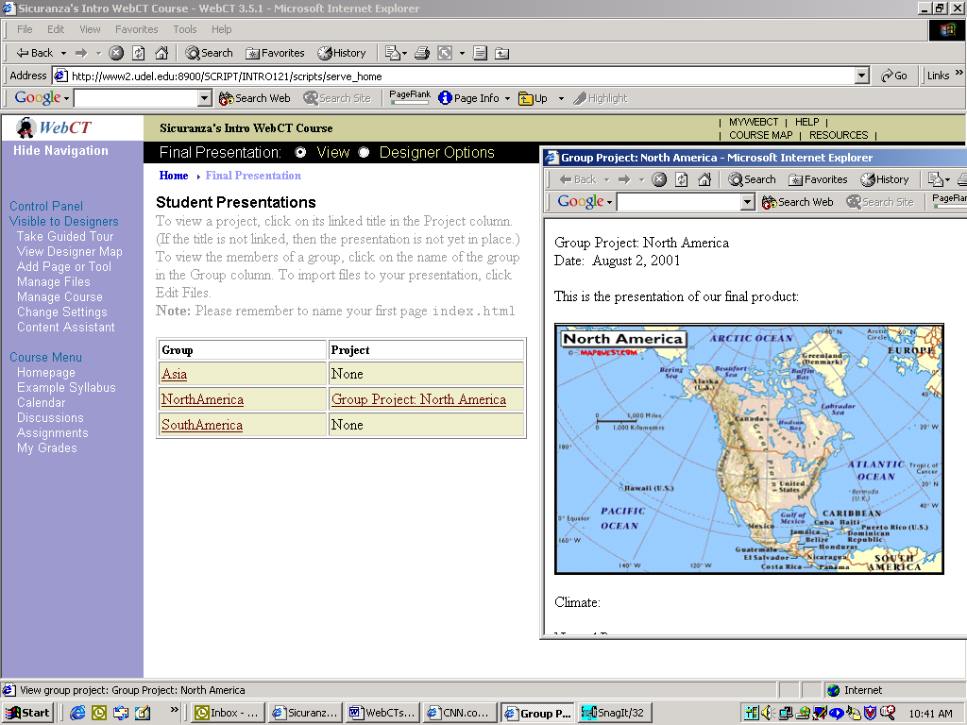

Managing Student Group Files

As the Instructor, you have the ability to manage the files stored in the students’ group folders. You can edit, delete, download, and store files. You also have the option to create sub-folders for the individual student groups.

- Click the “Manage Files” link.
- Select the folder or the file you wish to manage.
- Select the appropriate task from the File Options or Folder Options at the top of the window, and click the corresponding Go button.

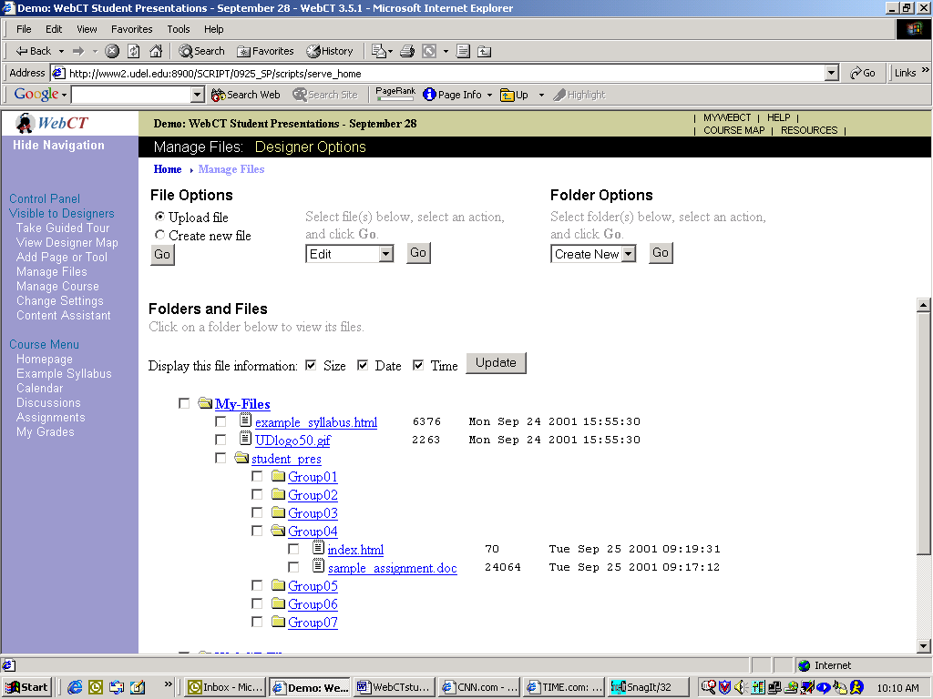

Teaching Considerations and Suggestions

If you plan to incorporate collaborative learning into your WebCT course using the Student Presentations tool, you may wish to review the following suggestions and considerations. These are meant to be a guideline only, so you may wish to select those that will pertain to your situation. This list is not all-inclusive.

Considerations:

- Students can create HTML files in by coding in WebCT’s File Manager, or an external software package such as a word processor, spreadsheet, presentation, or Web page editor. They do not need to know HTML.

- Students do not have to be online to work on the files. They can download files to their computers so they can work offline.

- Graphics files are not editable once they are uploaded to WebCT. They must be edited locally in a graphics software package.

Suggestions:

- Use this tool to enhance interactivity. Break up large lecture classes into smaller, more manageable groups.

- Use the tool to post case studies or problems for completion by student groups.

- Give the students as much direction and instruction as possible. For many students, this may be the first exposure to creating Web pages and uploading files.

- Provide student instructions. You may modify the instructions contained in this document for use in your class.

- Create a uniform home page (index.html) for each student group with pre-created links to assignment files. Store them in the group folders.

- Enforce assignment deadlines by removing all members of each group. This makes the files viewable to students, but not editable.

Student Group Presentations:
Student Instructions

Accessing the Student Presentations Area

- Locate and click the Student Presentations tool, either on the course Homepage or Course Menu.

- In the Presentations area, you will see a list of the projects by student group. To view group members, click the underlined text in the Group column. The group members’ names will appear in the Group Member list to the right.

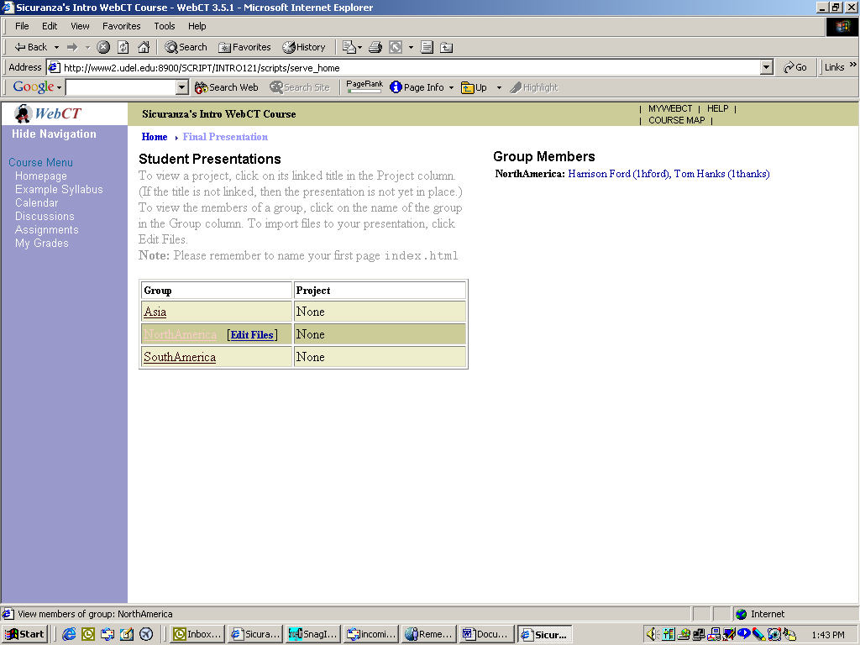

Uploading Files to the Group Folder

To submit your presentation assignment, you must upload files to your group folder in WebCT. Your main page must be named index.html, but it may contain links to other files that you store in the folder.

- Click the link “Edit Files.”

- In the File Manager, select your group folder at the bottom, then select Upload file and click Go.

- The File Manager allows you to edit files that are already uploaded. In the middle section, you will see a dropdown list that gives options such as Edit, Rename, Move, and Delete. To perform any of the actions in this list, you will need to first select the file you wish to manage.

