
WebCT: Student Activities
Information
Technologies
January 2002
Copyright © 2002 University of Delaware. Permission to copy without fee all or part of this material is granted provided that the copies are not made or distributed for direct commercial advantage or profit and that the material duplicated is attributed to Information Technologies, University of Delaware. To copy otherwise or to republish requires specific permission and a fee.
Table of Contents

Introduction 1
System Setup 1
Accessing WebCT 1
Discussions 2
Introduction 2
Getting Started 2
Composing a Message 3
Viewing a Message 5
Replying to a Message 6
Display Options 7
Managing Topics 10
Managing Messages 10
Assignments 12
Introduction 12
Creating 12
Editing 15
Student Management 15
Introduction 15
Listing your Students 15
Grades 16
Introduction 16
Marking an Assignment 17
Editing 19
Releasing Grades to Students 19
Extra for Experts 21
Discussions: Private Topics 21
Assignments: Including a File 21
Assignments: Deleting an Assignment 22

Introduction
This document is designed to supplement “WebCT Introduction” and assumes you are working on a course that follows the University of Delaware template.

System Setup
To view changes as you make them while designing a WebCT course, it is important that you set the cache settings of your web browser to verify web documents Every time. If you do not make this change, your web browser will often display a cached copy of a document (i.e., a previous version that it has stored locally on your computer). In addition, you will need to Enable Java in your web browser.

The following table provides the steps to make these two changes.

Browser Type | How to Enable Java | How to Change the Cache
Netscape Communicator 4.x | Edit →  Preferences →  Advanced →  Enable Java and JavaScript | Edit →  Preferences →  Advanced →  Cache →  Every time
Internet Explorer 5.0 | Tools →  Internet Options →  Advanced →  Java JIT compiler enabled | Tools →  Internet Options →  General →  Temporary Internet files →  Settings →  Every visit to the page

Note: Your students will also need to make these changes in their web browsers.

Accessing WebCT
- The main WebCT course server can be accessed from the web page

http://www.udel.edu/webct

From this page,
- Click Logon to WebCT at the top of the page.
- Click Log on to myWebCT.
- Type your WebCT ID and password.
- Close all browser windows when you finish, including any e-mail windows. If you do not, your personal course information will be available to the next person who uses the computer.

Discussions

Discussions: Introduction
Discussions allow you and your students to communicate electronically in a way that involves everyone in the class or group but can continue regardless of time. Discussions can be organized into topics of which all or some of the students are members. When a participant posts a message, any member of the topic can view it and either respond directly to it or send comments following a new train of thought. If many participants are involved in a topic, they may find it easier to follow the flow of the exchanges by viewing the threads of the discussion showing which messages are posted in direct response to others. The instructor can direct the discussion by including messages to keep the comments on track.

Discussions: Getting Started
- If you want to use Discussions in your course, you should first set the instructor’s name so your students will see your name when you post a message instead of just “Instructor.” Because the designer of the course may not always be the one who is presenting the material, the instructor’s name is not automatically set.

- On the Navigation Bar, click Change Settings.
- Type your first and last name in the “Instructor first / last name” text boxes.

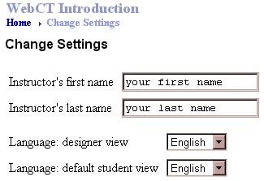

- Click Update.
- On the Navigation Bar, click Homepage.

Discussions: Composing a Message
- On the Homepage, click Discussions.

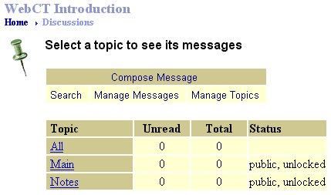

- When the “Select a topic to see its messages” screen appears, you are automatically placed in the Designer Options view. Click View to switch to the Student View to consider what your students will see upon entering Discussions.

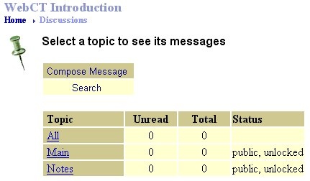

Note: In the Student View, the “Manage Messages” and “Manage Topics” features are unavailable. Students have only the ability to compose, view, and search messages.

By default, Discussions contains the following three public topics:

- All contains the messages in all the public topics in a course
- Main is a general topic present in all courses
- Notes includes messages related to a page of content in a Content Module

- Click the topic in which you want to post a comment. A list of that topic’s contents will appear.

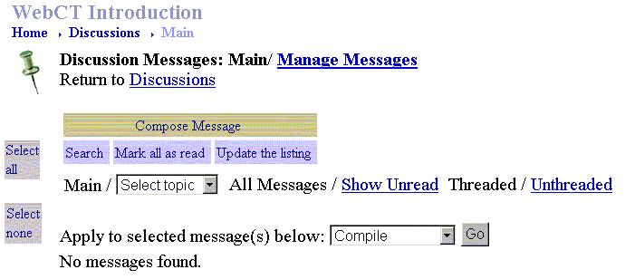

- Click Compose Message and a “Compose Discussion Message” window appears.

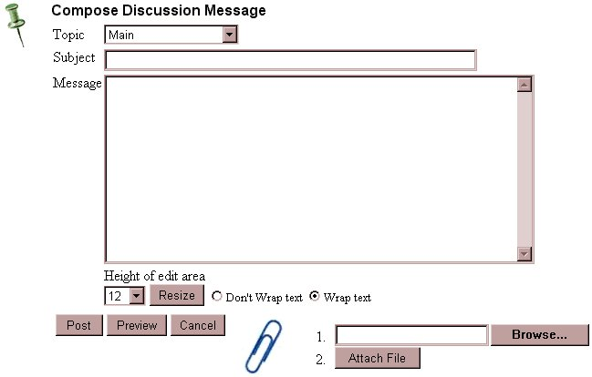
Do not include special characters in the Subject of your message.

- Type a subject in the “Subject” field to identify your message.
- In the “Message” field, type your message.
- Click Post.
- Click Update the listing, and your message will appear in the list of messages labeled “NEW.”
- On the Navigation Bar, click Homepage.

Discussions: Viewing a Message
- On the Navigation Bar, click Discussions.
- The “Unread” and “Total” columns show that there is now a message in the Main discussion.

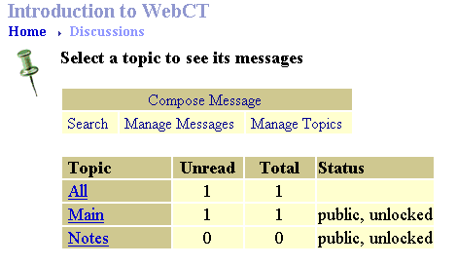

- To view messages in all of the discussions, click All.
- When the “Discussion Messages: All” screen appears, messages in all discussions are listed at the bottom with new ones marked with the word “NEW.” The topic to which each message belongs is noted at the end of the subject of the message.

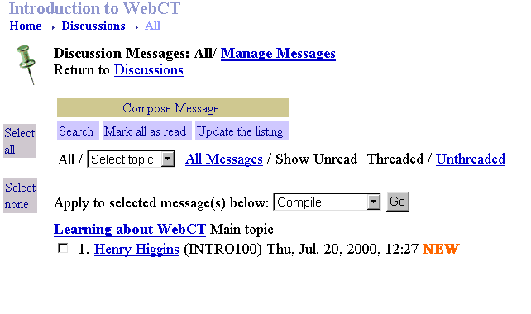

- To view a message, click the author’s name.
- A new window showing the contents of the message appears.

- When you finish reading the message, click Close.
- Click Update the listing, and the message you just read will no longer be labeled “NEW.”
- On the Navigation Bar, click Homepage.

Discussions: Replying to a Message
- On the Navigation Bar, click Discussions.
- Click the topic containing the message to which you want to send a reply.
- If you do not see the message and “All Messages” is underlined, click All Messages to view all the messages in the topic whether they have been read or are new. If “All Messages” is not underlined, you can click Update the listing to view new messages.
- View a message by clicking the author’s name.
- In the window showing the contents of the message, click Reply.
- The “Reply to message” screen appears, and displays the number of the message. The subject field is already filled in with the original subject.

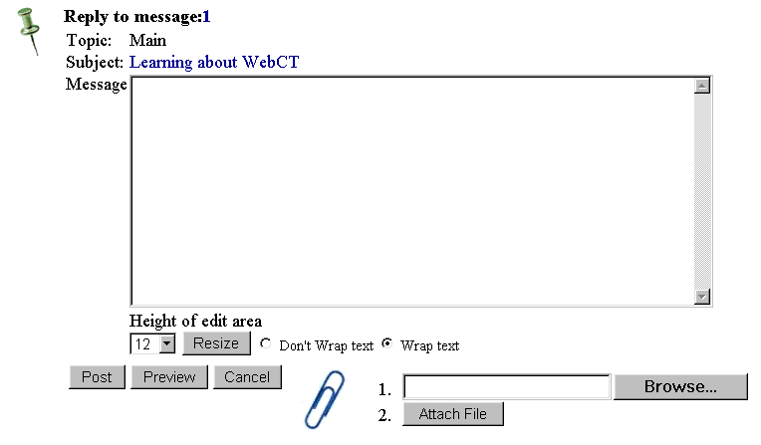

- In the “Message” field, type your reply.
- Click Post.
- Click Update the listing and the reply you just sent will appear (labeled “NEW”).
- On the Navigation Bar, click Homepage.

Discussions: Display Options
WebCT allows you to view a list of all messages or a list of a particular topic in various ways.

Discussions: Show Unread vs. All Messages
You may find it helpful to display all the messages or only those that have not been read.

For illustration, you may want to compose a new message. Remember to click Update the listing to see your new message in the list.

- On the Homepage, click Discussions.
- To view messages in all of the discussions, click All.
- The new message is listed as “NEW” (i.e., it has not been read). To show only new messages that have not been read, click Show Unread. (If this option is unavailable, you will already be viewing only the unread messages.)

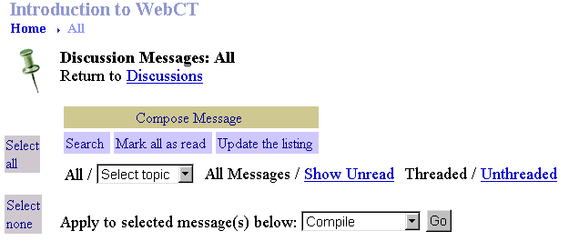

- Only the messages that are new or have not been read are listed at the bottom of the screen. The options will now show the All Messages as being available.

- To display all messages again, click All Messages.

Discussions: Threaded vs. Unthreaded Messages
A thread is a series of messages that have been posted as replies to each other. By reading each message in a thread, one after the other, you can see how the discussion evolved. Viewing messages as unthreaded displays messages as if they were not connected to each other.
To view messages as “Threaded,” you must have at least one message to which a reply has been posted.

For illustration, you may want to reply to a message. Remember to click Update the listing to see your new message in the list.

- On the Homepage, click Discussions.
- To view messages in all of the discussions, click All.
- To show all the messages, click All Messages. (If this option is unavailable, you will already be viewing all the messages.)
- To show how the messages are related, click Threaded. (If this option is unavailable, you will already be viewing the threads of the topic.)

Notice the hierarchy of messages. When a reply is sent to a message, it is listed indented below the message. Replies made to replies are further indented.

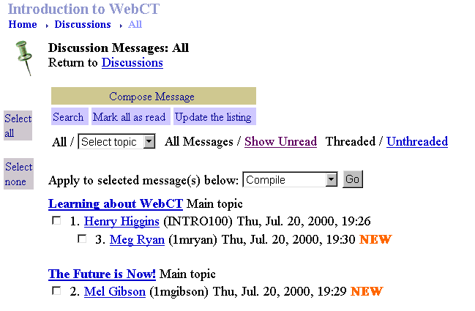

- To list the messages in the order in which they were posted, click Unthreaded.

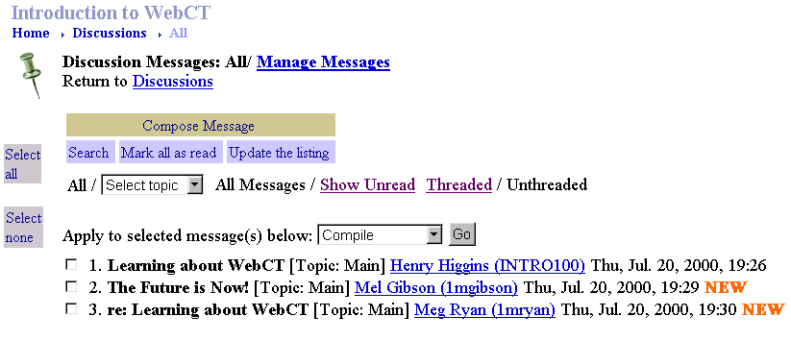

Discussions: Managing Topics
If you are discussing multiple issues in your course, WebCT can help you manage the topics. For example, if your course is focusing on Shakespeare, you may want separate discussion topics for each play being studied. This way, students discussing Macbeth can post messages to the “Macbeth” topic, and students studying Hamlet can exchange comments in the “Hamlet” topic. Only instructors can create, delete or rename topics.

Adding a Topic
- On the Homepage, click Discussions.
- Click Designer Options.
- Click Manage Topics.
- Click Add and type the name of the new topic in the field next to “Add.”

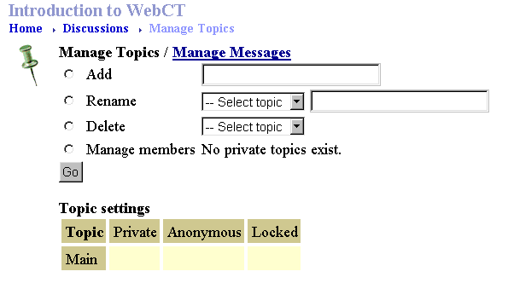

- Click Go.
- On the Navigation Bar, click Discussions to see the new topic added to the list.

Discussions: Managing Messages
- WebCT allows you to move individual messages from one topic to another or delete messages within a topic. Only the instructor can perform these functions.

- On the Homepage, click Discussions.
- Click Designer Options.
- Click the topic that contains the messages you’d like to move.
- Click Manage Messages.

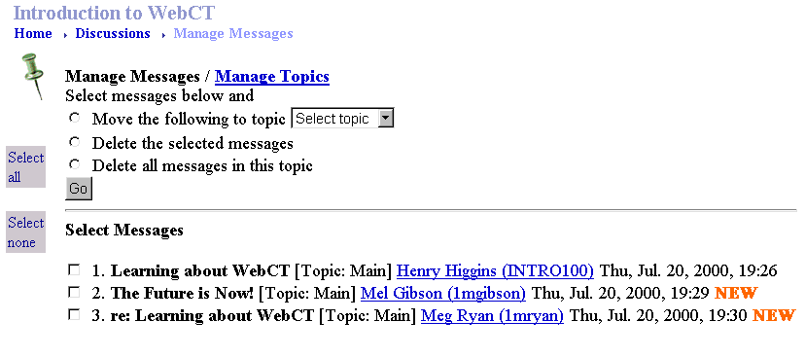

- Using the check boxes, select one or more messages you’d like to rearrange.
- Click one of the following options:

- Move the following topic (Then, in the “Select Topic” menu, choose the topic to which you want to move the message[s].)
- Delete the selected messages
- Delete all messages in this topic (It is not necessary to check any of the messages below.)

- To perform the function you checked, click the Go button.

If you delete a message to which there is a reply, the reply will no longer be threaded. The subject of the reply will be “re:” followed by the subject of the original message.

Assignments

Assignments: Introduction
WebCT lets you set aside space for your students to turn in their work electronically. You describe the assignment, allot a point value to it and set the due date. The students prepare and save their answers in files using other software, such as a word processing or spreadsheet program, upload their files and submit them for grading.

Assignments: Creating
- On the Homepage, click Assignments.
- Click Designer Options.
- Under “Assignment Options,” click Add.

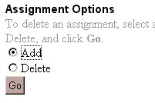

- Click Go.
- In the “Assignment Title” field, type a title for this assignment (e.g., “Term Paper”).

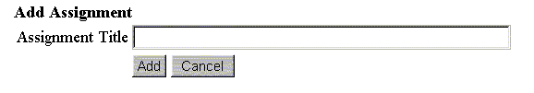

- Click Add.
- When the “Assignments” screen appears, you will see the assignment listed by title.

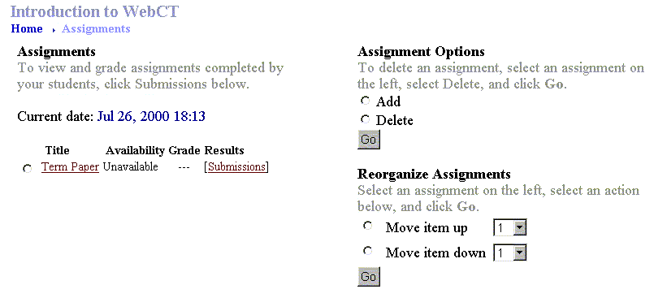

- Click the title of the assignment and a screen appears showing the parameters of the assignment.

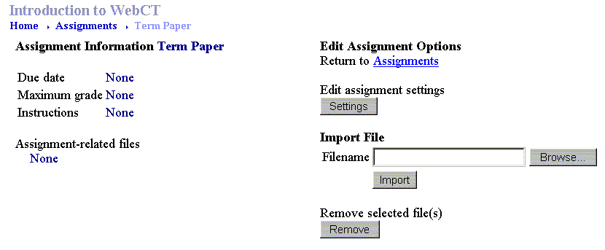

- Notice that each of the parameters under “Assignment Information” is set to “None.” Under “Edit Assignment Options,” click Settings.

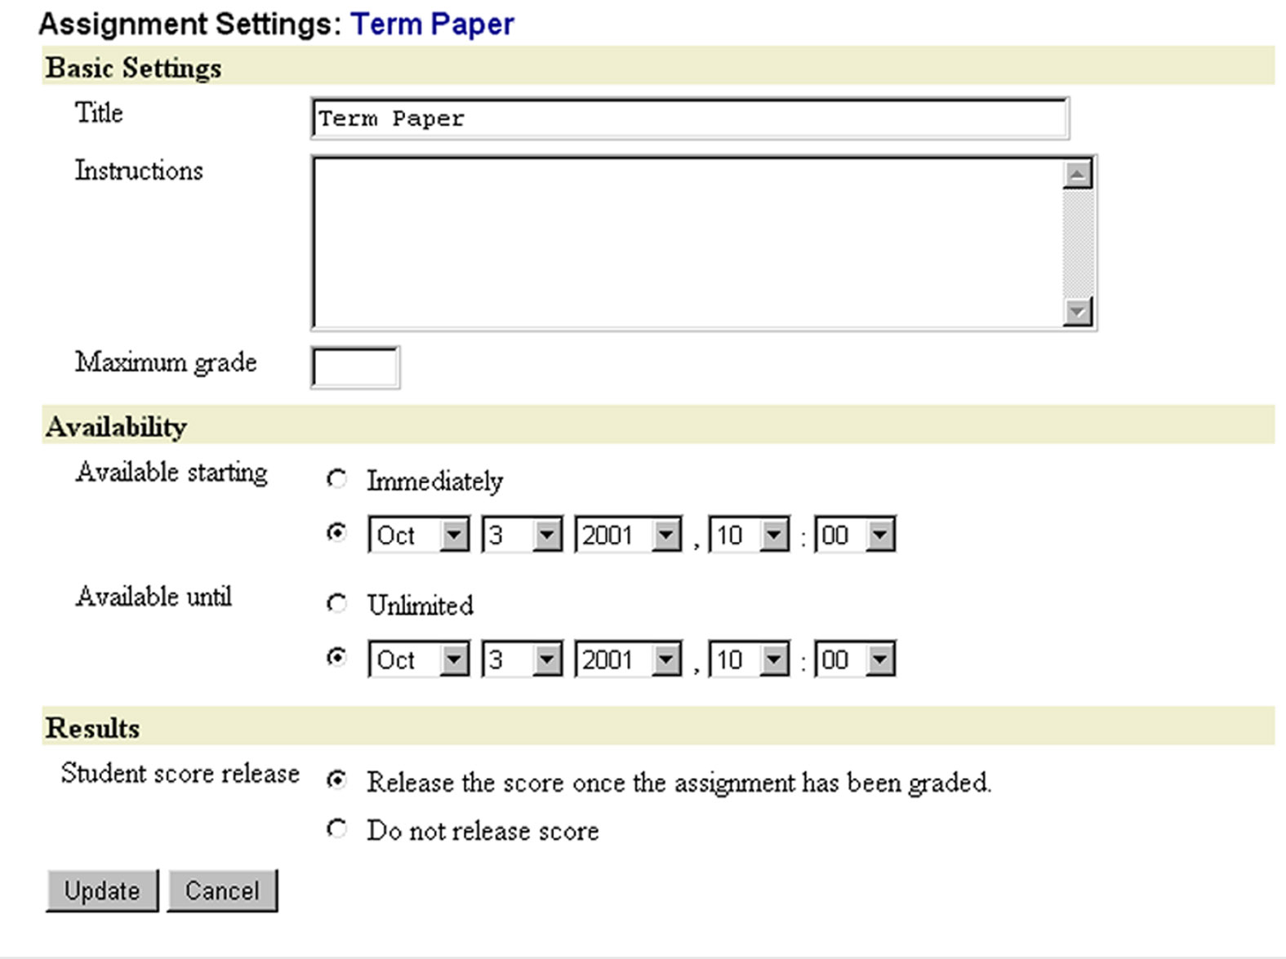

- Fill in the following information:

- Instructions: Describe the assignment.
- Maximum grade: Type the total point value of this assignment. The total number of points for all assignments need not total 100.
- Available starting: Select either Immediately or set a date and time when your students will see this assignment listed.
- Available until: Select either Unlimited or set a date and time after which your students will no longer see this assignment listed.
- Student Score Release: Choose Release the score once the assignment has been graded or Do not release score.

- Click Update.
- On the Navigation Bar, click Assignments to view the newly listed assignment. You can click the assignment title to see details about it, but you will not be able to submit anything yourself.

Assignments: Editing
- On the Homepage, click Assignments.
- Click Designer Options.
- Under “Title,” click the title of the assignment you need to edit.
- Under “Edit Assignment Options,” click Settings.
- On the “Assignment Settings” screen, make the necessary changes.
- Click Update.

Student Management

Student Management: Introduction
The WebCT administrator will handle adding students to a WebCT course. To request an official course and give access to registered students, visit the web page

http://www.udel.edu/webct/

From this page, choose For Faculty, then Request an official course. Complete and submit the form.

Student Management: Listing your Students
- You can view a partial or complete list of the registered students in your WebCT course. This will be helpful when you post grades.

- On the Navigation Bar, click Manage Course.
- Click Manage Students.
- On the “Manage Students” screen, you will see a list of your students. Note: You can use the Previous Page and Next Page buttons to see the entire list.

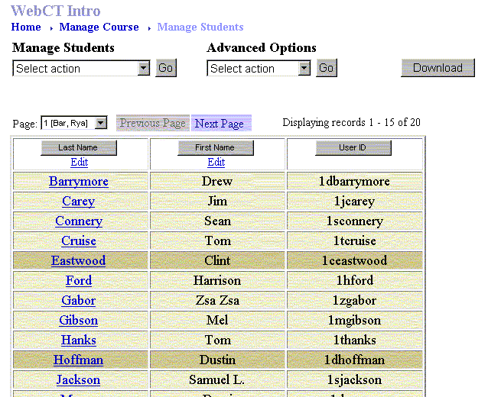

Grades

Grades: Introduction
In the table containing students’ names, WebCT lets you store other information about students, particularly their grades. When you create an assignment or quiz in WebCT a column for the grade of that assignment or quiz is automatically added to the table. You can add other columns manually for other graded activities, such as participation or presentations. Other columns for calculating final grades or translating a number of points to a letter grade can also be added to the table.

Grades: Marking an Assignment
- For illustration, you should add an assignment as described in the previous section. A column for the grade for that assignment will be placed automatically in the student information table.

- On the Navigation Bar, click Manage Course.
- Click Manage Students.
- On the “Manage Students” screen, click Submissions at the top of the column that shows the assignment you want to grade.

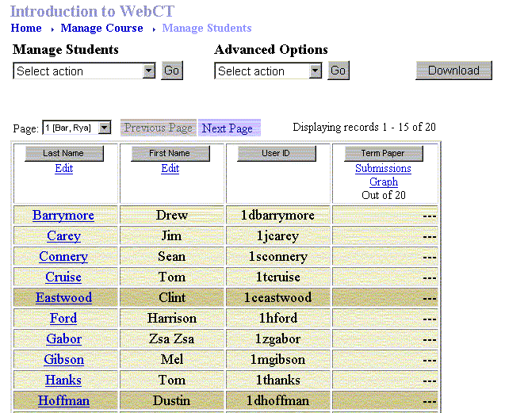

- On the “Submissions” screen, in the cells under the “Status” column, you will see which students have submitted files and need to be graded. You may need to use the horizontal scroll bar at the bottom of the screen to view the right column.

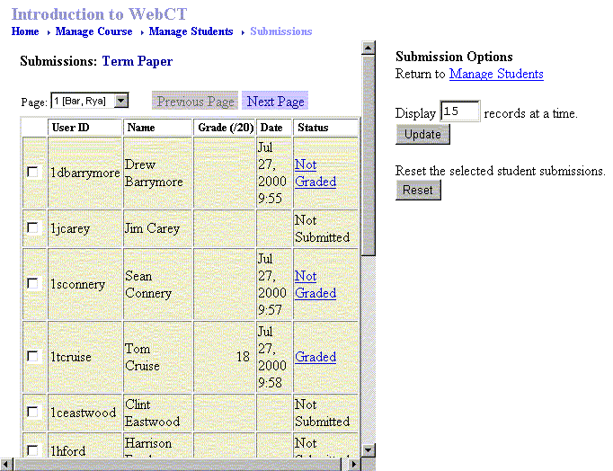

- Next to the student whose assignment you want to grade, click Not Graded.
- On the individual student’s screen, click the name of the submitted file. Depending on the preferences of your browser, the file may open automatically or you may be asked if you want to open or save the file. When you finish viewing the file, close it. If the “WebCT Assignment Dropbox” is still open, click Close.
- In the “Grade” field, type the number of points the student earned out of the total possible for this assignment.
- In the “Comments” field, you can type remarks that the student will see when viewing his or her grade.
- Click Grade at the bottom of the screen.
- The “Submissions” screen appears, ready for you to grade the assignment of another student. The row of the student whose assignment you just graded will read “Graded” in the “Status” column.

Grades: Editing
- To change the grade of a student’s assignment, follow the procedure above. However, in Step 5, click Graded.

- If a student needs to resubmit his or her work for an assignment, you must first reset the student’s grade. WebCT then acts as if the student never submitted a file.

- On the Navigation Bar, click Manage Course.
- Click Manage Students.
- On the “Manage Students” screen, click Submissions for the assignment grade you’re editing.
- Check the box next to the appropriate student.
- Click Reset on the right side of the screen.
- Several windows will appear warning you that “All of the selected students’ assignment grades will be reset.” This refers only to the one assignment. Click OK in both windows if you want to proceed.

Grades: Releasing Grades to Students
- For the students to view their grades, you must release the grades for each column in the student table.

- On the Navigation Bar, click Manage Course.
- Click Manage Students.
- On the “Manage Students,” in the “Advanced Options” menu, choose Modify columns.

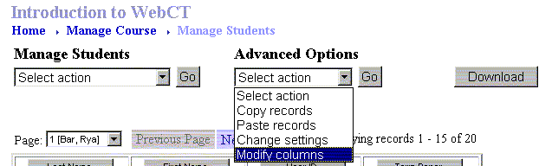

- Click Go.
- On the next screen, you will see a table with columns listing the students’ names and any assignments created in your course.

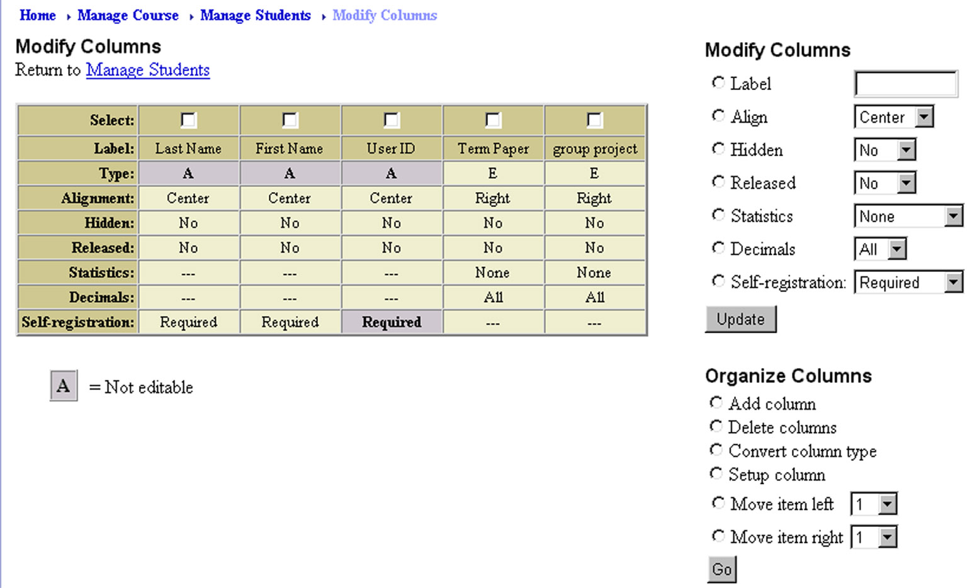

- Select the assignment whose grades you want the students to see by checking the box at the top of the column for that assignment.
- Under “Modify Columns,” click the Released radio button, then select Yes from the drop-down menu.
- Click Update.

When a column is released, students are able view their grades from the My Grades link. The designer cannot access that link.

Extra for Experts

Discussions: Private Topics
- You can create private topics when you wish to allow only certain students to participate in a particular topic.

- On the Homepage, click Discussions.
- Click Manage Topics.
- In the “Topic Settings” table, check the “Private” column for any topic(s) for which you want to restrict access.
- Click Update.
- In the “Manage Topics” list, click Manage members and select the name of the new topic in the box next to “Manage members.”
- Click Go.
- At first a private topic will have no members. Click Select Members.
- A list of students will appear. Click the box next to each student you want to include in the topic. Don’t forget to check yourself if you want to participate in that topic.
- Click Update.

You can add or remove anyone from the topic by following the steps above and unchecking or checking the box next to the person’s name.

Assignments: Including a File
- WebCT allows you to attach a file (e.g., images, documents, spreadsheets, etc.) to an assignment and make the file available to students when they work though an assignment. First upload the file you want to attach using the WebCT File Manager. Once the file is uploaded, it may be imported into an assignment.

- On the Homepage, click Assignments.
- Click Designer Options.
- Click the assignment title link for which you want to include a file.
- Under “Import File,” next to the “Filename” box, click Browse.
- Find the file you uploaded to the WebCT File Manager and click the radio button next to it.

If you need to upload the file from your computer:
- Next to the “Filename” field, click Browse… to locate the file to upload.
- In the “File Upload” dialog field, find the file you’d like to upload and click Open. (Note: If you can’t find the file, using the “Files of Type” menu, change the file extension to All Files.)
- When the filename appears in the Filename field, click Upload below the filename.
- Click the radio button next to the filename.

- Click Pick.
- Click Import.

The file and its attributes now display under “Assignment Information.” When your students access this assignment, the file will be available to them.

Assignments: Deleting an Assignment
Removing an assignment from your course involves the following two steps: deleting the assignment and deleting the column from the student list.

- To delete an assignment:
- On the Homepage, click Assignments.
- Click Designer Options.
- Click the radio button of the assignment you want to delete.
- Under “Assignment Options,” click Delete.
- Click Go.
- Several windows will appear warning you that “The assignment and all its associated student submissions will be deleted.” Click OK in both windows if you want to proceed.

- To delete a column in the Student Management Table:
- On the Navigation Bar, click Manage Course.
- Click Manage Students.
- On the “Manage Students” screen in the “Advanced Options” menu, choose Modify columns.
- Check the box at the top of the column showing the assignment you just deleted.
- Under the “Modify Columns” list, click Delete columns. (Note: You may need to use the upper scroll bar to see this option.)
- Click Go at the bottom of the list.
- A window will appear asking you to confirm the deletion. Click OK if you want to proceed.
- At the top of the screen, click Manage Students.

