
WebCT Introduction for Instructors
Information
Technologies
October 2002
Copyright © 2002 University of Delaware. Permission to copy without fee all or part of this material is granted provided that the copies are not made or distributed for direct commercial advantage or profit and that the material duplicated is attributed to Information Technologies, University of Delaware. To copy otherwise or to republish requires specific permission and a fee.
Portions of this material were adapted with permission from
the Technology Enhanced Learning Department, University of Maryland.
Table of Contents

Overview 1
Getting Started 1
System Setup 2
Accessing WebCT 2
Finding Your Way 4
Finding Your Way: Navigation Bar 4
Finding Your Way: Breadcrumbs 4
Views 5
Introduction 5
Student View 5
Designer Options 6
Customizing Your Homepage 7
Introduction 7
Editing a Textblock 7
Homepage Links 12
Introduction 12
Content 12
Properties 13
URL 15
Introduction 15
Adding a Link 15
File Manager 17
Introduction 17
Accessing the File Manager 17
File Hierarchy 18
Uploading Files 19
Single Page 21
Introduction 21
Adding a Link 21
Deleting a Link from the Homepage and the Navigation Bar 25
Organizer Page 26
Introduction 26
Adding a Page 26
Calendar 29
Introduction 29
Adding Entries 30
Editing Entries 32
Deleting Entries 32

Overview

WebCT is a course management system that facilitates the creation of sophisticated World Wide Web-based educational environments by providing the following elements:

- a set of educational tools to facilitate learning, communication and collaboration,

- an interface allowing the design of the presentation of the course (color schemes, page layout, etc.), and

- a set of administrative tools to assist the instructor in the process of management and continuous improvement of the course.

It can be used to create entire online courses or to publish materials that supplement existing courses.

Getting Started
Before you start working with WebCT on your first course at the University of Delaware, you’ll need to attend the User Services WebCT Introduction for Instructors. At the training, you will be issued a WebCT ID and an initial password.

To establish a new course or have a guest account created, visit the UD WebCT web page at

http://www.udel.edu/webct

System Setup
To be able to view changes as you make them while designing a WebCT course, it is important that you set the cache settings of your browser to verify web documents Every time. If you have not made this change, your web browser will often display a cached copy of a document (i.e., a previous version which it has stored locally on your computer). In addition, you will need to Enable Java in your browser.

The following table provides the instructions for what you need to change in your browser.

Browser Type | How to Enable Java | Change the Cache
Netscape Communicator 4.x | Edit →  Preferences →  Advanced →  Enable Java and JavaScript | Edit →  Preferences →  Advanced →  Cache →  Every time
Internet Explorer 4.0 | View →  Options →  Advanced →  Java JIT compiler enabled | View →  Internet Options →  General →  Temporary Internet files →  Settings →  Every visit to the page
Internet Explorer 5.0 | Tools →  Internet Options →  Advanced →  Java JIT compiler enabled | Tools →  Internet Options →  General →  Temporary Internet files →  Settings →  Every visit to the page

Note: Your students will also need to make this change in their browser.

Accessing WebCT
- The main WebCT course server can be accessed from the web page

http://www.udel.edu/webct

From this page,

- Click Logon to WebCT at the top of the page.
- Click Log on to myWebCT.
- Type your WebCT ID and password.

Note: Click LOGOUT in the upper right corner to end your WebCT session. Failure to do so will make your personal course information available to the next person who uses the computer.
myWebCT

myWebCT is a central location where faculty and students can see a list of courses in which students are registered, and instructors can see a list of all the courses they are teaching. myWebCT allows you to access all your courses from one page. Clicking the title of a particular course allows you to access that course.

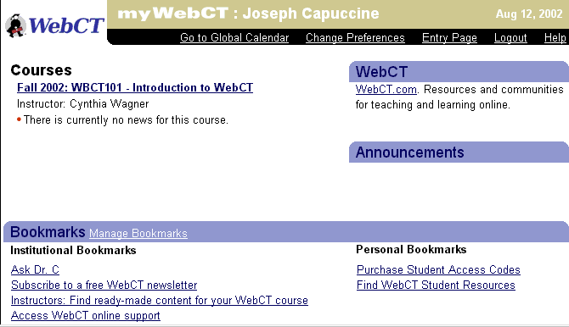

Courses lists all of the courses that you have connected to myWebCT. This section will also list all of the new items that are available in each of the classes (e.g., mail, bulletin board, calendar, quizzes that are available, etc.) with links to the new items.

Bookmarks provides hyperlinks to useful Internet sites. Campus WebCT administrators set Institutional Bookmarks, and they cannot be deleted or edited by instructors or students. Users, however, can customize Personal Bookmarks.

Announcements displays updates and bulletins provided by your WebCT administrator.

WebCT is a link to the main WebCT site which contains teaching and learning resources and offers access to a community of peers across WebCT courses and disciplines. Within these communities, students and faculty can share information, ideas, goals, and WebCT support resources.

WebCT Courses

The remainder of this document deals with the tools and features you use to create the content of each course. Click the title of a course from myWebCT to view the homepage for that course.

Finding Your Way

Finding Your Way: Navigation Bar
The light blue column on the left of the WebCT screen, called the Navigation Bar, lets you move to elements of your course quickly. The Navigation Bar provides access to Control Panel links, which provide Designers access to course management tools. The Course Menu portion is a customizable navigation tool that is available to students and Designers. Often, Designers provide Course Menu links to many of the tools that are also found on the Homepage.

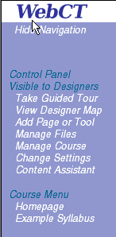

Finding Your Way: Breadcrumbs
As you move through the pages of your course, at the top of the screen a list of the pages shows the path you are following appears. This list is made of “breadcrumbs” that act as links to any of the pages previously visited in a series.

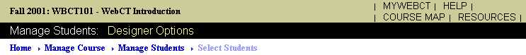

Views

Views: Introduction
From the WebCT Homepage, students can access the elements of your course. As the instructor, you become the designer of how your course will look when viewed by students. WebCT includes a range of powerful tools and functions available from the Homepage. WebCT offers two Homepage views for instructors: Student View and Designer Options View.

Views: Student View
As a designer, you can view your course information to see how students will see the information. Two areas that do not appear for students are the following:
- the option, “Control Panel Visible to Designer,” on the Navigation Bar (the blue column on the left), and
- the black bar with radio buttons for different views at the top of the page.

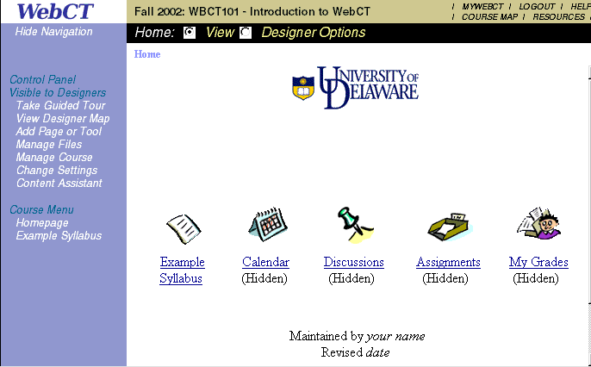

Views: Designer Options
- To design or modify a course, enter the Designer Options mode, which provides a range of features and functions for customizing your WebCT course.

To enter the Designer Options mode, click Designer Options.

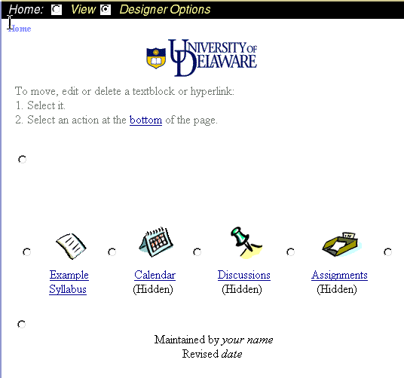
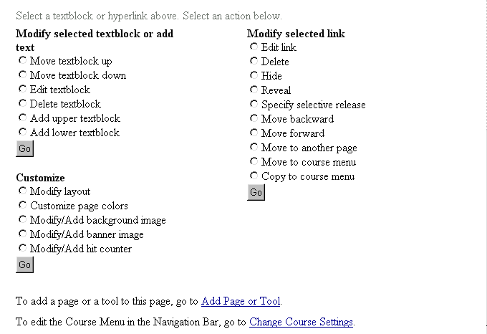

Customizing Your Homepage

Customizing Your Homepage: Introduction
A course created on the UD WebCT server is based on a template that acts as a starting point for you. Some of the more common elements used in a course are included in the template along with placeholders for general information.

Various features let you add a personal touch to your WebCT course by adding or modifying colors, images, a banner or sections of text.

The following section examines adding and editing a textblock.

Customizing Your Homepage: Editing a Textblock
Textblock radio buttons allow you to change what is displayed at the top and bottom portions of your Homepage. You can edit the template textblocks by choosing the Upper Textblock or Lower Textblock radio button.

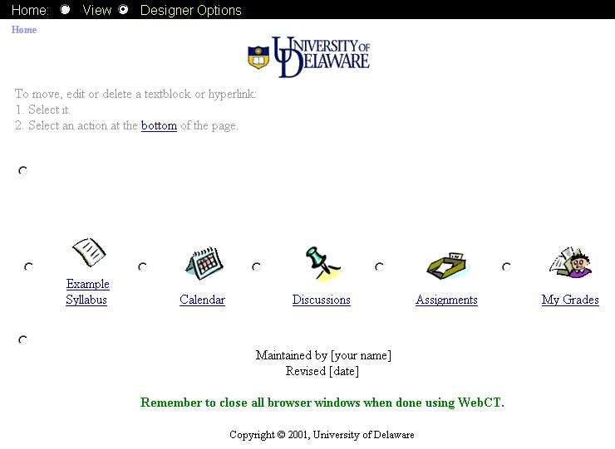
Upper Textblock radio button.
Lower Textblock radio button.
The Upper Textblock will display here.
The Lower Textblock will display here.

Edit Upper Textblock

Notice the two radio buttons along the left side of the Designer Options window. Although they are not labeled, the top radio button selects the Upper Textblock and the bottom selects the Bottom Textblock.

- Click the radio button for the Upper Textblock.
- Scroll down to the “Modify selected textblock or add text” list and click Edit text.
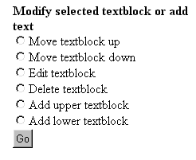

- Click Go at the bottom of the list. The “Edit Top or Bottom Text/Image in Page” screen appears.

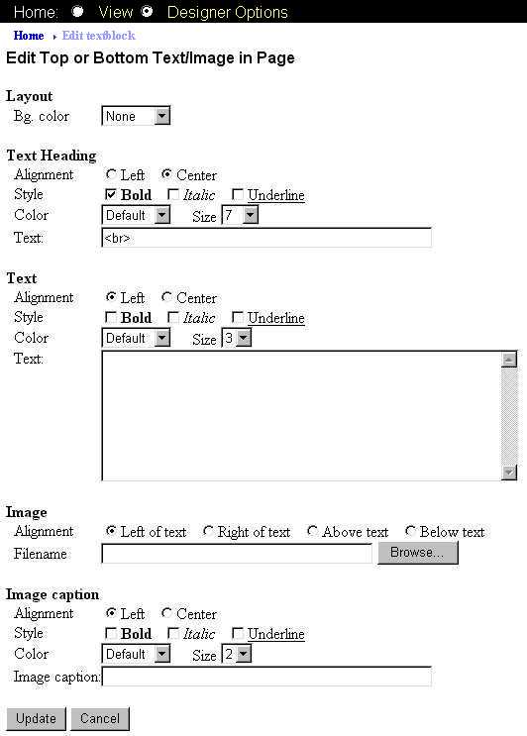
Choose a background color.
Choose formatting options for the text heading.
Delete <br>, type text heading.
Choose text-formatting attributes.

- Under “Layout,” use the “Bg. color” drop-down menu to choose a background color.
- Under “Text Heading,” decide which text formatting attributes you’d like to apply:

  - Alignment—select Left or Center
  - Style—select Bold, Italic or Underline
  - Color—click drop-down menu to choose color
  - Size—click drop-down menu to choose font size

Replace “<br>” with the text you want to appear at the top of the page (such as a short description of the course).
- Under “Text,” decide which formatting attributes you’d like to apply.
- Click in the “Text” box to add text.
- At the bottom of the page, click Update.
- On the Navigation Bar, click Homepage to view the changes.
Edit Lower Textblock

- From the Homepage, click Designer Options.
- Click the radio button for the Lower Textblock.
- Scroll down to the “Modify selected textblock or add text.” Click Edit text.
- Click Go at the bottom of the list. The “Edit Top or Bottom Text/Image in Page” window appears.

When adding a Bottom Textblock, be sure to keep the HTML tags in place. Deleting these tags (e.g., <br> may distort how the text looks on your Homepage.

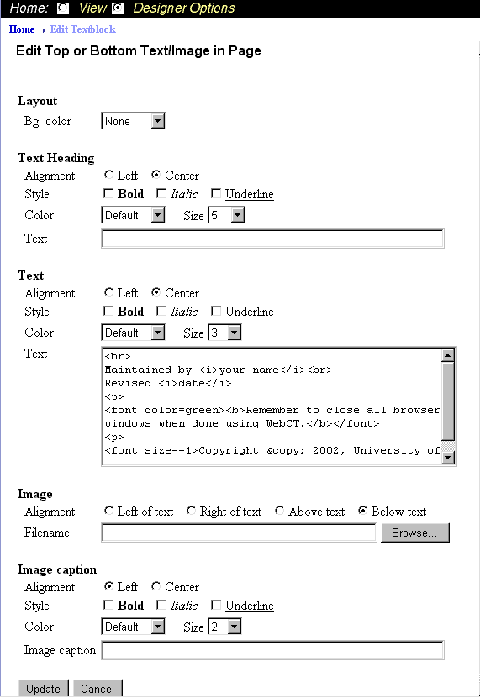

- Under “Text,” notice the placeholders in the Text section. Replace the following placeholders, including the brackets, with your own text:
- [your name]
- [date]

- Click Update at the bottom of the page.
- On the Navigation Bar, click Homepage to view the changes.

Homepage Links

Homepage Links: Introduction
WebCT uses icons linked to pages, tools and content within your course. These links can be created or modified by the designer (instructor).

- To edit the properties of a link, switch to Designer View, click the radio button to the left of the link, and then select Edit link. Click Go.

- To change the contents of a link, click the link, then switch to Designer View and modify the options particular to that link.

Homepage Links: Content
WebCT lets your students access several types of information. From the broad range of media available in WebCT, you can add links for the following types of information:

Single Page | An HTML file can be uploaded using the WebCT File Manager.
WebCT tools | The Calendar, Discussions, Glossary or Index are just a few of the tools available for your course.
URL | Place a link to a Web site on the Homepage for fast and convenient access to important material.
Organizer Page | Use the Organizer Page to consolidate URLs and other links in one location.
Content Module | Put as much or as little of your course content in a single outline. The Content Module contains structured course material with links to your HTML files, URLs on the Web and other resources.

Homepage Links: Properties
- To give you full control over how links function in WebCT, the instructor is able to change their properties. Modifying the properties does not alter the contents of the link’s destination but rather how the link is displayed and to what it refers.

- From the Homepage, click Designer Options.

When the Designer View appears, notice the radio buttons next to each icon.

- Click the radio button next to the icon you want to modify (e.g., Calendar, Discussions or Assignments).
- Scroll down to the “Modify selected link” section and click Edit link.
- Click Go at the bottom of the list.
- When the “Update Link to WebCT Tool” screen appears, notice the various properties of this link.

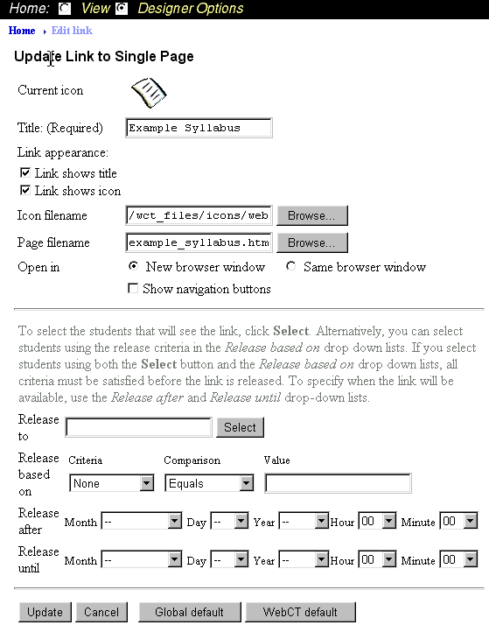

You can change the following:
- Title
- Link appearance
- Icon filename (the icon’s visual style)
- Page filename (where the icon/link refers to)
- Open in (whether the screen will open in the same browser or start a new browser when clicked)

- You can also control when the link will be available to students by using the “Release” features. If you decide to modify the properties of a link, click Update when you’ve completed making the necessary changes. If you haven’t made any changes, click Cancel.

URL

URL: Introduction
Whether your course incorporates a few Web sites or dozens, creating links to pages on the World Wide Web is easy.

URL: Adding a Link
- If you have existing web pages you can direct your students to them through a URL link.

- On the Navigation Bar, click Add Page or Tool.

- Scroll down (if necessary), then on the “Pages/URLs” list, click URL.

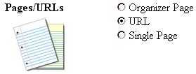

- Scroll down (if necessary) to the line marked “Choose page or tool:,” then click Add.
- In the “1. Enter a title for the page.” box, type a name for the URL. For training purposes, type Yahoo! .

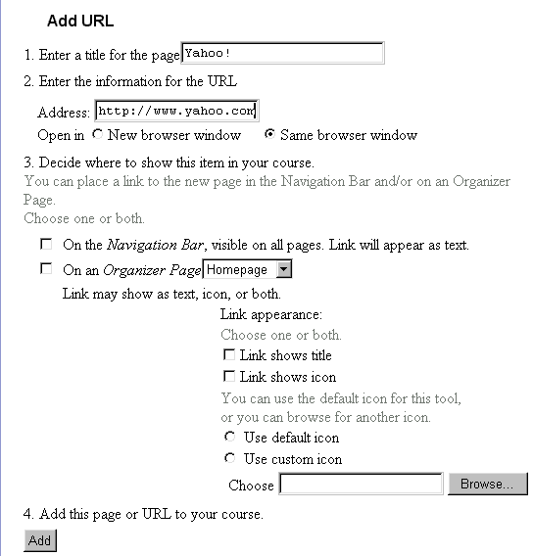

- In step 2, “Enter the information for the URL” field, type the address of the URL (be sure not to delete http://). For training purposes, type www.yahoo.com

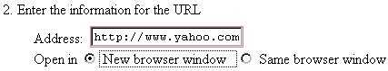

- So that when the URL icon is clicked, its contents will appear in a separate browser window, in the “Open in” line, click New browser window.

- In the section “3. Decide where to show this item in your course,” check On the Navigation Bar, visible on all pages. Link will appear as text. and also check On an Organizer Page - Homepage.
- At the bottom of the screen, click Add.
- On the Navigation Bar, click Homepage to view the changes.
- Click the URL icon (the linked chain). The web page will open in a new browser window.
- Close the window.

File Manager

File Manager: Introduction
The File Manager allows you to control the files referenced in your course. These files reside on the WebCT server. Files uploaded to the WebCT File Manager will mostly be in HTML, GIF, JPEG, audio or video file formats. The File Manager provides the ability to upload files from the designer’s computer, create subfolders for file organization, rename and move files, delete files, preview files and edit files. Other types of files, including those created using word processing and spreadsheet programs, may be uploaded for use in assignments.

File Manager: Accessing the File Manager
- The Manage Files link on the Navigation Bar allows you to access your files or to upload files to the server.

On the Navigation Bar, click Manage Files.

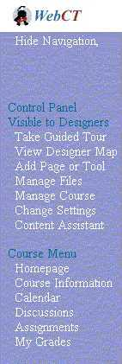

File Manager: File Hierarchy
There are two main folders in a WebCT course: the My-Files folder and the WebCT-Files folder. These two folders cannot be deleted.

The WebCT-Files folder contains a library of clip art, icons, banners, etc. that can be used in any course. Files in this folder cannot be altered in any way (deleted, renamed, moved, modified, etc.). These files can, however, be used or copied to the My-Files directory.

The files and folders in the My-Files folder are private to your course and have been saved there by you. The My-Files folder serves as the location for files and folders you create when building course content.

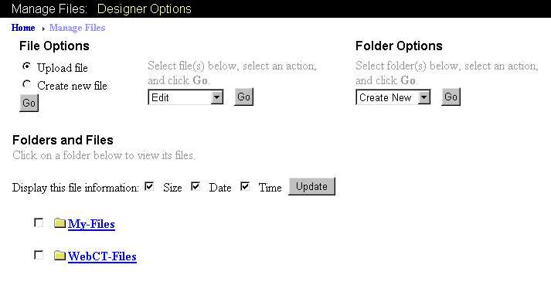
The files you create are stored in My-Files.
WebCT’s clip art, icons, and backgrounds are stored in WebCT-Files.

Some folders contain subfolders as well as files. WebCT-Files, for instance, contains several subfolders, that you can click to view their contents.

- To view the contents of the folders:

- Click My-Files and WebCT-Files to show all the files in each of these folders.

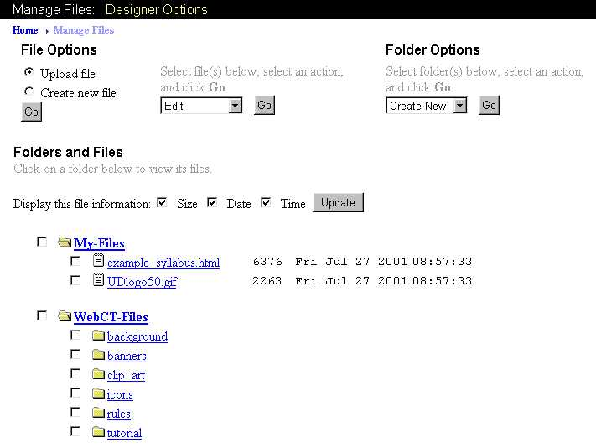
You are restricted from saving files to the WebCT-Files folder. All files are to be saved in the My-Files folder.

- Click My-Files and WebCT-Files to collapse each of these folders.

File Manager: Uploading Files
- Course information not available at an existing web site must be stored in files on the WebCT server and referenced by links on your course pages. Using the File Manager, you can copy or upload files from your local PC into your WebCT course.

- In the “File Options” list, click Upload File.
- Click Go at the bottom of the list.
- In the “Upload File” screen, click Browse… to locate the file to upload.

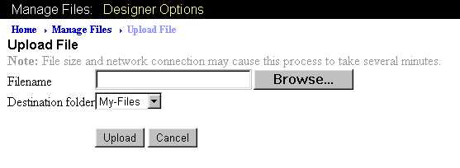

- In the “File Upload” dialog box, find the file you’d like to upload and click the Open button.

If you can’t find the file, using the “Files of Type” menu, change the file extension to All Files (*.*).

Note that WebCT does not allow filenames with spaces or the following special characters:
: ~ [ ] ! @ # $ % ^ & * ( )
+ ` } } | \ < > , ? / ; ' "
Files whose names contain spaces or one of these characters must be renamed before they can be uploaded to WebCT. A common practice is to use the underscore character ( _ ) to replace spaces in a filename.

- When the filename appears in the Filename box, check the “Destination folder” to make sure the file will be placed in the appropriate folder in the WebCT File Manager.
- Click Upload.

In this example, a file with the name “UploadDemo.html” is being copied from a diskette in the A drive:

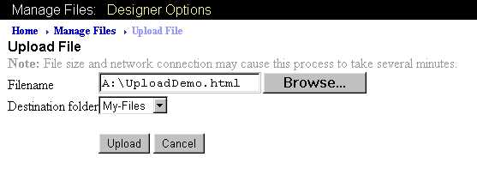

- If the file appears in the destination folder list, then the uploading process has been successful.

Single Page

Single Page: Introduction
The Single Page link in WebCT allows you to provide students access to any type of electronic data file such as an HTML page, MS Word document, or MS PowerPoint Presentation, to name a few. It is important to note that students must have the software necessary to read the files. For instance, if you give students a Single Page link to an Adobe PDF file, the students must have the Adobe Acrobat Reader installed on their computer to read the file.

If you create a web page (.htm or .html), and make that available to your students through the Single Page link, you must also upload any supporting or referenced files associated with your web page including graphic files.

Single Page: Adding a Link
Including a Single Page of information in your WebCT course begins with uploading your HTML file (or files) into WebCT using the File Manager. From there, you add a Single Page link which references the file(s).

Uploading an HTML File

- On the Navigation Bar, click Homepage.
- Click Manage Files.
- Following the instructions in the previous section “File Manager: Uploading Files,” copy your HTML syllabus file to the My-Files folder.
- If your HTML file contains graphics stored in other files, follow the same procedure to upload each of those files.

After adding a file named “CourseSyllabus.html,” the File Manager list of files might look similar to the following:

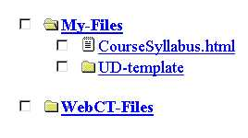

Creating a Single Page Link

- On the Navigation Bar, click Add Page or Tool.

- On the “Add Page or Tool” screen, in the “Pages/URLs” list, click Single Page.

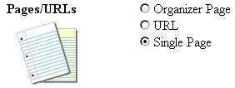

- Scroll down (if necessary) to the line marked “Choose page or tool:,” then click Add.

- When the “Add Single Page” screen appears, next to “1. Enter a title for the page,” type the text you want to appear next to the icon you’ll create on the Homepage. For example, you can type Course Syllabus.

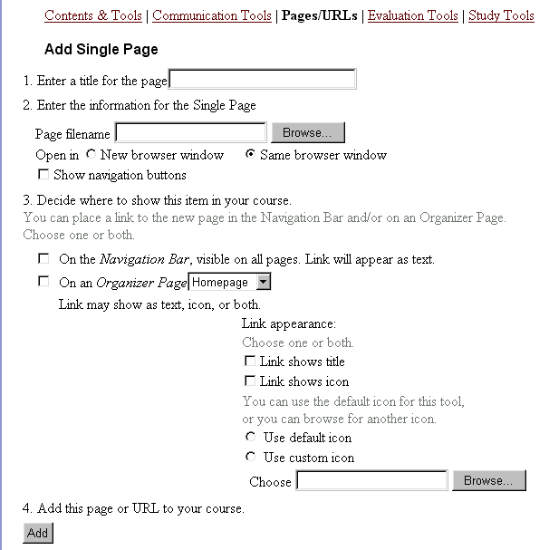

- Next to the “Page filename” box, click Browse... to find the name of your file in the My-Files folder.

- A separate window will open showing you all the files available to your WebCT course. Click the radio button next to the name of the file you want to use in your Single Page.

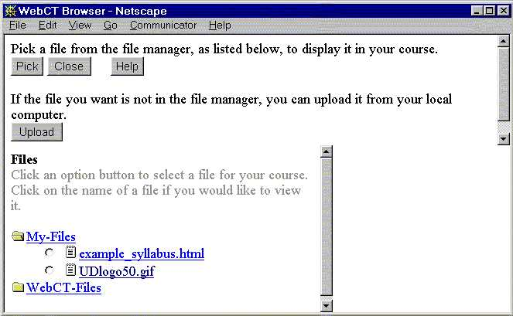

- At the top of the screen, click Pick.

The filename will appear back in the “Page filename” box of the “Add Single Page” window.

- So that when the Single Page icon is clicked, its contents will appear in a separate browser window, in the “Open in” line, click New browser window. If you also select the Show Navigation option, Close, Back and Forward buttons will appear in the new browser window.

- You can choose where you want this link and icon to display: the Navigation Bar, Organizer Page (Homepage), or both. If you check both options, a link to the Single Page will always appear on the Navigation Bar at the left of the WebCT screen and a link will also show on the Homepage. Check both options.

- Choose the icon style to appear on the Homepage. If you click Default icon, WebCT will match an icon with the type of page or tool you are adding. In this case, the picture will be that of a single sheet of paper for a Single Page. Or, you can select Use custom icon and use an image that you have stored on your PC.

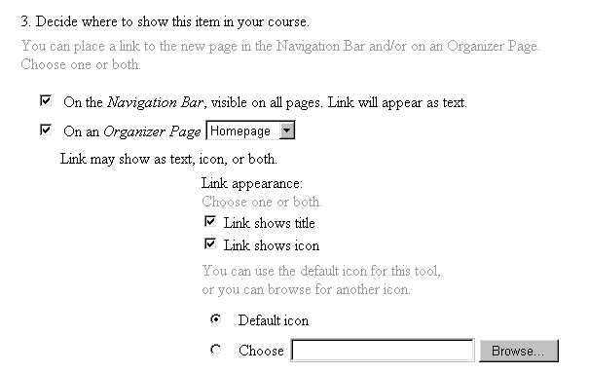

- At the bottom of the screen, click Add.

- If you selected to show the Single Page on both the Navigation Bar and the Organizer Page, a note like the one below will appear. Once these links are created, any changes must be made to each link individually.

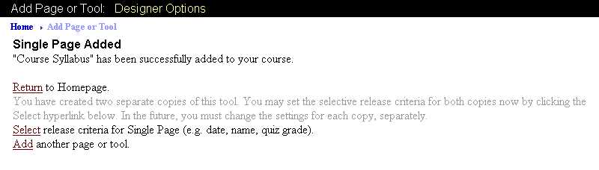

- On the Navigation Bar, click Homepage to view the changes.

Single Page: Deleting a Link from the Homepage and
the Navigation Bar
- You can delete a link from the Homepage in just a few steps.

- On the Navigation Bar, click Homepage.
- Click Designer Options.
- Click the radio button next to the link you need to delete.
- Scroll down (if necessary) and in the “Modify selected link” list, click Delete.
- Click Go.
- “This item will be deleted. Proceed?” window appears. Click OK.
- On the Navigation Bar, click Homepage to view the changes.

- If the link was originally set to be shown on the Navigation Bar as well as the Homepage, when you delete the link from the Homepage, you must also delete the link from the Navigation Bar.

- On the Navigation Bar, click Change Settings.
- Under “Course Menu,” click Go.
- On the “Edit Navigation Links” window, in the “Course Menu” list, click the radio button next to the link you need to delete.

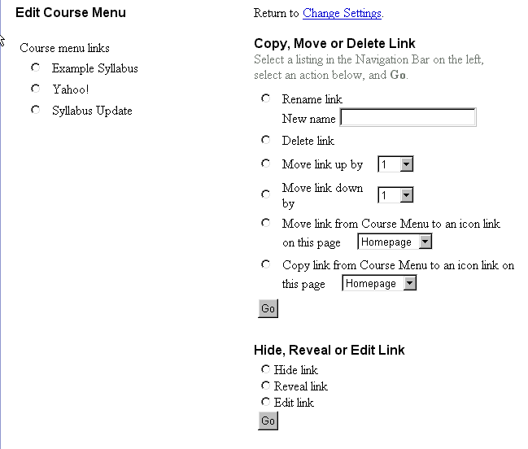

- On the right side of the window, in the “Copy, Move or Delete Link” list, click Delete selected link.
- Click Go at the bottom of the list.
- “This item will be deleted. Proceed?” window appears. Click OK.
- On the Navigation Bar, click Homepage to view the changes.

Organizer Page

Organizer Page: Introduction
Adding an Organizer Page to your course Homepage allows you to group various links in WebCT. The Homepage has limited space for icons and can become cluttered. For instance, if you have a need to make 10 URLs available to your students, it would be inefficient to place each link individually on the Homepage. Instead, create an Organizer Page that will hold all 10 URLs in one area.

As you begin to use WebCT as a command center for resources and materials for students, take time to plan how various links might be grouped. Then, use an Organizer Page to consolidate those links.

Organizer Page: Adding a Page
- In this section, you will add an Organizer Page to the Homepage. Organizer Pages are similar to directories or folders on your PC, and as such, you can also nest them within other Organizer Pages.

- On the Navigation Bar, click Add Page or Tool.

- Scroll down (if necessary) to the “Pages/URLs” list, then click Organizer Page.

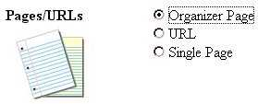

- Scroll down or up (if necessary) and click Add.

- When the “Add Organizer Page” screen appears, next to “1. Enter a title for the page.”, type the text you want to appear next to the icon you’ll create. For example, you can type Additional Resources.

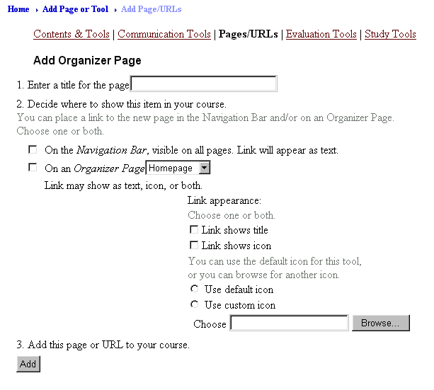

- You can choose where you want this link and icon to display: the Navigation Bar, Organizer Page (Homepage) or both. If you check both options, a link to the new Organizer Page will always appear on the Navigation Bar at the left of the WebCT screen and a link will also show on the Homepage.

- Choose the icon style to appear on the Homepage. If you click Use default icon, WebCT will match an icon with the type of page or tool you are adding. In this case, the picture will be that of an in-box with several sheets of paper to depict an Organizer Page. Or, you can select Use custom icon and use an image that you have stored on your pc.

- Click Add.

- On the Navigation Bar, click Homepage to view the changes.

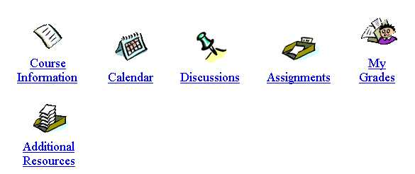

The “Additional Resources” icon displays on the Homepage. To place links into that Organizer Page, click Add Page or Tool on the Navigation Bar and select the desired type of link. This time, however, instead of displaying the link or icon on the Homepage, select to display it on the “Additional Resources” Organizer Page.

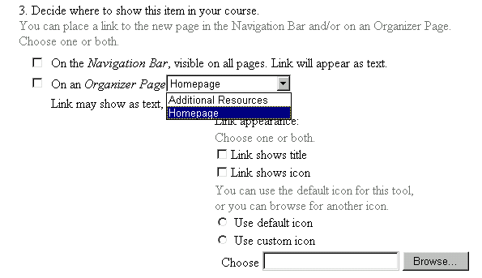

Calendar

Calendar: Introduction
The Calendar tool provides a quick and easy way for you and your students to post notices about class events. You and your students can post public messages (visible to everyone in the course) or private ones (visible only to the person who added it). Messages can be simple text or can contain HTML tags and links, as well as start and end times.

- The Calendar can be accessed in either Student or Designer Options view.

- On the Navigation Bar at the left of the screen, click Homepage.
- At the Homepage, click the Calendar icon. The course Calendar will open to the current month with the current day highlighted.

The Calendar Entry lets you view any month and year between 1999 and 2010. You may also view adjacent months by clicking Previous Month or Next Month.

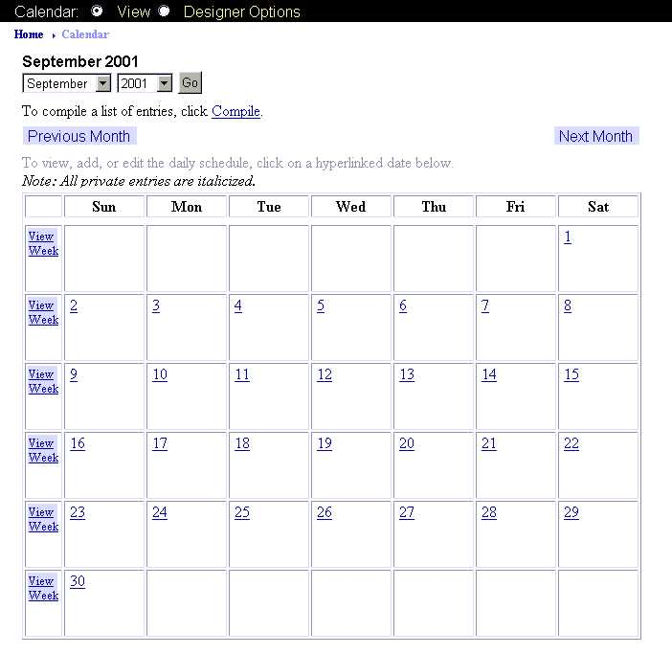
Calendar: Adding Entries
- For each day of the Calendar, you may add new entries or update existing entries. An instructor may enter both public and private entries. Unless authorized by the instructor, students may only add private entries.

- To view a different month or year, select the month and year using the pull-down menus and click Go.
- On the calendar, click the date number for which you want to add an entry.
- On the “View Day” screen, click Add entry.

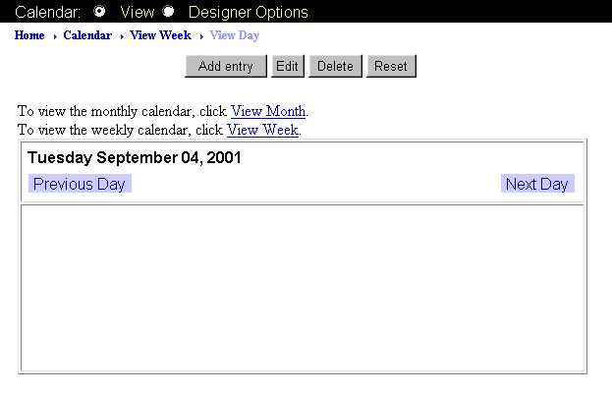

- The “Add a Calendar Entry” screen appears. Complete the form for your message.

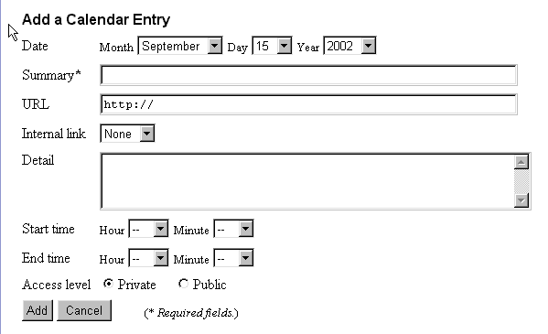

- Date: Displays the date you selected in the calendar. You may choose a different date using the menus available for day, month and year.
- Summary*: (a required field) Describe briefly the topic you’re making available to students. The summary will become the hyperlink when the Calendar is viewed.
- URL: You can add a Web site address here (e.g., www.cnn.com). When the Calendar is viewed, the Summary you entered will act as the hyperlink to the address in the URL field. (Note: Be sure to leave the http:// in the url box.
- Internal link: You can include a link to an item in a Content Module of your course.
WebCT will not allow you to include both a URL and an Internal link in one calendar entry.
- Detail: You can type a synopsis of the topic being considered. Content entered here will display when the date is clicked in the Calendar view.
- Start Time and End Time: Although not required, use the menus to designate a beginning and ending time associated with the entry. The time designations have no impact on the ability of students to view the Calendar entry before, during or after the time range. If you don’t specify a start and end time, the item will be available immediately.
- Access Level: Choose whether you want to make this entry viewable to everyone in the course (Public) or just you (Private).

- Click Add to complete the entry or Cancel to abort it.

- On the Navigation Bar, click Calendar to view the changes.

Every time you access the calendar, a window pops up informing you of all new public entries. Be sure to close the window before continuing.

When new calendar items are available, the icon on the Homepage displays a green burst.



Calendar: Editing Entries
- A Calendar entry can only be modified by the person who posted it.

- From the Homepage, click the Calendar icon.
- Select the date you wish edit.
- Click the entry you wish to edit.
- Click Edit.
- When the “Edit a Calendar Entry” screen appears, make the necessary modifications.
- Click Update.
- On the Navigation Bar, click Calendar.
- Select the date you’ve just modified to view the changes.

Calendar: Deleting Entries
- For each day of the calendar, you can delete individual entries or remove all entries for one day.

- From the Homepage, click the Calendar icon.
- Find and select the date containing the entry you wish to delete.
- Click the entry you wish to delete.
- Click Delete.
- Click OK.
- On the Navigation Bar, click Calendar.
- View your changes.

