
WebCT Grading
Information
Technologies
January 2002
Copyright © 2002 University of Delaware. Permission to copy without fee all or part of this material is granted provided that the copies are not made or distributed for direct commercial advantage or profit and that the material duplicated is attributed to Information Technologies, University of Delaware. To copy otherwise or to republish requires specific permission and a fee.
Table of Contents

Introduction 1
System Setup 1
Accessing WebCT 1
Grading and Recording Student Information 2
Introduction 2
Student Management Table 3
Columns Automatically Created by WebCT Tools 4
Columns Created Manually 4
Independent Column Types 5
Related Column Types 9
Overriding Calculated or Letter Grades 14
Display Options 15
Graphing Grades 16
Sorting Data 17
Deleting a Column 17
Importing Data 19
Exporting Data 20

Introduction
This document supplements the WebCT Introduction and assumes that you are working on a course following the University of Delaware template.

System Setup
To be able to view changes as you make them while designing a WebCT course, it is important that you set the cache settings of your browser to verify web documents Every time. If you have not made this change, your web browser will often display a cached copy of a document (i.e. a previous version which it has stored locally on your computer). In addition, you will need to Enable Java in your browser.

The following table provides the instructions for what you need to change in your browser.

Browser Type | How to Enable Java | Change the Cache
Netscape Communicator 4.x | Edit →  Preferences →  Advanced →  Enable Java and JavaScript | Edit →  Preferences →  Advanced →  Cache →  Every time
Internet Explorer 5.0 | Tools →  Internet Options →  Advanced →  Java JIT compiler enabled | Tools →  Internet Options →  General →  Temporary Internet files →  Settings →  Every visit to the page

Note: Your students will also need to make this change in their browsers.

Accessing WebCT
- The main WebCT course server is located at

http://www2.udel.edu:8900/

When you arrive at this server,

- Click Log on to myWebCT.
- Type your WebCT ID and password.
- Close all browser windows when you are finished, including any mail windows. Failure to do so will make your personal course information available to the next person who uses the computer.

Grading and Recording Student Information

Grading: Introduction
In WebCT, student information is stored in a table consisting of one row for each student and columns containing various types of data. By default, each row of the table holds the first name, last name and WebCT ID in separate columns for a particular student. In this document, the table is referred to as the Student Management Table.

Certain columns, such as assignments and quizzes, are automatically added to the Student Management Table by WebCT tools. When a designer assigns a grade for a WebCT assignment or a quiz that is scored by WebCT, the value is recorded under the appropriate column.

Other columns can be added to the table manually to store data such as
- Grades for papers or projects submitted or tests taken outside of WebCT.
- Grades calculated from other grades such as the average of several assignments.
- Grades for classroom-based performance such as participation in class or attendance.
- Letter grades base on the numeric value of another column.
- Non-grade related information, particularly for sorting student records.

Grading: Student Management Table
To access the Student Management Table,

- On the Navigation Bar, click Manage Course.
- Click Manage Students.

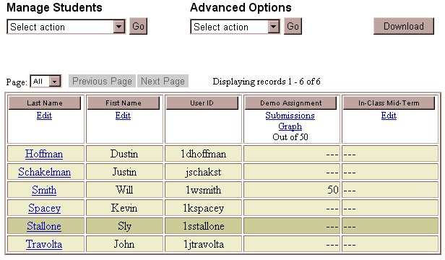

- To make sure you view all of the students, from the “Page:” menu, select All.
- Note the columns showing the Last Name, First Name, and User ID (WebCT ID) for each student. In the example above, there are two other columns that were automatically added to the Student Management Table when the designer of the course used the WebCT tools to include an assignment (Demo Assignment) and a quiz (In-Class Mid-Term) to the course.

Grading: Columns Automatically Created by WebCT Tools
Assignments
When you create an assignment using the WebCT Assignment tool, a column is automatically added to the Student Management Table. The column heading displays the maximum value for the assignment. Students’ grades are stored in this column. You can find details about using the WebCT Assignment tool in the WebCT Student Management training document.

Quizzes
In a quiz produced using WebCT, you allot a point value to each question. WebCT totals the number of points possible for all the quiz questions and creates a column in the Student Management Table. The students’ quiz scores are recorded automatically in the column when the quiz is taken and completed.

Grading: Columns Created Manually
WebCT allows you to record data in columns of several types depending on how the data will be used.

All manually created columns are added to the Student Management Table in the same way:

- On the Navigation Bar, click Manage Course.
- Click Manage Students.
- Under “Advanced Options,”choose Modify columns.
- Click the Go button to the right of the menu.

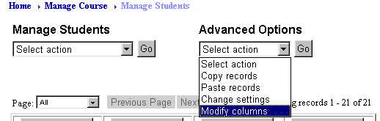

- Under “Organize Columns,” select Add column.
- Scroll down in the top frame, if necessary, and click the Go button at the bottom of the list.

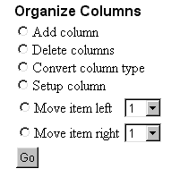

- Type a Label (title) for the new column.
- Select a column Type.
- Click the Add button.
- The new column appears to the right of the existing columns. You may need to use the horizontal scroll bar to view it and its attributes.
- At the top of the screen, scroll up, if necessary, and click the link “Return to Manage Students.”

Grading: Independent Column Types
There are several types of columns whose data are independent of data in other columns:
- Alphanumeric
- Numeric
- Selection Box

Alphanumeric Columns

Alphanumeric columns contain any sequence of characters, including letters and numbers. The data in a column of this type are usually unrelated to grades and may include information such as students’ course section number or major. Often this column is used to sort student records.

Creating an Alphanumeric Column:
- On the Navigation Bar, click Manage Course.
- Click Manage Students.
- Under “Advanced Options,” choose Modify columns.
- Click the Go button at the right of the menu.
- Under “Organize Columns,” select Add column.
- Scroll down in the top frame if necessary and click the Go button at the bottom of the list.
- In the “Label” box, type a title for the column (e.g., Section).
- In the “Type” menu, select Alphanumeric.
- Click the Add button.

Adding or Editing Alphanumeric Data:
- To add or edit information in this column for the students in your course, click the link to Return to Manage Students (or from the Navigation Bar, click Manage Course, then click Manage Students).
- In the Student Management Table, find the newly added Alphanumeric column.
- Click the Edit link at the top of the column.

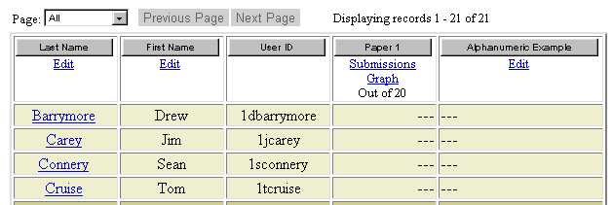

- Note the student’s name at the beginning of a row. Click in the text box along that row and under the Alphanumeric column. Type the value for that student.

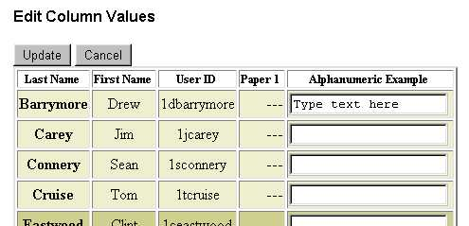

- Press TAB to move to the next row of the same column.
- Repeat the previous two steps for as many students as you have data.
- Click either Update button at the bottom or top of the table to return to the Student Management Table.

Numeric Columns

Numeric columns contain only numbers, particularly grades that can then be totaled in a Calculated column. Data stored in Numeric columns can include grades from sources outside of WebCT, such as assessments of presentations or projects.

Creating a Numeric Column:
Create a Numeric column using the same procedure as that for an Alphanumeric column.

Specifying the Maximum Score for Numeric Data:
Before adding data to a Numeric column, you must indicate the total possible points for the grade stored in that column.

- Click the link “Return to Manage Students.”
- In the Student Management Table, locate the newly added Numeric column.
- Click the Edit link at the top of the column.

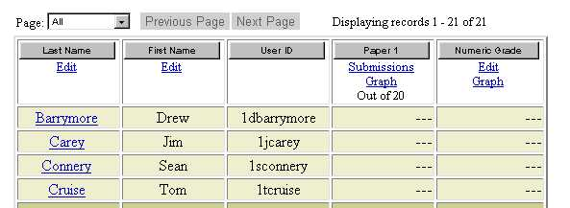

- In the “Out of” box, type the maximum number of points a student can earn for the grade in this column.
- Click the Update button.

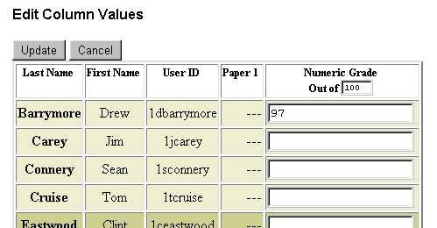
Adding or Editing Numeric Data:
- On the Navigation Bar, click Manage Course.
- Click Manage Students.
- Click the Edit link at the top of the column.
- Note the student’s name at the beginning of a row. Click in the box along that row and under the Numeric column. Type the number of points earned for this grade by that student.

- Press TAB to move to the next row of the same column.
- Repeat the previous two steps for as many students as you have data.
- Click either Update button at the bottom or top of the Student Management Table.

Selection Box Columns

Selection Box columns allow you to create a drop-down list of choices, making data entry and editing easier and more efficient. Consider using a Selection Box if you wish to offer qualitative feedback to your students from a list such as “Excellent,” “Satisfactory” and “Unsatisfactory.”

Creating a Selection Box Column:
Follow the same procedure as above to create a column of Selection Box type.

Listing the Choices for a Selection Box Column:
Before adding data to a Selection Box column, you must record the list of choices for values to be stored in that column.

- Click the link to Return to Manage Students.
- In the Student Management Table, find the newly added Selection Box column.
- Click Selection at the top of the column.

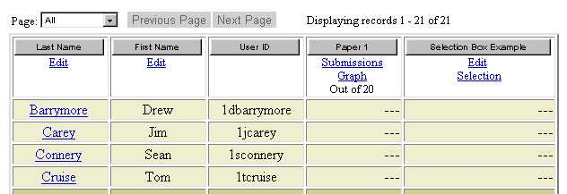

- In the “Selection box choice” fields, type each item for the list of values for this column. If you need more than five choices, click the More Selections button

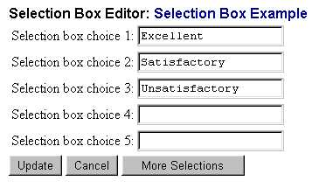

- Click the Update button to return to the Student Management Table.

Adding or Editing Selection Box Data:
- On the Navigation Bar, click Manage Course.
- Click Manage Students.
- Click the Edit link at the top of the selection column.
- Note the student’s name at the beginning of a row. Click in the box along that row and under the Selection Box column. Use the drop-down menu to select the value for that student.

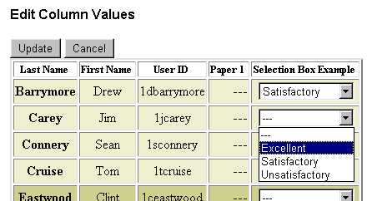

- Repeat the previous step for as many students as you have data.
- Click either Update button at the bottom or top of the Student Management Table.

Grading: Related Column Types
Two types of columns hold data that is related to data in other columns:
- Calculated
- Letter Grade

Calculated Columns

You can compute a value for each student based on the numeric contents of that student’s other columns using a Calculated column. For example, you can create a Calculated column called “Final Grade” that adds the grades from all of your Quiz columns and calculates the average score. You can also have WebCT determine a grade in which the lowest of several quiz scores has been eliminated.

The Calculation Editor allows you to incorporate only data in Numeric columns (which includes WebCT-based assignments and quizzes) into a formula.

Creating a Calculated Column:
Follow the same procedure as above to create a column of Calculated type.

Constructing a Formula:
- Click the link “Return to Manage Students.”
- In the Student Management Table, locate the newly added Calculated column.
- Click Formula at the top of the column.

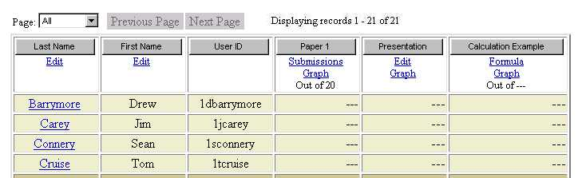

WebCT provides a Calculation Editor that works much like a calculator in which you chose functions, operators and numbers to combine the scores from one or more Numeric columns. It also includes other elements described below.

Calculation Editor Elements | Description
Column | Specifies a column whose data is included in the formula.
Insert button | Places the name of the selected column in the Formula window.
Function | Specifies an operation to be performed on the data from a list of columns. These include finding the maximum, minimum or sum of the values in the list.
Start List | Inserts the selected function into the Formula window.
Next Item | Inserts a comma between columns function in a function list.
End List | Closes a function.
CE – Clear Entry | Deletes one formula element at a time starting from the right.
( ) – Open and closed parentheses | In a mathematical expression, groups functions to control the order of operations.
Update | Applies the calculation.

- Select the appropriate buttons to construct a formula. For example,

  - To add the grades from two columns:
- From the “Column” menu, select the first column.
- Click the Insert button.
- Click the plus sign (+) button.
- From the “Column” menu, select the second column.
- Click the Insert button.
- Click Update.

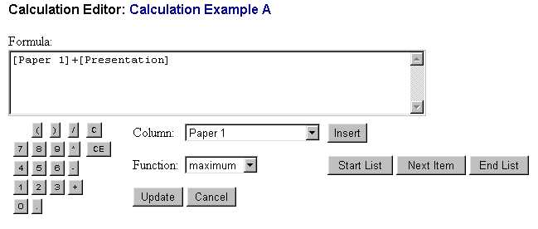
[Paper 1]+[Presentation]

Note: To remove the above calculation, click the “C” button on the calculator.

  - To select the maximum grade from two columns:
- From the “Function” menu, select maximum.
- Click the Start List button.
- From the “Column” menu, select the first column.
- Click the Insert button.
- Click the Next Item button.
- From the “Column” menu, select the second column.
- Click the Insert button.
- Click the End List button.

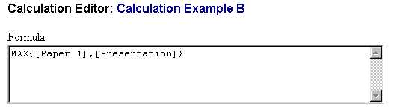
MAX{[Paper 1],[Presentation]}

Note:
- WebCT automatically determines the highest possible score for the formula and sets it as the maximum for the Calculated column. Therefore, it is recommended that you assign the same highest score for each column used in a maximum or minimum function.
- Do not leave a formula empty. You can press one of the number buttons as a placeholder and edit the correct formula later.

- Click the Update button to save the formula and return to the Student Management Table.

Letter Grades

To display a letter grade (such as A, B, or C) for a particular quiz, assignment, exam, or other quantitative grade, you can use a Letter Grade column. Such columns show the letter that corresponds to another column’s numeric value.

Creating a Letter Grade Column:
Follow the same procedure as above to create a column of Letter Grade type.

Specifying the Numeric Column on which to Base a Letter Grade:
- Click the link “Return to Manage Students.”
- Access the Student Management Table and locate the newly added Letter Grade column.
- Click Edit at the top of the column.

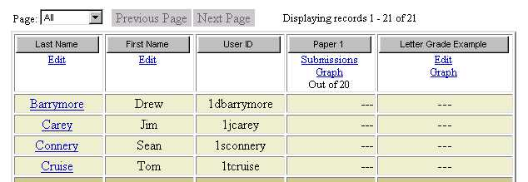

- To select the Numeric column on which this Letter Grade is based under the “Apply the grading scheme to” menu, choose the appropriate column.

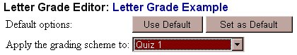

Defining the Grading Scheme:
Letter grades are based on percent ranges. The default percent ranges for the grades F (Fail) through A+ appear when you first create a Letter Grade column.

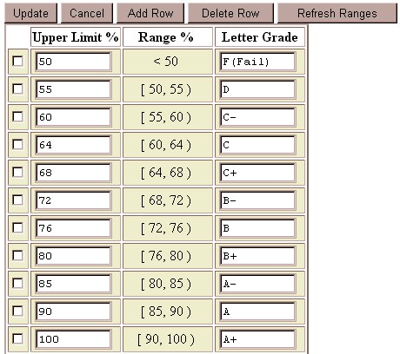

Each range includes percent grades from the upper limit of the range below it, up to but excluding its own upper limit. For example, using the above ranges, if a student scores 76% on a quiz recorded in a Numeric column, B+ is displayed in the associated Letter Grade column; whereas a score of 80% would show as A–. The lowest range includes any value less than but not equal to its upper limit so a student with a grade of less than 50 would fail the quiz.

Since the ranges are viewed as percentages, if the maximum grade for the Numeric column using the above grading scheme is 50 and a student scores 43, the Letter Grade column would show A (43/50 = 86%).

To change the percentage ranges:
- Click in the “Upper Limit %” column of the letter grade you want to change and type the new upper limit.
- Click the Refresh Ranges button to reset the boundaries of the various letter grades.

To broaden the percentage ranges by deleting one or more ranges:
- Check the box to the left of the range(s) you want to remove.
- Click the Delete Row button; the boundaries of the remaining ranges will be reset.

To narrow the percentage ranges by adding a range:
- Check the box to the left of the range above which you want to insert a new range.
- Click the Add Row button.
- Click in the “Upper Limit %” column of the new range and type the new upper limit.
- Click in the “Letter Grade” column of the new range and type the corresponding letter grade.
- Click the Refresh Ranges button to reset the boundaries of the various letter grades.

Examples

1. Total Points Expressed as a Letter Grade

Example 1 illustrates a basic formula using the SUM function to total a set of grades. Remember, WebCT automatically calculates the highest possible score for the formula based on its components. A Letter Grade column is created to express the numeric result as a letter grade.

Quiz 1, Quiz 2 and Final Exam are all Numeric columns. The Final Grade column is a Calculated column. The Final Letter column is a Letter Grade column.

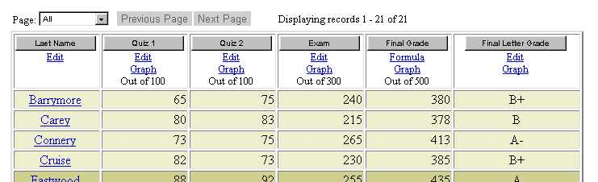

Since each quiz has a total of 100 points and the final exam is worth 300 points, the total number of points possible for the final grade is 500 (100+100+300). The following formula is applied to the Final Grade column:

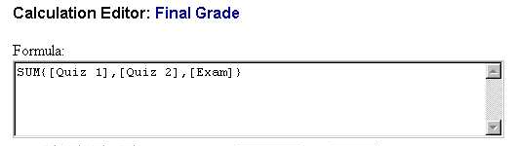
SUM{[Quiz 1],[Quiz 2],[Exam]}

2. Drop the Lowest Quiz Grade

Example 2 illustrates the use of the SUM function including a MIN function to exclude the lowest quiz grade. The sum of the individual points for each quiz counted is divided by the total possible points to achieve an average. A Letter Grade column is created to express the numeric result as a letter grade using the default percentage ranges.

Quiz 1, Quiz 2 and Final Exam are all Numeric columns. The Final Grade and Final Grade Percent columns are Calculated columns. The Final Letter column is a Letter Grade column.

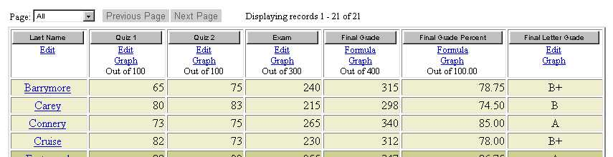

Since each quiz has a maximum of 100 points and the highest score on the Final Exam is 300 points, the total number of points possible for the Final Grade is 400 (100+300) since only one quiz is counted.

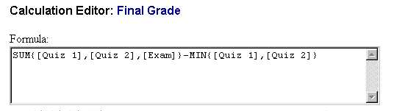
SUM{[Quiz 1],[Quiz 2],[Exam]}-
MIN{[Quiz 1],[Quiz 2]}

Dividing the Final Grade by 400 will express it as a percentage. Multiplying the percentage by 100 converts the score to a whole number. This does not affect the Letter Grade since WebCT automatically assumes numbers greater than 1 are out of 100. The following formula was applied to the Final Grade Percent column:

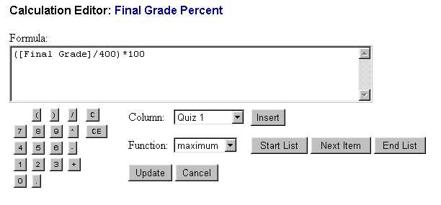
([Final Grade]/400)*100

Grading: Overriding Calculated or Letter Grades
After WebCT has calculated a grade or assigned a letter grade based on a numeric column value, you can override that value for individual students.

- Click the link to Return to Manage Students (or from the Navigation Bar, click Manage Course, then click Manage Students).
- In the Student Management the data in the first column will appear as a link to each students’ individual record.
- In the first column, click the link identifying the student. This may be the first name, last name or WebCT ID.

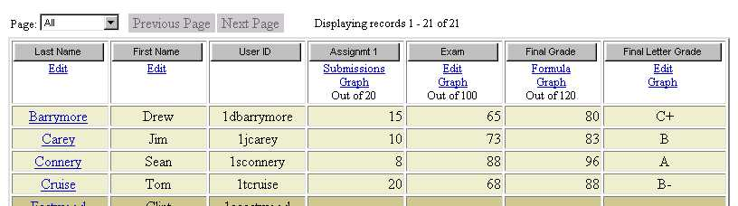

- Scroll over, if necessary, to find the column for the Calculated or Letter Grade you want to override. Click the Override link at the top of the column.

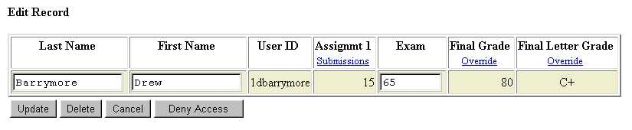

- Type the new value:
- for a Calculated grade, click the number buttons, then click the Update button;
- for a Letter Grade, type the new letter in the box next to “New letter grade” and click the Override button.
- Click the Update button on the student’s screen to return to the Student Management Table.
- Note that a grade that you have overridden will appear in gray on the student’s row.

Grading: Display Options
WebCT lets you control how data is displayed in the Student Management Table and shown to the students using the MyGrades tool.

- On the Navigation Bar, click Manage Course.
- Click Manage Students.
- Under “Advanced Options,”choose Modify columns.
- Click Go.
- A table shows the current attribute settings for each column. You can change these.

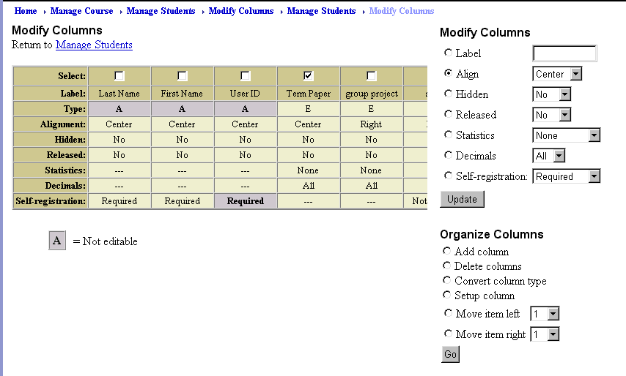

Alignment: how the data is arranged in the column (center, left or right)
Hidden: whether the column is visible to the designer; this is helpful when you have many columns and you want to view a column closer to the student name
Released: whether students can view their own data in that column using the MyGrades tool
Statistics: which summary information students can view using the MyGrades tool (only available for Numeric, Calculated and Letter Grade columns):
None – no statistics will be shown
All – the minimum, maximum, average, and median marks will be shown, as well as a histogram of mark distribution
Mean Only – only the average mark for that particular column will be shown
Decimals: number of decimal points to display data in the column (only available for Numeric and Calculated columns)

- After you change any of the settings in the table, click the Update button at the top of the table.
- Click the link to Return to Manage Students.

Grading: Graphing Grades
From the Student Management Table, you can view a bar graph showing the distribution of students’grades stored in a Numeric, Calculated or Letter Grade column.

- On the Student Management Table, find a Numeric, Calculated, or Letter Grade column and click Graph.

- The histogram appears showing the distribution of values in the column and the following statistics:
- Highest grade
- Lowest grade
- Mean grade
- Median grade

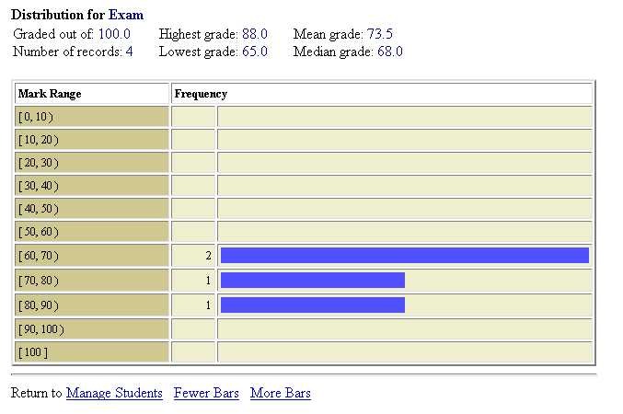

- To increase or decrease the distributed score ranges, at the bottom of the screen, click the Fewer Bars or More Bars button. Note: Letter Grade columns do not offer this feature.
- Click the link to Return to Manage Students.

Grading: Sorting Data
To make it easier to view the Student Management Table, you can sort the rows according to the values of the data in the columns. At the top of any column, click the button with the name of the column to sort the displayed rows.

Grading: Deleting a Column
To delete a column:
- On the Navigation Bar, click Manage Course.
- Click Manage Students.
- Under “Advanced Options,” choose Modify columns.
- Click the Go button at the right of the menu.
- Check the box at the top of the column you want to remove.
- Click the Go button at the right of the menu.
- Under “Modify Columns,” select Delete columns.
- Scroll down in the top frame, if necessary, and click the Go button at the bottom of the list.
- Click the appropriate buttons to confirm the deletion.
- Click the link to Return to Manage Students.

Note: If you delete an assignment or quiz, its corresponding column is not deleted; you must delete the column manually. However, you cannot delete the grade column for an existing assignment or quiz; you must delete the assignment first.

Grading: Importing Data
To make it easier to add batches of student data, you can prepare a text file outside of WebCT, upload it using the File Manager and import the file to the Student Management Table.

Creating a Text File Containing Student Data:
The text file must be formatted so that:
- The first line of the file contains the names of the columns to be updated or created, including User ID.
- Successive lines contain the data, with one student record per line and values listed in the order imposed by the first line.
- The values on each line are separated by either commas or tabs

For example, a text file may consist of the following lines:
User ID,Quiz 1,Exam
mgibson,95,250
mryan,88,230
jroberts,92,275
dhoffman,74,225

Uploading a Text File using the File Manager:
Details about uploading the text file can be found in the WebCT Introduction training document.

Importing the Data into the Student Management Table:
- On the Navigation Bar, click Manage Course.
- Click Manage Students.
- Under “Manage Students,”choose Import student data.
- Click the Go button to the right of the menu.
- Next to the “Filename” box, click the Browse button to choose the text file from the File Manager.
- In the File Manager, click the radio button next to the filename and click the Pick button.
- In the “Separator” menu, select the character you used to separate the values in the file, either a comma or a tab.
- Click the Import button.
- A screen will appear asking you to confirm how WebCT will match the data in the file with the current fields (columns) in the Student Management Table. Click the Continue button if it is correct.
- A screen will appear showing how WebCT will interpret the data in the file. Click the Continue button if it is correct.
- Wait for the data to be imported. The Student Management Table will appear when it is finished.

Grading: Exporting Data
You may want to use the data from the Student Management Table in another program, such as Excel, to perform statistics or organize it. You can export the Student Management Table to a text file in which each row is stored on a separate line and the column information is separated by either commas or tabs. From the Student Management Table, click the Download button and follow the instructions to save the student data in a file.

