
WebCT: Adding Course Content
Information
Technologies
January 2002
Copyright © 2002 University of Delaware. Permission to copy without fee all or part of this material is granted provided that the copies are not made or distributed for direct commercial advantage or profit and that the material duplicated is attributed to Information Technologies, University of Delaware. To copy otherwise or to republish requires specific permission and a fee.
Table of Contents

Introduction 1
Practice Files 1
Content Modules 2
Introduction 2
Creating a Content Module 2
Working with the Table of Contents 3
Adding Headings and Subheadings 3
Adding Content Pages 4
Viewing Content Pages 5
Modifying the Table of Contents 5
Working with Content Page Attributes 6
Editing the Text in a Content Page 9
Designing the Action Menu 10
Adding Items on the Action Menu Specific to the Content Page 11
Adding WebCT Tools to the Action Menu 23
Specifying Tools for the Action Menu on all Content Pages 24
Linking to a Content Module from the Calendar 24

Introduction
This document is designed as a supplement to the WebCT Introduction. It is assumed that you are working on a course following the University of Delaware template.

Practice Files
Examples in the document make use of several practice files provided by User Services. To follow along with the exercises, upload the practice files to the File Manager of your WebCT course. Refer to the WebCT Introduction for Instructors document for details.

Content Modules

Introduction
A Content Module lets you organize subject matter information and guide your students to related material. With its Table of Contents, a Content Module allows you to group information stored in files, or content pages, using headings and subheadings. Each content page contains an Action Menu where you can specify hyperlinks to the Discussions or Calendar of the WebCT course as well as to a set of references, a glossary and an index. Tools for students to add their own notes and bookmarks can be also added to the Action Menu of content pages.

Just as you might use several textbooks in the course you are teaching, you can include several Content Modules in your WebCT course.

Creating a Content Module
- To add a Content Module tool:
- On the Navigation Bar, click Add Page or Tool.
- On the “Course Content and Related Tools” list, click Content Module.
- Next to “Choose page or tool:” line, click the Add button.
- In the “1. Enter a title for the page” box, type a name for the URL. For example, type
European History
- In the section “2. Decide where to show this item in your course,” check the box next to On an Organizer Page and, using the pull-down menu, select the page on which you want the icon to appear.
- At the bottom of the screen, click the Add button.
- Click the Add link in the line “Add content to this Content Module.”

- To edit an existing Content Module tool:
- Click the icon that links to the Content Module.
- Click Designer Options.

Working with the Table of Contents
The Table of Contents in a Content Module displays headings and links to content pages. Each line of the Table of Contents can be indented to form a hierarchical structure. Each of these items is numbered automatically.

Adding Headings and Subheadings

- To add a heading:
- Make sure you are viewing the Table of Contents in Designer Options.
- On the right side of the window, in the “Add or Delete Items” list, click Add heading.
- Click the Go button at the bottom of the list.
- Type a title for the heading. For example, type
Western Europe
- Click the Add button.

- To add a subheading:
- Add a new heading as above. For example,
France
- Click the radio button next to the new heading.
- On the right side of the window, in the “Reorganize Table of Contents” list, click Indent item.
- In the pull-down menu, choose More to move the heading to a lower level in the hierarchy of the Table of Contents.
- Click the Go button at the bottom of the list.

Notes:
- The new heading is renumbered using an outline scheme.
- A blue triangle appears next to the heading under which the subheading has been added. Clicking this triangle expands (pointing downward and showing subordinate headings and content pages) or collapses (pointing to the right and showing no subordinate items) the heading.
- New headings are added on the same level as the heading whose radio button is selected. If no button is selected, the new heading will be placed at the bottom of the Table of Contents on the same level as the last item.

Adding Content Pages
The information you provide in a Content Module is stored in files that make up the content pages of this section of a WebCT course. Each file will appear as a separate entry in the Table of Contents. You can use files already uploaded into the File Manager or create and name new files directly.

- To add a content page from a file already in the File Manager:
- Click the radio button of the item after which you want the content page to appear. For example, click the radio button next to the France heading.

If you do not select an item, the new content page will appear at the end of the Table of Contents.

- On the right side of the window, in the “Add or Delete Items” list, click Add file.
- Click the Go button at the bottom of the list.
- In the list of files from the File Manager, highlight the file you want to include in the Content Module. For example, highlight the louisxiii.html filename.
- Click the Add button.
- Follow steps 2 through 5 to add the file louisxv.html.

- You can create a new file and add the text later. This is recommended if you have a short amount of text for this file or the text requires little formatting and you are familiar with the HTML language.

To add a new content page:
- Click the radio button of the item after which you want the content For example, click the radio button next to the Louis XIII heading.
- On the right side of the window, in the “Add or Delete Items” list, click Create and add HTML file.
- Click the Go button at the bottom of the list.
- Type the filename to be used in the File Manager for the new file. The filename cannot contain spaces. The extension “.html” will automatically be added to the filename. For example, type
louisxiv
to create the file “louisxiv.html” in the File Manager.
- Type the title to appear in the Table of Contents. For example, type
Louis XIV
- Click the Add button.

Viewing Content Pages
Designer Options view allows you to organize, modify and lay out the components of a Content Module. To see the formatted content pages, you must use the Student View.

- At the top of the window, click View.
- Note that headings appear in bold and content page titles are links to the content page files.
- Click the link for a content page. For example, click Louis XIII.
- Note the Action Menu that appears at the top of the page:

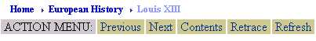

The link buttons on the Action Menu allow you to navigate through the Content Module:

Next or Previous: move through the content pages in sequential order
Retrace: move through the pages in the order in which they were selected
Contents: return to the Table of Contents
Refresh: return to the text of the content page after using other tools in the Action Menu

- Click the Contents button to return to the Table of Contents.

Modifying the Table of Contents
Changing the Layout
You can change the appearance of the Table of Contents and content pages by specifying whether or not to number items, where to place the Action Menu and whether or not to include the Table of Contents on each content page.

- To position the Action Menu on the side of each content page and remove the Table of Contents numbering:
- At the top of the window, click Designer Options.
- On the right side of the window, in the “Edit” list, click Edit settings.
- Click the Go button at the bottom of the list.
- Under the “Action menu location” list, click To the left of each page and, using the pull-down menu, specify the amount of space to allow for the Action Menu.
- Under the “Page numbering” list, click Hidden.
- Click the Update button.
- To see the formatted page, at the top of the window, click View.
Making Changes to Headings or Content Page Titles
After you add a heading or content page, you can modify the title of that item.

- To change heading or content page titles:
- At the top of the window, click Designer Options, if necessary.
- Click the radio button next to the item you want to delete.
- On the right side of the window, in the “Edit” list, click Edit titles.
- Click the Go button at the bottom of the list.
- Make any changes to the titles. For example, edit the first title to read:
Western Europe - 17th and 18th Centuries
- Click the Update button.

Deleting Items
You can remove items from the Table of Contents one at a time.

- To delete a heading or content page:
- At the top of the window, click Designer Options, if necessary.
- Click the radio button next to the item you want to delete.
- On the right side of the window, in the “Add or Delete Items” list, click Delete.
- Click the Go button at the bottom of the list.
- You will be asked to confirm the deletion.

Working with Content Page Attributes
When you look at the Table of Contents for a Content Module in Designer Options view, each heading and content page has a radio button next to it. You can click a radio button and choose an option to delete or change the level of any item.

If you click the link for a content page, you can modify attributes of that particular page. For example, you can edit the text in the page, add tools to the Action Menu on the page, or specify colors for the page.

- To access the attributes of a particular content page:
- At the top of the window, click Designer Options.
- Click the title link for the page you want to edit.
- A list will appear showing the various settings you can modify.

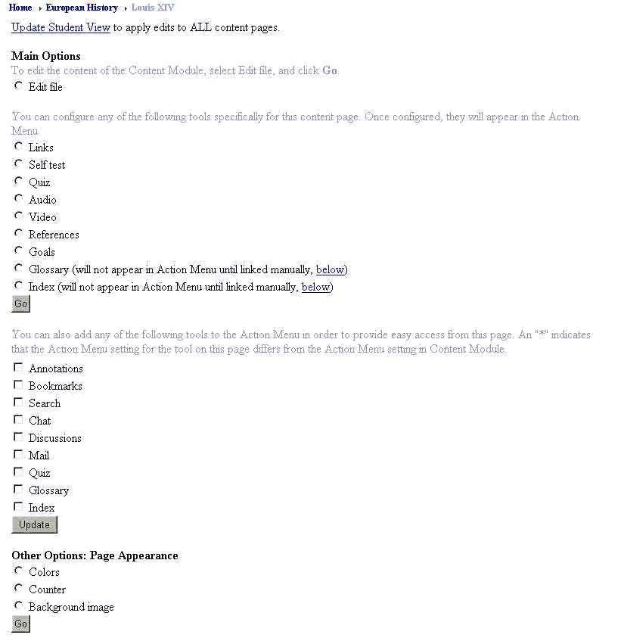

Updating the Student View
After making changes to some of the attributes of a content page, you must update the Student View to register the changes. This is true when you:
- upload a newer version of a file;
- modify the text of a file;
- modify colors, counters, or background images of content pages;
- modify the Action Menu on a content page.

- To apply your modifications for students to see:
- Click the Update Student View link.
- Click Update entire course to refresh all the content pages in all the Content Modules or click Update changes to text, colors, and Action Menu to refresh just the changes you made.
- Click the Update button.
- Click the link at the bottom of the window to return to the content page or use the Breadcrumbs to move to a different page.
- Click View at the top of the page if you want to see these changes.

Editing the Text in a Content Page
If you have created a new file in the Table of Contents, you will need to edit the content page to add text to the file. Knowledge of HTML tags is necessary if you want to use extensive formatting, but not required for simple text editing.

You can also perform simple editing tasks for the text in a file that you uploaded to the File Manager.

- To make changes or add text to a content page:
- Access the attributes of a content page following the instructions on page 7. For example, click the Louis XIV link to select the file you created earlier.
- In the “Main Options” list, click Edit file.
- Click the Go button at the bottom of the list.
- A box appears showing the text stored in the file. Notice that if you are working on a file you created from the Table of Contents, a line with HTML <TITLE> tags is automatically placed in the file with the title you provided.

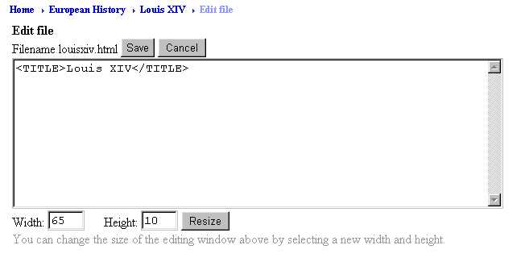

- Click in the box with the file’s text and type new text or edit the existing text. For example, type
<H2>Louis XIV</H2>
Louis XIV of France was known as the <I>Sun King</I>. During the early years of his reign, he deferred to his mother and the Prime Minister, Italian Cardinal Mazarin. He had his first serious love affair with Mazarin's niece, Marie Mancini.
- Click the Save button above the editing window.
- Follow the instructions on page 8 to update the Student View.
- To see the formatted content page, at the top of the window, click View.
Designing the Action Menu
Besides the link buttons that automatically appear on the Action Menu of each content page, you can add links to other tools and components of your WebCT course. In the Designer Options view of a content page, under “Main Options,” is a list of tools that can be added to the Action Menu. These tools can be grouped into four categories.

- Links to information particular to the page:
- links: collections of web locations arranged into named groups
- self test: ungraded quiz
- quiz: one or more existing quizzes created using the Quiz tool
- audio: files for students to listen to from this content page
- video: files for students to view from this content page
- goals: learning objectives for the content page

- Pointers to central repositories for all content pages to use
- references: books, articles or URLs chosen from a resource bank to be used on any page, specifying particular pages, chapters or units for this content page
- glossary: links to definitions of keywords
- index: links to other content pages through index entries

- Links to WebCT student tools
- annotations: personal notes recorded by individual student and associated with any content page, available only to the student who created them
- bookmarks: personal bookmarks to content pages maintained by individual students, available only to the student who created them
- search: tool to help students find information in headings, content page text and discussions

- WebCT tools in other parts of the course
- chat
- discussions
- mail
- quizzes
- references
- glossary: displays an alphabetic directory to all glossary terms
- index: displays all index entries with links to content pages

Adding Items on the Action Menu Specific
to the Content Page
Generally, choosing tools for the Action Menu of a content page is straightforward, although some tools involve several elements.

Links
You can arrange series of related web locations into sets or link names by defining a link name, then listing the associated URLs.

- To create a link name and include a “Links” entry in the Action Menu:
- Follow the instructions on page 7 to access the attributes of a content page. For example, click the Louis XIII link you created earlier.
- In the “Main Options” list, click Links.
- Click the Go button at the bottom of the list.
- Type a name for a group of web locations. For example, type
French Monarchy
- Click the Add button.

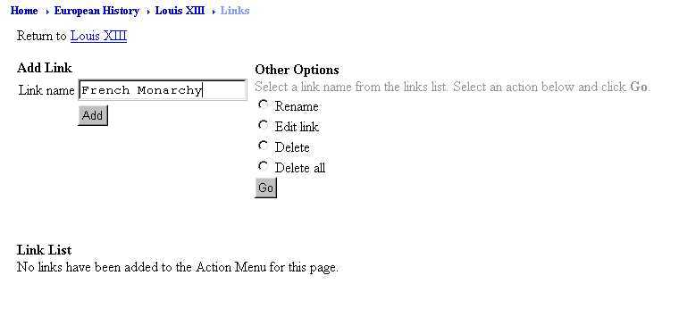

- To add web locations to a link name:
- Access the attributes of a content page.
- In the “Main Options” list, click Links.
- Click the Go button at the bottom of the list.
- Check the box next to the link name to which you want to add a URL. For example, check French Monarchy.
- In the “Other Options” list, click Edit link.
- Click the Go button at the bottom of the list.
- Under “Add Link,” click the Go button.

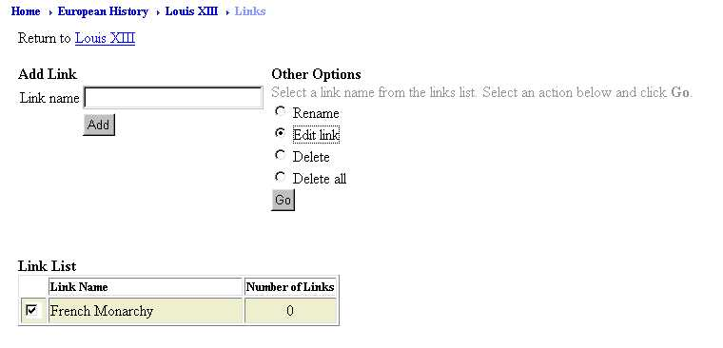

- Type the URL. For example,
http://www.ac.wwu.edu/~stephan/Rulers/bourbon.html
- Type a description. For example,
Bourbons
- Click New window.
- Click the Add button.

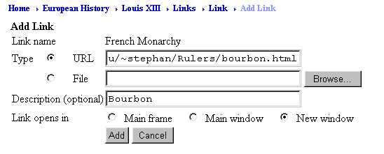
- The “Links List” box showing the description (link) and URL (location) appears.

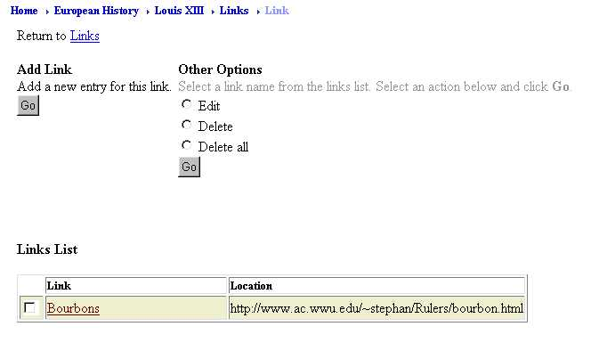

- Following the above steps, add another URL to this link name:
URL: http://www.homeschoolchristian.com/Books/FrenchKings.html
Description: Kings of France
- On the Breadcrumbs line at the top of the page, click the title of the content page. For example, click Louis XIII.
- To make the changes available to your students, click the Update Student View link, then apply the changes following the instructions on page 8.

- To view the links for a content page:
- To see the formatted content page, at the top of the window, click View.
- Notice the link names at the bottom of the Action Menu.

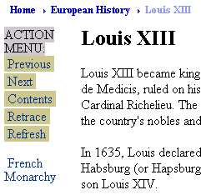

- Click the link name to see the associated list of web locations.

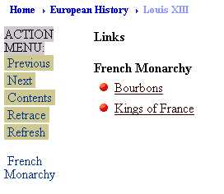

- Click the Refresh button on the Action Menu to return to the content page.

References
You can place information about books and articles in a resource bank. From the Action Menu of a content page, you can refer to this reserve and specify appropriate pages or chapters.

- To add an item to a resource bank:
- Follow the instructions on page 7 to access the attributes of a content page.
- In the “Main Options” list, click References.
- Click the Go button at the bottom of the list.
- Click the link for the resource bank.

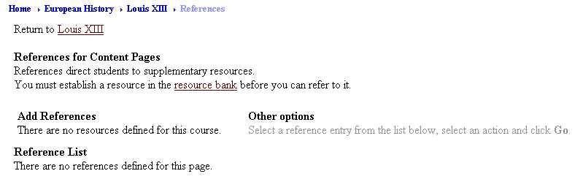

- Using the pull-down menu, select the type of resource you want to add. For example, select Book.
- Click the Go button below and to the left of the pull-down menu (you may need to scroll down on the right to see it).

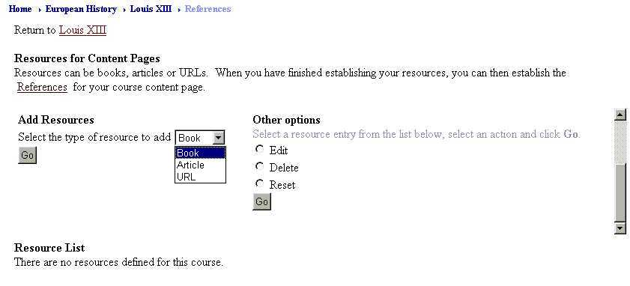

- Type the information about the reference. Note that several boxes indicate required fields. For example,
The Sun King by Nancy Mitford
New York, Harper & Row
1966
- Click the Add button.

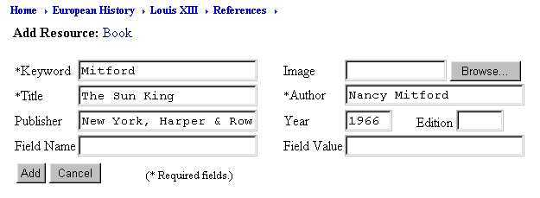

- To reference an item in the resource bank and include a “References” entry in the Action Menu:
- Follow the instructions on page 7 to access the attributes of a content page.
- In the “Main Options” list, click References.
- Click the Go button at the bottom of the list.
- Under “Add References,” use the pull-down to select the reference you want to use for this content page. For example, choose Mitford.
- Click the Add button.

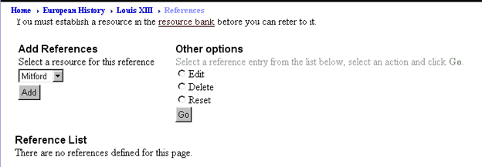

- Specify the page, section, chapter or unit number, if necessary (for example, pages 105-143) and click the Add button.
- A Reference List box showing the resource and page reference appears.

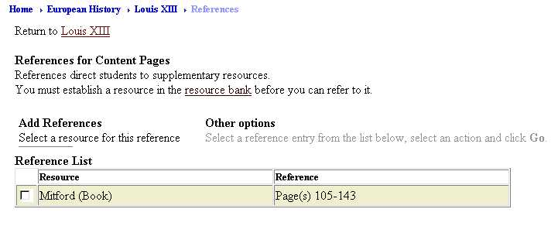

- On the Breadcrumbs line at the top of the page, click the title of the content page. For example, click Louis XIII.
- To make the changes available to your students, click the Update Student View link, then apply the changes following the instructions on page 8.

- To view the references for a content page:
- To see the formatted content page, at the top of the window, click View.
- Click the References link in the Action Menu to display the references for this content page.

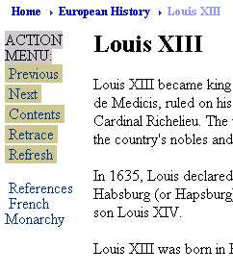

- Click the Refresh button on the Action Menu to return to the content page.
Glossary
The glossary lets you provide definitions for certain terms or more information about a subject mentioned in a content page. You begin by defining a keyword or phrase; WebCT will find occurrences of the keyword in the content page and allow you to activate a link to its definition.

- To add an entry to the glossary:
- Follow the instructions on page 7 to access the attributes of a content page. For example, click the Louis XIV link you created earlier.
- In the “Main Options” list, click Glossary.
- Click the Go button at the bottom of the list.
- In the “Add New Keyword to Glossary” list, click Add a keyword.
- Click the Go button at the bottom of the list.

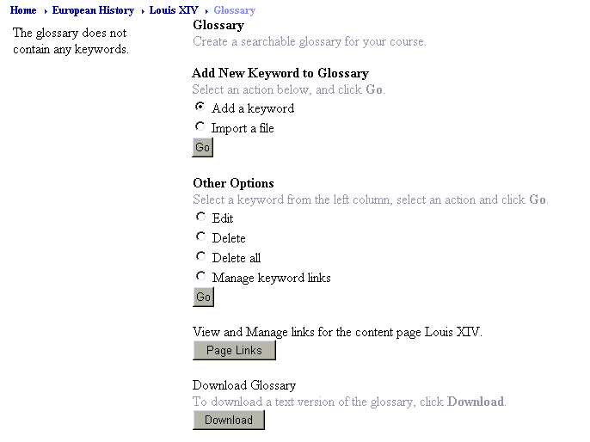

- Type the keyword and definition. For example,
Keyword: Sun King
Definition: Louis XIV chose the sun as his royal emblem. The name was derived originally from his performance as the Sun in a ballet by Isaac Benserade.
- Click the Add button.
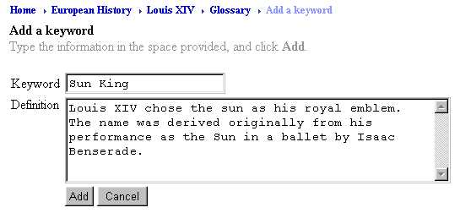

- Following the above steps, add another keyword to the glossary:
Keyword: Mazarin
Definition: Born in 1602, Cardinal Jules Mazarin was the first minister of France after the death of Cardinal Richelieu in 1642.

- To create a link from a content page to the definition of a keyword:
- Follow the instructions on page 7 to access the attributes of a content page.
- In the “Main Options” list, click Glossary.
- Click the Go button at the bottom of the list.
- Click the Page Links button on the right side of the window.

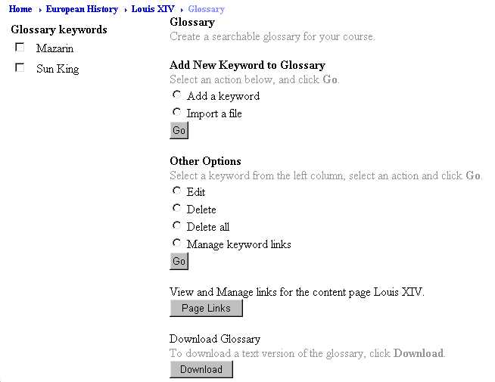

- A window appears with the text of the content page. Each occurrence of a glossary keyword has a radio button next to it and a list of keywords found in the page is displayed. To create a link from the keyword to its definition, click the keyword radio button. For example, click the radio button next to Sun King and the second one next to Mazarin.
- Click the Update button.

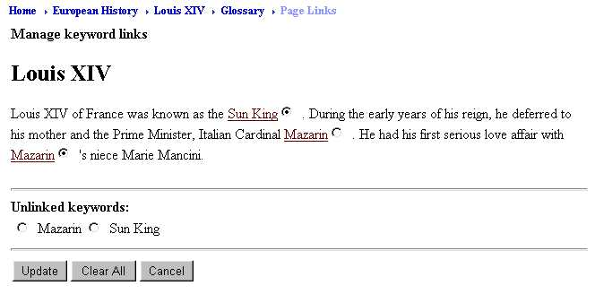

- On the Breadcrumbs line at the top of the page, click the title of the content page. For example, click Louis XIV.
- To make the changes available to your students, click the Update Student View link, then apply the changes following the instructions on page 8.

- To view the glossary terms for a content page:
- To see the formatted content page, at the top of the window, click View.
- Notice the links on the keywords you specified. Note that even though you selected the second occurrence of Mazarin, the first instance in the page has the link.
- Clicking a glossary keyword link opens a new window containing the definition.

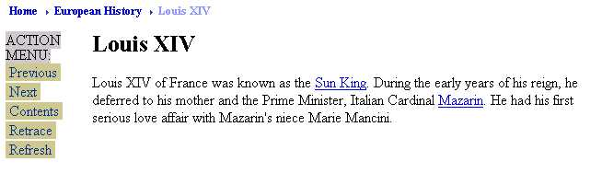

Importing Glossary Items
An efficient way to add many glossary items at once is to save the items and their definitions in a text file, upload it to the File Manager of your WebCT course and import the file into the glossary.

The file must be saved as a text file (.txt) and formatted so that:
- each glossary entry is preceded by a colon (":") and is on a separate line;
- the lines following the entry contain the glossary entry description

For example, a text file may consist of the following lines:
:Fronde
An alliance of French nobles and the judges of the Parlement.
:Versailles
The official residence of the Kings of France from 1682 until 1790.

- To include in the glossary entries that are stored in a text file:
- In the File Manager, upload the glossary text file.
- Access the attributes of a content page.
- In the “Main Options” list, click Glossary.
- Click the Go button at the bottom of the list.
- In the “Add New Keyword to Glossary” list, click Import a file.
- Click the Go button at the bottom of the list.
- Next to the “Filename” box, click the Browse button to choose the text file from the File Manager.
- In the File Manager, click the radio button next to the filename (for example, glossary.txt) and click the Pick button.
- Click the Import button.
- A screen will appear showing how WebCT interpreted the glossary entries and their definitions from the text file. Click the Continue button if it is correct.



Adding WebCT Tools to the Action Menu
In Designer Options mode when you click the link for a content page, you see a list of options with check boxes. These check boxes allow you to add links on the Action Menu to WebCT Tools. You can choose as many of these as you want and then click the Update button.

Note that for the Discussion tool, clicking this link in the Action Menu of a content page will send students to the main Discussion page.

When you add a link for the Glossary tool to the Action Menu, clicking that link will show an alphabet list allowing students to access all the glossary terms, not just those appearing in the content page text:
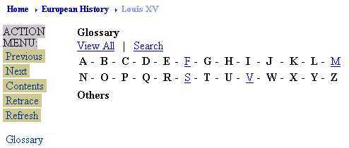
Specifying Tools for the Action Menu on all Content Pages
If you want a link for a WebCT tool to appear on all the Action Menu of all content pages, you can indicate this from the Table of Contents, rather than choose the links individually on each content page. Any tool added in this way can be selectively removed from an individual content page.

- To add WebCT tools to all content pages:
- On the Breadcrumbs line at the top of the page, click the title of the Content Module. For example, click European History.
- Click Designer Options.
- On the right side of the window, in the “Edit” list, click Edit Action Menu.
- Click the Go button at the bottom of the list.
- Click all the check boxes next to each WebCT tool you want to appear on each content page and click the Update button.
- To make the changes available to your students, on the right side of the window, click the Update Student View link, then apply the changes following the instructions on page 8.

Linking to a Content Module from the Calendar
Once you have created a Content Module, you can insert links from Calendar entries to any content page. When you create a Calendar entry, select a content page from the “Internal Links” pull-down menu.

