Getting to Know UD

Helpful Websites for All New Graduate Students

www.udel.edu/hr
Office of Human Resources

www.udel.edu/gradoffice
Office of Graduate & Professional Education

Registered Student Organizations
Listing of all registered student organizations, including multicultural, religious, and recreational

www.udel.edu/gradoffice/gradsenate
Graduate Student Senate
- Sign up for “What’s Happening” on GSS Website
- Weekly listing of upcoming events and activities, most of which are free or very affordable and located in or near Newark!

http://www.udel.edu/gradoffice/campuslife/ index.html
Links to aid new students in becoming familiar with various aspect of campus life at UD

http://www.udel.edu/transportation/ud_route/ index.html
A comprehensive website with detailed bus route information on and around campus

http://www.udel.edu/housing/
Information about on and off-campus housing options for graduate students
http://www.udel.edu/ofs/community/shopping.html
Places to shop for groceries, clothing, etc.

http://www.udel.edu/ofs/community/enrolling.html
Enrolling a child in school

http://www.udel.edu/recreation/
Information about fitness facilities, recreation sports and other leisure activities

www.udel.edu/bookstore
Order textbooks online and browse UD apparel and gifts!

http://www.udel.edu/udaily/
UD News, events, and campus FYI

http://www.bluehens.com/
Official website of Blue Hen Athletics!

https://mail.udel.edu/wm/mail/login.html
Access your UD email from the web

http://www.udel.edu/gradoffice/financial/index.html
Funding resources for graduate students

http://www.udel.edu/gradoffice/polproc/index.html
Policies and procedures, including forms, for graduate students

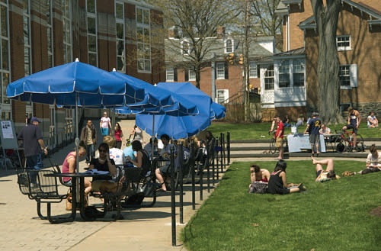 | 

