New Funded Graduate Student’s Check-In List

Provided by the Office of Human Resources and the Office of Graduate & Professional Education

Welcome to the University of Delaware!

Please use this checklist to guide you through the set up of your payroll records at the University of Delaware. If you have questions, please contact us at (302) 831-8677 or by email at hronboard@udel.edu.

ITEMS TO DO FOR INTERNATIONAL GRADUATE STUDENTS:

- Upon arrival to campus, please report directly to the Office of Foreign Students and Scholars located at 30 Lovett Avenue (Student Services Building) with your passport, I-20 or DS 2019, I-94 and U.S. VISA.

- The Office of Foreign Students and Scholars will complete an I-9 Form for you and give you a Foreign National Form to complete.

- Proceed to your academic department office to let them know you have arrived and to seek advisement for courses for the upcoming semester

- When you come to your onboarding appointment, please bring the following:
- The Bayh-Dole Act Form “Agreement to Assign”
- Voided check from your U.S. bank account

- Visit the Office of Graduate and Professional Education located at 234 Hullihen Hall to submit final, official academic documents (transcripts, degree certificates, etc.)

ITEMS TO DO FOR DOMESTIC GRADUATE STUDENTS:

- Proceed to your academic department office to let them know you have arrived and to seek advisement for courses for the upcoming semester

- When you come to your onboarding appointment, please bring the following:
- At least two documents that identify who you are. Appropriate documents are listed on page 5 of the I-9 Form.
- The Bayh-Dole Act Form “Agreement to Assign”
- Voided check from your U.S. bank account

- Visit the Office of Graduate and Professional Education located at 234 Hullihen Hall to submit final, official academic documents (transcripts, degree certificates, etc.)

Calendar of Events for New Graduate Students

Fall 2009

- July 15, 2009: Onboarding Session for ELI ITA students. 8:30 am in the Rodney Room of the Perkins Student Center

- July 15, 2009 to August 14, 2009: Summer ELI ITA program is in session from 8 am to 4 pm each day; Students attending this session may not be a research assistant during the time period of this program

- August 24, 2009 to August 26, 2009 (Morning sessions): Annual Conference for Graduate Teaching Assistants (all first time Teaching Assistants are required to attend)

- August 25, 2009: Onboarding Session for first time domestic teaching assistants. 12:00pm in Trabant Multipurpose Room A-C

- August 27, 2009: Onboarding Session for all other new students. Daugherty Hall in the Trabant Center.

- August 27, 2009: Orientation Program for new International Students (graduate and undergraduate students); Attendance required for all new international students; 8:30 am to 1 pm in Trabant A & B

- August 27, 2009: GRADUATE STUDENT INFORMATION FAIR for all graduate students from 12 pm to 4 pm; Trabant C; Representatives from IT HELP, Health Services, Safety Training, Library, Parking, Registration, Payroll Services, ID Office, CTE, Writing Center, Graduate Student Senate, Office of Foreign Students & Scholars, and Office of Graduate & Professional Education available for one-stop services throughout the afternoon.

- September 1, 2009: Classes begin at 8 am.

- September 1, 2009: OPENING CONVOCATION AND RECEPTION FOR NEW GRADUATE STUDENTS: 3 o'clock pm. Location to be announced.

Departmental Orientation Programs
TBA

Getting to Know UD

Helpful Websites for All New Graduate Students

www.udel.edu/hr
Office of Human Resources

www.udel.edu/gradoffice
Office of Graduate & Professional Education

Registered Student Organizations
Listing of all registered student organizations, including multicultural, religious, and recreational

www.udel.edu/gradoffice/gradsenate
Graduate Student Senate
- Sign up for “What’s Happening” on GSS Website
- Weekly listing of upcoming events and activities, most of which are free or very affordable and located in or near Newark!

http://www.udel.edu/gradoffice/campuslife/ index.html
Links to aid new students in becoming familiar with various aspect of campus life at UD

http://www.udel.edu/transportation/ud_route/ index.html
A comprehensive website with detailed bus route information on and around campus

http://www.udel.edu/housing/
Information about on and off-campus housing options for graduate students
http://www.udel.edu/ofs/community/shopping.html
Places to shop for groceries, clothing, etc.

http://www.udel.edu/ofs/community/enrolling.html
Enrolling a child in school

http://www.udel.edu/recreation/
Information about fitness facilities, recreation sports and other leisure activities

www.udel.edu/bookstore
Order textbooks online and browse UD apparel and gifts!

http://www.udel.edu/udaily/
UD News, events, and campus FYI

http://www.bluehens.com/
Official website of Blue Hen Athletics!

https://mail.udel.edu/wm/mail/login.html
Access your UD email from the web

http://www.udel.edu/gradoffice/financial/index.html
Funding resources for graduate students

http://www.udel.edu/gradoffice/polproc/index.html
Policies and procedures, including forms, for graduate students

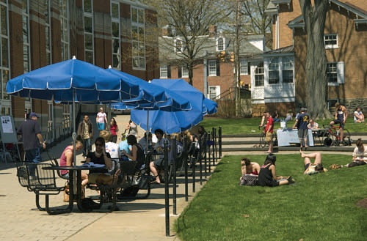 | 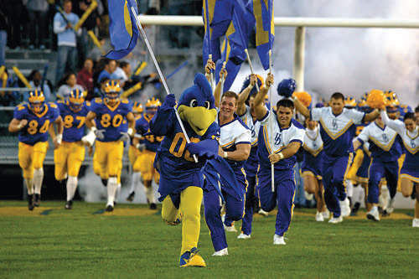

Welcome New International Students and Scholars!

On behalf of the Office of Foreign Students and Scholars I would like to invite you to visit our website (www.udel.edu/ofs) and view the important information provided for international students and scholars interested in attending the University of Delaware. There are approximately 2700 international students and scholars from over 100 countries currently attending the University of Delaware. Our goal is to enhance international spirit and diversity through our programs and services. We strive to achieve success in promoting international education in our academic community in order that our students, scholars and dependents have a successful and enjoyable stay in Newark!

Best wishes,  Susan C. Lee  302-831-2115  302-831-2123 (fax)  Email: foreignservices@udel.edu | 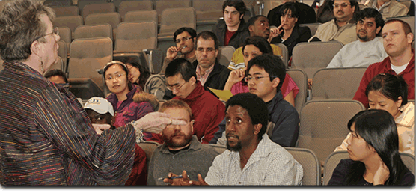

Helpful Websites for New International Students

http://www.udel.edu/ofs/ community/phone.html
Emergency phone numbers
Important phone numbers in the UD Community

http://www.udel.edu/ofs/community/housing.html
Finding housing in Newark
Signing a housing agreement

http://www.udel.edu/ofs/community/shopping.html
Places to shop for groceries, clothing, etc.

http://www.udel.edu/ofs/community/enrolling.html
Enrolling a child in school

http://www.udel.edu/ofs/maint_status/maintain_f1.html
Maintaining F-1 visa status

http://www.udel.edu/ofs/maint_status/f1j1.html
Responsibilities of F-1 & J-1 Students

http://www.udel.edu/ofs/maint_status/maint.html
Academic Information (Advisement, registration, academic concerns, etc)

http://www.udel.edu/ofs/forms/forms.html
Index of forms specific for international students

http://www.udel.edu/ofs/information/studentins.html
Medical insurance instructions

http://www.udel.edu/ofs/community/campus.html
Campus Services

http://www.udel.edu/SuppSrvc/bus/UDbus.html
Shuttle bus routes and schedules

http://www.udel.edu/ofs/community/community.html
Post Office, Banking, Travel, Newspapers

http://www.udel.edu/ofs/community/social.html
Social and extracurricular activities

http://www.udel.edu/ofs/information/misc.html
Immigration Service, Obtaining a Driver’s License,
Cars on Campus, Changes of Address, ID cards and Social Security Cards, Income Tax, Mail

http://www.udel.edu/ofs/information/KnowYourRights.html
Know Your Rights

http://www.udel.edu/ofs/information/immig_reform.html
Immigration Reform Act

http://www.udel.edu/ofs/information/pubcharge.html
Public Charge Announcement

http://www.udel.edu/ofs/information/religious.html
Local religious organizations and churches

http://www.udel.edu/ofs/information/SecurityClearance.html
Travel/Security Clearance Information

Health Related Services at UD

Student Health Services
http://www.udel.edu/shs/
Located at Laurel Hall
(302) 831-2226

Services
Medical Clinic - see a doctor or nurse
Women's Health Clinic - gynecology & family planning
Men's Health - services about men's health
Sports Medicine Clinic - for UD athletes
Self Care Cold & Wound Centers - self-serve information & medication for minor colds & injuries
Dispensary - prescription, over-the counter drugs & medical supplies
Immunization & Allergy Clinic - routine allergy shots, immunizations & vaccines for overseas travel
Lab & X-ray - blood work and radiological services
Wart Clinic - wart treatment by a registered nurse
Inpatient Services - when an overnight stay is needed
Nutrition Clinic - evaluation & counseling about nutritional & dietary concerns

Student Health should be your first stop for
minor injuries and illnesses. In the event of an emergency, dial 911 or proceed to the closest emergency room.
Christiana Hospital (302) 733-1000
Newark Emergency Center (302) 738-4300

Student Health Center Fee is a mandatory fee on bill each semester for all full-time students.
This fee will provide you with unlimited visits to practitioners and nurse practitioners, all in-house laboratory work, all inpatient care in the infirmary, gynecology services including annual exams and Pap smears (thin preps), nutrition services, visits to the Sports Medicine Clinic, many immunizations and administration of allergy injections using serum provided by your allergist. The health fee also covers services offered by the Center for Counseling and Student Development. There are separate fees for x-rays, most medications and orthopedic supplies, and some immunizations.

This fee, along with the mandatory Student Center Fee, maybe be payroll deducted for funded graduate students. Payroll deduction form: http://www.udel.edu/gradoffice/ forms/feepayment.pdf

Student Accident and Sickness Insurance Plan
The University sponsors a Student Accident and Sickness Insurance Plan, which offers substantial benefits for covered medical expenses at a relatively low cost for single students. Coverage is also available for a student's spouse and/or dependent children at an additional charge. You're urged to enroll in this plan if you have no other coverage, if your coverage expires during the academic year, or as a supplement to existing insurance coverage. Students from outside the United States are required to have either insurance offered by the University or equivalent insurance coverage.

Description of Student Health Service and Student Insurance Plan: http://www.udel.edu/shs/insurance guid0708.pdf
Policy: Nationwide Life Insurance Company
Policy Number: 302-001-0705

Enrollment: http://www.universityhealthplans.com/intro/ UDEL.html
*** The enrollment period begins upon your arrival on campus. DO NOT enroll prior to arrival.***
International students who wish to upgrade to the Blue and Gold Plan and/or who wish to add a spouse and/or children should use this application.
Claim Form: http://www.consolidatedhealthplan.com/ pdf/claimform.pdf

Frequently Asked Questions

Dental Insurance
Available to all students; subsidized for funded students. Cost and enrollment located at http:// www.universityhealthplans.com/intro/UDELDental.html

Vision Care Discount Plan
Available to all students and families. Cost and enrollment located at http://www.universityhealthplans.com/ letters/letter.cgi?school_id=170



Banking at the University of Delaware

 | http://www.udel.edu/banking/index.html  UD, through its partnership with WSFS Bank, offers free checking accounts to University students—with your UD#1 Card doubling as your ATM card! In addition to the bank branch located in the Trabant University Center, there are thirteen WSFS Bank ATMs on campus at the following locations:

Trabant University Center (4)
Rust Ice Arena Lobby
Perkins Student Center (2)
Clayton Hall
Smith Hall Lobby
Pencader Dining Hall
Rodney Market Bob
Carpenter Center Lobby
Christiana Commons

Other Banks in Newark

Citizens Bank
117 East Main Street
(302) 731-2290 http://www.citizensbank.com/home/

Commerce Bank
230 E. Delaware Avenue
(302) 455-1781 https://www.commercebank.com/default.asp

Delaware National Bank
281 East Main Street
(302) 737-7766
http://delawarenational.com/

PNC Bank
201 Newark Shopping Center
(302) 733-7150
https://www.pnc.com/webapp/unsec/Homepage.do? siteArea=/PNC/Home/Personal

Wachovia Bank
622 S. College Avenue
(302) 631-1505
https://www.wachovia.com/

Wilmington Trust
82 East Main Street
(302) 651-1618
https://www.wilmingtontrust.com/wtcom/

