Cultural Assignment #4 Name __________________
Spain Section ____

I. GEOGRAFÍA
A. Identify the cities that are marked with an arrow. [8 points)

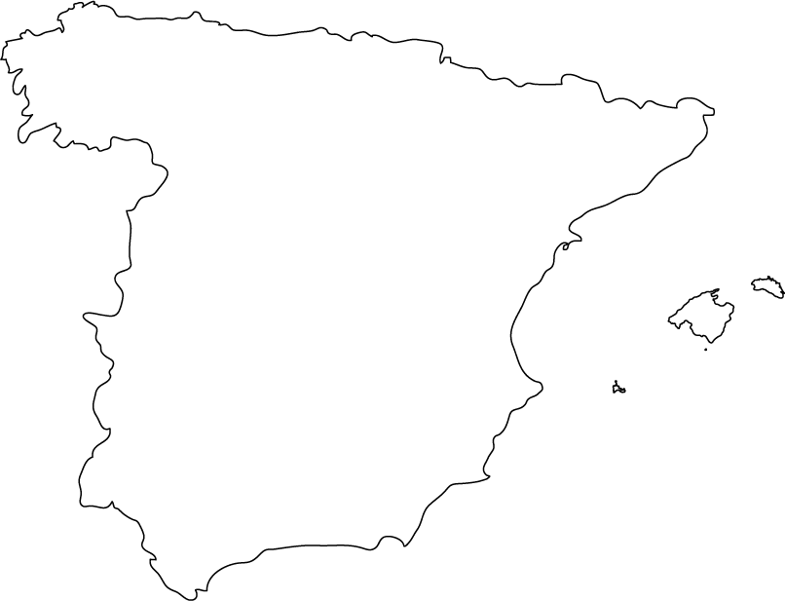

B. Identify the following locations. [10 points]
(Hint: three are bodies of water and two are countries)
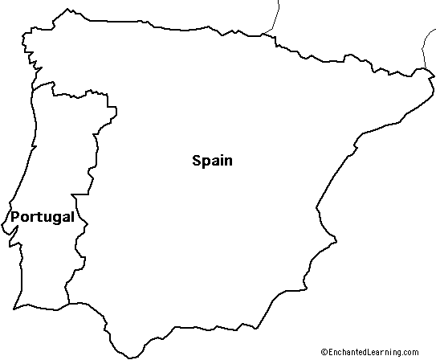
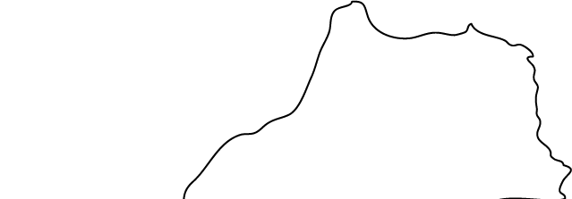

II. HISTORIA
A. Match the historical figure on the left with the correct description on the right.
(Refer to the Country Profile links or do a web search to answer these questions.)
[24 points]

____ | 1. General Francisco Franco | a. Captured Granada, the last Moorish city in Spain, and ended the “Reconquista” in 1492.
____ | 2. Francisco Goya | b. Also known as Domenico Theotocopoulos, painter, sculptor and architect.
____ | 3. El Greco | c. On November 20, 1975 he was designated King of Spain according to the law of succession  established by Franco.
____ | 4. Fernando and Isabel | d. Spanish author, best known for his novel, Don Quijote de la Mancha
____ | 5. Juan Carlos de Borbón | e. Ruled Spain as a dictator from 1939 until 1975.
____ | 6. Miguel de Cervantes | f. A portraitist of royalty and chronicler of history, his best known paintings areThe Nude Maja (La Maja desnuda) and The Clothed Maja (La Maja vestida).

B. Briefly answer each of the following questions. [12 points]
(Refer to the Country Profile links or do a web search to answer these questions.)

1. What is ETA? What is the goal of this organization? What does the acronym “ETA” stand for?
_________________________________________________________________
_________________________________________________________________

2. Who invaded and ruled the Iberian Peninsula during the 2nd century B.C.? What’s their
legacy in terms of present day Spain (mention three)?
_________________________________________________________________
_________________________________________________________________

C. Mark each statemnt “t” (true) or “f” (false). [16 points]
(Refer to the Country Profile links or do a web search to answer these questions.)

_____ 1. From the 8th to the 15th centuries, parts of the Iberian peninsula were ruled by Muslims (also known as the Moors).
_____ 2. Spanish is the only language spoken in the Iberian Peninsula.
____ 3. Spain is divided into 17 autonomous communities and two autonomous cities.
_____ 4. During the 16th century, during the reigns of Carlos I and Felipe II, Spain became the most powerful European nation.

III. ESTADÍSTICAS de la ACTUALIDAD (Current Statistics)
Mark each statement “t” (true) or “f” (false). [15 points]
Refer to: http://www.cia.gov/cia/publications/factbook/geos/sp.html

____ 1. The highest elevation is the “Pico de Teide” (Tenerife) Canary Islands 3,718 m.
____ 2. 26% of the population of Spain speaks a language other than Castilian Spanish.
____ 3. The currency in Spain is the “peseta”.
____ 4. The size of Spain is slightly more than twice the size of Oregon
____ 5. The estimated population of Spain in July 2005 was just over 40 million.

IV. INFORMACIÓN CULTURAL
Do a general web search to find the information needed to briefly answer these questions. Include the URL of any site(s) used. [10 points if you write in English; 15 points if you write in Spanish. Answer using your own words (i.e., don’t copy directly from any site whether it’s in Spanish or English).]

- What is la paella? What are the main ingredients?
________________________________________________________________
URL used: ________________________________________________________
2. What is el flamenco? What are its origins?
___________________________________________________________
URL used: ___________________________________________________
3. Who is Pablo Picasso? What does his painting “Guernica” portray?
___________________________________________________________
URL used: ___________________________________________________
4. Who is Antonio Gaudí? Describe his style.
___________________________________________________________
URL used: ___________________________________________________
5. What is Real Madrid? When was the team founded?
________________________________________________________________
URL used: ________________________________________________________

