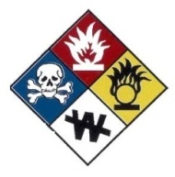
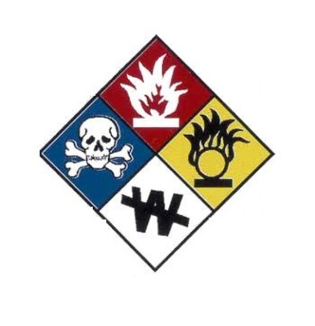
University of Delaware

Department of Environmental Health & Safety

Laboratory Safety Certification Form

Use this form to document your Initial or Annual Right-To-Know Training, Chemical Hygiene Plan Training and any other chemical/laboratory safety training as appropriate.

This form is designed for Personnel, Researchers, Faculty, Staff and Students who work in research and teaching laboratories.

Date of Chemical Hygiene Plan/Safety and Right-To-Know Training:

Please Check All That Apply: I DO USE OR WORK AROUND CHEMICALS
I DO NOT USE OR WORK AROUND CHEMICALS

I certify I have received training pursuant to the Hazardous Chemical Information Act (Right To Know) and University of Delaware Policy. In addition to training on my rights under the law, I:

- know where the Workplace Chemical List/Chemical Inventory is located and understand its purpose.
- know how to interpret labels and MSDSs.
- know where the MSDSs are located and know that online resources exist through the EHS Web Page (http://www.udel.edu/ehs) .
- have been instructed in the physical and health hazards, proper handling, storage and disposal practices for the chemicals I use.
- have been instructed in any special hazard consideration (if applicable).
- understand the protective measures, first aid procedures and emergency procedures necessary for the chemicals I use.
- know that the Hazardous Materials Safety Manual is available online at http://www.udel.edu/ehs/hazmatman.pdf and have reviewed the manual. Print copies may be available upon request from Environmental Health and Safety
- have received a Job Hazard Analysis and know what Personal Protective Equipment is required for my duties. I understand that I must wear eye protection at all times in the laboratory when an eye hazard exists.
- understand that there are special procedures and requirements for managing chemical and hazardous waste and that these materials must not be poured down the drain or placed in the regular trash.
- am aware that there are special requirements for shipping and transporting chemicals, research samples, etc. I am aware that I must contact the Department of Environmental Health and Safety to assist with shipping and transporting these materials.
- understand that the Occupational Safety and Health Administration (OSHA) requires that laboratory workers be made aware of the Chemical Hygiene Plan (CHP) (29 CFR 1910.1450). It is located at http://www.udel.edu/ehs/chemhygieneplan.pdf. Contact your Departmental Chemical Hygiene Officer for more information or to access a printed copy.

SPECIAL TRAINING (Document any chemical, task specific or laboratory safety training below that is not covered by the Right- To-Know and Chemical Hygiene Plan Training. Attach additional pages as necessary)

The named individual has been thoroughly trained and demonstrates competency in safe work practices involving the chemical and/or special laboratory procedures listed below.

Date | Training Topic | Date | Training Topic

After becoming familiar with the "University of Delaware Chemical Hygiene Plan and Hazardous Material Safety Manual," please complete and return a copy of this form to your supervisor or the Department Chemical Hygiene Officer. By checking the box and signing below you acknowledge that you are aware of the Chemical Hygiene Plan and the policies and procedures applicable to the OSHA standard (29 CFR 1910.1450). Your supervisor will provide additional information and training as appropriate.

Date | Printed Name of Supervisor/Instructor
Printed Name of Employee/Student | Signature of Supervisor/Instructor
Signature of Employee/Student | Department

Distribution: 1. Department Safety File 2. Safety Committee 3. Environmental Health and Safety

