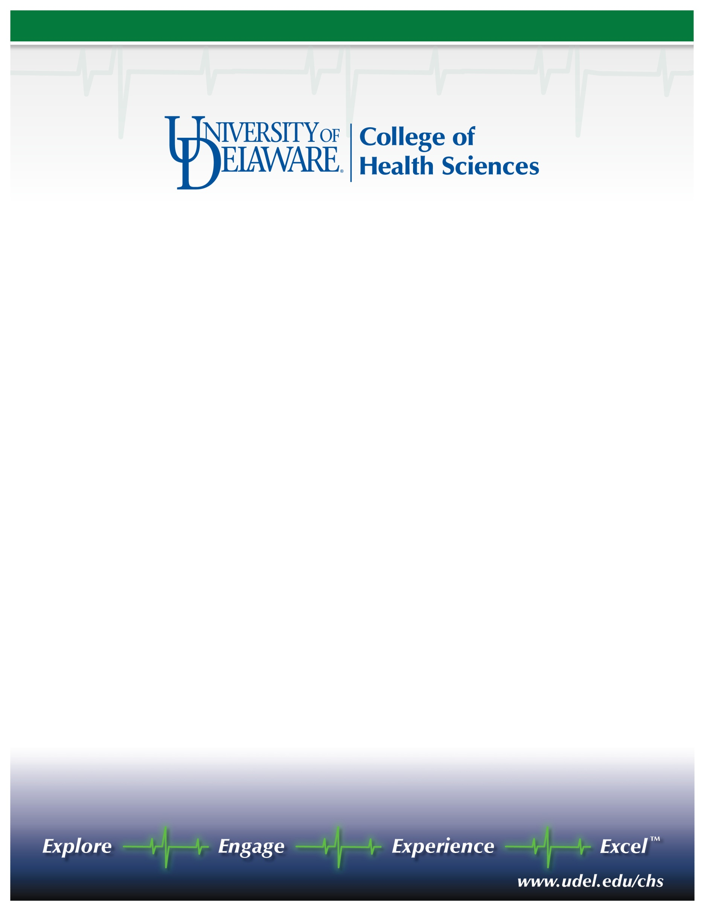

Unidel Professor of Health Sciences  
Appointment effective September 1, 2011

The College of Health Sciences (CHS) at the University of Delaware seeks nominations and applications for a newly created endowed chair with expertise in physiology, broadly defined. We seek a visionary senior scientist with a vigorous research program, strong record of mentoring graduate students and postdoctoral fellows, and significant extramural funding, to provide leadership in developing 1) an exciting new clinical research complex, and 2) new inter-institutional collaborations through the emerging Delaware Health Sciences Alliance. The Unidel Professor of Health Sciences will also be expected to continue a productive, externally funded research program, mentor graduate students and postdoctoral fellows, and do some teaching.

The College of Health Sciences is a thriving academic unit of over 2000 students and approximately 100 faculty with state-of-the-art research and teaching facilities. The college includes the departments of Behavioral Health and Nutrition, Kinesiology and Applied Physiology, Medical Technology, and Physical Therapy, and the School of Nursing. Joint appointments for the new endowed chair with other campus units or clinical institutions are also possible. The college is poised to establish an exciting new comprehensive clinical research complex on a recently acquired 272-acre tract of university property that is slated for joint development as a prominent new hub for collaborative clinical research in what is already one of the nation’s leading life science regions.

The endowed chair will also have the opportunity to partner with CHS Dean Kathleen S. Matt in leading the development of the Delaware Health Sciences Alliance (http://www.delawarehsa.org/.) The alliance includes four major institutions - the University of Delaware, Christiana Care Health System, Alfred I. duPont Hospital for Children/Nemours, and Thomas Jefferson University-Jefferson Medical College. These DHSA institutions are aligning their resources to facilitate innovative collaborations among experts in medical practice, health economics and policy, population sciences, and public health, as well as the biomedical sciences and engineering.

Founded in 1743, the University of Delaware combines tradition and innovation, offering students a rich heritage along with the latest in instructional and research technology. Located in scenic Newark, Delaware, within 2 hours of New York, Philadelphia, Baltimore, and Washington, D.C., the University is a state-assisted, privately governed institution. One of the oldest land-grant institutions in the nation, one of 19 sea-grant institutions, and one of only 13 space-grant institutions, the University has nationally recognized research (Carnegie rated, very high research activity) and educational programs supported by state-of-the-art facilities and an expansive library. External funding at the University exceeds $160 million.

Review of applications will begin on October 1, 2010. Nominations and applications will be accepted until the position is filled. Nominations and expressions of interest will be held in confidence, and references will not be contacted without a candidate’s permission. Candidates should submit a letter of interest, a detailed resume, and the names and contact information for four references to: Deputy Dean Susan J. Hall, Chair, Unidel Chair Search Committee, 345 McDowell Hall, University of Delaware, Newark, DE 19716. For inquiries, phone: (302) 831-8372 or sjhall@udel.edu.

*The UNIVERSITY OF DELAWARE is an Equal Opportunity Employer and encourages applications from Minority Group Members and Women.*