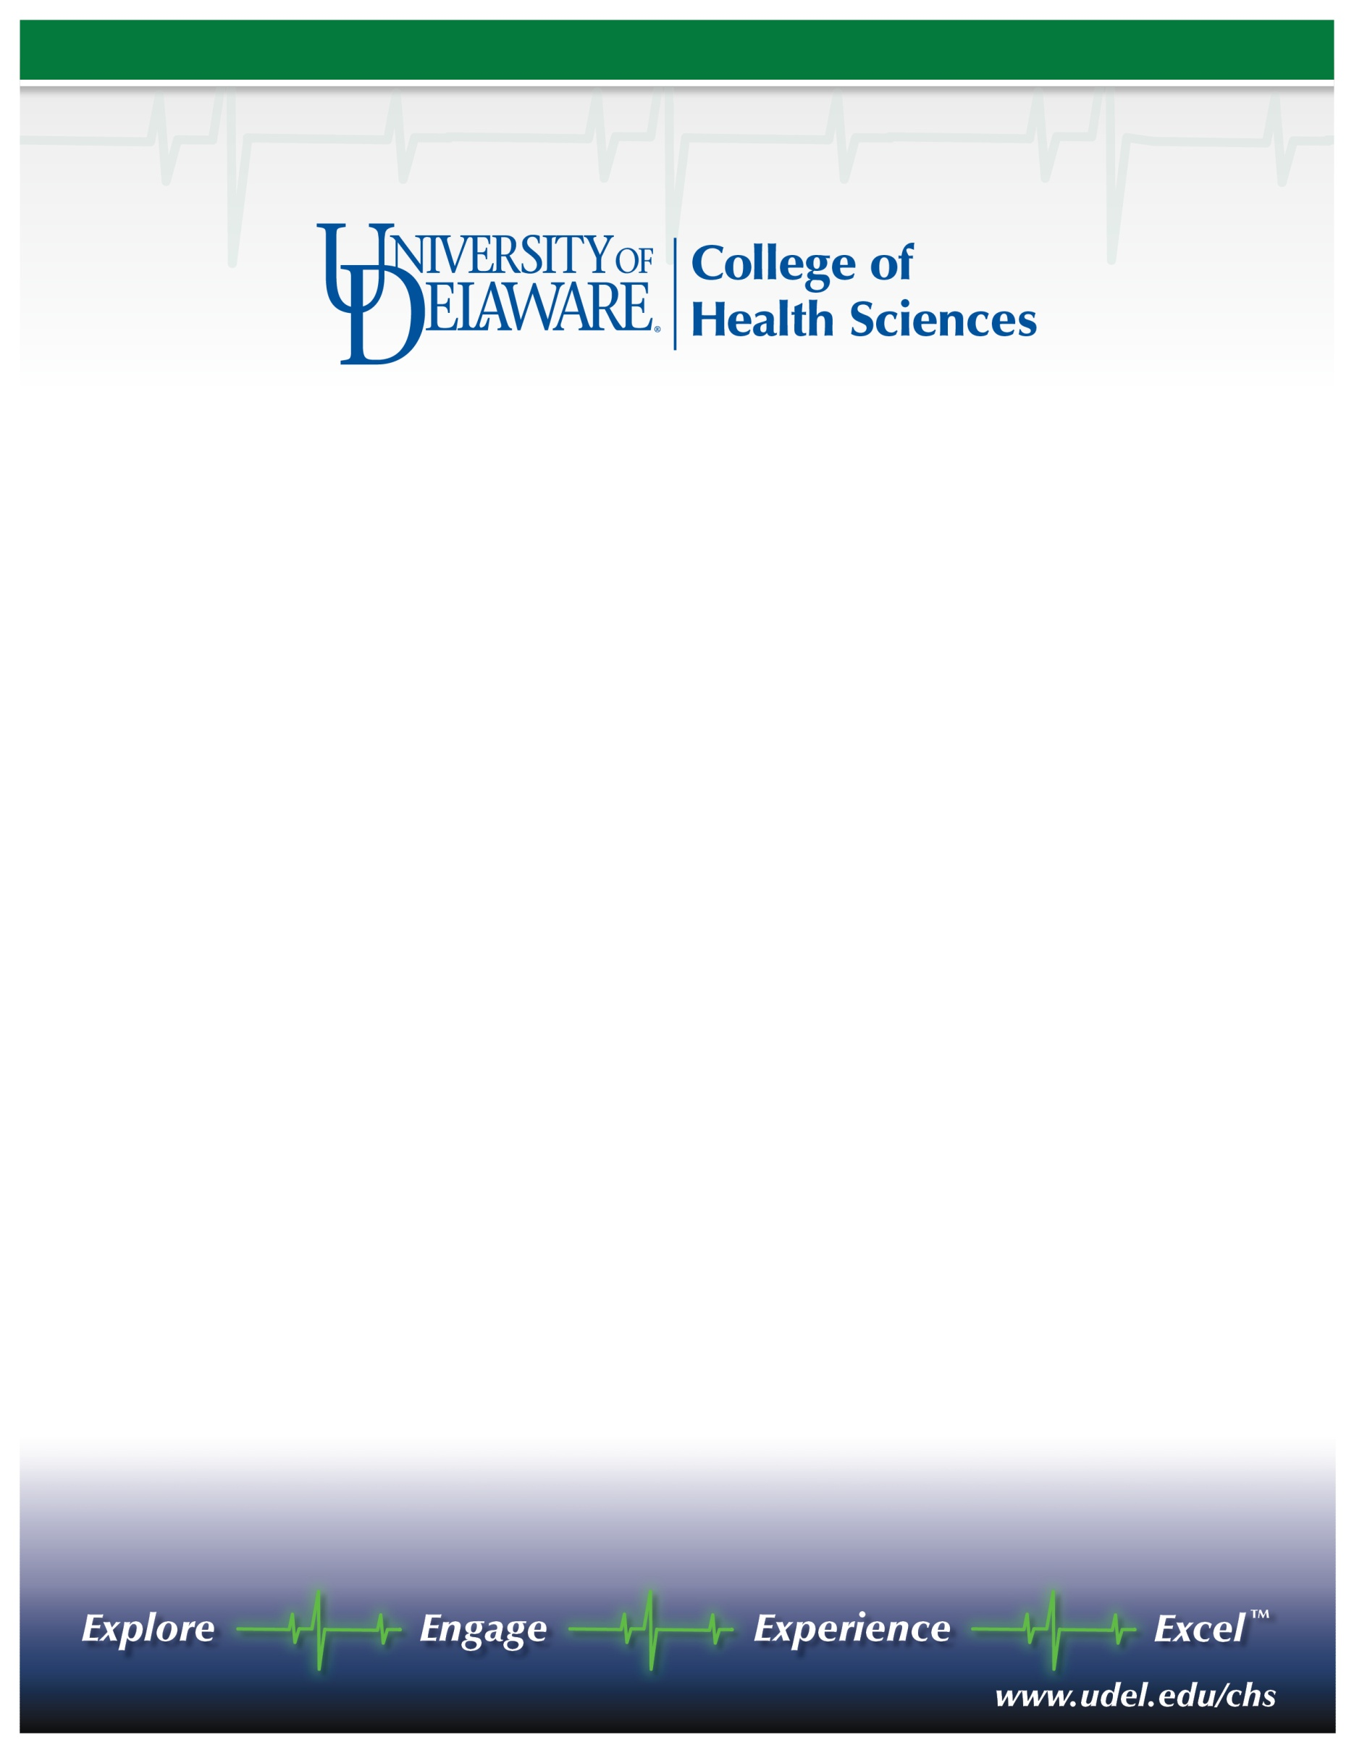

Department of Physical Therapy  
Assistant or Associate Professor/Anatomist  
Appointment effective January 1, 2011

The Department of Physical Therapy at the University of Delaware invites nominations and applications for a nine-month tenure track Assistant or Associate Professor. We seek a clinical scientist with strong research training, a commitment to professional and graduate education, as well as effective interpersonal skills. The candidate should have an earned doctorate in a related field, have post-doctoral research training, be eligible for licensure as a physical therapist in Delaware, and possess a strong desire to develop and conduct a nationally/internationally recognized research program and to teach effectively. The successful applicant will lead the Department’s teaching efforts in the areas of Gross Anatomy and Neuroanatomy. The teaching load will be appropriate to allow the candidate to pursue a rigorous research program. Rank and salary are commensurate with experience and qualifications. Start-up funds accompany this position.

The Department of Physical Therapy (<http://www.udel.edu/PT>) is a thriving academic unit of 20 faculty and professionals, approximately 100 graduate students pursuing a Doctor of Physical Therapy, 30 graduate students pursuing a Ph.D., Biomechanics and Movement Science, post-professional residencies in Sports, Orthopedic and Geriatric Physical Therapy and active Sports & Orthopedic, Neurological and Older Adult and Pediatric Clinics. The Department provides an environment that supports and fosters the development of a focused, productive and high-quality research program by all faculty members. The department is part of the College of Health Sciences, which also includes the departments of Behavioral Health and Nutrition, Medical Technology, and Kinesiology & Applied Physiology, and the School of Nursing. The college is poised to establish an exciting new comprehensive clinical research complex on a recently acquired 272-acre tract of university property (<http://www.udel.edu/udaily/2010/nov/chrysler112309.html>) that is slated for joint development as a research and technology campus by the university and our health science alliance partners <http://www.delawarehsa.org/>.

Founded in 1743, the University of Delaware combines tradition and innovation, offering students a rich heritage along with the latest in instructional and research technology. Located in scenic Newark, Delaware, within 2 hours of New York, Philadelphia, Baltimore, and Washington, D.C., the University is a state-assisted, privately governed institution. One of the oldest land-grant institutions in the nation, one of 19 sea-grant institutions, and one of only 13 space-grant institutions, the University has nationally recognized research (Carnegie rated, very high research activity) and educational programs supported by state-of-the-art facilities and an expansive library. External funding at the University exceeds $160 million. More information is available at [www.udel.edu](http://www.udel.edu).

Review of applications will begin on July 1, 2010 and will continue until the position is filled.. Nominations and applications will be accepted until the position is filled. Nominations and expressions of interest will be held in confidence, and references will not be contacted without a candidate’s permission. Candidates should submit a letter of interest, a detailed resume, and the names and contact information for four references to: Professor Lynn Snyder-Mackler, PT, ScD, FAPTA, Search Committee Chairperson, Department of Physical Therapy, University of Delaware, 301 McKinly Laboratory, Newark, DE 19716; 302-831-3613, or email to [smack@udel.edu](mailto:smack@udel.edu). The curriculum vitae and letters of reference shall be shared with departmental faculty.

*The UNIVERSITY OF DELAWARE is an Equal Opportunity Employer and encourages applications from Minority Group Members and Women.*