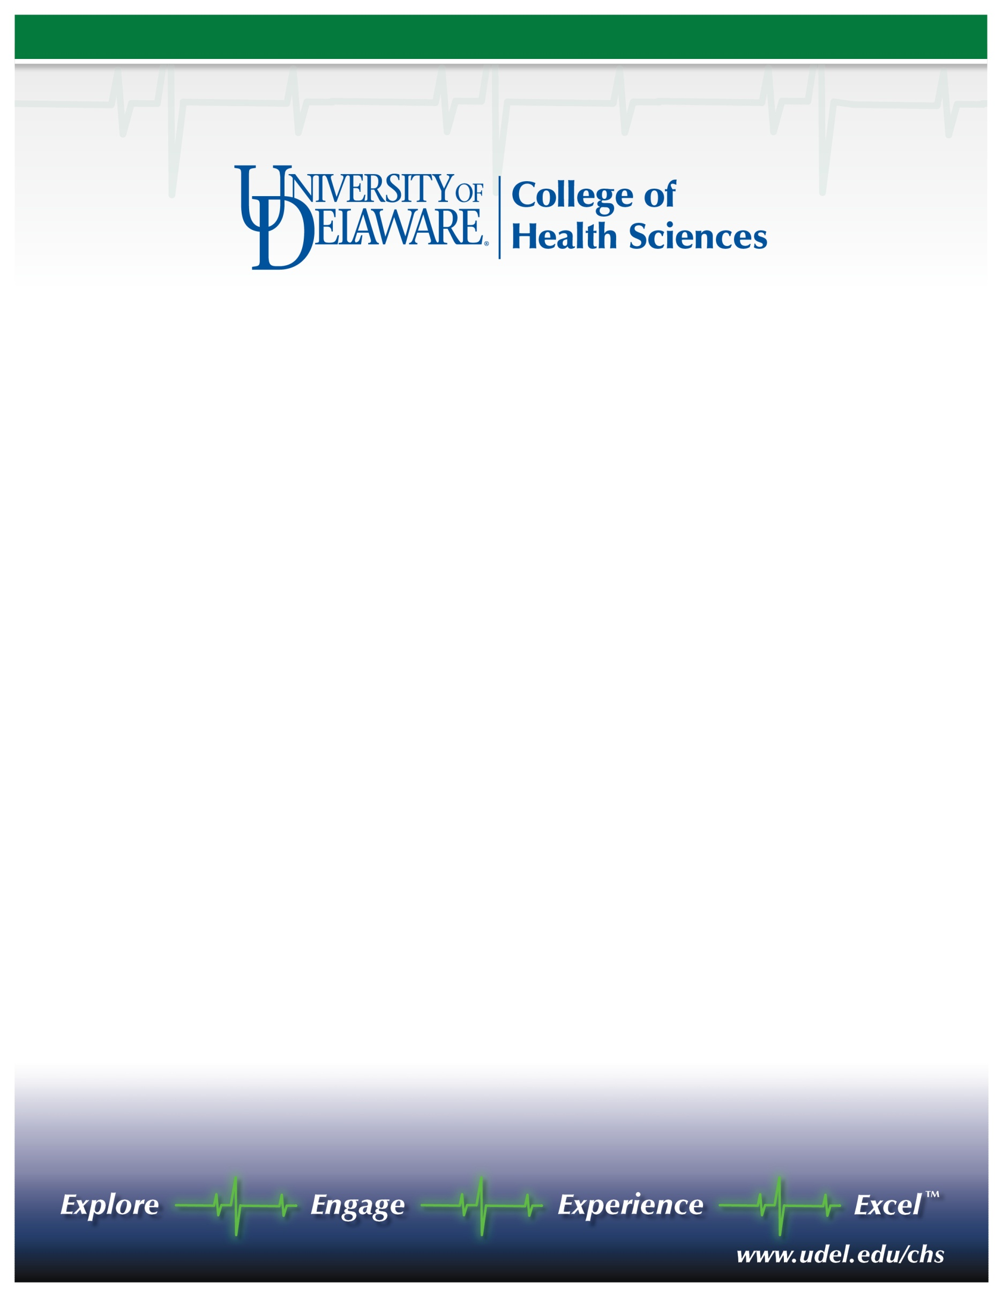

Named Professor, School of Nursing  
Appointment effective September 1, 2011

The School of Nursing at the University of Delaware invites nominations and applications for the Nannie Longfellow Professor of Nursing Science. We seek a visionary senior scholar with a vigorous, extramurally funded research program that aligns with one of the School’s existing research strengths who will provide strong, dynamic, and innovative leadership for the School’s new Ph.D. program. Doctorate and current faculty rank of associate or full professor required. Potential for a cluster hire such that the successful candidate may have the opportunity to bring in 1-2 colleagues who qualify for tenure-track positions at assistant/associate professor level. Independent applications for a tenure-track assistant professor position are also encouraged. Doctorate required; doctoral candidates (ABD) will be considered.

Faculty research in the School of Nursing is organized around three foci: Health Promotion & Risk Reduction across the Lifespan; Health System, Management, Policy & Education; and Management of Chronic Conditions. Faculty working within these foci have expertise in adult health, oncology, neurology, gerontology, and women's health. The School of Nursing is part of the College of Health Sciences (<http://www.udel.edu/chs/>), which also includes the departments of Behavioral Health and Nutrition, Kinesiology and Applied Physiology, Medical Technology, and Physical Therapy. The college is poised to establish an exciting new comprehensive clinical research complex on a recently acquired 272-acre tract of university property (<http://www.udel.edu/udaily/2010/nov/chrysler112309.html>) that is slated for joint development as a research and technology campus by the university and our health science alliance partners <http://www.delawarehsa.org/>.

The University of Delaware is a state-assisted, privately governed institution. Located in scenic Newark, Delaware, within 2 hours of New York, Philadelphia, Baltimore, and Washington, D.C., the University has nationally recognized research (Carnegie rated, very high research activity) and educational programs supported by state-of-the-art facilities and an expansive library. External funding at the University exceeds $160 million. Faculty receive annual across the board and competitive merit salary increases and the benefits package is one of the best in the nation.

Review of applications will begin on October 1, 2010. Nominations and applications will be accepted until the positions are filled. Nominations and expressions of interest for the named chair will be held in confidence, and references will not be contacted without a candidate’s permission. Application materials for the assistant professor positions will be shared with faculty in the College of Health Sciences. Candidates should submit a letter of interest, a curriculum vitae, and the names and contact information for three references to: Veronica F. Rempusheski, PhD, RN, FAAN, Search Committee Chair, 207 McDowell Hall, University of Delaware, Newark, DE 19716. (302) 831-8502 or [vrempush@udel.edu](mailto:vrempush@udel.edu).

*The UNIVERSITY OF DELAWARE is an Equal Opportunity Employer and encourages applications from Minority Group Members and Women.*