Gin and Quinine Anyone?

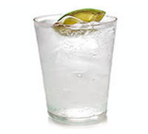

A Case Study on Quinine and Malaria

Susan Lorenz
December 2, 2005

Case Summary:

The main point of this case study was to give a “source to sink” perspective of the malarial drug quinine. There is so much information about quinine, there could be a whole entire class devoted to it. The case study is developed in a sequential order that seeks to do the following:
- Introduce alkaloids as the class of chemical compounds to which quinine belongs.
- Consider the biosynthesis of quinine.
- Develop the idea of plant secondary metabolites derived from amino acids.
- Use isotopic labeling in elucidating biosynthetic pathways.
- Introduce the “life cycle” of malaria, in terms of the plasmodium (protozoan parasite), mosquito (insect vector), and human (host target).
- Develop the mechanistism of action of quinine.
- Introduce the problem of dealing with foreign chemicals in the human body
- Develop the general concept of P450 metabolism with specific reference to CYP3A4

The case study encourages group participation at all levels. It warrants a group assignment to make a source to sink illustration of quinine as well as a follow up class discussion with the professor of any unresolved learning issues. This allows students to finish the case study with a solid understanding of the material.

Gin and Quinine Anyone? | 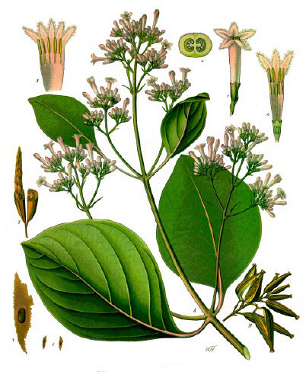  Cinchona
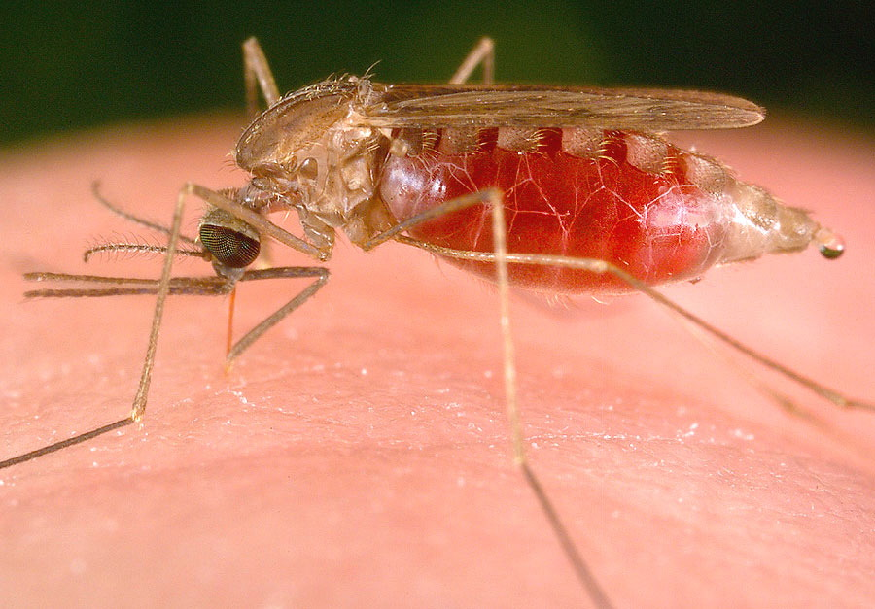
Malaria Mosquito

Page 1: Disturbing the Peace: Malaria in Thailand

Amy was working in the jungle of Thailand as a Peace Corps volunteer after finishing college. After she had been in the country for about 3 months she began experiencing flu-like symptoms including fever, chills, headache, muscle aches, tiredness, nausea, vomiting, and diarrhea. Amy got quite ill over the next few days and decided to go to the hospital in the nearby city of Bangkok and consult with a doctor.
With the help of an interpreter Amy was diagnosed with malaria, an infectious disease caused by parasites that are transmitted through the bite of an infected mosquito, and given an intravenous dosage of quinine. The name quinine rang a bell in Amy’s mind and she began racking her brain. After a long day in the hospital, Amy was feeling parched and reached into her suitcase and pulled out her trusty bottle of tonic water. She
had promised her mother before leaving for Thailand that she would only drink bottled water.
Amy took a sip of her Schweppes and made the connection, quinine was an ingredient in tonic water. Amy was intrigued and ready for a little bit of research. Her main question was, how can quinine be both flavoring in tonic water and an anti-malarial drug? She sighed with relief that she was out of the jungle and in a major city where she could rely on the World Wide Web for answers. Amy was exhausted and still feeling ill and decided to hold off on her research until she got her strength back.
After a few more intravenous doses of quinine, Amy felt well enough for a little research. Amy learned that quinine was an alkaloid from the bark of a tree and first used by Peruvian Indians in the 1600’s as a remedy for curing fevers. Legends claim, that the tree was named for the Countess of Chinchón, the Viceroy of Peru’s wife, who was cured by this miraculous bark. Spanish Jesuit missionaries throughout South America learned about Cinchona’s medicinal purposes and the ground up bark slowly made its way into Europe as one of the first pharmaceutical drugs. Cinchona bark dissolved in water was used during the British colonization of India in the 17th century as an anti-malarial remedy. Its bitter taste led the British to mix the powdered bark with a small amount of gin or vodka to improve the taste. Tonic water originated from this usage.
In 1820 two scientists, Pelletier and Caventou, isolated an alkaloid chemical in cinchona bark with strong anti-malarial properties and named it quinine. In 1944, Robert Woodward and William Doering were the first people to synthetically synthesize quinine from coal tar. Amy was thrilled with all of the information she had collected but still had several questions about the chemical that was being pumped into her body.
Amy recalled the term alkaloid from an organic chemistry class she had taken a few semesters ago. She knew alkaloids were a class of compounds primarily from plants. Amy was immediately intrigued that a chemical produced by plants could cure her of malaria. Amy wanted to know more about the properties alkaloids. She wanted to understand the role of alkaloids in nature, and what the precursor molecules to alkaloids may be.

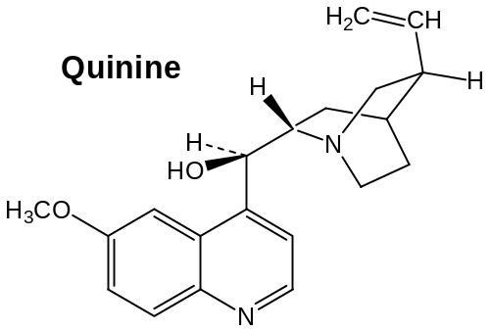

- To assist Amy further in her research, come up with a list of 5 learning issues that you would like to explore about plant alkaloids and their medicinal roles.

- Amy read that most alkaloids are secondary metabolites derived from amino acids. Tryptophan is the likely precursor of quinine. Based on your knowledge of intermediary metabolism, compare the structure of quinine with that of tryptophan and predict where each carbon and nitrogen specifically corresponds to those in quinine. Also suggest what other natural product may be a component of quinine besides tryptophan.

- What are the major biochemical principles of alkaloid biosynthesis?

Page 1: Disturbing the Peace: Malaria in Thailand - Teaching Notes

The purpose of page 1 is to introduce students to alkaloids and their role in nature. This will be a new concept for most students, so they will not posses much background knowledge on the topic. As a concept directly relating to alkaloids, is their role as secondary metabolites of amino acids. Many alkaloids are derived from amino acids or a combination of amino acids and other common metabolites. There are many learning issues that can be developed regarding alkaloids. The following are some questions that might arise and the kinds of information the students should discover.

To assist Amy further in her research, come up with a list of 5 learning issues that you would like to explore about the role of plant alkaloids in nature and in medicinal uses.

- What are the chemical properties of plant alkaloids? One of the properties of alkaloids can be derived just from looking at the name, alkaline. Alkaloids are basic organic compounds that have at least one nitrogen atom connected to carbons within a heterocyclic ring system. Alkaloids are usually white or colorless solids. They are a large and divers group of chemical compounds.

- What are the different types of alkaloids, what are the structural differences between different types of alkaloids? There are several different types of alkaloids including: Pyridine-piperidine alkaloids tropane alkaloids, quinoline alkaloids, isoquinoline alkaloids, quinolizidine alkaloids, pyrrolizidine alkaloids, indole alkaloids, imidazole alkaloids, alkaloidal amines, purine alkaloids, steroidal alkaloids.

- Pyridine-piperdine alkaloids are classified as having nitrogen atoms in six membered rings. Their precursor molecules are usually ornithine and nicotinic acid. Nicotine is an example of a pyridine-piperdine alkaloid. | 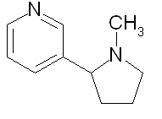
- Quinoline alkaloids have a bicyclic ring system normally containing fused benzene and pyridine rings. The normal precursor molecules are tryptophan and a terpene unit. Quinine is an example of a quinoline alkaloid. | 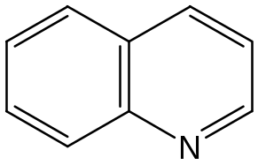
- Isoquinoline alkaloids are condensed from phenylthylamine and phenylactedaldehyde. The precursors are phenylalanine or tyrosine. There are many important types of these alkaloids including morphine and codeine. | 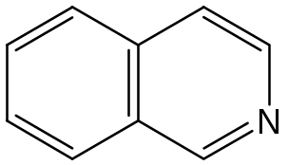
- Tropane alkaloids contain two types of ring structures, pyrrolidine and piperidne. They are formed from ornithine and phenylalanine. | 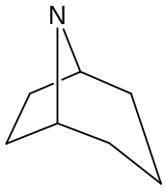
- Quinolizidine alkaloids have a fused ring structure with a shared nitrogen as seen below. The precursor molecule to these alkaloids is lysine. | 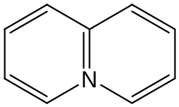
- Pyrrolizidine alkaloids have two 5 membered fused rings with a shared nitrogen atom. The precursor is ornithine. | 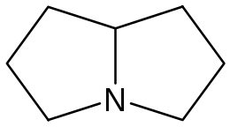
- Indole alkaloids are a large group of compounds. The basis of their structure is a pyrrole ring connected to a benzene ring as seen at the right. The precursor is tryptophan and an isoprene unit. | 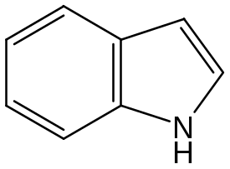
- Steroidal alkaloids have a nitrogen atom in their isoprene structure that separates them from their steroid counterparts. | 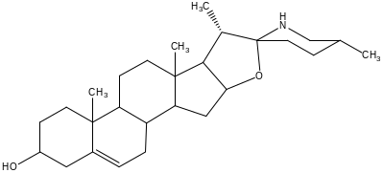
- Alkaloidal amines are derived from aromatic amino acids and their amino group occurs in the side chain attached to a ring structure. An example of an alkaloidal amine is ephedrine. | 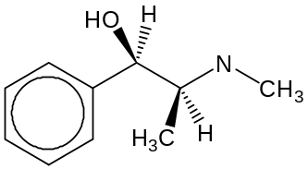
- Purine alkaloids are derived from xanthine, which is an oxidized purine. It is a product of nucleic acid breakdown. Purine alkaloids are mehtylated xanthines. An example of this type of compound is caffeine. | 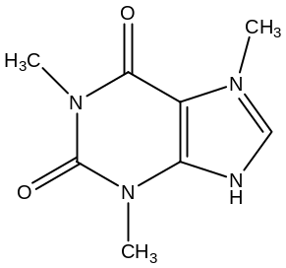

- Do alkaloids exist in a specific type of plants? Alkaloids are not specific to one family or type of plants. Alkaloids occur in 15-30% of all flowering plants. Many of these plants have more than one type of alkaloid in them. Higher plants are the main source of alkaloids, they also occur in lower plants like algae, fungi, microorganisms and some insects. There are about 6 types of plants that alkaloids are very common in. Alkaloids are found in all the different pars of the plant including roots, fruit, leaves, bark and seeds.

- What are their pharmacological actions in humans? Do the different types of alkaloids all have similar mechanism? Akaloids have many diverse pharmacalogical actions in humans. For example morphine is used as a narcotic to fight pain. Vinblastine is used as an antileukemic drug. Berbeine is used as an anti-microbial, quinine is used as an anti-malarial, strychnine is used as stimulate and ephedrine is used as a hypertensive drug.

- What is the chemical role of alkaloids in plants? Blieve it or not, little is known about the role of alkaloids in plants. There have been several different mechanisms proposed for their actions in plants including that differ from species to species. One of the main roles of alkaloids is that of pesticides. Some alkaloids like quinine have a bitter taste that ward off potential predators.

- What type of alkaloid is quinine? What is its pharmacological action? Quinine is a quinoline alkaloid derived from tryptophan and geraniol. Its pharmological action is that it inhibits the heme polymerase activity in plasmodium acting as an anti-malarial drug.

Based on your knowledge of intermediary metabolism, compare the structure of quinine with that of tryptophan and predict where each carbon and nitrogen specifically lies in quinine. Also suggest what other natural product may be a component of quinine besides tryptophan.

- The student can use their knowledge of intermediary metabolism to look at quinine as a secondary metabolite in plants and compare it with tryptophan and show how the specific atoms of tryptophan have been incorporated into quinine.
- One of the key aspects of this comparison is for the student to understand the role of nitrogen in alkaloid molecules. Alkaloids as mentioned above are nitrogen-containing compounds.
- The amino acid tryptophan has nitrogen that stems off of the alpha carbon molecule, and a nitrogen atom contained in the 4-carbon ring.
- It is essential that the student can make this connection and place tryptophan into quinine by focusing on the positioning of the nitrogen atoms.
- It is also important for the student to understand that there is another chemical component of quinine that is not derived from an amino acid.
- By counting the carbons in tryptophan and comparing them to quinine it is obvious that the second chemical unit involved has to account for 10 carbons.
- Based on knowledge of cholesterol biosynthesis, the idea of a 10-carbon unit should trigger the idea of isoprene units.
- A 10 carbon compound would consist of two isoprene units making it a monoterpene.
- A common 10-carbon monoterpene especially in plants, is geranial.
- The next phase of the case study ties together the idea the quinine is formed from two different metabolic pathways.

What are the major biochemical principles of alkaloid biosynthesis?
- This question is meant to provoke interest in the basic biosynthesis principles of alkaloids.
- There are three major types of reactions involved in alkaloid biosynthesis.
- In many of the scholarly articles on alkaloid biosynthesis, the prevalence of these reactions in alkaloid chemistry is noted.
- These reactions include oxidative coupling of phenols, Mannich-type reactions and Schiff base formation.
- This concept is introduced so that on the following page, students can try and identify what type of reaction is involved in the biosynthesis of quinine.

References:

Hirono I. Naturally Occurring Carcinogens of Plant Origin. 1987: Elsevier, Tokyo.

Oaks SC. Mitchell VS. Pearson GW. Carpenter CCJ. Malaria Obstacles and Opportunities. 1991: National Academy Press, Washington DC.

Pengelly K. Constituents of Medicinal Plants. 2004: Allen and Unwin, UK and US.

Staba JE. Chung AC. Quinine and Quinidine Production By Cinchona Leaf, Root and Unorganized Cultures. Phytochemistry 1981; 20, 11: 2495-2498.

Woodward RB. Doering WE. The Total Synthesis of Quinine. The American Chemical Society 1944; 67: 860-873.

Zenk MH. Phillipson JD. Indole and Biogenetically Related Alkaloids. 1980; Academic Press, New York.

Gin and Quinine Anyone?
Page 2: Comparative Advantage - Chemistry

Amy’s competitive nature inspired her to check to see if her prediction for tryptophan’s location in quinine was correct as well as her guess for the 10 carbon donator metabolite. A quick email to her former organic chemistry professor provided her with the original journal article that proposed the biosynthetic pathway for quinine. Her professor informed her that the chemists who elucidated this interesting pathway had fed labeled ¹⁴C tryptophan to a cinchona plant then isolated quinine to identify the placement of the label.
They had also tested the hypothesis of another chemist by labeling the monoterpene geraniol with ¹⁴C and feeding it to the cinchona plants. Their results showed that geraniol was indeed the 10 carbon primary metabolite.
Amy gave herself a pat on the back for being correct in her prediction. Even though she wasn’t in school any more, she still had it! Amy wondered how two chemicals from two different metabolic pathways came together to form quinine? Amy decided to examine the pathway in detail to try and deduce this interesting phenomenon. Amy also started to wonder about how this drug cured malaria.

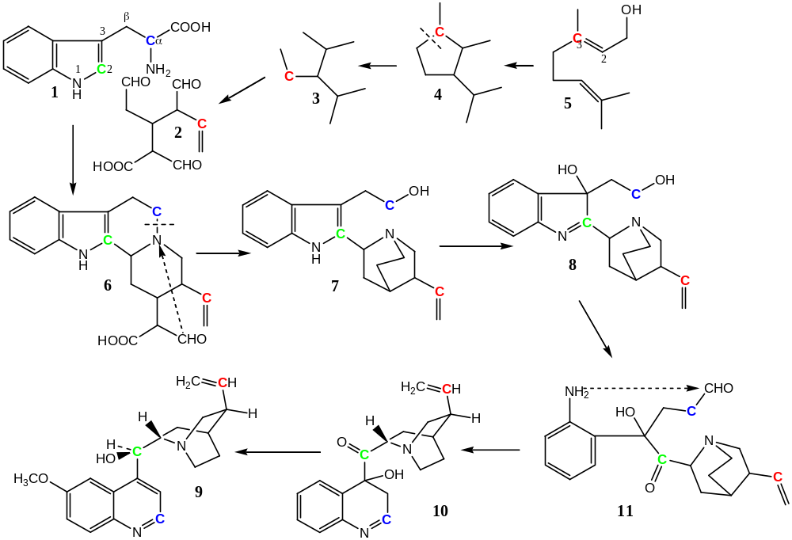

Proposed biosynthetic construction of quinine (9) from geraniol (5) and tryptophan (1). Modified from Leete & Wemple JACS 91:2698-2702 (1969).

- Was your prediction from the previous page correct? Write out a list of chemical observations that occur in this biosynthetic pathway. Using your knowledge of page one on the principles of alkaloid chemistry, try to identify the overall biochemical principle that ties together tryptophan and geraniol (hint: identify the type of organic reaction).

- To help Amy understand how these two metabolic pathways come together, use your knowledge of intermediary metabolism and alkaloid chemistry to make a diagram that tie these two pathways together.

- From what you have learned about quinine thus far and its pharmacological action, come up with a list of learning issues and try and find answers to them in preparation for next class.

Page 2: Comparative Advantage - Chemistry - Teaching Notes

The purpose of page 2 is to help students become more familiar with the concept of secondary metabolites derived from amino acids in plants. The original proposed pathway of quinine biosynthesis is provided to illustrate this point. It is unlikely that students would deduce the pathway shown. In using this pathway, it also exposes students to the use of isotopically labeled compounds in biochemical research and that the labeling patterns must be consistent with the proposed pathway.

Was your prediction from the previous page correct? Make note of the types of chemical reactions that occur in each step of this biosynthetic pathway.
- This question allows students to examine their proposed answers against the original pathway and see how they differ from the proposed pathway.
- Students are then aware of their differences as they are going through the pathway writing out the chemical observations.
- Writing out observations in each step of the pathway help the student conceptualize what is occurring, and facilitates discussion within the group so that students can help explain to each other what kinds of reactions are taking place.
- Students, by observing this pathway, can follow the isotopically labeled atoms and get an even better understanding of the biosynthetic pathway. The isotopically labeled compounds allow students to see where specific atoms from either of the two precursors are in the compound. Without these labeled compounds it would be much more challenging to identify which precursors where in what positions.

Using your knowledge of page one on the principles of alkaloid chemistry, try to identify the overall biochemical principle that ties together tryptophan and geraniol (hint: identify the type of organic reaction).
- This question if meant to have students identify what kind of alkaloid reaction is specifically involved in quinine biosynthesis
- Tryptophan labeled with ¹⁴C at C-2 in the indole group and ¹⁵N on the indole nitrogen combine with geraniol labeled with ¹⁴C at the 3-C.
- Geraniol is compound number 5 in the pathway. It goes through a series of re-arrangements to compound number 2.
- Compound 2 then combines with tryptophan in a Mannich reaction to form compound 6. This is a key step in the pathway because it represents a major concept in alkaloid chemistry covered in the first page.
- Mannich reactions are involved in reactions in many biosynthetic pathways especially for alkaloids.
- Compounds capable of forming an enol, in this case, compound 2 in the pathway, react with imines from formaldehyde and a primary or secondary amine to yield aminoalkyl carbonyl compounds, Mannich bases, in this case compound 6.

- A general pattern for a Mannich reaction is illustrated below:

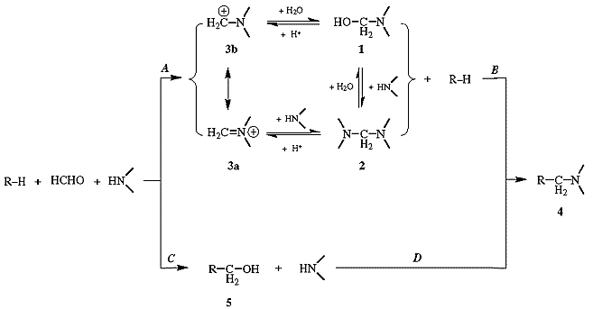

Use your knowledge of intermediary metabolism and alkaloid chemistry to make a diagram that ties these two pathways together.
- This question is not as open ended as other questions in this section.
- It is mean to help students conceptually pull together these two pathways in the context of alkaloids. It also applies the knowledge that students already have of the metabolic pathways.
- The diagram below is an example of a what students could do outline the relationships:
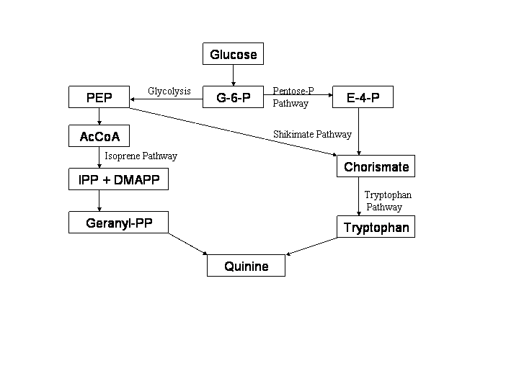
Note: there is an isoprene biosynthetic pathway in plants that differs from that in animals.
From what you have learned about quinine thus far and its pharmacalogical action, come up with a list of learning issues.

- The point of this question is for students to discuss the possible mechanisms that quinine may take in the human body to cure malaria.
- Students from page one will have basic information on the medicinal role of quinine and from that should be able to come up with several questions that delve deeper into this issue.
- Questions could include many different topics such as the life cycle of the plasmodium in the mosquito and human body, how quinine affects the plasmodium, if there are different varieties of plasmodium, or if there are any side effects of the drug. These are just a few examples of the many different questions students could ask.
- By introducing these learning issues, students will be able to explore the mechanistic details of quinine in preparation for the next page.

References:

Bateman DN. Dyson EH. Quinine Toxicity. Adverse Drug Reactions. 1986; 4: 215-233.

Leete E. Wemple J. Biosynthesis of the Cinchona Alkaloids. Journal of the American Chemical Society. 1969; 91: 2698-2702.

Ramstad E. Agurell S. Alkaloid Biogenesis. Annual Review of Plant Physiology. 1964; 15: 143-168.

Wenkert E. Biosynthesis of the Indole Alkaloids. Journal of the American Chemical Society. 1961; 84: 98-102.

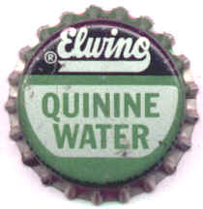 | Gin and Quinine Anyone?  Page 3: What if Mom was right for once?

Four days had gone by since Amy’s initial treatment with quinine, she was feeling better and decided it was time for a call home to tell her worrisome mother about her medical ordeal. Amy put up with the guilt trip her mother laid on her for not calling sooner. Her mother immediately began asking her what sorts of medications she was on and whether they were standard Western medicines or some Eastern concoction of natural herbs. All Amy needed to say was that quinine was a medicine taken from the bark of a tree and her mother was a basket case.
Her mother immediately started rattling off story after story of her friend’s son or daughter or cousin who had a bad experience with medicinal plants. Amy managed to convince her mother that she was doing better and that there was absolutely no need to charter a plane and send a medical staff to rescue her.
However Amy could not stop thinking about what her mother had said. She was in a foreign country and she was taking a natural product as medication. What if she somehow ended up with some other crazy side effect. It was decided. Amy had to learn about quinines path in her body, and what it did to cure malaria. This would be the only way she would be able to sleep tonight.
Amy was surprised to learn that very little information was available on the mechanistic details of quinine before the early 1990’s. She found a few articles and used her vast knowledge of biochemistry to put together the pieces of the mechanistic puzzle. Amy used the figure below as a starting point for her biochemical endeavor.

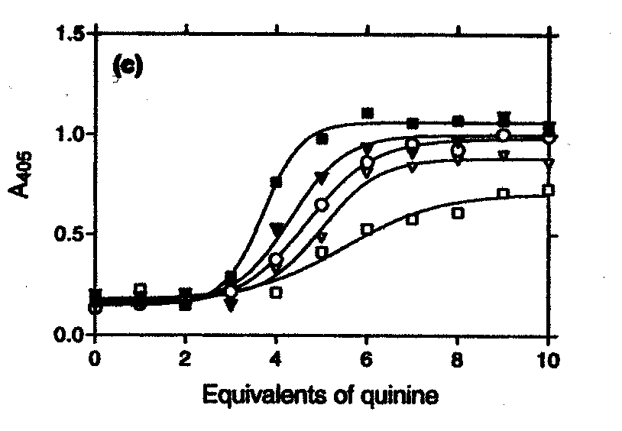
Fig. 3. The effect of incubation time on inhibition of β-hematin formation by chloroquine and quinine. The dose–response curves for chloroquine obtained with incubation times of 1 (■), 2 (), 3 (), 4 (♦), 5 (), 6 (), 7 () and 8 h () are shown in (a). The dependence of IC₅₀ for β-hematin inhibition by chloroquine on incubation time is shown in (b). The dotted line in (b) is shown for clarity and has no theoretical significance. Dose–response curves for quinine obtained with incubation times of 1 (■), 3 (), 5 (), 7 () and 24 h () is shown in (c).

- Using the information obtained from the learning issues discussed last class, link hemozoin to the life cycle and mode of action of the malaria parasite.

- Examine the above figure and discuss it as a group. Make a list of your observations, then try and explain them.

Page 3: What if Mom was right for once? - Teaching Notes

The purpose of page three is to help students become familiar with how malaria spreads. This is a very important concept that contributes to the overall understanding of the mechanistic detail of quinine. The idea is then to focus on the chemical details of quinines mechanism. A figure is provided to help stimulate the students’ discussion. There are a broad range of scientific issues that tie in with the spread of malaria and how malaria drugs work. Providing the students with this specific figure provides them with a focus for this topic so they do not become inundated with all the information available on malaria.

Using the information obtained from the learning issues discussed last class, link hemozoin to the life cycle and mode of action of the malaria parasite.

- The goal of this question is to get students to use the information they obtained after researching their learning issues from last class.
- The question asks the students to link this knowledge to hemozoin within the parasite.
- The diagram below develops this relationship in the context of all these concepts.

Gametocytes fuse to form
sporozoites in mosquito
Mosquito infects human
with plasmodium
sporozoites upon biting
Sporozoites enter
The liver
Sporozoites reproduce
asexually and
enter blood stream
Plasmodium (re)enters
Red Blood Cells
Red blood cells lyse
releasing merozoytes
Gametes enter a
new mosquito when
it bites infected human
Some merozoites
Develop into
male & female
gametocytes
Plasmodium reproduces
asexually in
red blood cells
Plasmodium digest
Hemoglobin in the
food vacuole
Plasmodium cannot
breakdown heme
Heme from hemoglobin
is released
into the vacuole
Free heme is toxic
In high concentrations
Detoxified by
heme polymerizase
forming hemozoin
Plasmodium
multiply

Examine the above figure and discuss it as a group. Make a list of your observations, then try and explain them.
- The curve shows a sigmoidal dependence on beta hematin (which is synthetic hemozoin) inhibition on quinine concentration.

The main observation that will provoke curiosity amongst students is the sigmoidal curve. The explanation for this curve is as follows:
- Normally when the system is in equilibrium and the reaction is competitive a hyperbolic curve will result.
- The sigmoidal curve indicates that 100% inhibition is not the case.
- This figure explains the fact that quinine works to slow down the rate of formation of hemozoin in plasmodium rather than irreversibly inhibiting it.
- This means that quinine does not completely inhibit heme polymerase activity.
- This conclusion is quite a recent one. The sigmoidal curve that results from testing quinine against heme polymerase has been noted by many scientists, but not explained. Many scientists have also come to the conclusion that quinine does not completely shut off heme polymerase. These two important concepts together are the most recent developments in quinine’s mechanism.
- But because it slows the rate of hemozoin formation it means that heme builds up in the food vacuole of the plasmodium.
- Heme is toxic to the plasmodium and it does not have the metabolic ability to break it down.
- Eventually heme concentrations build up to highly toxic levels in plasmodium food vacuole causing inhibition of plasmodium hemoglobinase and disruption in the membranes.
- Essentially the plasmodium is poisoned by the high levels of heme build up, and dies.
- The diagram below conceptualizes this mechanism.

Hemoglobin
Plasmodium
Toxic Heme
Hematin
Hemozoin
Heme Polymerase
Quinine
Food Vacuole
consumes
releasing
oxidized to
polymerized
into
by
accumulates in
inhibits
causing accumulation of
killing
lives in

References:

Bateman DN. Dyson EH. Quinine Toxicity. Adverse Drug Reactions. 1986; 4: 215-233.

Chou AC. Fitch CD. Control of Heme Polymerase By Chloroquine and Other Quinoline Derivatives. Biochemical and Biophysical Research Communications. 1993; 195: 422-427.

Demar M. Bernard C. Plasmodium falciparum In Vivo Resistance to Quinine: Description of Two RII Responses in French Guiana. American Journal of Tropical Medicine and Hygiene. 2004; 70: 125-127.

Egan TJ. Ncokazi KK. Quinoline Antimalarials Decrease the Rate of Beta-Hematin Formation. Journal of Inorganic Biochemistry. 2005; 99: 1532-1539.

Foley M. Tilley L. Quinoline Antimalarials: Mechanisms of Action and Resistance. International Journal for Parisitology. 1997; 27: 231-240.

Macleod CM. Reactions of Quinine, Chloroquine, and Quinacrine with DNA and Their Effects on the DNA and RNA Polymerase Reactions. Biochemistry. 1966; 55: 1511-1517.

Gin and Quinine Anyone?
Page 4: A Foreign Body in Thailand

Just as Amy felt out of place in Thailand as a 5’9 green-eyed Caucasian, she couldn’t help but wonder how her body was handling a foreign chemical. Was her body simply just expelling quinine, or was it breaking it down via the pathway for quinine’s precursor tryptophan?
Only minutes after Amy had begun to research this question, her doctor and interpreter came in to check her. The doctor gave Amy the good news that she was well enough to go back to her village and continue her duties as a Peace Corps volunteer. Amy was delighted but a little sad that she would not have the opportunity to answer her final question.
Amy had discovered the following data in a journal article and used it as her starting point.

Table Mean ± SD recovery, as percentage of dose (500 mg quinine hydrochloride), of quinine and its 3-hydroxylated metabolite in urine. From Mergani et al.
 | Quinine (n=9)
Quinine | 13.0 ± 3.5
3-hydroxyquinine | 14.5 ± 6.4
total | 27.5 ± 7.9

- What should Amy conclude about the quinine’s “exit-strategy” from examining this urinalysis data?
- Come up with a list of 10 learning issues surrounding the exit pathway of quinine from the human body. Take the rest of the class period to use the internet, textbooks, journal articles and your biochemical knowledge to answer these questions.

At the end of class if there are unresolved issues relating to any topic covered in this case study write it down and submit it to the professor for the case wrap up discussion next class. In the meantime, try and answer these questions for yourself.

Group wrap up assignment:
As a group decide on a method that would best facilitate your learning that illustrates the “source to sink” relationship of quinine. You can draw a diagram, make a poster, make a concept map, or write a paper. These are only suggestions of course. Incorporate the entire key elements of quinine discussed in this case study. Be creative and have fun.

Page 4: A Foreign Body in Thailand - Teaching Notes

The point of page 4 is to introduce the concept of drug metabolism in humans, also known as xenobiotics. This page incorporates experimental data that is intended to help guide group discussion. It is also assumed in this part of the case study that students will come up with questions on how this process occurs, and become introduced to the concept of P450 metabolism.

What should Amy conclude about the quinine’s “exit-strategy” from examining this urinalysis data?
- This question is intended to help students realize that quinine is not excreted 100% unchanged from the body.
- Students should realize from this data that some of the quinine is released chemically unmodified. In fact, only 18% of absorbed drug released unaltered.
- Students should also note that 3-Hydroxyquinine is excreted in a higher amount than quinine itself and therefore must be the major breakdown component.

Come up with a list of 10 learning issues surrounding the exit pathway of quinine from the human body. Take the rest of the class period to use the internet, textbooks, journal articles and your biochemical knowledge to answer these questions.
- The goal of this question is to get students thinking of what precise pathway quinine is broken down and how. A variety of different learning issues can result from this open-ended question.
- It is also intended that students will learn the basics of how quinine is metabolized in the broader theme of introducing Cytochrome P450 (CYP) Isoeenzymes
- Ultimately students will quickly come to the conclusion that CYP3A4 is the main P-450 responsible for breaking down quinine.
- Having the students confine their time on learning about this topic specifically in class will allow students to discover the central role of P450’s in human metabolism and cover the major highlights without getting bogged down in the details of the wide breadth of CYP3A4 material.
The Key Points of CYP3A4 Metabolism are as follows:
- Cytochrome P450 is named for its wavelength of light absorption, 450 nm these.
- CYP’s are heme-containing proteins. They are found mainly in the lipid bilayer of endoplasmic reticulum in liver cells.
- They follow a specific pattern of nomenclature where in CYP3A4 for example, 3 represents the family, A represents the sub family, and 4 represents the gene of origin.
- P450 enzymes catalyze a variety of detoxification reactions that take highly insoluble compounds and make them soluble enough to be excreted.
- P450’s are not limited to drugs, they also metabolize certain fatty acids, steroids and carcinogens.
- CYP3A4 is one of the most important of the P450’s and is responsible for the breakdown of many foreign chemicals in the body.
- CYP3A4 hydroxylates quinine to make it more soluble to pass through and out of the body.
- There is much more information available on the P450’s. They occupy an important role in drug interactions and have specific mechanistic details not touched on in this case study.
- For quinine, CYP34A is the main P450 involved in the breakdown. Surveying scholarly articles on this particular subject show that scientists believe that there are other CYP’s involved. Each scientist seems to have a different opinion, on which CYP it is.
- By bringing 3-hydroxyquinine into the experimental data, students are given a focus area in quinine P450 metabolism to work from.

The group assignment in this section is intended for the students to create a source to sink creative relationship, or write a paper on the concepts learned in quinine from this case study. An example diagram is attached.

This page also involves a wrap up discussion where groups bring unresolved learning issues up for class discussion to help all students gain better understanding of the addressed concepts.

References:

Mirghani RA. Ericsson O. Tybring G. Gustafsson LL. Bertilsson L. Quinine 3-hydroxylation as a biomarker reaction for the activity of CYP3A4 in man. Pharmacodynamics and Disposition. 2003; 59: 23-28.

Mirghani RA. Hellgren U. Westerberg PA. Ericsson O. Bertilsson L. Gustafson LL. The roles of cytochrome P450 3A4 and 1A2 in the 3-hydroxylation of quinine in vivo. Clinical Pharmacology and Therapeutics. 1999; 66: 454-460.

Zhang H. Coville PF. Walker RJ. Miners OJ. Birkett DK. Wanwimolruk S. Evidence for involvement of human CYP3A in the 3-hydroxylation of quinine.
British Journal of Clinical Pharmacology. 1997; 43: 245-252.

Zhao XJ. Ishizaki T. The In Vitro Hepatic Metabolism of Quinine in Mice, Rats and Dogs: Comparison with Human Liver Microsomes. The Journal of Pharmacology and Experimental Therapeutics. 1997: 283; 1168-1176.

Zhao XJ. Ishizaki T. Metabolic interactions of selected antimalarial and non-antimalarial drugs with the major pathway (3-hydroxylation) of quinine in human liver microsomes. British Journal of Clinical Pharmacology. 1997; 44: 505-511.
Extra Credit Section
Page 5: Social Science of Malaria

Although this is a science class, malaria brings up many interesting sociological issues. Over 3 million people each year in developing countries die from malaria even though there are dozens of treatment options available. This assignment will be graded on a scale of two points and added to the grade on the case study.

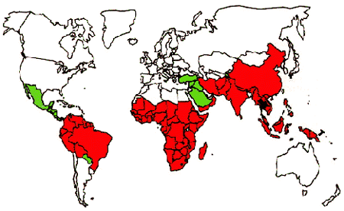
Red=Chloroquine resistant, Green=Mefloquine resistant, Black=resistant to both, White=Area of no infections

Assignment:
Write a one-page paper that answers the following questions,
- Where is malaria most prevalent in the world? What are the economic situations in these countries?
- What are the costs associated with malarial drug therapy? Do the one million people who die from malaria each year have the money to afford these medications? Cite an example of what is being done on a global level to help slow the spread of malaria?

Extra Credit
Page 5: Social Science of Malaria Teaching Notes

The point of this extra credit section is to provide an optional assignment that touches on the “non-chemical” aspects of malaria. While the science behind the disease is extremely important, it is also necessary to understand its social impact on the world. Many students sometimes forget that much of the world’s population still lives in extreme poverty. Jeffery Sachs author of “The End of Poverty” and head of the Earth Institute at Columbia University quoted to Time Magazine in March of 2005, that the World Bank’s latest estimates show that 1.1 billion people live in extreme poverty. The United Nations defines “extreme poverty” as living on less than $1.00 (US Dollar) per day. Approximately 2.7 billion people live on less than $2.00 (US Dollar) per day. The Center for Disease control reported that every 30 seconds, a child in Africa dies of malaria. This assignment is meant for students who are interested in these issues and wish to pursue them in their own time outside of class.
This section arises from a personal experience that I had this summer. I had the opportunity to visit 2 developing countries in Asia where malaria is prominent. I met a girl who was 17 years old. She could not read, write or even count money. She was tied to her village and her family for everything. She had no opportunity to move up in life, no money. Nothing. She lived in a small Malaysian village with no running water and extremely unsanitary conditions. I was awed by the fact that this is the situation for many people in our world. Seeing it in person made it so unbelievably real. This experience completely changed my perspective of the world, and my views on life. I have never felt more sheltered in my life as I did at that moment. As an undergraduate student I feel it is essential that we have a better appreciation of the diverse qualities of life of our global citizens. Even though this assignment is a one page optional paper in a biochemistry class, I feel it is an opportunity for me to provide my piers with a small glimpse into the quality of life of almost half of our global population.

- Malaria is prevalent in tropical climates. It is estimated that nearly 90% of all cases occur in Africa. Malaria also affects many countries in Asia, and a few countries in Central and South America. Most of the countries seriously affected by malaria are developing countries. These countries do not have the infrastructure of industrialized countries to conduct all the necessary measures to prevent the spread of Malaria. In certain more advanced developing countries, Malaysia for example, the government has a stronger ability to prevent malaria. The Malay government requires that before any travelers exit a plane, the cabin is sprayed down with a DEET insecticide to kill any mosquitoes stowed away on the aircraft. The government also sprays stagnant pools of water that may be harvesting mosquito larvae. In the economically advanced Asian countries like Hong Kong, airports are equipped with special temperature sensors that check for fevers as you exit the plane. Poorer developing countries do not have the government structure to enact such measures.
- Reduced costs for malarial drugs for poor countries according to GlaxoSmithKline range from $0.40 a day to $8.50 per day. For people on $1.00 a day income, this is a very difficult financial situation to be in. Unicef and many other organizations are trying to further reduce costs of malarial drugs for poor people. They UN, it its “prototype” African city Sauri is trying to implement such measures as mosquito nets with special repellent on them to help prevent malarial spread. These nets cost a minimal amount of money and last a very long time. Measures such as these help to eradicate malaria from poor countries and also reduce costs associated with medical expenses.

Sources:

http://www.unmillenniumproject.org/facts/

http://www.cdc.gov/malaria/faq.htm

http://www.malaria.org/wheredoesitoccur.html

http://www.cptech.org/ip/health/pcuts.html

http://www.unicef.org/media/media_20448.html

www.mrcophth.com/plants/cinchona.jpg
http://www.ames.k12.ia.us/webstar4/schools/roosevelt/classrooms/1V/1V.html
http://www.organische-chemie.ch/literatur/Index/0223f01.gif
< http://www.phac-aspc.gc.ca/publicat/ccdr-rmtc/95vol21/21s3/images/map.gif>

