Diels-Alder

For background information, see pgs. 101-103 of your lab book.

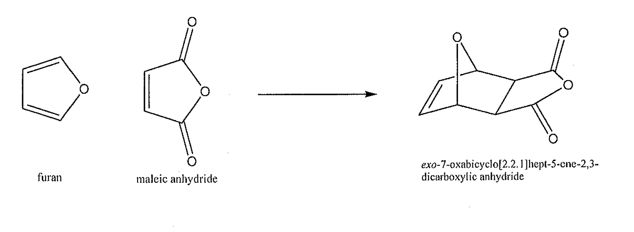

**Materials and Equipment**

Furan Scintillation Vial

Tetrahydrofuran 125 mL Erlenmeyer flask w/ side arm

Maleic Anhydride Buchner Funnel

Melting Point Apparatus

**Reagents and Properties**

*Substance Quantity mol mass (g/mol)*

Furan 1.7 mL 68.03

Tetrahydrofuran 15 mL 70.05

Maleic Anhydride 2.5 g 98.00

**Procedure**

**Week 1:** Weigh out 2.5 g of maleic anhydride and add it to the scintillation vial. Add into the vial 8 mL of tetrahydrofuran (THF) and 1.5 mL of furan. Thoroughly mix the products. Cap the vial and make sure to label it with your lab group. Place the vial in the designated spot where your TA tells you.

**Week 2:** Assemble a filtering apparatus. Wet the filter paper with 5 mL of cold THF. Filter your product, making sure to get all of the crystals out. Let stand for 5 minutes to thoroughly dry. Mass your crystals to obtain a % yield. Take a melting point of both your compound and maleic anhydride. Your product is called *exo*-7-oxabicyclo[2,2,1]hept-5-ene-2,3-dicarboxylic anhydride. Its literature melting point is 116-117 °C.

**Post Lab Questions**

1. Calculate the percent yield for your product. Discuss why it might not be 100%.
2. Compare the melting point of your product to that of literature.
3. The product of this reaction can be hydrolyzed by water. Show the product of hydrolysis.
4. Recrystallizing an anhydride (such as the product of this reaction) from water or from an alcohol is rarely a good idea. Explain why (drawing a reaction might be a good idea).