In the Production database (www.udel.edu/grants):
Navigate to UD Processes> UD Grants Reports and (for the initial report run) select Add a New Value.

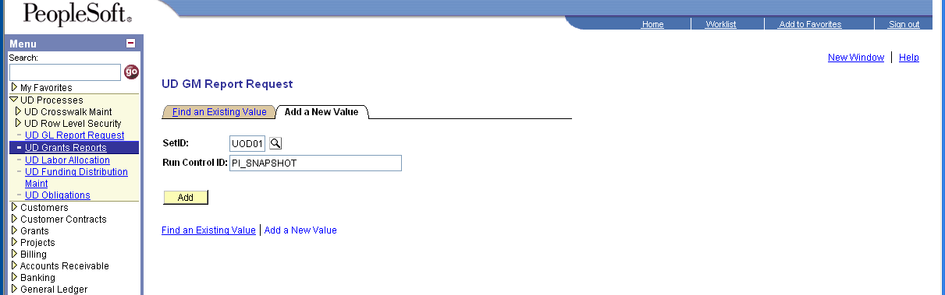

On the Add a New Value tab:
- Enter the SetID “UOD01”
- Name the Run Control ID using consecutive characters (no spaces).
- Click “Add” button.

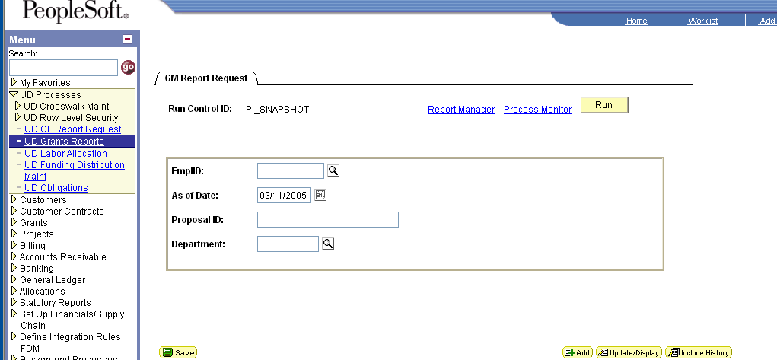

This report request is used for more than one report. Not all fields are needed for this report. The PI Project Statement can be run by Employee ID or by Department. An As of Date is helpful for report tracking.
- Enter the as of date and
- Either the EMPLID or the DEPTID for the report.

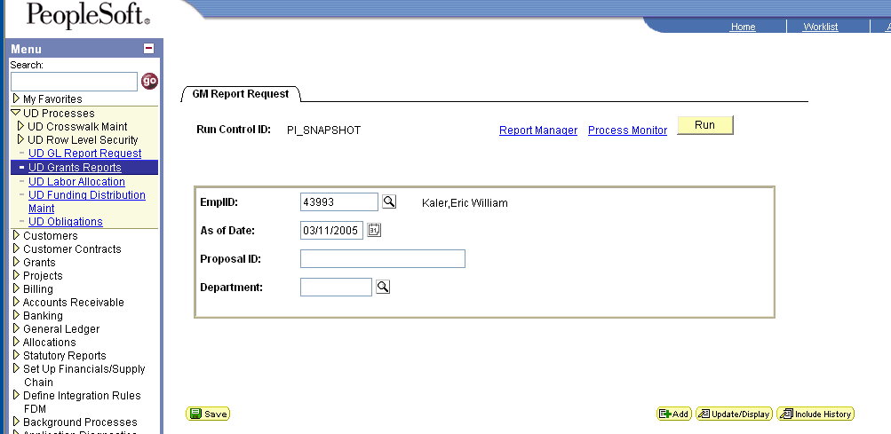

Once the parameters are selected, simply click the RUN button (Save is not necessary).

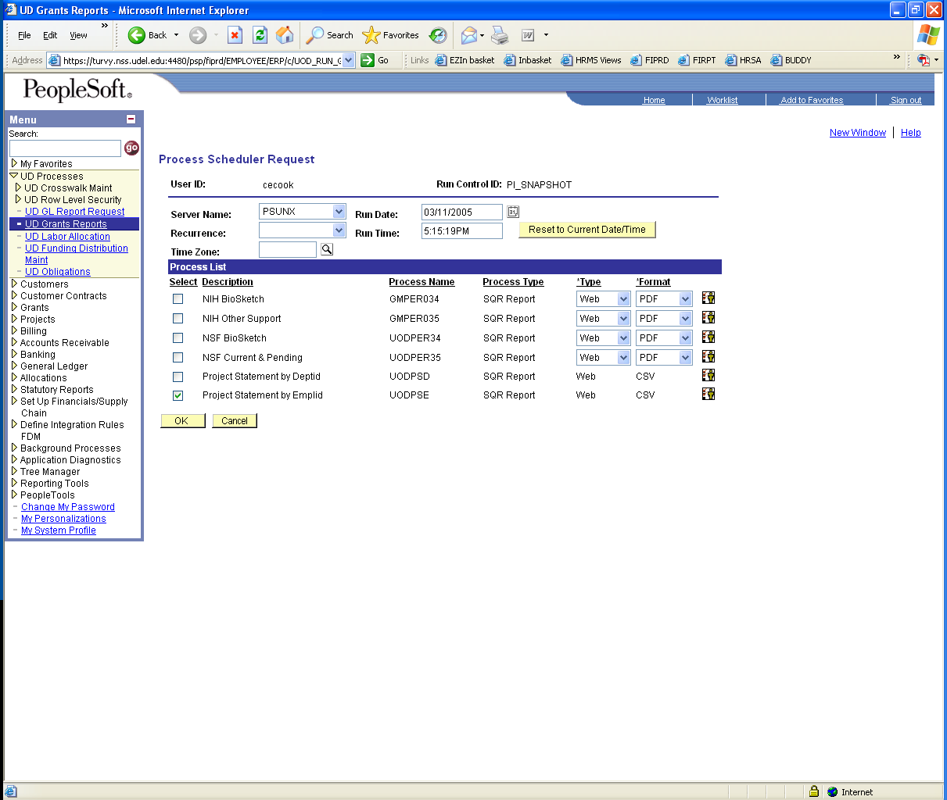

At this page:
- Simply set the server name to PSUNX
- Select the report to run, choose either:
  - Project Statement by Deptid, or
  - Project Statement by Emplid
- Click OK button.
- NOTE: other parameters are needed for the BioSketch or the C&P/Other Support but the same run control is used for processing.

Click on Process Monitor link (do not click Run button again)
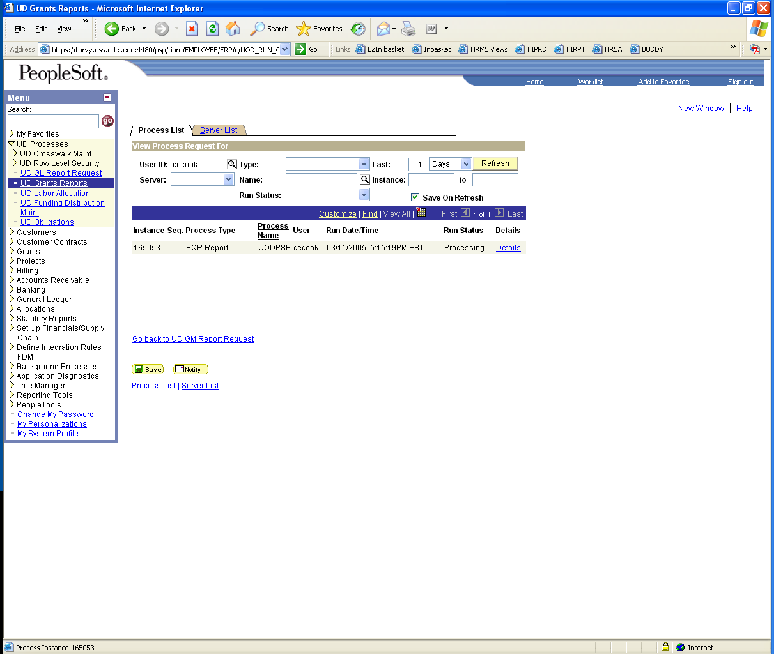

The Process List will refresh on demand by clicking the Refresh button and will have a run status of Initiated, Processing, Posting or Success.

Once in Success status, click “Details” link to go to the Process Detail page (below):

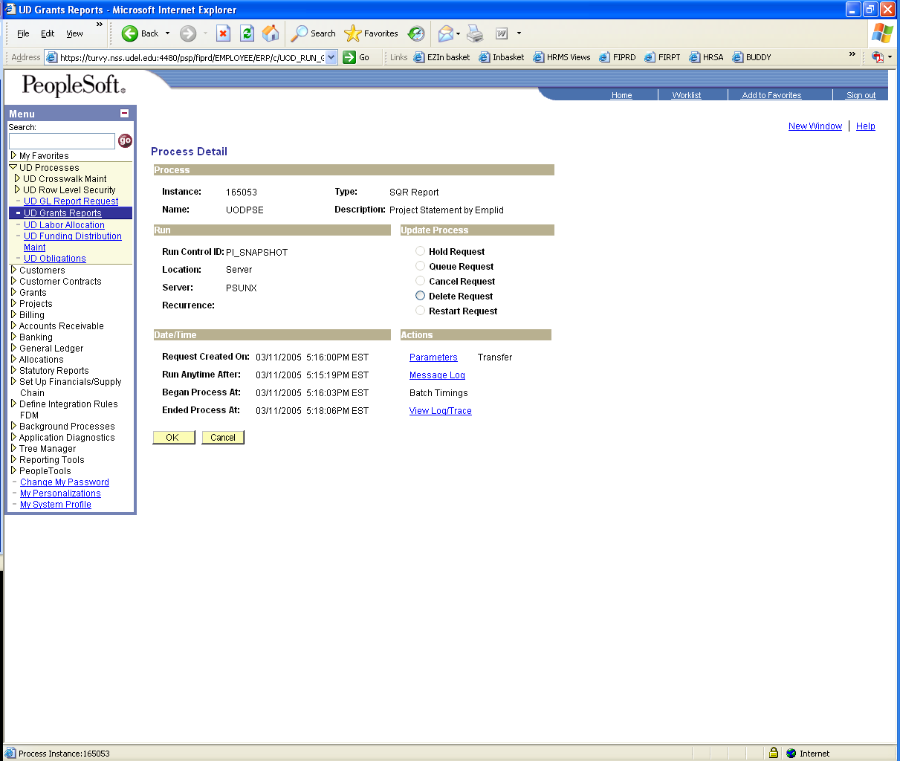

Click View/Log/Trace link to see the results of your process.
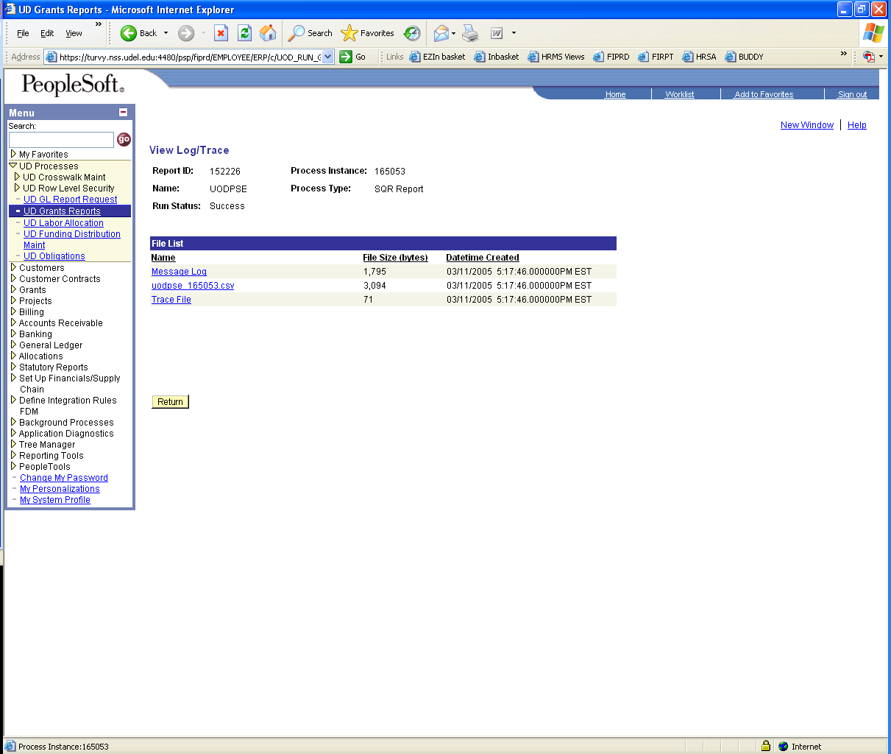

The .csv file is the outcome of your request.
Click on the hyperlink to continue.

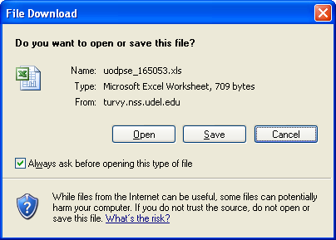

In most cases, you’ll be prompted to either Open or Save the file. Select your preference to continue.

NOTE: the recommendation is that you OPEN the file or SAVE AS .csv to retain the field formats.
Once this is complete, you’ll have a chance to reformat as you see fit. Once you open the file, you’ll see rows and columns which are derived as follows:
Demographic data about your PI’s grants/projects are listed in the first few columns. Project ID, title, begin and end date and award amount are listed. The next several columns provide expense data for your project as either direct sponsor expenses (Grant Activity) or cost shared expenses related to the project (Cost Share Activity).
There are three rows per project.
- The first row contains the demographic data and then is the row where the grant activity and cost share acitivity appears
- The second row contains the obligations data derived from the obligations table, remaining obligation field relative to each of the expense headers
- The third row contains the sum of the first two rows
The Grant Activity is derived from the GL_EXP - TOTAL EXPENSES & TRANSFERS node of the GL_ACCT tree. All expenses roll up in to those categories and are then displayed in the columns in the grant activity section of the report. This data is all based on the Purpose/Project combo of the main project.
The Cost Share Activity is derived from proj_resource transactions based on the analysis type. The analysis type is noted when transactions enter the Proj_resource table. When the Purpose meets certain criteria the transaction is identified as cost share activity.
Analysis Type Column Heading Description
CBU Cost Sh Bud C/S Budget
CGE Cost Share Exp C/S Expenditures
CCO, CAJ, CCR, CRQ, CQR Cost Sh PO C/S PO Commitments
CFA Cost Sh FA C/S F&A

