ACCESSING PEOPLESOFT WEBSITE for “Crosswalk” Utility

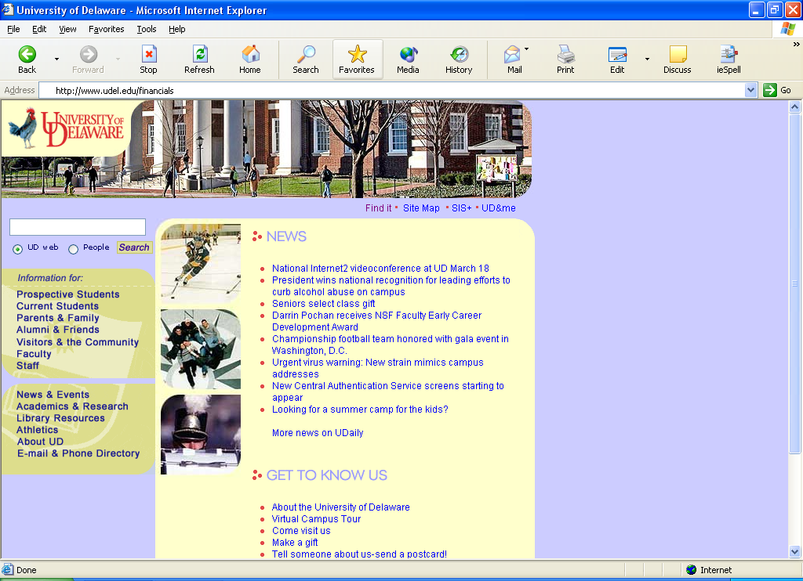

- In Internet Explorer, go to UDEL home page
- Type “financials” at the end of the address
- Hit “ENTER” key
LOGGING-IN TO PEOPLESOFT

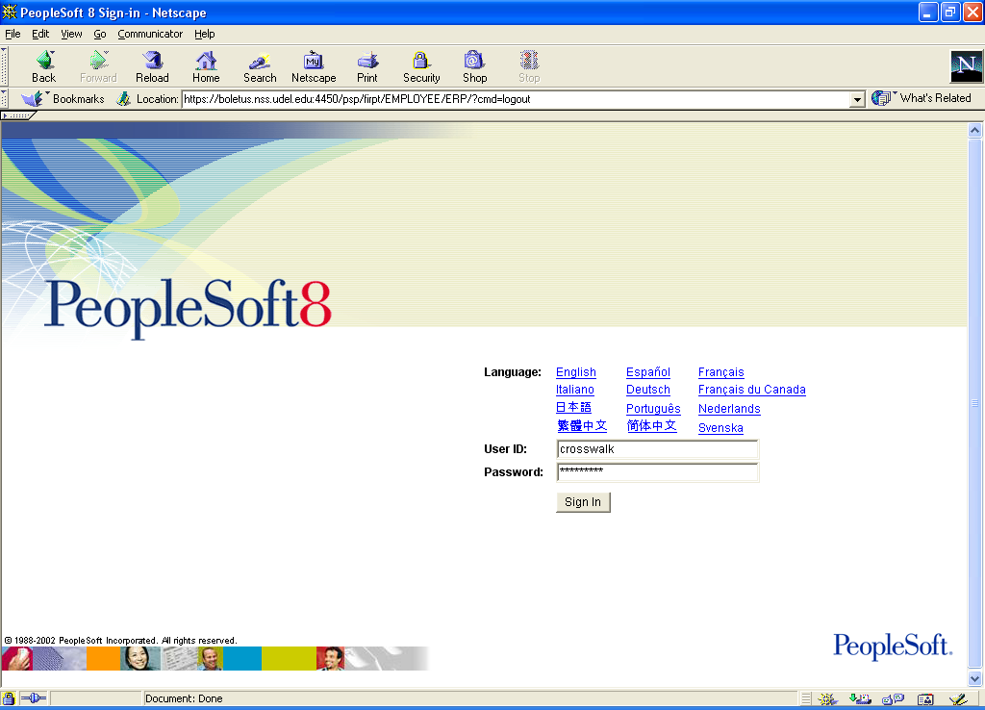

- User ID – type “crosswalk” (all lower case letters)
- Password – type “crosswalk” (all lower case letters)
- Click “Sign-In” button
TRANSLATING LEGACY ACCOUNT CODE to PS CHARTFIELDS

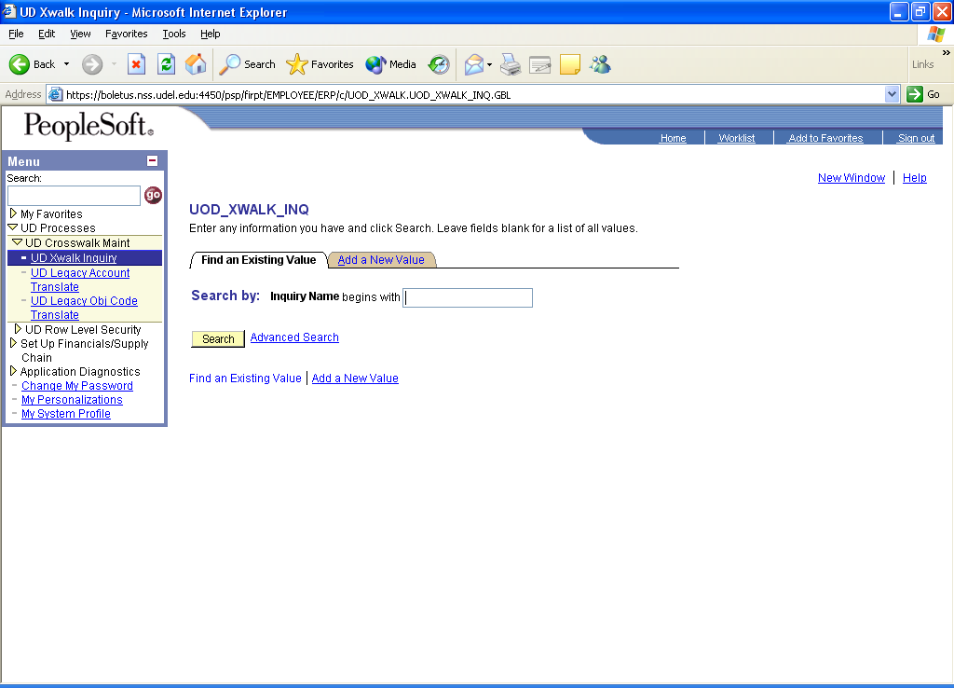
2
1
- In the Menu, click:
- UD Processes
- UD Crosswalk Maint
- UD Xwalk Inquiry
- Click the “Search” button

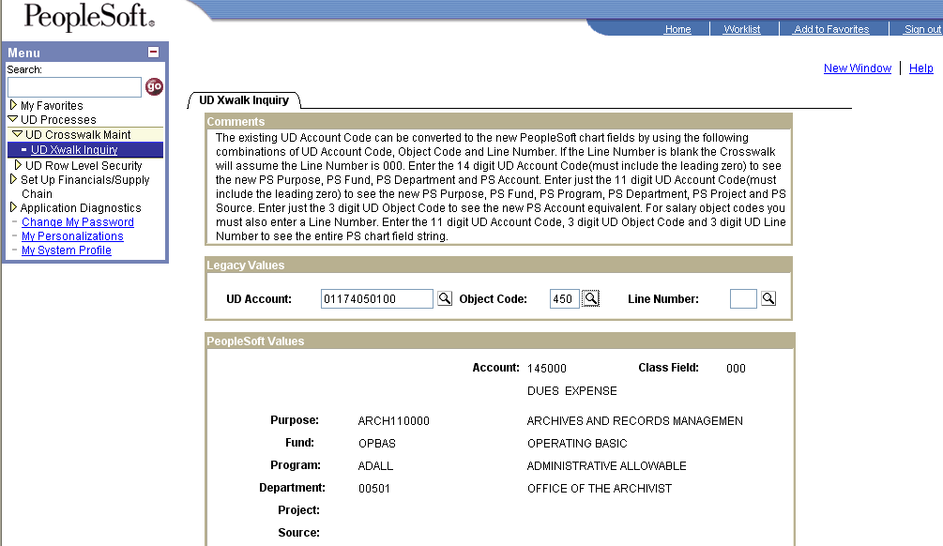
7
4
3
5
6
8
- Enter legacy UD 14-digit account code (must include leading 0). If the account code is an asset or liability, enter all 17 digits.
- Enter legacy Object Code
- Enter legacy Line Number (for salary expenses only)
- PeopleSoft Values are displayed below the Legacy Values
- PS Account is equivalent to the legacy Object Code
- Class Field is equivalent to the legacy Line Number

