QPCR Enumeration of Microbial Species in

Environmental Samples

Prepared by: Kathryn Coyne

302-645-4236

kcoyne@udel.edu

Location: University of Delaware
College of Earth, Ocean, and Environment
Lewes, DE

Cannon Lab Room 104

Date: Friday, Jan. 27, 2012

Agenda:

10:00 – 10:15 Introduction, overview of methods

10:15 – 11:30 DNA extraction methods

11:30 – 12:15 Introduction to ABI 7500 Real-Time PCR Machine

Setup and run reactions

12:15 – 1:00 Lunch Break

1:00 – 2:00 Powerpoint presentations:

Primer and probe design (K. Coyne)

QPCR analysis of diatom indicators (K. Lee)

QPCR analysis of Vibrio species (C. Main)

2:00 – 3:00 Data analysis
Questions and Discussion

This workshop is funded by grants from Delaware Sea Grant and NOAA MERHAB.

Table of Contents

DNA Isolation 3
QPCR preparation 6

Applied Biosystems 7500 Real-Time PCR System:

How to set up instrument 7

To Load Plate on ABI 7500 11

Following Your Run 12

Data Analysis 14
Standard Curve Method 14
ΔΔCt method 15

Statistical Analysis 15

Example of Data: ΔΔCt method 16

Recipes 17

Primer and Probe Sequences 18
Optimizing Primer Concentrations 19
Optimizing Taqman Probe Concentrations 20

Glossary 21

Bibliography 25

DNA Isolation

Good quality DNA that is suitable for QPCR can be extracted from water samples using either a quick extraction method or the long extraction protocol. In general, QPCR reactions using DNA from the quick extraction method will result in higher Ct values (reduced sensitivity). For DNA from sediments, we recommend the MoBio PowerSoil DNA Isolation Kit.

Quick extraction method

1. Prepare a filter tower with a 3 μm 47-mm polycarbonate (Isopore) filter (Fisher Chemical Co. Cat. # TSTP04700).

2. Filter 100 ml of environmental water sample. Use a low vacuum (5 in. Hg VAC), as a stronger one will break up fragile cells.

3. Using forceps, fold the filter in half twice and place filter into 700 µl of CTAB buffer (see recipe below) in 2-ml screw-cap tube.

4. Place the tube in a heating block for 10 min at 50ºC.

5. Cool briefly. Add 700 µl of chloroform:isoamyl alcohol (24:1) to the tube with the filter and vortex for about 45 seconds. The filter will dissolve in the chloroform.

6. Place the tube on the rocker for 10-20 minutes.

7. Centrifuge for 10-15 min at 12,500 rpm.

8. Remove 10µl of supernatant and add to 1ml of LoTE (recipe below).

9. Vortex well to mix.

Long Extraction Protocol

For greater sensitivity of detection, we recommend the Long Extraction Protocol presented here. For this procedure, follow steps 1-4 of the rapid protocol (above) and freeze the filter in CTAB buffer at -80 ºC until extraction.

- Place the tube from the freezer directly into a 60-65ºC water bath for 10 min.

- Allow to cool slightly. Add 700 µl Chloroform:Isoamyl Alcohol (24:1).

- Vortex well. Rock for 20 min.

- Centrifuge for 15 min. The DNA will be in the top aqueous layer.

- Using a 200µL pipettor, transfer 400 µl of the supernatant (top layer) to a new tube.

- Add 200 µl of 5M NaCl and 400 µl of isopropanol (ice cold).

- Mix well. Centrifuge for 15min. There will be a small pellet of DNA at the bottom of the tube which may not be visible.

- Carefully decant liquid into a waste receptacle. Add 150 µl of 70% ethanol down the inside wall of the tube without disturbing the DNA pellet. Centrifuge for 5 min.

- Remove the 70% ethanol carefully with a pipettor without disturbing the pellet.

- Repeat steps 8-9.

- Allow the pellet to dry. Add 10 µL of LoTE to resuspend. Allow DNA to resuspend for 30 min, mix by pipetting gently 4-5 times.

The quantity of DNA can be determined by UV spectrometry by measuring the absorbance of a dilution of the DNA at 260 nm wavelength.

MoBio PowerSoil DNA Isolation Protocol

This kit can be purchased from MoBio Laboratories at mobio.com. The catalog number is 12888-50 or 12888-100 depending on the number of sample preps. We have modified the protocol to include an RNALater (Invitrogen.com) preservation step, which preserves cell morphology and stabilizes nucleic acids.

- Weigh empty 2-ml screw-cap tube.

- Mix sediment (stored in 10-ml RNALater) and pour into weighed tube.

- Centrifuge for 2 minutes at 12,500 rpm.

- Remove RNALater and weigh to ensure 0.25-0.30 g of sediment.

- Add 1.5 mL Marine PBS and vortex well.

- Centrifuge for 2 minutes at 12,500 rpm.

- Remove Marine PBS and reweigh to get final weight of sediment.

- Add beads from kit to sample and gently vortex.

- Add 60 µl of Solution C1 (provided with kit) and vortex briefly.

- Shake for 10 minutes on a horizontal vortexer.

- Centrifuge for 30 seconds at 10,000 g.

- Transfer supernatant to a clean 2 ml tube (provided in kit) and add 250 µl of Solution C2.

- Vortex and incubate for 5 minutes at 4ºC.

- Centrifuge for 1 minute at 10,000 g.

- Transfer 600 µl of supernatant to a clean 2 ml tube and add 200 µl of Solution C3.

- Vortex and incubate for 5 minutes at 4ºC.

- Centrifuge for 1 minute at 10,000 g.

- Transfer 750 µl of supernatant to a clean 2 ml tube and add 1200 µl of Solution C4.

- Vortex.

- Transfer 675 µl onto a Spin Filter (provided in kit).

- Centrifuge for 1 minute at 10,000 g and discard the flow through.

- Repeat steps 20-21 twice more until all supernatant has been loaded onto the Spin Filter.

- Add 500 µl of Solution C5 to Spin Filter.

- Centrifuge for 30 seconds at 10,000 g and discard the flow through.

- Centrifuge for 1 minute at 10,000 g and transfer Spin Filter to a clean 2 ml tube.

- Add 100 µl of Solution C6 to Spin Filter.

- Centrifuge for 30 seconds at 10,000 g.

- Discard the Spin Filter.

- Store DNA at -80ºC.

QPCR preparation (10 uL reactions)

1. Add 3.3 µl of your prepared template from above to 29.7 µL of QPCR mix (see recipe below) and vortex very well.

2. Transfer 10 µL of the mix into 3 adjacent wells of a 96-well QPCR plate (Phenix Research Cat. # MPS-3580).

3. Cover the plate with optical adhesive tape (Phenix Research Cat. # LMT-RT2)

4. Make sure the liquid is in the bottom of the well and that there are no bubbles present.
Applied Biosystems 7500: How to set up instrument

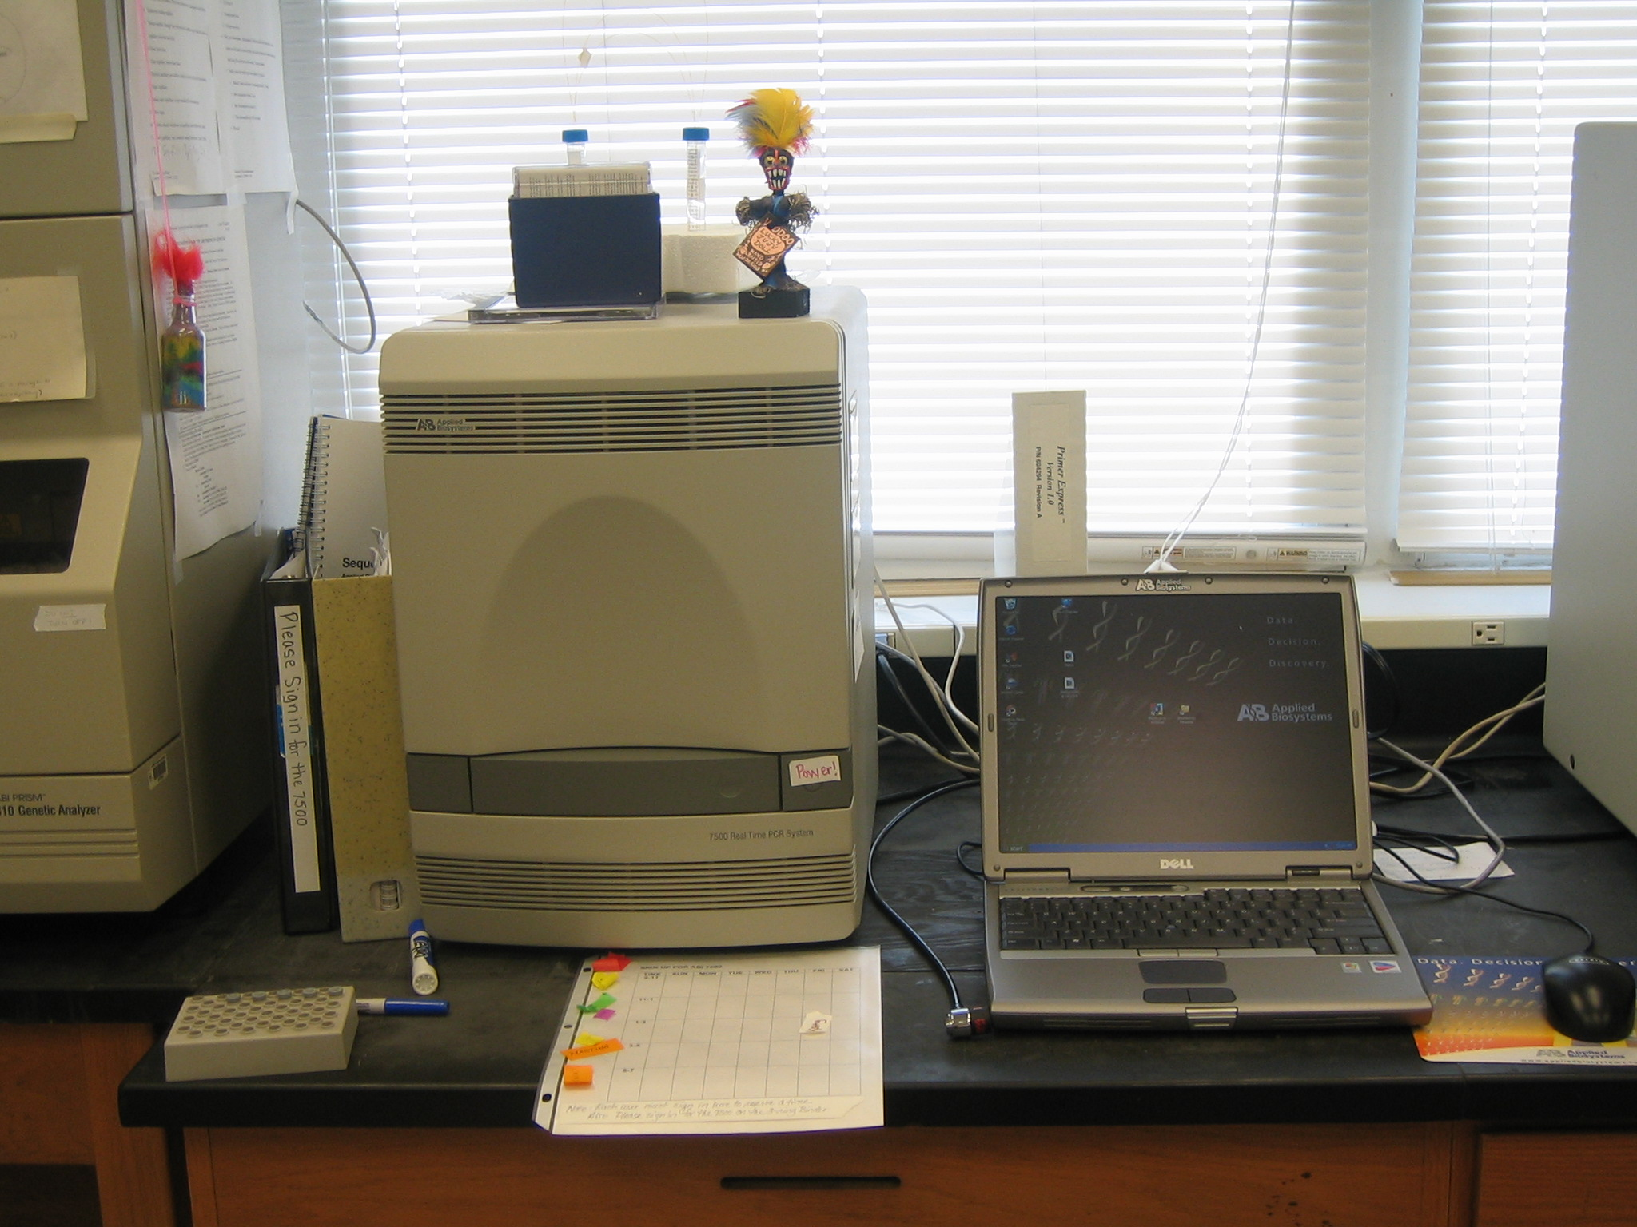

1. Instrument must be turned on for 30 minutes before run.

2. Open SDS Shell program.

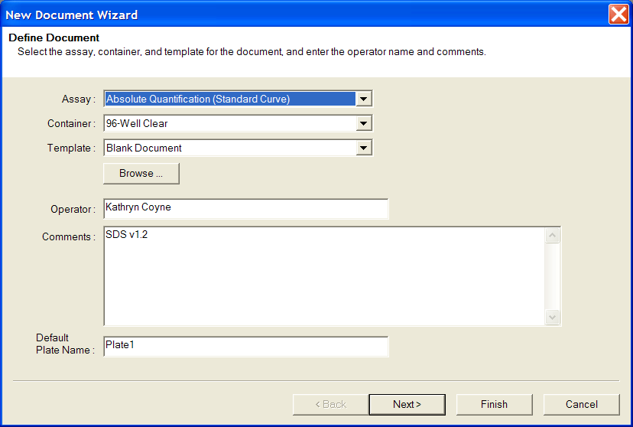
3. Click on “File” then “New”.
Fill in your name here
Name your plate
4. Change the operator name to your name.

5. Name the plate in space provided next to “Default Plate Name”. Everything else on the page can stay the same.

6. Click “Next”. Choose your probe under “Detector Name” by clicking on it and then click “Add” to add it to “Detectors in Document” box. Make sure the Passive Reference is set on “ROX”.
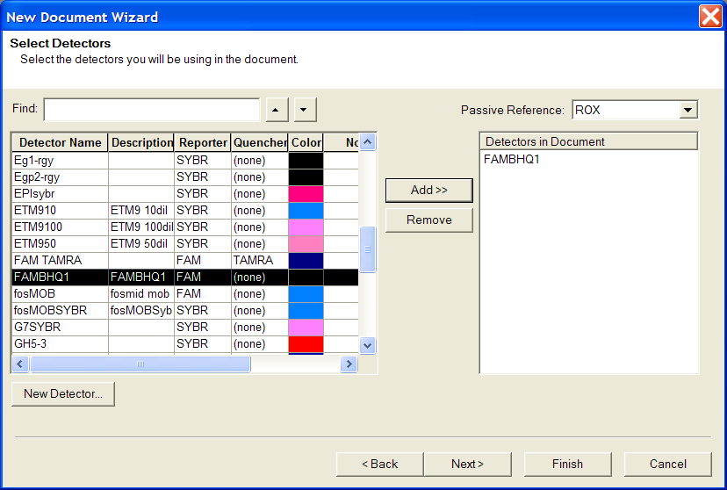

Make sure Passive Reference is set to “ROX”

Highlight the detector name and click “Add”

7. Click “Next”

8. The next page will bring up a sample sheet. Highlight wells you intend to use and click on the square under “Use” to indicate which probe will be detected in that well.

9. Be sure to indicate under “Task” the identity of each well as “Unknown”, “Standard” (if you are using standards), or “NTC” (no template control) by using the drag down box (default is set as unknown).

10. For standards, you can indicate the quantity of template in the well.
Check mark for wells using FAMBHQ1 reporter
Indicate which wells are NTC
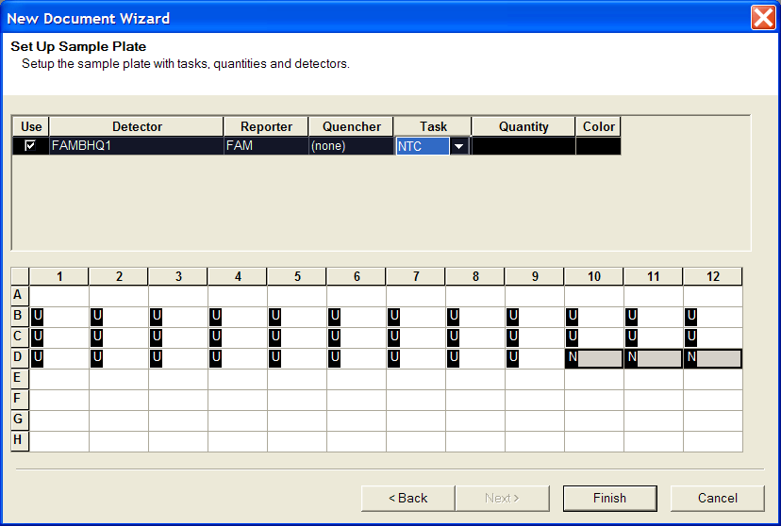
11. Click “Finish”.

12. The next window will have three tabs at the top labeled “Setup”, “Instrument”, and “Results”. In the Setup window, you can open “View” – “Well inspector” and, if necessary, change any of the sample information entered in the previous window. You can also label each well with the template contents. This can be done before or after the run.

13. Click on the “Instrument” tab. Under “Settings” at bottom of page, change “Sample volume” to 10µL.

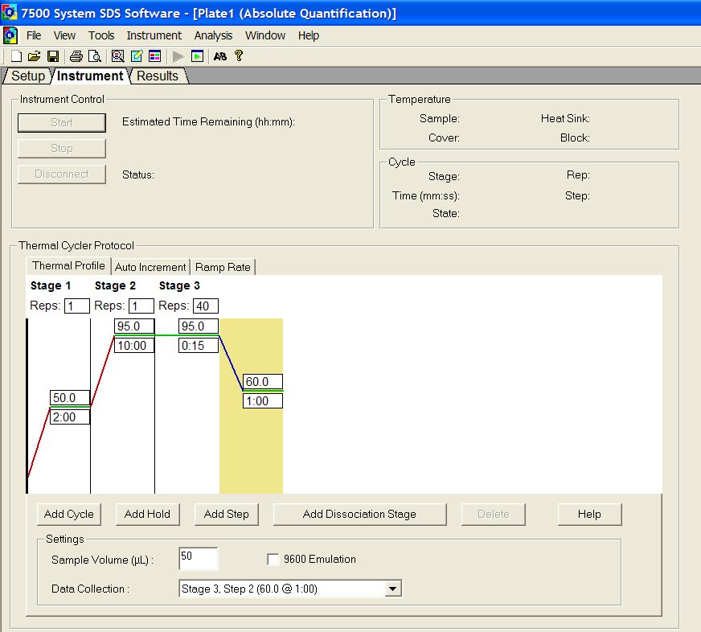

Add annealing step

Change to 10

14. If you are using SYBR Green detection, click “Add Dissociation Stage”.

15. If needed, you can add an annealing step after the 95°C, 15s step by clicking on the left border of the yellow rectangle and clicking “Add Step”.

- Click “File” – “Save” and save the file.

To Load Plate on ABI 7500

1. Press the indented circle on the right side of the door on the instrument to open the tray. Take care not to click the Power button which is also on the right side as you will have to leave the instrument off for 15min and then warm it back up for 30 min.
Open button
Power button
2. Load the plate with A1 in the upper left corner. Be sure that the plate is flat in the rack.

3. Gently push the indented circle on the right side of the door in an upward and right direction to close it.

4. On the computer, press the “Start” button in the “Instrument” window. After an initial instrument check, the run time will be calculated and should appear.
Start button
Following your run

1. Click on the “Results” tab on the computer. Several new tabs will appear. To see the reaction real-time, click on “Amplification Plot” and highlight the wells of interest at the bottom of the screen. Remember, the data shown here is “raw” data and may not be optimal.

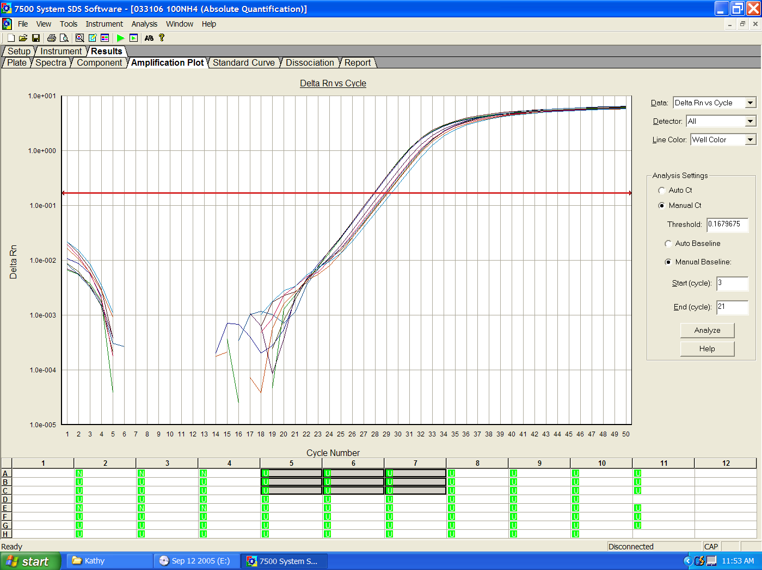
Highlight wells of interest to see amplification
Change Y-axis if necessary
Adjust baseline here

2. After your run is complete, you can adjust the Y-axis if necessary by double-clicking on the Y-axis and changing the values in the “maximum” or “minimum” boxes. Click “Apply” and “Close”.

3. Adjust the baseline next by changing the number in the “End cycle” box to about 2-3 cycles below the cycle that you first see an increase in fluorescence.

4. Next, adjust the red bar that determines the Ct values. This is done by holding down the left button on the mouse and dragging the bar to the correct place in the window. The bar should be adjusted to fall within the exponential phase of the curve. After all adjustments are finished, click “Analyze” to calculate correct Ct values.

5. If you are running several different probes with different reporters, the Ct values will have to be recalculated for each reporter. This can be done by clicking on the correct reporter under the pull-down menu labeled “Detector” to the right side of the window. After Ct values are calculated for each reporter, open the “Report” tab and save Ct values before setting Ct values for other reporters.

Pull down detector window
Save Ct values in Report before analyzing other detectors.
Set bar to determine Ct values then click “Analyze”

6. If you are using SYBR Green detection, view the Dissociation curve for each sample by clicking on the “Dissociation” tab.

7. Save the results by clicking “File” – “Export…” and choosing “Results”. Save the file in the “Export File” where it can be retrieved onto a disc for archiving or further analysis.

Data Analysis

Your data will be saved as an Excell Spreadsheet. All calculations can be done on the spreadsheet. There are 2 ways to calculate the results: using a standard curve or by the ΔΔCt method. The standard curve method requires that a set of standards be run for the target DNA template and for the pGEM internal standard. The ΔΔCt method only requires a “calibrator” sample, for which the number of cells of the target organism is known. This method must first be validated by running 10-fold dilutions for both the target DNA and pGEM. Plot the difference in Ct values (target - pGEM) vs. the log of the sample concentration. If the slope of the curve is < +/-0.1, then the ΔΔCt method is valid to use.

Standard Curve Method

1. Enter values for each standard on the Well Inspector (for example, 10,000, 1,000, 100 and 10 for 10-fold dilutions).

2. After analyzing the results, the program will calculate the average relative concentration of target DNA and pGEM DNA in each of your unknowns.

3. Divide the average target DNA concentration by the average pGEM concentration for each sample:

Ratio of target:pGEM = Avg. concentration of target
Avg. concentration of pGEM)

4. If the number of cells is known for one sample (a “calibrator”), the number of cells for other samples can be calculated by dividing the ratio from step 3 above by the ratio for the calibrator sample, and multiplying by the number of cells in the calibrator:

Number of cells filtered = ratio of target:pGEM_{(sample)} X cells filtered _{(calibrator)}
ratio of target:pGEM_{(calibrator)}

5. To calculate the number of cells per liter, divide by the number of liters of sample water filtered:

Cells/L = Number of cells filtered
Volume filtered (L)

ΔΔCt method

1. Calculate the average Ct of triplicate reactions for both the target species and for the standard pGEM for each sample.

2. Determine the ΔCt values for each sample and calibrator by subtracting the average Ct for the pGEM from the average Ct for the target species:

ΔCt = Ct(target) – Ct(pGEM)

3. Calculate the ΔΔCt by subtracting the ΔCt of the calibrator from the ΔCt of the unknown samples:

ΔΔCt = ΔCt(unknown) - ΔCt(calibrator)

4. Determine the concentrations of target species in each unknown sample relative to the concentration of the target species in the calibrator:

Relative concentration = 2^{-ΔΔCt}

Note that the “2” in this equation is an efficiency value for reactions with 100% efficiency. The efficiency of reactions for each template and primer-probe set must be determined empirically. For Chattonella subsalsa the efficiency value is 2.0. For Heterosigma akashiwo, the efficiency value is 1.8.

5. To calculate the actual number of cells of the target species per liter, multiply the relative concentration by the number of cells in the calibrator and divide by the number of liters of sample water filtered.

Cells/L = (relative concentration X cells filtered from calibrator sample)
Volume filtered (L)

Statistical analysis:

Calculate standard error for triplicate samples:

Std. Error = sd² + sd² 1/2
N(target) N(pGEM)

where sd is standard deviation of Ct values and N is the number of replicate reactions.
Example of Data: ΔΔCt method

Document Name: 61005Ha dilutions
Plate Type: Absolute Quantification
User: Kathryn Coyne
Document Information
Operator: Kathryn Coyne
Run Date: Friday |  | June 10 |  | 2005 13:53:59
Last Modified: Friday |  | June 10 |  | 2005 15:46:31
Instrument Type: Applied Biosystems 7500 Real Time PCR System
Comments:
SDS v1.2
Well | Sample |  | Detector |  | Ct |  | StdDev Ct |  | Step 1: Calculate average Ct for triplicate reactions.
B2 | Ha Cal |  | FAMBHQ1 |  | 17.18 |  | 0.153
B3 | Ha Cal |  | FAMBHQ1 |  | 17.42 |  | 0.153
B4 | Ha Cal |  | FAMBHQ1 |  | 17.13 |  | 0.153
B5 | Ha 1 |  | FAMBHQ1 |  | 20.36 |  | 0.184
B6 | Ha 1 |  | FAMBHQ1 |  | 20.72 |  | 0.184 |  | Step 2: Calculate ΔCt for each sample:  ΔCt = Avg Ct(target)-Avg Ct(pGEM)
B7 | Ha 1 |  | FAMBHQ1 |  | 20.48 |  | 0.184
B8 | Ha 2 |  | FAMBHQ1 |  | 24.49 |  | 0.166
B9 | Ha 2 |  | FAMBHQ1 |  | 24.82 |  | 0.166
C2 | Ha 2 |  | FAMBHQ1 |  | 24.64 |  | 0.166
C3 | Ha 3 |  | FAMBHQ1 |  | 29.31 |  | 0.356 |  | Step 3: Calculate ΔΔCt for each sample:  ΔΔCt = ΔCt(unk)- ΔCt(Cal)
C4 | Ha 3 |  | FAMBHQ1 |  | 28.61 |  | 0.356
C5 | Ha 3 |  | FAMBHQ1 |  | 28.89 |  | 0.356
C6 | Ha 4 |  | FAMBHQ1 |  | 33.12 |  | 1.683
C7 | Ha 4 |  | FAMBHQ1 |  | 36.32 |  | 1.683
C8 | Ha 4 |  | FAMBHQ1 |  | 35.63 |  | 1.683 |  | Step 4: Calculate relative number of cells in filtered volume:  Cells = 2 ^{-ΔΔCt}
D2 | pGEM Cal |  | FAMBHQ1 |  | 17.17 |  | 0.54
D3 | pGEM Cal |  | FAMBHQ1 |  | 17.82 |  | 0.54
D4 | pGEM Cal |  | FAMBHQ1 |  | 18.25 |  | 0.54
D5 | pGEM 1 |  | FAMBHQ1 |  | 20.8 |  | 1.129
D6 | pGEM 1 |  | FAMBHQ1 |  | 21.4 |  | 1.129
D7 | pGEM 1 |  | FAMBHQ1 |  | 22.98 |  | 1.129 |  | Step 5: Calculate actual number of cells per Liter:  Cells/L = cells in unknown X cells in calibrator/vol filtered (L)
D8 | pGEM 2 |  | FAMBHQ1 |  | 25.13 |  | 1.158
E2 | pGEM 2 |  | FAMBHQ1 |  | 24.08 |  | 1.158
E3 | pGEM 2 |  | FAMBHQ1 |  | 26.39 |  | 1.158
E4 | pGEM 3 |  | FAMBHQ1 |  | 28.66 |  | 0.613
E5 | pGEM 3 |  | FAMBHQ1 |  | 28.1 |  | 0.613
E6 | pGEM 3 |  | FAMBHQ1 |  | 29.33 |  | 0.613
E7 | pGEM 4 |  | FAMBHQ1 |  | 37.15 |  | 1.035
E8 | pGEM 4 |  | FAMBHQ1 |  | 37.16 |  | 1.035
E9 | pGEM 4 |  | FAMBHQ1 |  | 35.36 |  | 1.035
F3 | ntc |  | FAMBHQ1 |  | NTC |  | Undetermined
F4 | ntc |  | FAMBHQ1 |  | NTC |  | Undetermined
F5 | ntc |  | FAMBHQ1 |  | NTC |  | Undetermined

Recipes

Marine PBS
0.45 M NaCl
50 mM Sodium Phosphate (pH 7.4)

For 100 mL, add 9 mL of 5M NaCl and 5 mL of 1 M Sodium Phosphate (pH 7.4) to sterile milliQ water to make 100 mL total volume.

QPCR mix for each replicate:
5.0 µl Universal Master Mix (Applied Biosystems, Part # 4304437)
1.0 µl of Forward primer
1.0 µl of Reverse primer
1.0 µl of probe
1.0 µl of sterile water

CTAB buffer
For 1L of buffer: Final concentration:

100 mL of 1M Tris-HCl (pH 8.0) 100mM Tris-HCl (pH 8.0)
280 mL of 5M NaCl 1.4M NaCl
10 g Polyvinylpyrollidone (PVP) 1% (w/v) PVP
20 g Cetyltrimethylammonium bromide (CTAB) 2% (w/v) CTAB
40 mL of 0.5M EDTA (pH8.0) 20mM EDTA (pH 8.0)

Add sterile milliQ water to make 1L. Mix well, but don’t shake! Low heat may be necessary to get everything in solution. Add 20 μg of pGEM plasmid (pGEM-3Z Vector; Promega, Cat. #P2151) for a final concentration of 20 ng/mL. Store at room temperature. Before use, aliquot a portion into another bottle and add 4 μL β-mercaptoethanol per mL of buffer [final concentration = 0.4% (v/v)].

LoTE buffer
For 1L of buffer: Final Concentration:

3 mL of 1M Tris-HCl (pH 7.5) 3mM Tris-HCl (pH 7.5)
4 mL of 0.5M EDTA (pH 8.0) 0.2mM EDTA (pH 8.0)

Add sterile milliQ water to make 900 mL. Adjust pH to 7.5. Add sterile milliQ water to make 1L. Autoclave and store at 4°C. Aliquot a small amount into a separate container and bring to room temperature before use (small amounts can be stored at room temperature for several weeks).

Primer and probe sequences
DNA Target | Primer Name | Sequence (5’-3’)
Chattonella subsalsa  18S rDNA¹ | Cs 1350F | CTAAATAGTGTGGGTAATGCTTAC
Chattonella subsalsa  18S rDNA¹ | Cs 1705R | GGCAAGTCACAATAAAGTTCCAA
Chattonella subsalsa  18S rDNA¹ | Raph Probe | CAACGAGAGTACTTTCCTTGGCCGGAA
Heterosigma akashiwo  18S rDNA¹ | Hs 1350F | CTAAATAGTGTCGGTAATGCTTCT
Heterosigma akashiwo  18S rDNA¹ | Hs 1705R | GGCAAGTCACAATAAAGTTCCAT
Heterosigma akashiwo  18S rDNA¹ | Hs Probe | CAACGAGTAACGACCTTTGCCGGAA
pGEM plasmid DNA¹ | M13F | CCCAGTCACGACGTTGTAAAACG
pGEM plasmid DNA¹ | pGEM R | TGTGTGGAATTGTGAGCGGA
pGEM plasmid DNA¹ | pGEM Probe | CACTATAGAATACTCAAGCTTGCATGCCTG
Skeletonema sp 1² | Skel sp1 Probe | ATCCATTGCCGTCACGAGGACATGCA
Skeletonema sp 1² | Skel 132F | CACTCTTCGGAGTTGATCTGGTGAAT
Skeletonema sp 1² | Skel 259R | TGACGGGTAACGAATTGTTAGGGC
Skeletonema japonicum² | Skjap Probe | ATCCATTGCCGCAACATGTGCATGCA
Skeletonema japonicum² | Skjap 221F | CACTCTTCGGAGTTGATTTGGTGAGT
Skeletonema japonicum² | Skjap 348R | GCCCTAACAATTCGTTACCCGTTA
Navicula gregaria² | Ngreg Probe | AGCCGAAGCCATGCGATCCGCAAG
Navicula gregaria² | Ngreg 122F | CCGCTTCGGCGTGATGTGGT
Navicula gregaria² | Ngreg 286R | TTACGCGCCTGCTGCCTTCC
Thalassiosira pseudonana² | Thaps Probe | CGCATGGCTCCATGCCGGCG
Thalassiosira pseudonana² | Thaps 79F | CCGACTGTTCGCGGAAGGGT
Thalassiosira pseudonana² | Thaps 336R | TTTACGCGCCTGCTGCCTTC
Diatom primers² | Stram 9F | CTGCCAGTAGTCATACGCTC
Diatom primers² | Euk 517R | GACGGGGGA CCAGACTTGCCCTC
Vibrio spp.³ | rpoA 294F | AAATCAGGCTCGGGCCCT
Vibrio spp.³ | rpoA 535R | GCAATTTTRTCDACYGG
¹Coyne et al., 2005
²Lee et al., in prep.
³Dalmasso et al., 2009

ABI 7500
Optimizing primer concentrations:

- Prepare 0.500 μM, 3.0 μM, and 9.0 μM, concentrations of each primer.

- Make up a 41X mix:

205 µL Universal Master Mix
41 µL Water
41 µL Taqman Probe (2 μM)
41 µL Template

- Aliquot 35.2 µL into each of 9 tubes labeled:

50/50 300/50 900/50
50/300 300/300 900/300
50/900 300/900 900/900

These are concentrations of forward/reverse primers.

- Add 4.4 µL each of forward and reverse primers to each tube.

- Aliquot 10 µL into each of 4 reaction tubes.

- Load onto the ABI 7500. Change the reaction volume to read “10”. Run reactions.

- Analyze and print out the results. Average Ct values and ΔRn values for each set of 4. Use the primer concentrations that give the highest ΔRn values and the lowest Ct values.

ABI 7500
Optimizing TaqMan probe concentration

NOTE: YOU MUST FIRST OPTIMIZE PRIMER CONCENTRATIONS.

1. Prepare the following concentrations of your probe from a 5 μM stock solution:

Concentration of dilute to 30 μL final concentration
diluted stock from 5μM stock in QPCR reaction
250 nM 1.5 uL 25 nM
500nM 3.0 uL 50 nM
750 nM 4.5 uL 75 nM
1000 nM 6.0 uL 100 nM
1250 nM 7.5 uL 125 nM
1500 nM 9.0 uL 150 nM
1750 nM 10.5 uL 175 nM
2000 nM 12.0 uL 200 nM
2250 nM 13.5 uL 225 nM

2. Make up a 41X mix:

205 µL Universal Master Mix
41 µL Water
41 µL Forward primer
41 µL Reverse primer
41 µL Template

- Aliquot 39.6 µL into each of 9 tubes labeled with probe concentrations.

- Add 4.4 µL of probe to each tube. Mix well.

- Aliquot 10 µL from each tube into 4 reaction tubes.

- Load onto the 7500. Run reactions.

- Analyze and print out the results. Average Ct values for each set of 4. Use the lowest probe concentration that gives the lowest Ct values.

Glossary

Amplicon: PCR product. The amplicon size and sequence is defined by the primers.

Black Hole Quencher (non-fluorescent quencher): A type of quencher that has no native fluorescence and therefore does not have to be resolved by the QPCR instrument. As a result, replicates are more robust and also less variable.

Calibrator: A sample with a known concentration of template that is compared with unknown samples to determine the starting template concentration. A calibrator sample is used in conjunction with the comparative Ct method.

Comparative Ct method: A method for calculating target abundance in which sample template concentrations are determined by comparison to a calibrator sample and normalized to a reference standard DNA. The standard DNA can be exogenous (artificial DNA template added to reaction) or endogenous (DNA template that co-extracts with target DNA template).

Ct value: The cycle threshold number. The Ct value is measured during the exponential phase of the QPCR reaction. Threshold cycle (Ct) number is inversely proportional to copy number of the target DNA template.

Ct value

LoTE: Buffer for DNA to prevent degradation.

No template control: For each QPCR reaction, a negative control is also run without adding any DNA. This allows us to see if reagents have become contaminated with DNA.

pGEM: A DNA plasmid (pGEM-3Z Vector; Promega, Cat. #P2151) that can be added to the extraction buffer as a reference standard.

Primer: The DNA fragment to be amplified is determined by selecting primers. Primers are short, artificial DNA strands — not more than fifty and usually only 18 to 25 base pairs long nucleotides that are complementary to the beginning and end of the DNA fragment to be amplified. They anneal by adhering to the DNA template at these starting and ending points, where the Taq Polymerase binds and begins the synthesis of the new DNA strand.

PCR: (polymerase chain reaction) technique for enzymatically amplifying DNA in an exponential manner. This method involves denaturing the DNA into two complementary strands, annealing primers complementary to the sequence to be amplified, and using DNA polymerase to synthesize double-stranded DNA from each single strand. These steps are repeated to many times, doubling the amount of amplicon produced for each cycle.

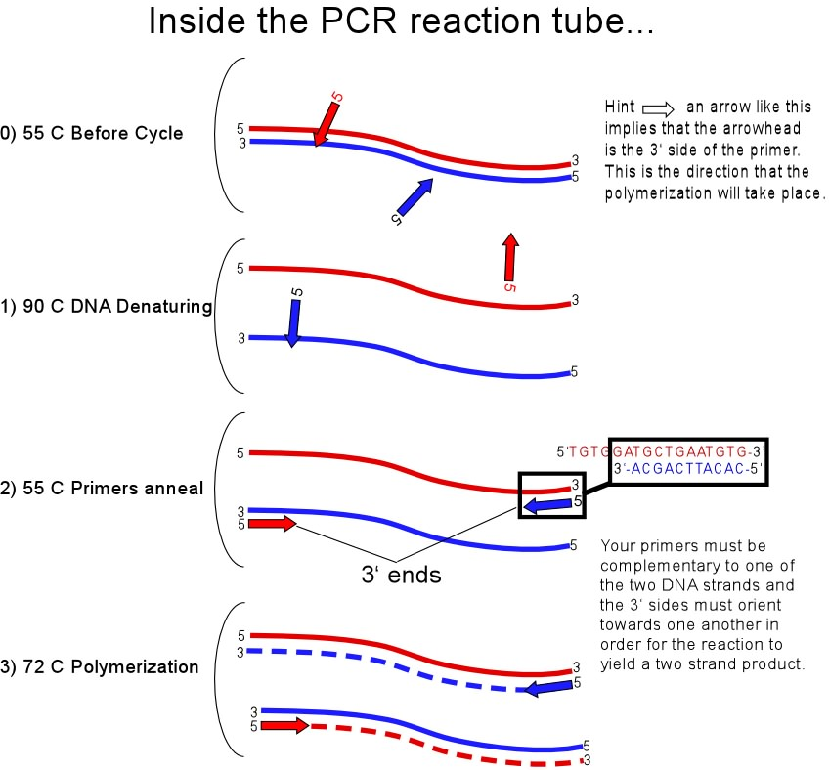
http://www.abrf.org/JBT/1999/March99/mar99grove.html

Quencher: A molecule that absorbs the energy of the reporter molecule when it is in close proximity to it.

QPCR: (Quantitative real-time PCR) PCR technique that results in an increase in fluorescence with each cycle. The fluorescence generated during each cycle is detected by a QPCR machine.
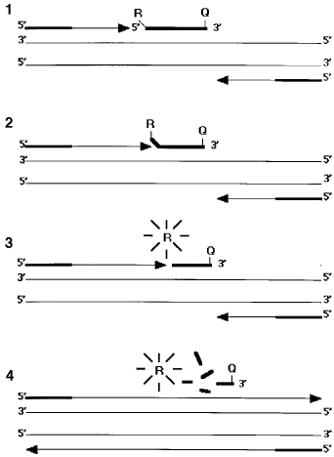

Reporter: Fluorescent molecule attached to the probe that is released during amplification in a QPCR.

ROX: a dye found in purchased master mixes which is used by the ABI 7500 to normalize volume differences in each well. It will correct for some pipetting errors. This feature can be turned off.

Standard curve method: A method for calculating target abundance in which each assay is run with a dilution series of standard template DNA. A standard curve of Ct vs. DNA concentration is constructed. Unknowns are then calculated by linear regression analysis.

Taqman Probe: Fluorescent DNA strand that anneals to the template between the two primers. The probe is cleaved as the DNA is amplified by Taq polymerase, releasing its reporter molecule, which then produces a fluorescent signal.

TAMRA: a commonly used quencher molecule that does have its own fluorescence, which is resolved by the QPCR machine.

Taq Polymerase: Enzyme responsible for amplification of DNA produced in the polymerase chain reaction.

Template: DNA initially added to a PCR or QPCR reaction which contains the target sequence to be amplified.

Universal Master Mix: A commercially prepared QPCR master mix from Applied Biosystems (ABI) that contains the polymerase, nucleotides, buffer, magnesium and ROX. Prepared mixes are also available from other commercial suppliers.

Bibliography (arranged in chronological order)

Tilney, C.L., Pokrzywinski, K. L., Coyne, K. J., and Warner, M.E. (2014) Effects of a bacterial algicide, IRI-160AA, on dinoflagellates and the microbial community in microcosm experiments. Harmful Algae 30:210-222.

Main, C. R., Doll, C., Bianco, C., Greenfield, D. I., and Coyne, K. J. (2014) Effects of growth phase, diel cycle and macronutrient stress on the quantification of Heterosigma akashiwo using qPCR and SHA. Harmful Algae 37:92-99.

Cary, S. C., Coyne, K. J., Rueckert, A., Wood, S. A., Kelly, S., Gemmill, C. E. C., Vieglais, C. and Hicks, B. J. (2014) Development and validation of a quantitative PCR assay for the early detection and monitoring of the invasive diatom Didymosphenia geminata. Harmful Algae 36:63-70. DOI: 10.1016/j.hal.2014.04.003

Doll, C., Main, C. R., Bianco, C., Coyne, K. J., Greenfield, D. I. (2014) Comparison of sandwich hybridization assay and quantitative PCR for the quantification of live and preserved cultures of Heterosigma akashiwo (Raphidophyceae). Limnology and Oceanography: Methods 12:232-245.

*Portune, K. J., Coyne, K. J., Hutchins, D. A., Handy, S. M. and Cary, S. C. (2009) Germination of Heterosigma akashiwo and Chattonella subsalsa (Raphidophyceae) cysts in Delaware’s Inland Bays, DE. Aquatic Microbial Ecology 55: 229-239.

*Demir, E., Coyne, K. J., Doblin, M. E., Handy, S. M. and Hutchins, D. A. (2008) Microzooplankton grazing rates on Heterosigma akashiwo in the Delaware Inland Bays: A species-specific approach combining quantitative real-time PCR (QPCR) and dilution methods. Microbial Ecol. 55: 583-594.

*Handy, S. M., Demir, E., Hutchins, D. A., Portune, K. J., Whereat, E. B., Hare, C. E., Rose, J. M., Warner, M., Farestad, M., Cary, S. C., and Coyne, K. J. (2008) Using quantitative real-time PCR to study competition and community dynamics among Delaware Inland Bays harmful algae in field and laboratory studies. Harmful Algae 7:599-613.

Doblin, M. E., Coyne, K. J., Rinta-Kanto, J. M., Wilhelm, S. W., and Dobbs, F. C. (2007) Dynamics and short-term survival of cyanobacteria species in ballast water—implications for HAB invasions. Harmful Algae 6:519-530.

Gobler, C. J., Davis, T. W., Coyne, K. J., and Boyer, G. L. (2007) The interactive influences of nutrient loading and zooplankton grazing on the growth and toxicity of cyanobacteria blooms in a eutrophic lake. Harmful Algae 6:119-133.

Coyne, K. J., Hare, C. E., Popels, L. C., Hutchins, D. A., and Cary, S. C. (2006) Distribution of Pfiesteria piscicida cyst populations in sediments of the Delaware Inland Bays, USA. Harmful Algae 5:363-373.

*Handy, S. M., Cary, S. C., Hutchins, D. A., and Coyne, K. J. (2006) Simultaneous enumeration of multiple raphidophyte species by quantitative real-time PCR: capabilities and limitations. Limnol. Oceanog. Methods 3:193-204.

*Coyne, K. J., Handy, S. M., Demir, E., Whereat, E. B., Hutchins, D. A., Portune, K. J., Doblin, M. E. and Cary, S. C. (2005) Improved quantitative real-time PCR assays for enumeration of harmful algal species in field samples using an exogenous DNA reference standard. Limnology and Oceanography Methods 3:381-391.

*Handy, S. M., Coyne, K. J., Portune, K. J., Demir, E., Doblin, M. E., Hare, C. E., Cary S. C., and Hutchins, D. A. (2005) Evaluating vertical migration behavior of harmful raphidophytes in the Delaware Inland Bays utilizing quantitative real-time PCR. Aquatic Microbial Ecology 40:121-132.

Coyne, K. J. and S. C. Cary (2005) Molecular approaches to the investigation of viable dinoflagellate cysts in natural sediments from estuarine environments. Journal of Eukaryotic Microbiology 52:90-94.

Doblin, M. E., L. A. Drake, K. J. Coyne, P. A. Rublee and F. C. Dobbs. (2004) Pfiesteria species identified in ships' ballast water and residuals: a possible vector for introductions to coastal areas, pp. 317-319. In K. A. Steidinger, J. H. Landsberg, C. R. Tomas and G. A. Vargo (eds) Harmful Algae 2002. Florida Fish and Wildlife Conservation Commission, Florida Institute of Oceanography, and Intergovernmental Oceanographic Commission of UNESCO.

Doblin, M.E., Popels, L.C., Coyne, K.J., Hutchins, D.A., Cary, S.C. and Dobbs, F.C. (2004) Long-distance and local-scale transport of Aureococcus species by ships and boats in fresh and marine waters. Appl Environ Microbiol 70:6495-6500.

*Popels, L. C., S. C. Cary, D. A. Hutchins, R. Forbes, F. Pustizzi, C. J. Gobler, and K. J. Coyne (2003) The use of quantitative polymerase chain reaction for the detection and enumeration of the harmful alga Aureococcus anophagefferens in environmental samples along the United States East Coast. Limnology and Oceanography Methods 1:92-102.

