COGNOS Level I Training
Running Existing Reports
University of Delaware
Last Updated
7/2/2009

COGNOS Level I Training – Running Existing Reports (UDSIS Data)

Logging in page 3
Tour of Cognos Connection page 4
Running a report in your browser page 5
Run with Options page 8
Format Options
Downloading to Excel (includes PC settings for IE) page 9
Other Formats page 10
Delivery Options
Emailing a report to yourself page 11
Advanced Options
Emailing a report to others page 13
Scheduling a report page 16
Creating a report view page 17
Scheduling a recurring report page 18
My Area – Activities & Schedules / Personal Preferences page 21
Other Actions page 24
Other Helpful Information page 26

Logging in

- NOTE - Use Internet Explorer (IE) to get the full capabilities of Cognos.
- Start at Institutional Research’s Cognos web page: www.udel.edu/IR/UDEW
- Connect here link takes you directly to RBB-specific content in Cognos
- Please note the UDEW Data Dictionaries
(Currently only UDSIS data dictionaries are available; UD Financials & HR are coming later)

- Enter your UDelNet ID and password in the Connect to Cognos dialog box.

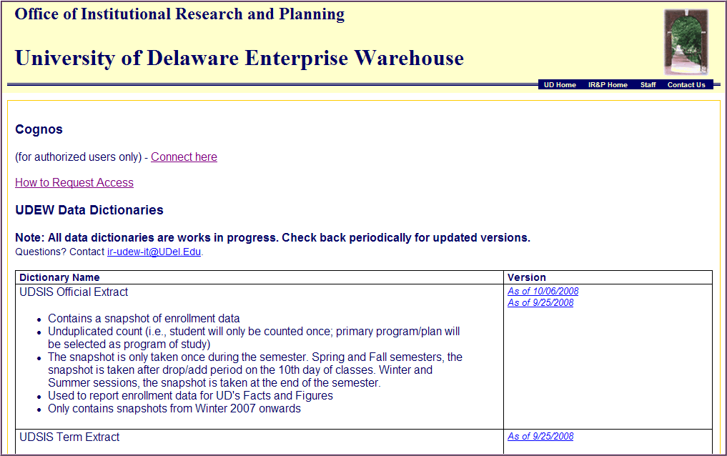
Access Info
Cognos link
Data Dictionaries

Click the links for complete information (open as Excel)

Tour of Cognos Connection
Home – use this to set any current page as your “home page”

My Area – use this to view your report history and schedules, or change your personal settings
Tool bar - hover your mouse over icons to see their functions

Cognos Connection is where the reporting content is stored.
Launch – use this to go to Report Studio (if you have access)

Content includes data packages (tables) and existing reports.
Search – type keyword(s) to find a report, folder or package
To create reports, go to Report Studio from the Launch link (access required).

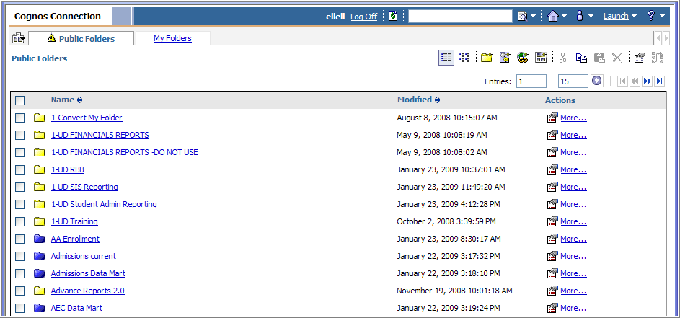
Actions – assorted action buttons that change depending on the type of content

Yellow folder icons – content folders that hold other content folders and/or reports.

This is the RBB folder.
This is the Training folder.

Blue folder icons – package folders that hold data tables by content area

My Folders – content available only to the person logged-on

Public Folders – content available to all campus users (based on your data access)
Checkboxes – use these boxes to copy, paste, delete, etc using the tool bar icons

Help
Use the up/down arrows to sort content by Name or Modified date

Navigation buttons

Running a report in your browser
Navigate to the report you want to run, by clicking on the folder links. The results will display in your browser in HTML format.

In this example, we’ll look at the report named Exercise 05 - List

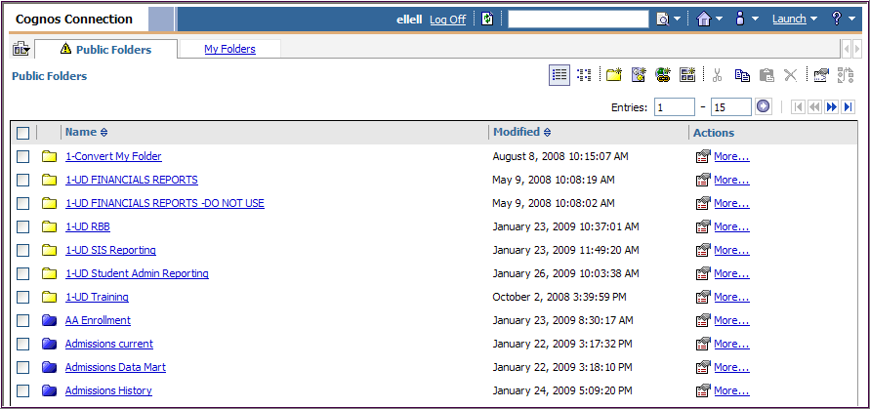
1. Click the link for the yellow folder called 1-UD Training
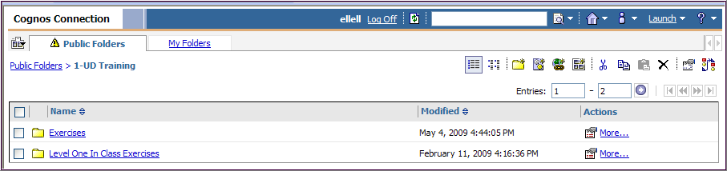
2. Click the link for Exercises

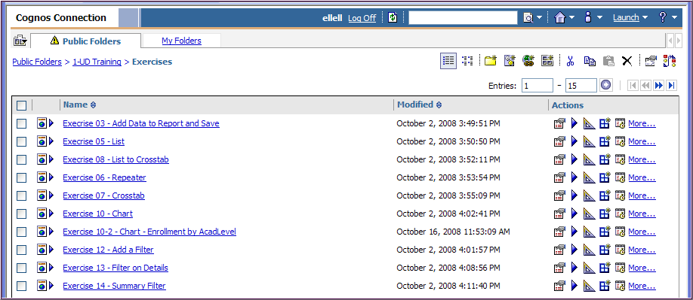
3. Click the link for Exercise 05 - List

This report has a Prompt for the Academic Term and Run Date ID (First, Tenth or Last Day of the semester)

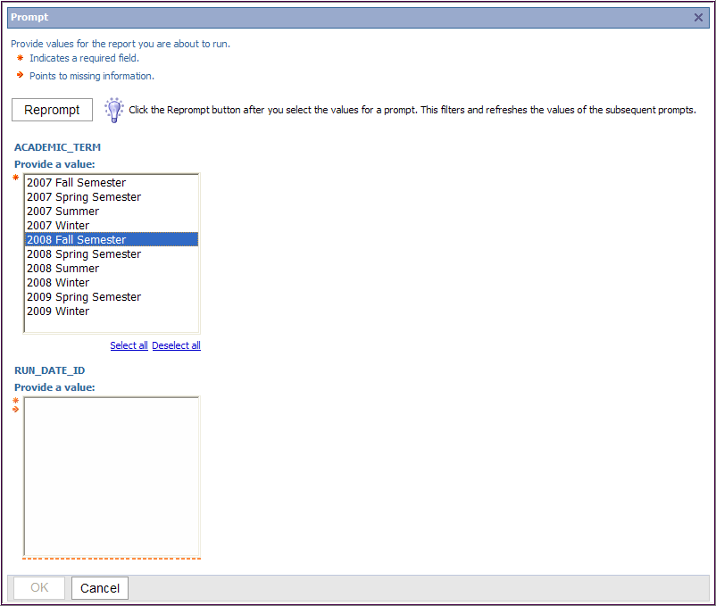
4. First select a Term and then click the Reprompt button

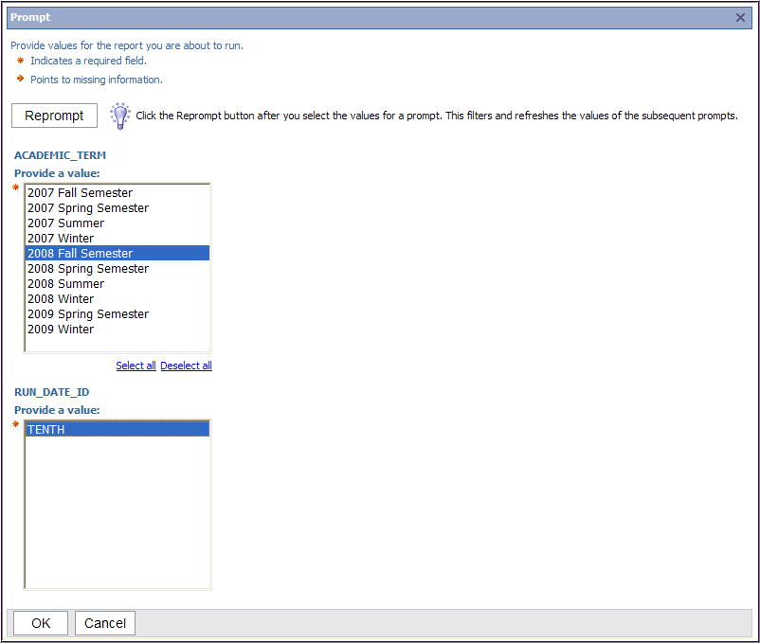
6. Click the OK button

5. Select a Run Date ID (even if there is only one)

This opens Cognos Viewer which shows a partial view of the report.

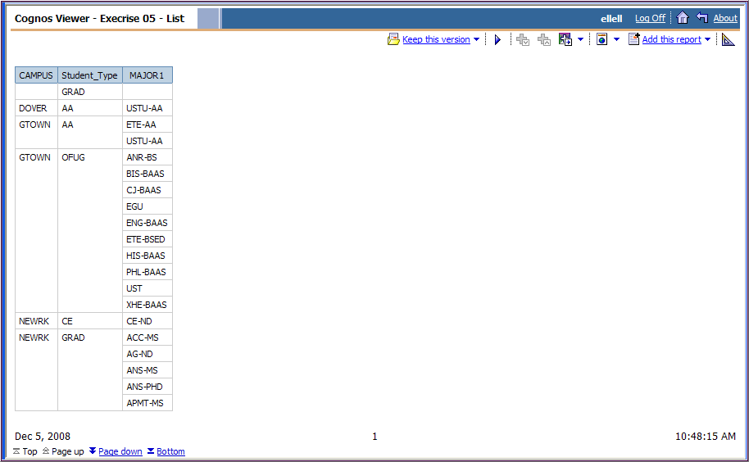
7. Use these links, such as Bottom, to view other pages of this report

This is the last page of the report:

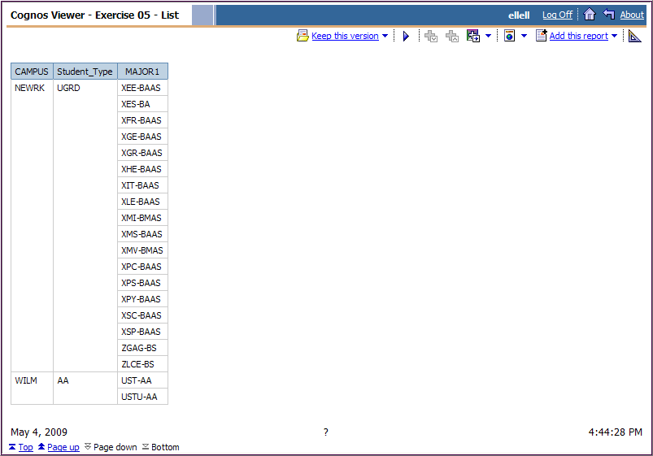
8. Click the Return button to go back to Cognos Connection

Run with options
Use this method to give yourself more choices for your report’s format and delivery options.

- Find the report you want to download.

2. Click this button

- In the Actions column, click (Run with options) – do not click the link
  - As an example, let’s download Exercise 05 - List

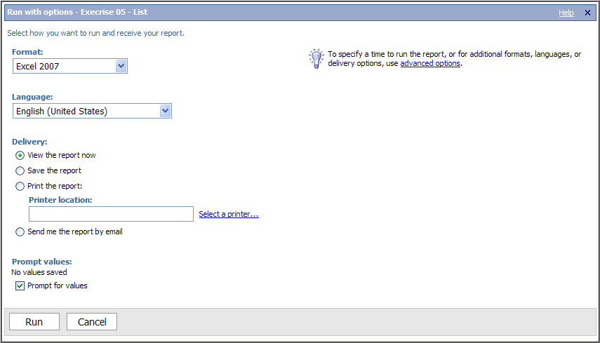

- The options you will most likely use are:
  - Format - HTML, various Excel versions, PDF, Delimited text or XML
  - Delivery – View report now or Send me the report by email
  - Advanced options – scheduling a report (once) or emailing to others

Run with options - Downloading to Excel

You must make sure your PC has these settings before attempting to download to Excel from Cognos Connection when using Internet Explorer:
Make these four setting changes in Internet Explorer (7.0 or higher):

- Tools/Internet Options/Security tab
  - Click Trusted Sites/Sites button,
  - Type https://cognos.udel.edu in the top box and click Add
  - Click checkbox labeled Require server verification…
  - Click Close button

- Tools/Internet Options/Security tab
  - In the section called Security level for this zone, click Custom level… button
  - Scroll to Downloads
  - Automatic prompting for file downloads – click Enable
  - File download – click Enable
  - Are you sure you want to change the setting for this zone? Click Yes
  - Click OK button

- Tools/Pop-up Blocker/Pop-up Blocker Settings
  - Type cognos.udel.edu in the top box and click Add
- Click checkbox - Play a sound when pop-up is blocked
- Click checkbox - Show Information Bar when pop-up is blocked
  - Click Close button

- Tools/Phishing Filter/Phishing Filter Settings (not needed)
  - You will be on the Advanced tab; scroll way down to Security
  - Under Phishing Filter, click Disable Phishing Filter
  - Click OK button

- In the Actions column, click Run with options (do not click the link)

4. Leave this checkbox checked ON

2. Choose Excel 2007 or Excel 2002

3. Leave the Delivery mode as View the report now

- Click the Run button

6. First select a Term and then click the Reprompt button

7. Select a Run Date ID (even if there is only one)

8. Click OK

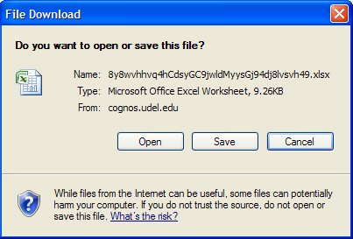

- Select Open or Save (your choice)

• Once Excel opens, you have full Excel functionality

• Save the file with a new meaningful name

FYI - Run with options – Other Formats

• HTML – results display in your browser.
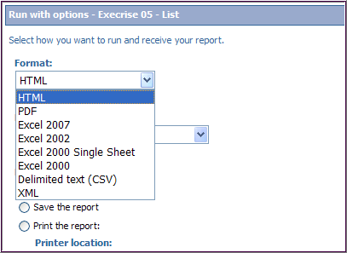

• PDF – creates a report that cannot be modified. (Acrobat Reader must be installed on your system)

• Delimited text (CSV) – creates comma separated values for using with Excel

• XML (extensible markup language) – allows you to see XML representation of the report’s queries, prompts, layouts and styles.
Run with options - Emailing a report to yourself

1. Click this button

- In the Actions column, click Run with options (do not click the link)

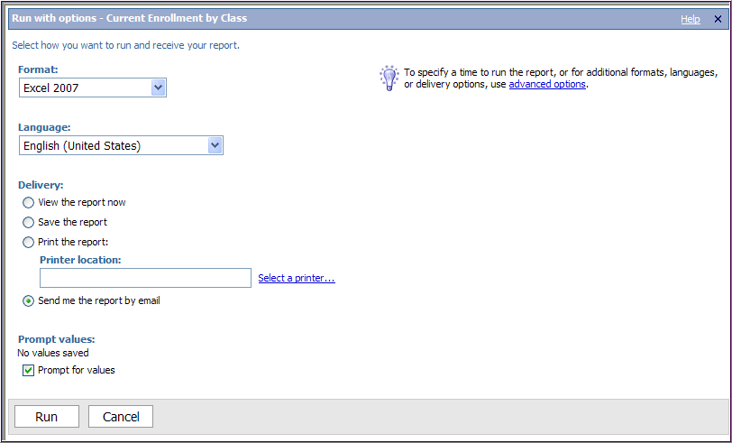
3. Click this radio button

4. Leave this checkbox checked ON

2. Choose Excel 2007 or Excel 2002

- Click the Run button
- If a Prompt page appears, select an appropriate values
  - In this example Term = 2088 and Run Date ID = TENTH

Note – If you want to send the report to additional emails beyond your own, go to pages 14 - 16 and follow instructions for advanced options.

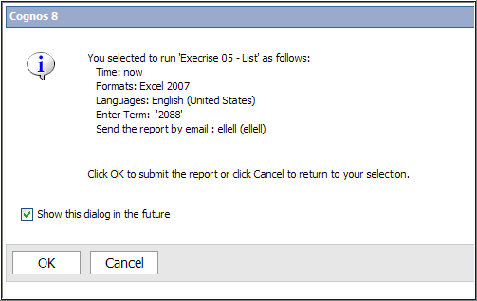
- This screen gives you a chance to verify your selection criteria
- Click the OK button to submit the report (or click Cancel to start over)

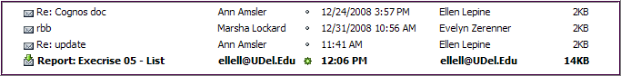
- Moments later an email will arrive in your Inbox with the report attached as an Excel file with your email address as the sender.

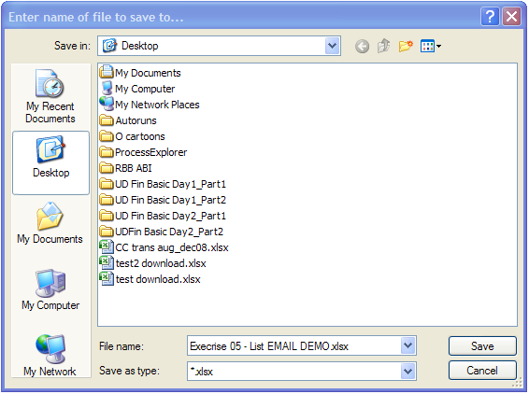

- Open the file from your email, immediately go to Save As
- File Name – change file name to suit you
- If needed, change Save as type to Excel Workbook (*.xls) or (.xlsx)
- Click Save button (this enables you to use all Excel features with report)
Note - If you select Excel 2002 or earlier version you may get a WARNING!!! message in your email that says in part “The following message attachments were flagged by the antivirus scanner”. Our IT-NSS staff say you may ignore this message and proceed with viewing or saving the Excel attachment.

Advanced Options - Emailing a report to others

- If needed, find your report and click Run with options

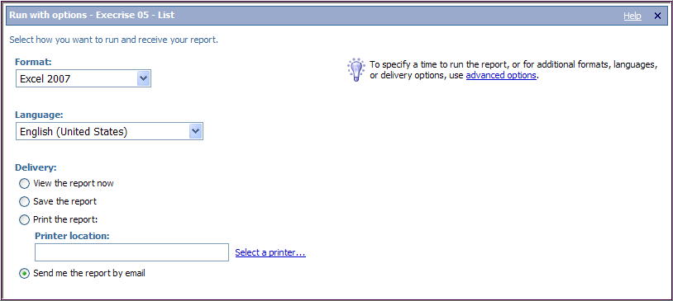
3. Click the advanced options link

2. Click this radio button

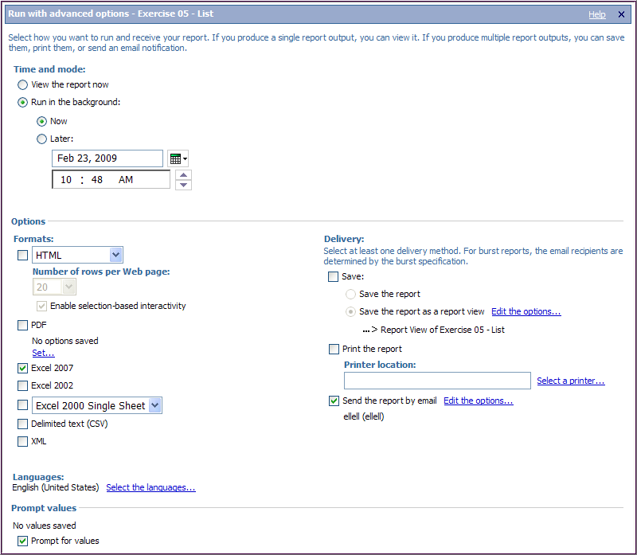
X
6. IMPORTANT - Click the 1st Edit the options… link to save a report view of the report in My Folders

5. Choose Format (Excel 2007, PDF, etc.)

4. Click radio buttons:
• Run in the background
• Now

Note: You can schedule the report to be emailed later by clicking Later and setting the date/time (see pg 17).

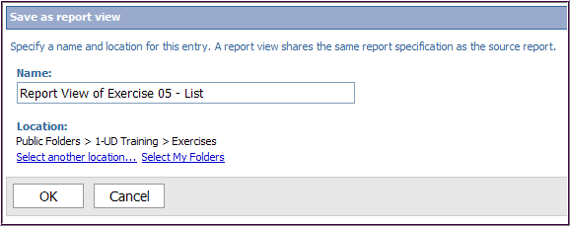
7. Click Select My Folders

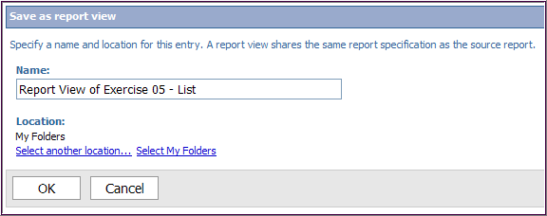
8. Notice the Location changes to My Folders

9. Click OK

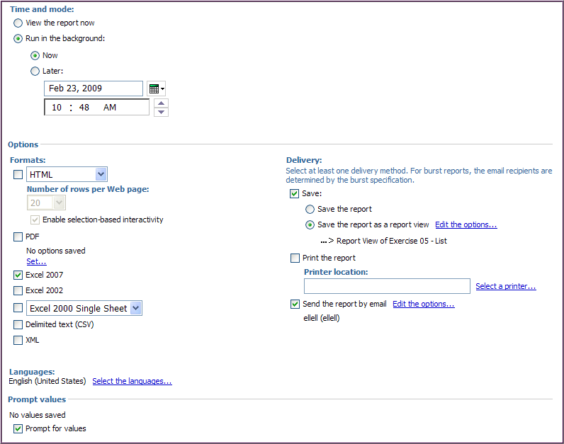
10. If not already checked, click checkbox for Send the report by email

X
11. Click the 2nd Edit the options… link

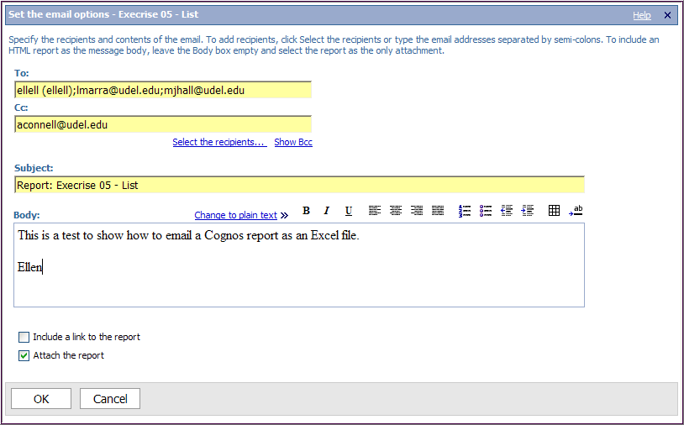
- Click OK button

15. Be sure this checkbox is clicked ON

13. Change Subject if needed

12. Type full email address for each new recipient, use semi-colons to separate them

14. Type your message here

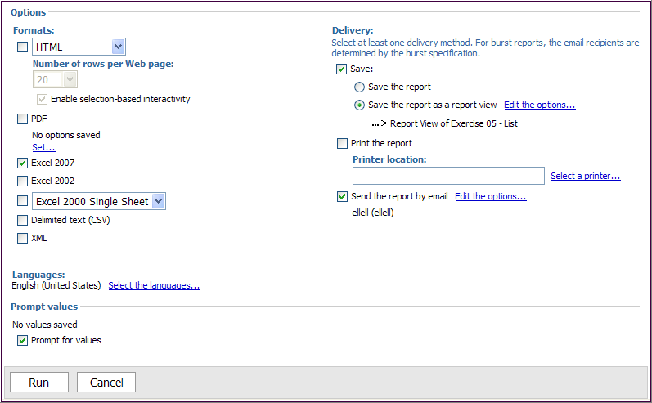
18. Click Run button

17. Make sure the Save checkbox is still checked ON

- When Prompt page appears select a Term and Run Date ID, and click OK
- Click OK when Cognos 8 page appears
- Check your email.
Advanced options -

Scheduling a report to run later and then get emailed to you

- If needed, find your report and click Run with options

3. Click the advanced options link

2. Click this radio button

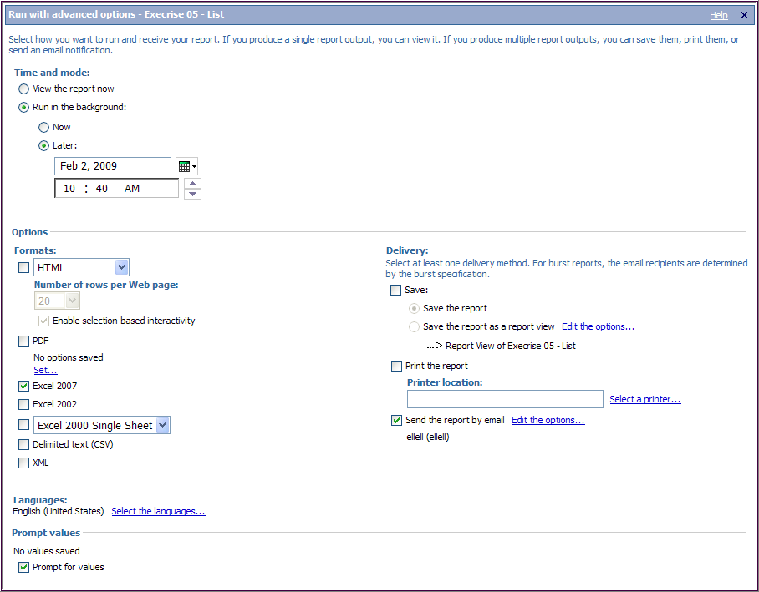
7. Choose Format (Excel 2007, PDF, etc.)

4. Click radio buttons:
• Run in the background
• Later

5. Select date with calendar button

6. Set time by typing the numbers or using the up/down arrows

- Follow the instructions on pages 14-15 (steps 7 – 20) to complete the process.
Create a report view of a report
A report view is a reference to another report that has its own set of properties, such as prompt values, schedules, and output results.

Use report view to schedule a recurring report after saving it in My Folders.

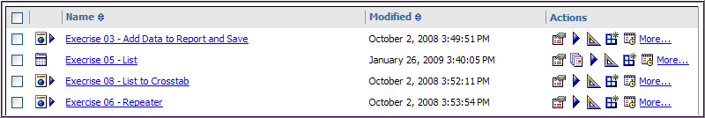
1. Click this button

This opens the New Report View wizard:

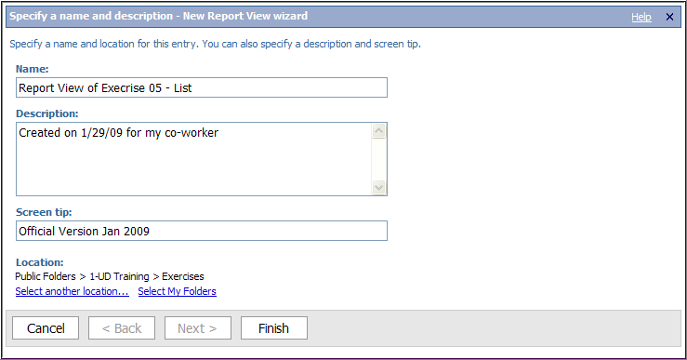
5. Location – Click Select My Folders (You will not be able to save it in Public Folders or in another location.)

6. Click the Finish button
4. This text will appear when someone hovers over the report icon.

2. The Name can be changed if needed.

3. Description is a useful field to store more info.

- Click the My Folders tab and use navigation arrows (if necessary) to find the Report View you just created.

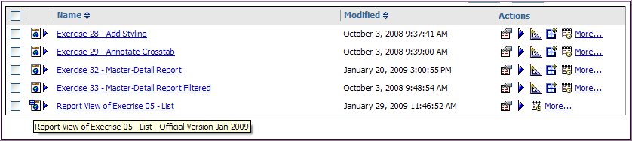
8. Hover your mouse over the report icon to see the screen tip

Schedule a recurring report

Use this method to schedule a report view from My Folders to run daily, weekly, monthly or annually. These instructions will show you how to schedule a report and have it emailed to yourself and/or others.

- Click on My Folders
- Find the report view you want to schedule
  - Select Report View of Exercise 05 – List (the report view you created on the previous page)
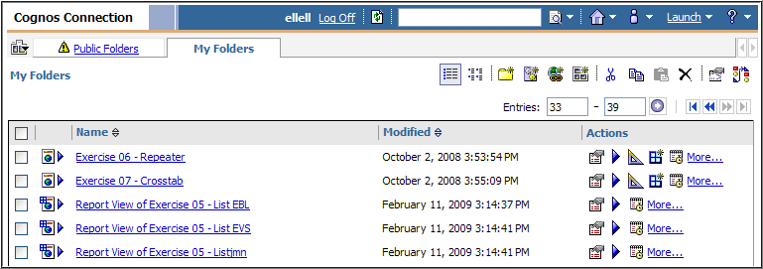
3. Click this button

- In the Actions column, click the Schedule button – do not click the link

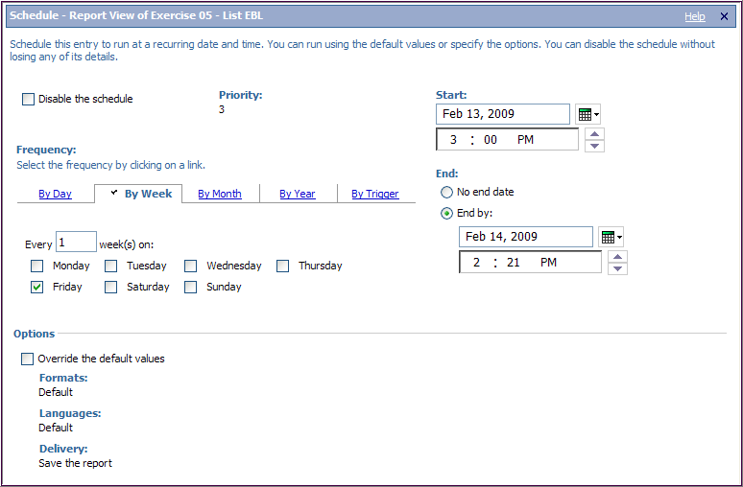
6. Choose the Start date and time

7. End - Click the End by radio button and choose a date/time OR click No end date

8. Click the Override the default values box ON

4. Select the Frequency

5. And then complete the appropriate boxes below.

The Options section opens up for making changes to Formats & Delivery options.

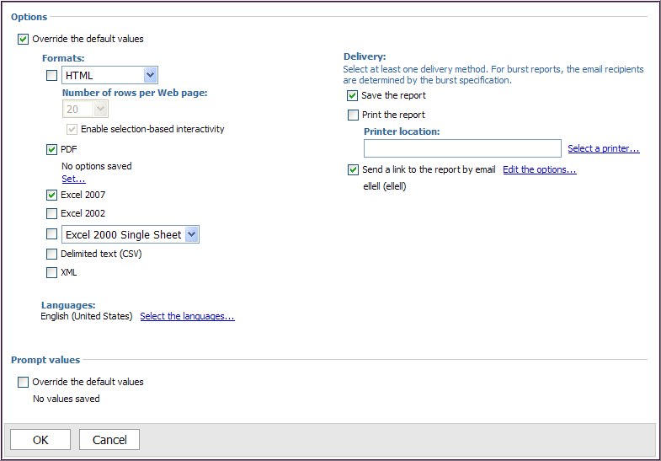
3. Click Send the report by email

4. Click Edit the options…

1. Select the Format(s)

2. Under Delivery, leave Save the report checked ON.

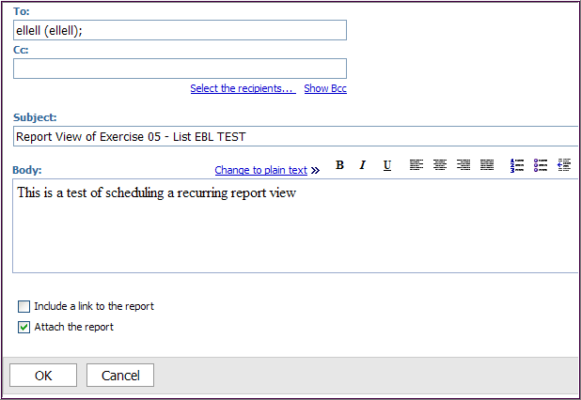
6. Check the Include a link to the report OFF
7. Check the Attach the report box ON

5. Add additional recipients, change the Subject and add a message if needed.

- Click OK
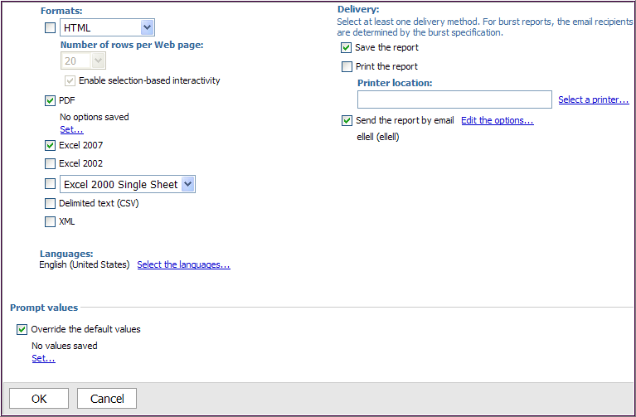
10. Click the Set… link

9. Very Important!
If the report has a prompt, click Override the default values ON.

11. Prompt page
  - Enter a value or values in the prompt page
  - Click OK

The Prompt values will reflect your choice(s) – shown below:

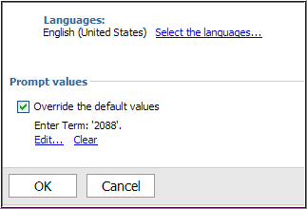
IMPORTANT NOTE
Be sure to update the Prompt default value(s) for a scheduled report when the value changes (e.g. the academic term)

12. IMPORTANT - Click OK on the Schedule page
  - Your recurring report has been scheduled!
  - You may come back to the Schedule page to modify or disable the report’s schedule as needed.

My Area

My Activities and Schedules – Use this feature to view your current and past activity as well as your scheduled recurring reports.

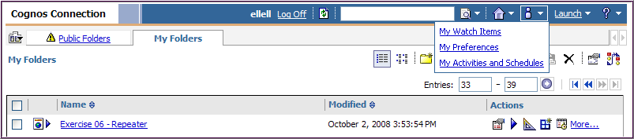
1. Click My Area and choose My Activities and Schedules

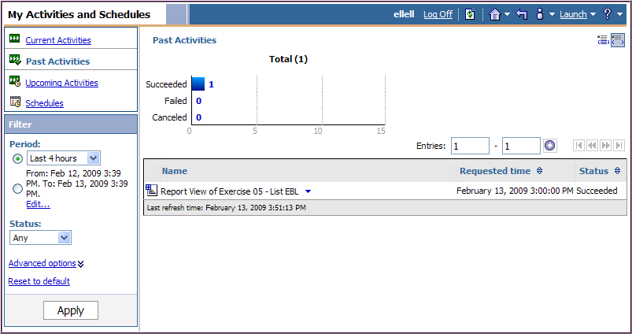
4. Filter – change these settings to see more or less history and then click Apply
2. Current Activities is the default – it displays anything currently running
3. Click the Past Activities link to see your report history

View or change your scheduled recurring reports:
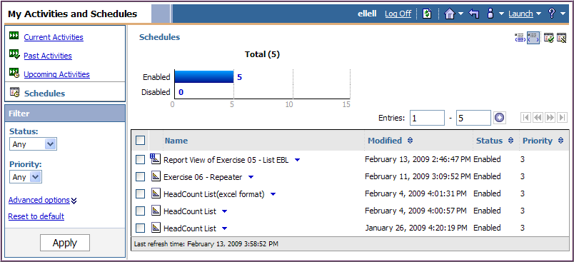
5. Click the Schedules link to see the scheduled reports or report views you have in place

Use the Return button to return to Cognos Connection

6. Click the blue triangle to see the options for each schedule.

Note: you should Remove the schedule after it is completed.
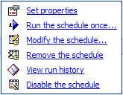

My Preferences – Use this feature to set personal settings and defaults

1. Click My Area and choose My Preferences

General tab:
2. Change settings according to your preferences and click OK

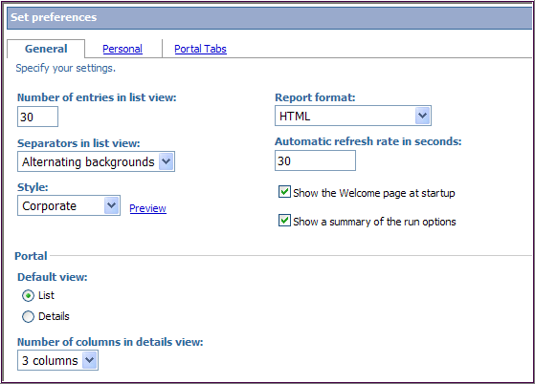
Separators in list view - Change to Alternating backgrounds to make the list view easier to use.

Style – the color scheme of Cognos can be changed if you want. The Preview link will let you see what the choices look like.

Personal tab:

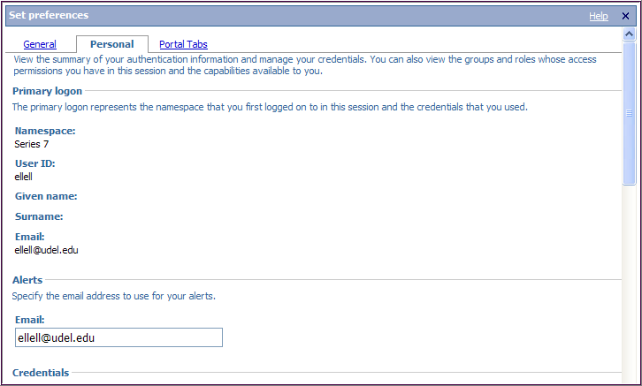
3. Do not change these settings. Scroll down to see your access Groups and roles.

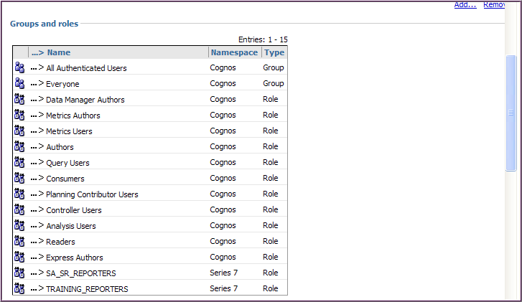
4. Your UD roles are in all CAPS.

(Ignore the other roles/groups; they came delivered with Cognos and we’re not using them.)

Other Actions - We’ll look at these additional Actions:

Set Properties
Open with Report Studio
More actions

Set Properties – view general information and set output or prompt properties
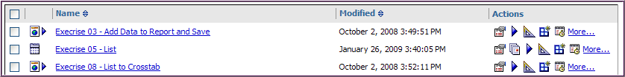
1. Click this button

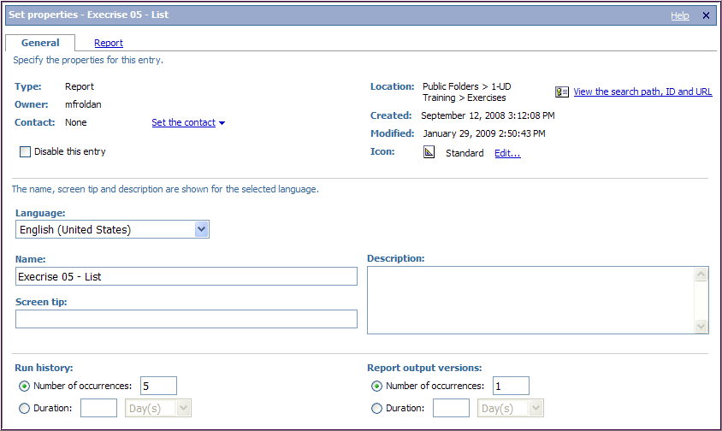
Note - Do not change any settings on the General tab

2. This section tells you who created the report and when

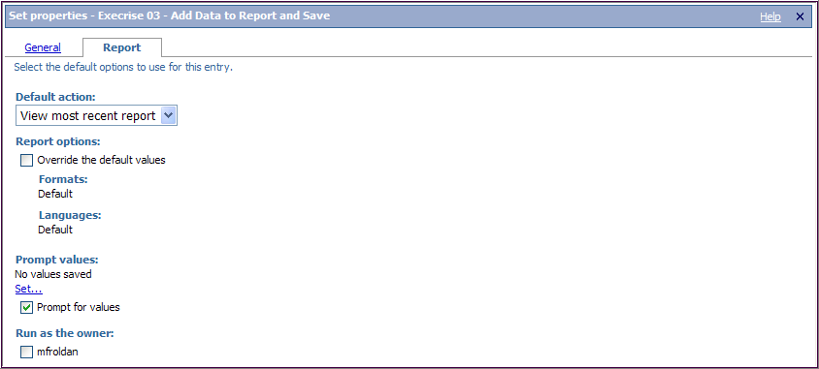
Click the X to go back to Cognos Connection

If you were to set the Prompt values here, it would “hard code” the value(s) in this report for everyone! Please do not do this.
Note - Do not change any settings on the Report tab

Open with Report Studio
Report Studio is the report writing tool in Cognos; it allows you to modify a report. You will get an error unless you’ve been given security access to Report Studio.

More actions
This link lets you see all the Actions available for a given report.
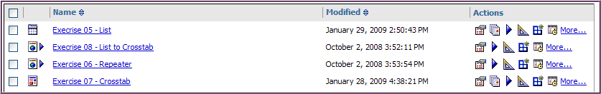
1. Click this link

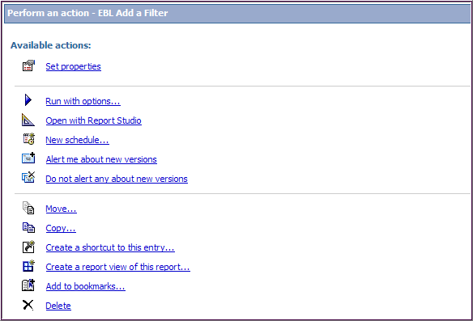
2. These links will vary from report to report and person to person, depending on each person’s access.

Use this action carefully! Do not move reports in the Public Folder or any of its subfolders. Move reports around in your My Folders area however you want.

Use this action to place a copy of a report in your My Folders area. Do not copy a report elsewhere in Public Folders without proper authority.

Use this action carefully! Do not delete any report in Public Folders you didn’t create.

Other Helpful Information
Breadcrumbs

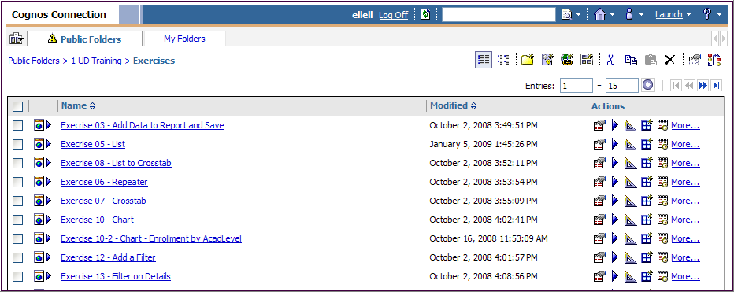
Use the breadcrumbs to:
• See where you are
• Navigate back to higher levels

Report Icons

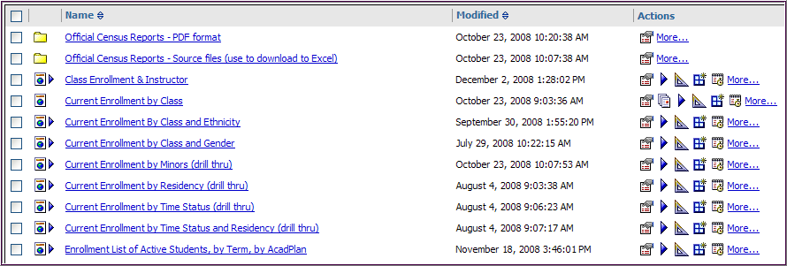
FYI about what the icons mean next to the links:
HTML Report
HTML Report with prompts
HTML Report View
Report with auto-download to Excel
Report results to Excel
Run with prompts, Excel format
Excel results
PDF report
Folder with additional reports/folders
Shortcut folder – the content actually resides in another folder, it allows users to access the same report from multiple locations.

