Unified Summative Assessment
Educational Research Edition

January 2009

Written Question Segment

Directions
The questions in this portion are multiple choice. Please mark your answers in #2 pencil on the Scantron sheet provided. Scrap paper is available if you wish to use it. If you would like to have the question read aloud, you may use Word Talk and the headphones provided. Any words highlighted in blue are terms/ideas that the examiner will not explain. Please feel free to ask the examiner for clarification about any other terms or questions that you do not understand.

- A group of research biologists is studying the local rabbit population. After six months, they examine the data that they have collected, looking for trends. Their data is shown in the table below.

Age and Number of Rabbits in Local Population
Age of Population in Months | Number of Rabbits in Population
0 | 2
1 | 6
2 | 18
3 | 54
4 | 162
5 | 486
6 | 1458

Which of the following graphs best represents the data given in the table?
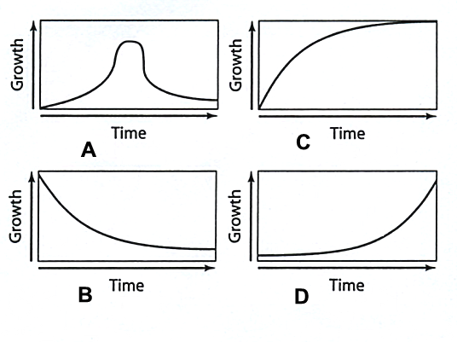

Use the following information to answer questions 2, 3, and 4 below.
Given below is a population pyramid for the country Nowhere. 50 years ago, this country was involved in a major war against its neighbor, Noplace. 35 years ago, Nowhere’s major crop shifted from being barley to rye. 10 years ago, the television became affordable for most Nowherian families.

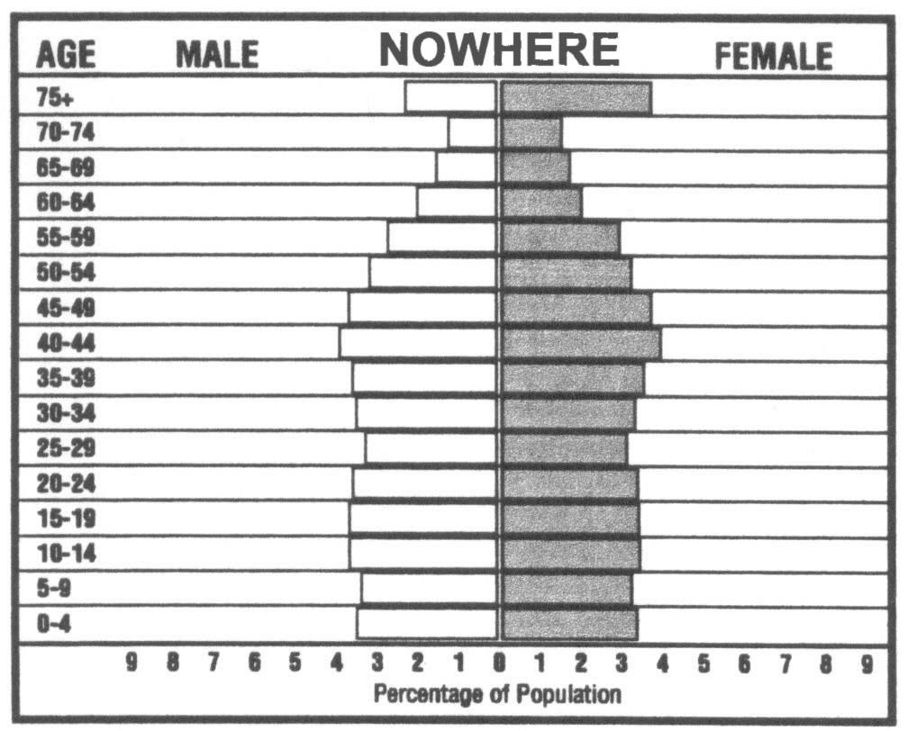

- In the 70-74 age bracket, which of the following statements is true?

A |  | There are more males than females.
B |  | There are more females than males.
C |  | There are the same number of males and females.

- In the 35-39 age bracket, which of the following statements is true?

A |  | There are more males than females.
B |  | There are more females than males.
C |  | There are the same number of males and females.

- What factor is most likely responsible for the population discussed in question 2?

A |  | The war with Noplace
B |  | The crop shift from barley to rye
C |  | The increase in availability of the television

- Which statement describes how humans are affecting the balance of carbon in the atmosphere?

A |  | Fewer crops reduce the amount of carbon dioxide in the air.
B |  | Burning fossil fuels has increased the amount of carbon dioxide in the air.
C |  | Overgrazing of grasslands has reduced the amount of carbon dioxide in the air.
D |  | Severe drought has decreased the amount of carbon dioxide in the air.

- What three things are needed to sustain life?

A |  | food, water, and shelter
B |  | money, water, and jobs
C |  | food preservation, education, and government
D |  | water, medicine, and money

- What would Earth be like if the greenhouse effect did not exist?

A |  | More tropical rainforests
B |  | Higher sea levels
C |  | Hot and humid
D |  | Cold nights and hot days

- Which of the following are alternative energy sources?

A |  | nuclear, solar, and wind
B |  | coal, oil, and wood
C |  | geothermal, oil, and wind
D |  | natural gas, propane, and butane

- Which of the following are alternative fuels for transportation?

A |  | oxygen, nitrogen, and helium
B |  | gasoline, hydrogen, and natural gas
C |  | rocket fuel, acetone, and hydrogen peroxide
D |  | hydrogen, ethanol, and biodiesel

- What is a light-year?

A |  | The same as an earth year (365 days)
B |  | The distance from Earth to the Sun
C |  | The distance light travels in a year
D |  | The amount of light the sun produces in a year

- What type of galaxy is the Milky Way?

A |  | spiral galaxy
B |  | cloud galaxy
C |  | elliptical galaxy
D |  | irregular galaxy

- What do scientists think is the age of the universe?

A |  | 1 to 5 million years old
B |  | 1 to 2 billion years old
C |  | 10 to 15 billion years old
D |  | 100 to 200 billion years old

- Two identical planets are in orbit around the same star. Planet B is twice as far away from the star as Planet A. Which of the following statements is true?

Star
Planet A
Planet B

A |  | The Planet A feels a stronger gravitational pull from the star than Planet B.
B |  | The Planet B feels a stronger gravitational pull from the star than Planet A.
C |  | Both stars feel the same gravitational pull from the star.

- The four fundamental forces are strong nuclear, electromagnetic, weak nuclear, and gravity. Arrange the forces from strongest to weakest.

A |  | strong nuclear, electromagnetic, gravity, weak nuclear
B |  | strong nuclear, gravity, electromagnetic, weak nuclear
C |  | gravity, strong nuclear, electromagnetic, weak nuclear
D |  | strong nuclear, electromagnetic, weak nuclear, gravity

- What does Einstein’s famous equation, E = mc² best explain?

A |  | A small amount of mass can be converted to a large amount of energy.
B |  | The energy formed is directly proportional to the square of the circumference.
C |  | The energy on Earth equals the mass times the square of the amount of carbon.
D |  | A large amount of mass can be converted to a small amount of energy.

Use the following information to answer questions 16 and 17 below.
Astronomers observing distant galaxies see them as redder than they would expect.

- What does this indicate about the galaxies?

A |  | They are moving away from us.
B |  | They are moving towards us.
C |  | They are swirling around us.
D |  | Their inhabitants are angry.

- What idea is supported by this evidence?

A |  | Evolutionary Theory
B |  | The Law of Gravity
C |  | Big Bang Theory
D |  | Conservation of Energy

- What explains the changing in pitch of a police car’s siren as it moves by you?

A |  | the Doppler effect
B |  | Resonance
C |  | the speed of sound
D |  | Intensity

- Which of the following parts of the electromagnetic spectrum has the highest energy?

A |  | radio waves
B |  | X-rays
C |  | visible light
D |  | microwaves

- Which of the following parts of the electromagnetic spectrum has the highest frequency?

A |  | visible light
B |  | infrared light
C |  | gamma rays
D |  | ultraviolet light

- What do electromagnetic waves and sound waves have in common?

A |  | They can both travel in a vacuum.
B |  | They both travel at the speed of sound.
C |  | They both require a medium to travel through.
D |  | They both transport energy.

- Why is Earth’s magnetic field important to humans?

A |  | Earth’s magnetic field provides electricity.
B |  | Earth’s magnetic field causes tides.
C |  | Earth’s magnetic field keeps the oceans warm.
D |  | Earth’s magnetic field protects from solar radiation.

