Choose one of the listed foods that would be best for the various scenarios below and explain why. (Make sure to state what each is mostly made of and how it effects the human body)

- 1 lb of butter
- 1 lb of sugar
- 1 lb of lean chicken
- 1 lb of prunes

- You have a stomach ache because you ate something that didn’t agree with you.

- You are in the desert starving and don’t expect a rescue for several days.

- You are a body builder trying to slim down before a competition.

- You are a marathon runner just who just ran 10 miles and still has 10 more miles to go.
1) Other than calories, Identify the 3 most important components that the human body requires on this label.
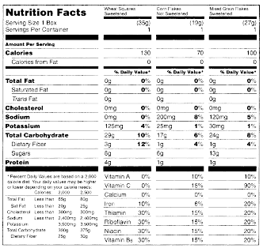
2) Would you consider the product discussed in the previous question a protein drink, energy drink, or weight gainer? And why?

3) What are calories (energy) actually from in reference to the label?

1) In your opinion, of the two drinks below, what serves as a better protein drink for someone wanting to put on muscle? Explain on back.

A)
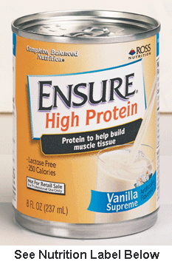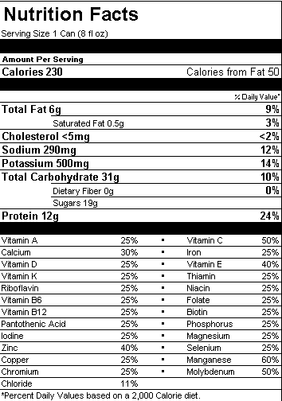

B)
