Name _______________
Date ________________
Period _______________

Scenario: You’ve placed an egg in vinegar for 24hrs and noticed that the shell has melted away revealing a membrane. This semi-permeable membrane (AKA the vitelline membrane) surrounds the egg and holds in its contents.

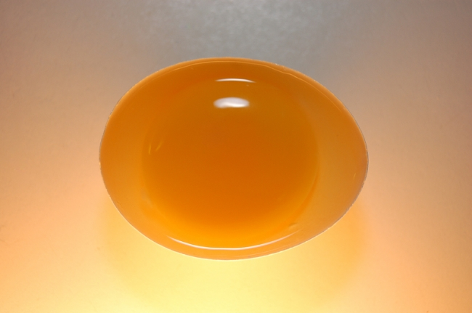

You then submerge this egg in 200mL of salt water for 24 hours. After that time you remove the egg from the salt water and record how much water is left in the container as compared to the amount you first put in. You also record the shape of the egg.

You then take the egg and submerge it in 200mL of distilled water (pure water) for 24 hours. After that time you remove the egg from the distilled water and record how much water is left in the container as compared to the amount you first put in. You also record the shape of the egg.

Questions:

1) What do you think the egg will look like after being in the salt water for 24 hours? Why? ________________________________________________________________

2) How much salt water will be in the container after removing the egg (more, less, or the same)? Why? ______________________________________________________

3) What do you think the egg will look like after being in the distilled water for 24 hours? Why? ________________________________________________________________

4) How much distilled water will be in the container after removing the egg (more, less, or the same)? Why? ______________________________________________________

