Name ________________
Date _________________
Period ________________

After being in the salt water for 24 hours the egg looked like this:
Before After
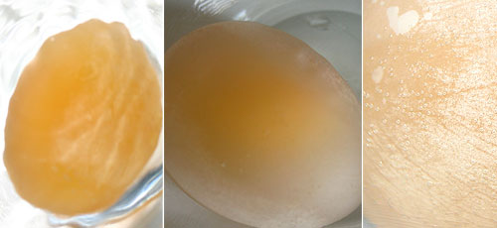

What happened to its size and shape? Was it what you predicted? ________________________________________________________________________________________________________________________________________________

After removing the egg from the container you realized that the water level increased. Why would there be more water in the container after taking the egg out then when you put it in? Is this what you predicted? ________________________________________________________________________________________________________________________________________________________________________________________________________________________

After being in the distilled water for 24 hours the egg looked like this:
Before After
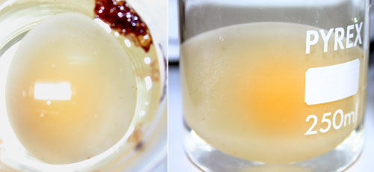

What happened to its size? Was it what you predicted? ________________________________________________________________________________________________________________________________________________

After removing the egg from the container you realized that the water level decreased. Why would there be less water in the container after taking the egg out then when you put it in? Is this what you predicted? ________________________________________________________________________________________________________________________________________________________________________________________________________________________

