Name: _____________________________________ Date: ________________________ Class:________

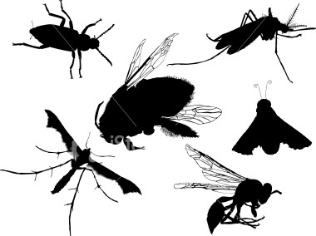
Measuring Arthropod Diversity Lab

GOAL: You will compare the diversity of arthropods of a meadow habitat from 2 different areas. One meadow will be in a disturbed landscape (Delcastle), and one meadow will be in an undisturbed landscape (Middle Run Natural Area; see attached maps). You will make a hypothesis as to which site has higher diversity, then we will collect and analyze data to test your hypothesis.

DATA COLLECTION:

Outside – You will divide into 4 groups, and each group will collect 2 arthropod samples per site (2 from Delcastle and 2 from Middle Run). Samples will be collected in the field using sweep nets. To use a sweep net, the net is rapidly swept across vegetation, and any arthropods on the plants are captured at the base of the net. To standardize our data collection, each sample will be taken by making 20 sweeping motions with the net. The arthropods from each sample will be placed into jars and killed by freezing.

Inside – The next step will be to bring the samples into the laboratory and sort and count the species in each sample. None of us is skilled enough to identify our insects to species, but with a little effort we should be able to sort them into reasonable groups based on their appearance. We will consider each unique-looking group a “species.” Once you have identified all of your “species” in your group, we will combine the data from the whole class for analysis.

DATA ANALYSIS:

Data – Data from period 1/2 and period 3/4 will be combined into one large data table. You will use this data table to calculate the indices described below. Spaces will be provided on this table for you to do your calculations.

Calculations – We will we use 3 analyses to describe the arthropod community characteristics:
- Species Richness (Total # species)
- Species Diversity (Simpson’s Reciprocal Index)
- Community Similarity (Jaccard Index)

1. Species richness is simply the number of different species that were collected at each site.

2. Species diversity is a more complex concept. Species diversity depends on the number of species present (richness), but also the proportion of each of those species (evenness). Consider the following example. Suppose there are two communities, A and B, each with 50 individuals and 5 species (richness = 5), and that the abundance of each species is given in the table below:

Community A B

Species #1 10 25
#2 10 10
#3 10 5
#4 10 5
#5 10 5

Total 50 50
Although each community has the same number of species and the same number of total individuals, the composition of those individuals is different. We use a species diversity measurement to describe this difference. For our analyses, we will use a standard index called Simpson’s Diversity Index (D), which is expressed as the following equation:

D = SUM (n/N)²

where n = the total number of individuals of a particular species and N = the total number of individuals of all species. For example, in the hypothetical community B above, n/N of species 1 is 25/50 = 0.5. Once you have calculated the values of n/N for each species, each value is squared and then summed to get D. Thus, the Simpson’s Diversity Index of community A = 0.2 and community B = 0.32.

To make these values more meaningful, scientist often use the Simpson’s Reciprocal Index which is simply 1/D. Therefore, the Reciprocal Index of community A is 1/0.2 = 5 and of community B is 1/0.32 = 3.125. Higher Reciprocal Index values mean greater diversity. In our example, community A is more diverse.

3. Another important measure used in quantifying diversity is determining how similar communities are in species composition. We will use the Jaccard Index of community similarity, to determine how similar the sites are to each other. The Jaccard formula is as follows:

CC_{J} = c/S

where c = the number of species ocurring at both sites and S = the total number of different species found at both sites. Consider the following example. Suppose there are two communities, C and D:

Community C D

Species #1 0 25
#2 0 11
#3 10 5
#4 7 0
#5 10 5
#6 24 0

For this calculation, the number of each species in not important, but the number of species present is. Species #3, #4, #5, and #6 were found at community C, and species #1, #2, #3, and #5 were found at community D. However, only species #3 and #5 were found at both sites, therefore c = 2. The total number of species found at both sites is S = 6. Therefore, CC_{J} = 2/6 = 0.33.

The Jaccard Index ranges from 0 (when no species are found in both communities) to 1 (when all species are found in both communities) and can be interpreted as a percentage. Therefore, in our example, community C and D are 33% similar.

WRITTEN ASSIGNMENT:

Data Table – Complete the calculations on the data table provided. Attach the data table to the lab report you turn in.

Results and Discussion – You will complete this lab by writing the results and a discussion. See separate sheet with results and discussion guidelines. The results and discussion should be typed in 12 pt Arial font. Be sure to include your name, class, date, and lab title at the top of the page.

Delcastle Technical High School
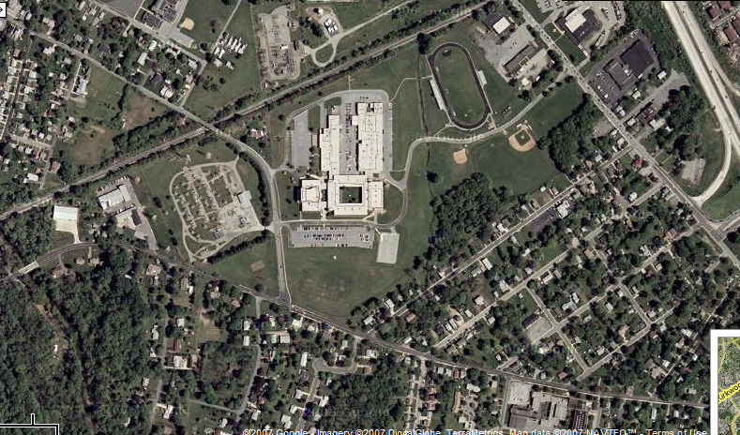

Middle Run Wildlife Area
