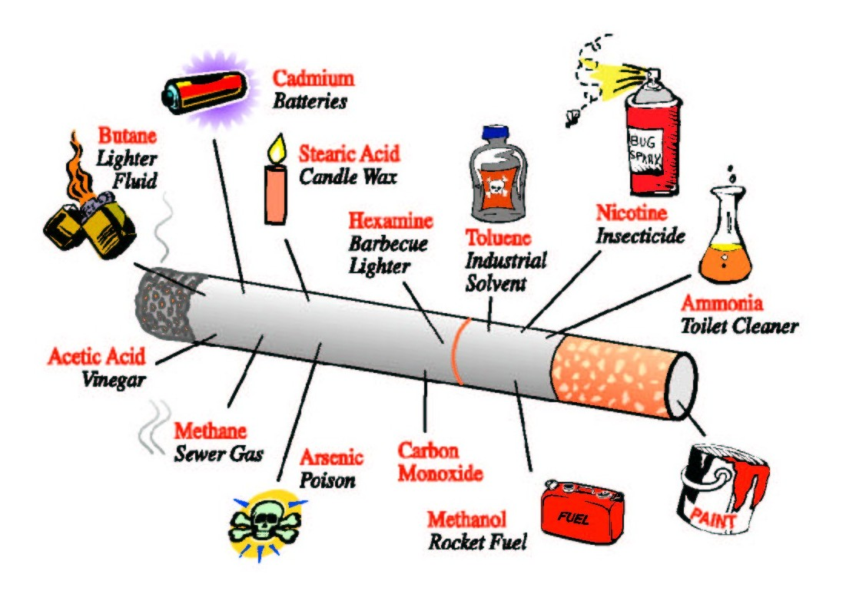
Bacterial Mutation Lab

In addition to nicotine, cigarette smoke contains over 4,000 different chemicals. The vast majority of these chemicals are added to the tobacco to add to its addictiveness, improve its flavor, and/or to increase burn rate, which increases sales.

Chemicals in tobacco circulate through the body and produce “free radicals” that damage DNA within cells similar to radiation. The accumulation of DNA damage (mutation) leads to drastic changes in the genetic code that lead to serious problems for the cell.
Not only does tobacco cause several types of cancer (including lung, larynx, mouth, stomach, kidney and pancreas) but can also lead to a number of other diseases and health problems including heart disease, stroke, emphysema, chronic bronchitis, reproductive damage, birth defects, stomach ulcers as well as a weakened immune system.

UV light also affects other organisms. UV light can cause mutations in bacteria that lead to a visible change in their appearance. In our case the Serratia, known to grow red, when exposed to UV light will grow white.

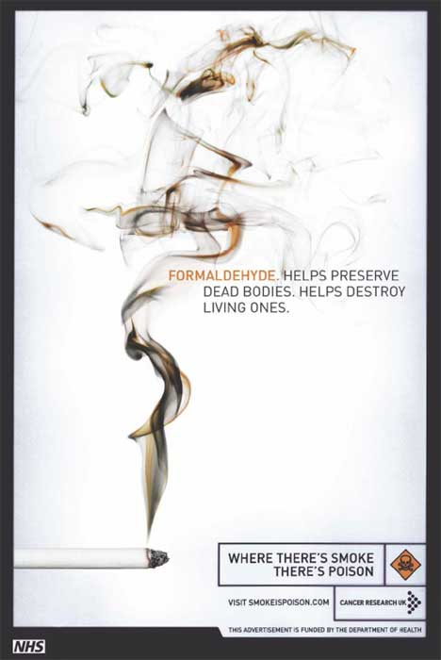
Day 1.

Today you will treat plates of nutrient agar with different concentrations of tobacco extract and then inoculate the plates with Serratia marsescens. One of the plates of bacteria will be a control without tobacco. You will add a designated concentration of a prepared tobacco extract to the other plates in order to see the effects of different strengths of tobacco on the bacteria.

What do you expect to see with increased concentration of tobacco? Draw your prediction on the graph.
Concentration of tobacco
# of white colonies

Do you expect to see any white colonies without any exposure to tobacco? Why or why not?

Directions for Day 1

1. Obtain 3 plates.
- Write your name on the bottom of the plate and the concentration of tobacco in permanent marker.
- You will be assigned 2 concentrations of tobacco to test. Obtain a sample of that concentration of pre-made tobacco extract from your teacher. Perform the next steps quickly after removing the lid so you do not contaminate your plate. DO NOT place the lid down or talk over the open plate!
a. Using a sterile pipette, draw up the tobacco until the second graduation on the pipette.
b. As shown below, release the tobacco extract onto the center of the designated plate.
- Use a sterile “blue” spreader to gently spread the tobacco extract across the entire plate.


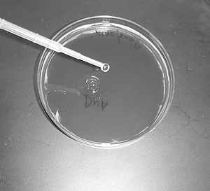
Fill pipette to
Second
Graduation

DO NOT TEAR or RIP the agar. Press GENTLY to spread the bacteria.

d. Place the lid back over the plate. Dispose of your pipette and spreader in the appropriate location designated by your teacher.
e. Repeat the above steps with the next plate using the second concentration of tobacco. You will have one plate that does not get tobacco added
f. Let the tobacco soak into the agar about 5 minutes

- The micro-test tube your group gets contains a culture of Serratia bacteria. You will transfer some of the bacteria to each plate and then use a spreader to spread the bacteria across the agar.
a. Using a sterile pipette, draw up the bacteria until the second graduation on the pipette.
b. As shown below, release the bacteria culture onto the center of the designated plate.
- Use a sterile “blue” spreader to gently spread the bacteria culture across the entire plate. Again, be gentle and do not tear the agar!
d. Place the lid back over the plate. Dispose of your pipette and spreader in the appropriate location designated by your teacher.
e. Repeat the above steps for the remaining plates. ALL plates get the same amount of bacteria.
f. Let the bacterial culture dry about 5 minutes and then place your plates, “upside down” in the location designated by your teacher. The bacteria will need 48 hours to grow before we check your plates again.

Day 2 Directions

- Obtain your plates. Do not open your plates at any time!
- Count the number of white colonies on each plate. Record data from your group and class data in the table provided.

Tobacco Concentration | # of white colonies | Average # of white colonies
No extract
1:1
1:100
1:1,000
1:10,000

Graph averages of class data

Time of UV exposure
# of white colonies

How did results compare to your expectations?

Explain how tobacco caused the bacteria to grow a different color using the gene to protein idea (gene→protein→trait).

Did you notice any changes in the overall number of bacteria that were present on plates with tobacco compared to your no treatment controls? What does this tell you about other effects of tobacco on bacteria (other than color change)?

If tobacco has such an affect on bacteria, do you think these same kinds of changes are happening in your body when you are exposed to tobacco? What changes occur over time due to tobacco?

