Protein Digestion by Enzymes

Introduction:
Almost every chemical reaction in the body is catalyzed by a class of proteins called enzymes. There are two main types of enzymes, metabolic and digestive enzymes. The unique amino acid sequence and shape of an enzyme determines its function. Digestive enzymes have a shape that allows it to bind another protein and cut it at a specific location. If the shape of the digestive enzyme shown below is altered or denatured it may work at a slower rate or not at all.

binds the protein
cuts the protein

Questions: What factors could denature an enzyme? Why does changing an enzyme’s shape have an effect on its function?

Digestive enzymes are important for digesting food because they act as catalysts in the chemical reactions necessary for breaking up the food elements. Every enzyme works best at a specific pH and temperature. Changing either pH or temperature can alter an enzyme’s rate of activity.
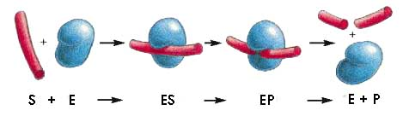

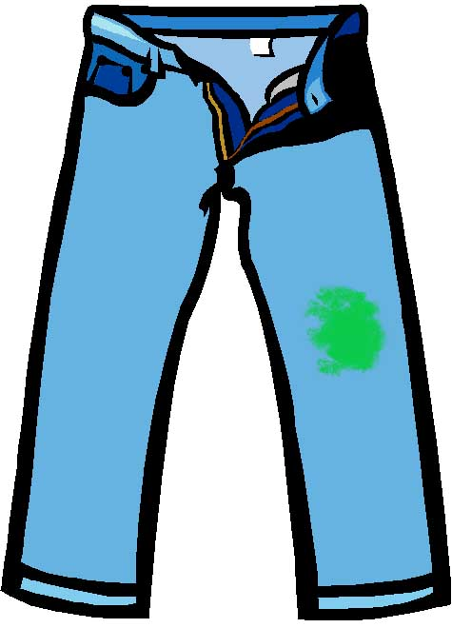
The enzyme above (denoted as E) catalyzes the cutting of another protein, which is its substrate (S). The enzyme first binds to the protein to form an enzyme–substrate complex (ES) and then catalyzes the cleavage of a specific bond in the protein, forming an enzyme–product complex (EP) that rapidly dissociates. Release of the severed protein (the products P) leaves the enzyme free to act on another substrate molecule.

Some, but not all, laundry detergents take advantage of enzymes to remove stains caused by proteins by breaking the proteins up and freeing the molecules from your clothes. Today’s lab will test several laundry detergents on the protein gelatin, the protein in JELL-O™ that allows it to hold its form.

Materials needed:
- 1 petri dish containing JELL-O™
- 1 plastic straw
- 1 toothpick
- 1 permanent marker
- 1 metric ruler
- different detergents and distilled water with their own pipettes

Procedure:
Day 1:
- Label the bottom of your petri dish containing the JELL-O™ near the side with your group number.

- Using the plastic straw cut a well in the JELL-O™ for
each detergent you will be testing plus an extra
one for the distilled water. Use this template as an
example of a pattern to follow and make sure you
leave an equal amount of space between each
well.

- Number each well on the back of the plate so that
they can be read from the front. This means you would
write the numbers backwards.

- Remove the plugs of JELL-O™ with the toothpick. Try not to tear the JELL-O™ outside the plug.

- Measure the diameter of each well and record it on your table.

- Decide which detergents will be tested and which well they will be tested in. Record this in your table. The distilled water should be tested in the center well.

- Using a different pipette for each load enough detergent or distilled water to fill its designated well. Do not drop any detergent on the surface of the JELL-O™.

- Put the lid back on the petri dish. Be careful not to spill the contents of the well or to turn the plate upside down.

- Let the plate sit overnight at room temperature.

Day 2:
- Using a pipette, remove the liquid from the wells and discard.

- Note any physical changes in the JELL-O™. Measure and record the diameters of the wells at the widest point in your table. Calculate the change in diameter for each well.

Data Table:
Well # | Detergent Name | Initial Diameter | Final Diameter | Change in Diameter
1
2
3
4
5
6
7

Discussion:
- What hypothesis would you propose for this experiment?

- What are the dependent and independent variables in this experiment?

- Why did the well diameters change?

- Which detergents worked best? Which didn’t work well? Why?

- Why do some detergent companies put enzymes in their products?

- Would enzymes work equally well on non-protein based stains like grease? Why?

In the introduction we discussed the effect of pH on the effectiveness of an enzyme. The JELL-O™ experiment you did was also done using detergents made at different pHs. The change in well size caused by the different detergents was measured and reported in the bar graph above. Distilled H₂O was used as a control.

- What is the dependent and independent variables in this experiment?

- What happens to a solution when its pH changes?

- How does changing the pH affect an enzyme?

- How does altering the pH change the effectiveness of an enzyme?

- The environment in your stomach has a pH of about 2. Do you think the enzymes used in these detergents would work well there?

Many living organisms have evolved to live in environments that we would consider extreme or even toxic. Some of these animals live in extreme temperature environments. The enzymes of these animals have evolved to work best at the temperature they live in. Below is a graph representing the activity of an enzyme in three different organisms, A, B, and C. Each organism lives in an environment with a different temperature.

A
B
C

- Describe what each of these organisms might be like and where they might live.

Lab Preparation

JELL-O™ Plates
Mix the JELL-O™ with boiling H₂O at a ratio of 36g/100ml. If you do not have a metric scale, it is approximately 3oz/1cup. This is about twice as concentrated as the directions on the JELL-O™ box. Some flavors of JELL-O™ don’t work as well. It has been found that black cherry does not work as well as lime green.

The enzymes work best at a pH of 8. Depending on the flavor, use a few grams of sodium carbonate (Na₂CO₃) per 100ml of dissolved JELL-O™ in boiling H₂O. It is recommended to use crystalline sodium carbonate over powdered due to excessive foaming. A 3oz box makes about ten 100mm plates.

Detergent Solutions
50% detergent solutions should be made fresh daily. The enzymes break down in solution.

Previously Tested Detergents
Detergent | Contains Enzymes?
Dreft | Yes
Tide | Yes
Cheer | Yes
ERA | Yes
Wisk | Yes
All | No
Woolite | No
Arm & Hammer | No

